Rotarians Recognized for Donations to The Rotary Foundation
The Mission of The Rotary Foundation is to enable Rotarians to advance world understanding, goodwill, and peace through the improvement of health, the support of education, and alleviation of poverty. Individual Rotarians make regular donations to The Rotary Foundation to support this work. Those donations are recognized by Awards given to Rotarians for each $1000 donated.
The first $1,000 donated the Rotarian becomes a Paul Harris Fellow named for the founder of Rotary. As a Paul Harris Fellow the Rotarian receives a Certificate and a lapel pin. Each $1000 donated after that increases the level of Paul Harris Fellow (PHF +1, 2, etc) with a unique lapel pin recognizing the new level.
These are personal donations made by the Rotarians to support the work of Rotary in the World. Within the Club, Rotarians work and raise funds for our local service projects in our local Community. It is only through personal donations that the Rotarians reach out from our community to the world.
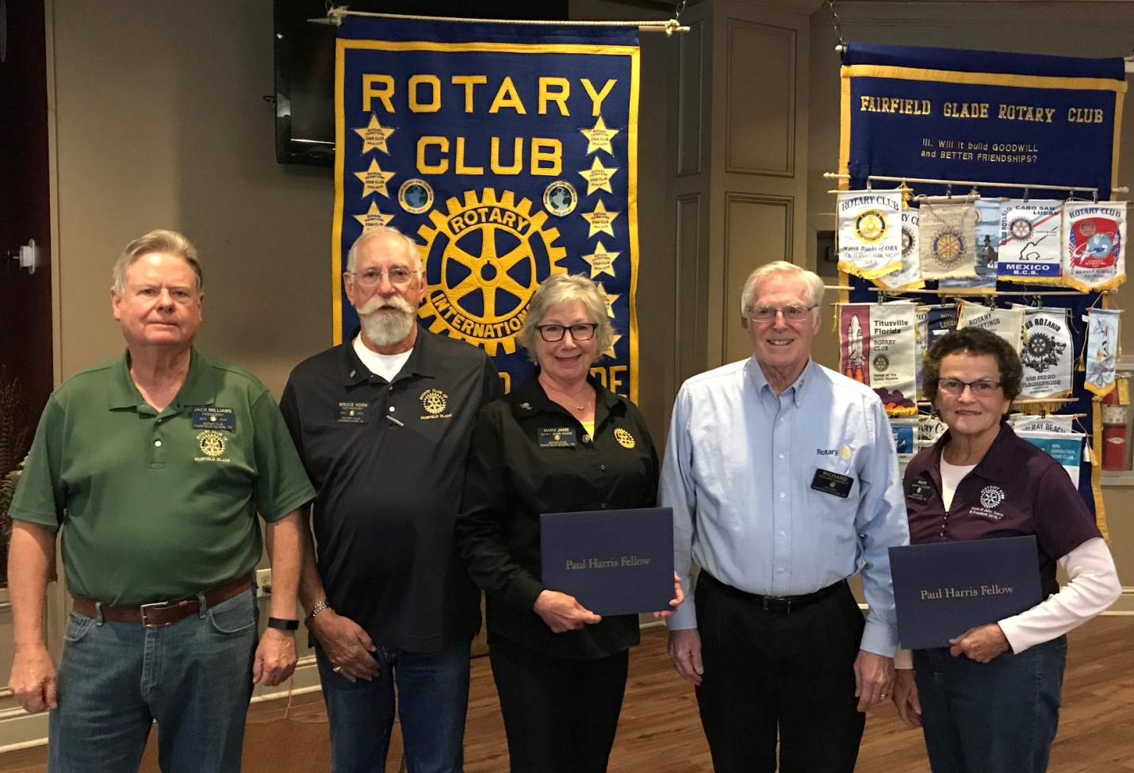
Fairfield Glade Rotarians being recognized for their donations to The Rotary Foundation of Rotary International . Left to right Jack Williams, PHF +2; Bruce Horn, PHF+1; Mary Jane Ware, Paul Harris Fellow; Richard Garrett, PHF+4; Mary Cooper, Paul Harris Fellow

