Cumberland County Rotaract Club held it First Meeting
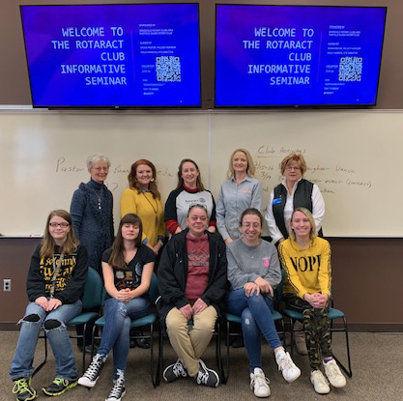
Front Row: Riannon Sexton, Makenzie Pentz, Connie Booth, Sienna Howe, Hannah Swenson; Back Row: Holly Hanson, President Crossville Noon Rotary, Bethany Davis, President Crossville Breakfast Rotary, Dr Sylvia Pastor, Rotaract Sponsor, Kelly Jones Crossville Noon Rotary, Chris Celik, FG Rotary.

The Cumberland County Rotaract Club was Chartered in January, 2019 and held its first meeting on January 30, 2019. This new Rotaract Club is jointly sponsored by Rotary Club of Crossville (Noon), Rotary Club of Crossville Breakfast, and Rotary Club of Fairfield Glade.
Rotaract Clubs give young men and women ages 18-32 opportunities to develop the knowledge and understanding of the needs and problems in the community and to develop personal and group activities to serve the community.

Rotary believes that young people, or New Generations, should have opportunities to take an active interest in community life and for professional development. Rotaract Club members (Rotaractors) are interested in serving the needs of their communities, in widening their personal and professional contacts, and increasing their understanding of the world.

This Club, and all Rotaract Clubs, will undertake projects and activates for professional development, leadership development, and service projects in the community selected by Club members. The service projects are designed to improve the quality of life in the community and address today’s most critical issues such as poverty, illiteracy, violence, drug abuse, hunger, and/or the environment. Cumberland County Rotaractors will also have opportunity to participate in the activities and projects of all three sponsoring Rotary Clubs.

This new Rotaract Club is seeking additional members interested in personal and professional development while serving their community following Rotary’s motto of Service above Self.

The next meeting is Wednesday, 13 February, 11:30 a.m. at Roane State College, 2567 Cook Road, Crossville, in the Community Room. Lunch is provided. Please join us and hear all about what it means to be a Rotaractor and serve the Community!!!!!!! Contact Dr. Sylvia Pastor pastorsh@roanestate.edu in case of questions or for more information go to https://www.rotary.org/en/get-involved/rotaract-clubs

