FG Rotary donates to Christian Counseling Center

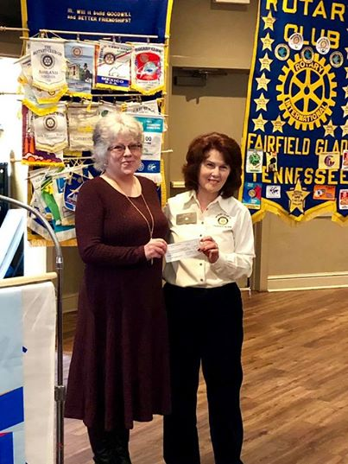

Rotary Club of Fairfield Glade presented a donation to Christian Counseling Center. Donna Cielma, Executive Director, Christian Counseling Center (on left) is shown receiving the check from Rotarian Jane. The Christian Counseling Center of Cumberland County is a nonprofit agency providing confidential, affordable counseling service from licensed professionals for children, teens, adults, and couples based on an “ability-to-pay” basis so help is available to all. For information or help please call 931-707-8200 or visit their website at www.christiancounselingotp.org

