Checklist for Initiating District Grant Applications
- Log into DACdb
- Click on the GRANTS Icon.
- Click on Club Grants View in left menu to get the screen below.
- Click on New Club Grant Request box.
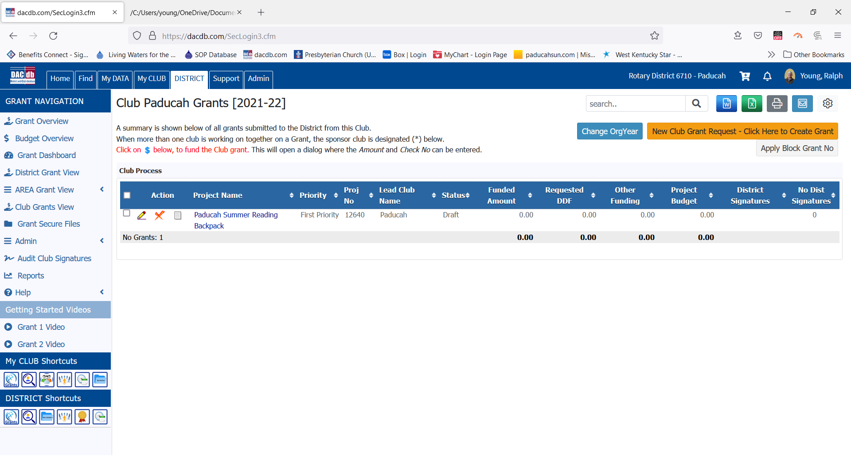
- Fill in the information requested in each of the text boxes. Click on each of the Tabs to complete the information. Save your information until ready to submit the grant application.

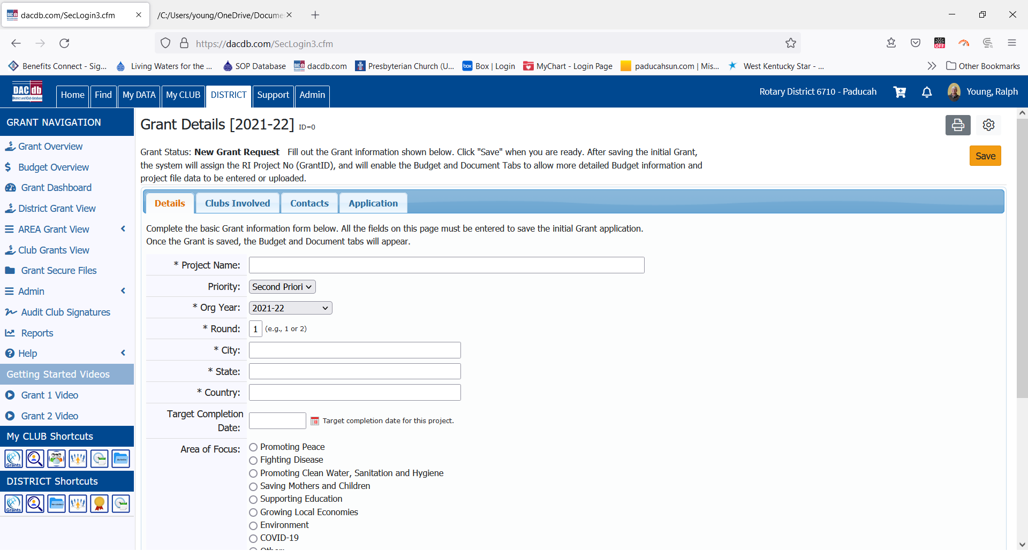
- As more information is added, more Tabs will appear - Budget & Documents. After all the information has been entered, click on the Club: Collect Grant Signatures box. See below.
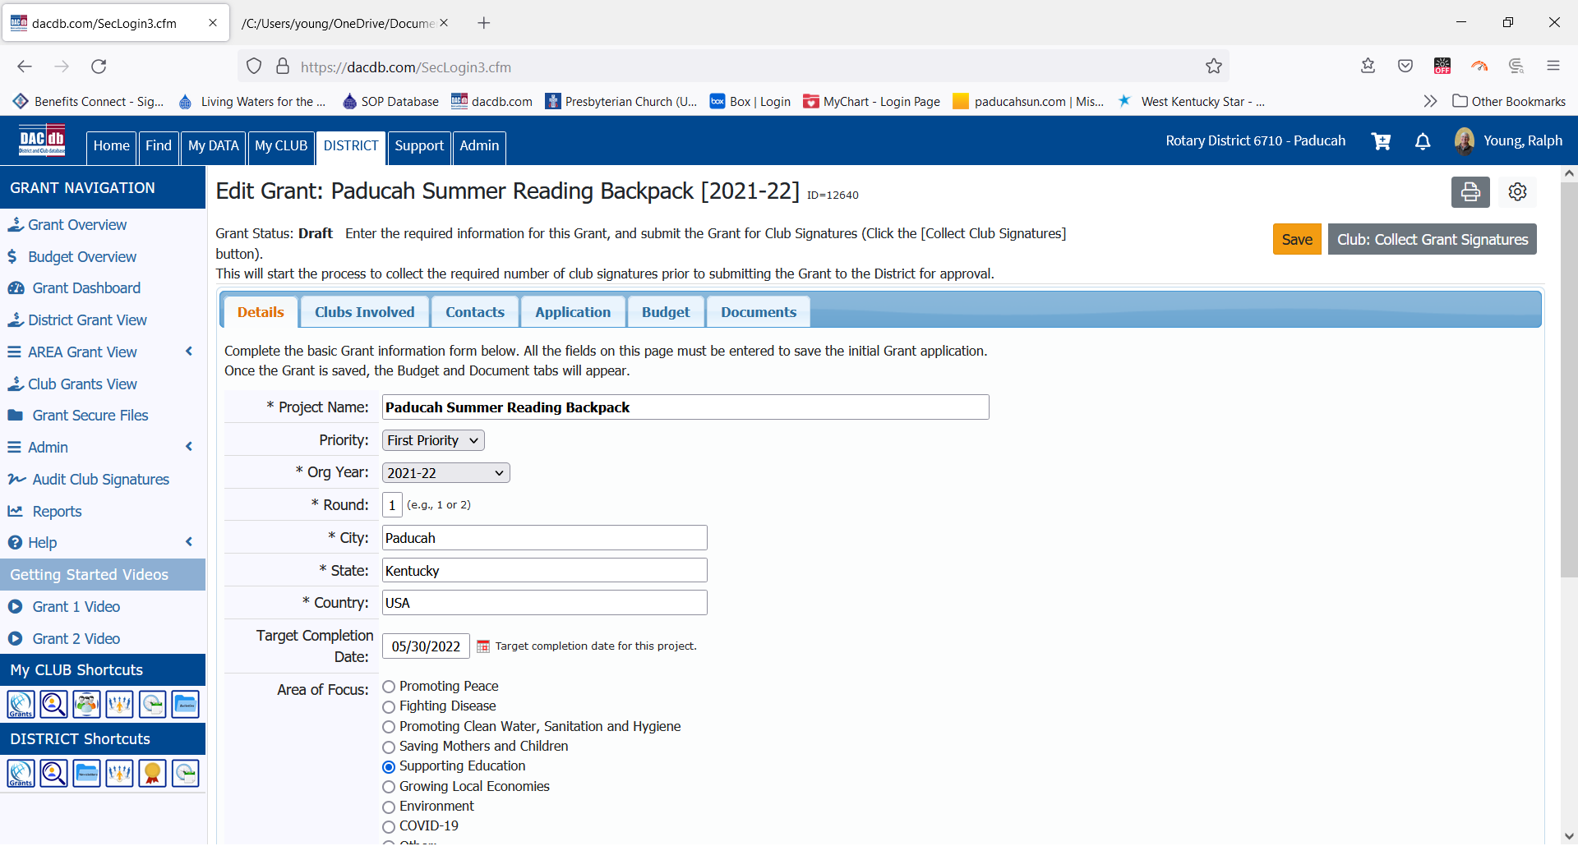
- Once two club authorized signatories have signed, submit the grant to the District for approval.
- You will be notified by the District Grant Committee when your grant has been approved.
- In some cases, your club may not have established authorized signatories to District Grants.
- Click on Admin in the left menu, then Club Signatures to make those authorizations.
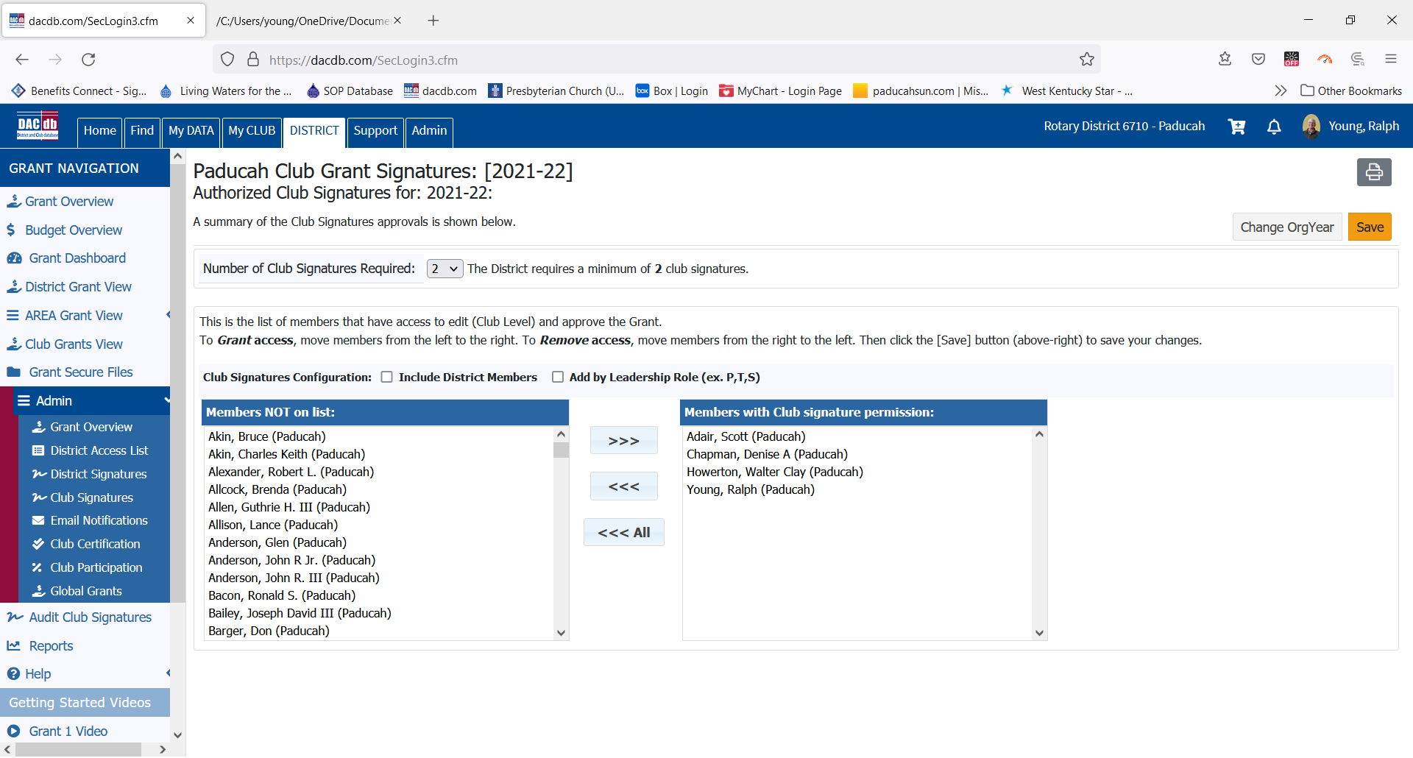

Rotary District Grant Application Format
These are the narrative questions presented in the on-line version of the District Grant application. Applicants can use this format to formulate their answers, then Copy & Paste them into the DACdb text boxes on the application.
Grant Timeframe
Start Date:
End Date:
Address To Mail Grant Payment
Name & Club
Address
Project Definition
*Describe the project objectives.

*How did you assess the community's need for this project? Describe how the project will benefit the community and/or improve the lives of the less fortunate. Describe ways in which the project's benefits to the community will be long-term and sustainable in nature.

*Active Rotarian Involvement: Describe the nonfinancial, hands-on participation by Rotarians in the project.

*Publicity Plan: How will the general public know this is a Rotary sponsored project? How will Rotarians be actively involved in publicizing the project?

*If the project involves a cooperating organization, please provide the name of the organization and attach a completed copy of the Cooperating Organization Memorandum of Understanding in the documents section.

The remaining input for the application contains checkboxes and other club information. Consult with your club officers if you have any questions.

