District 6710 Grant Management Seminar
1. First you have to go to My Rotary: www.myrotary.org
2. When you are there you have to sign in. If you don't have an account already set up, you will have to set it up.
3. Log into your account.
4. Click on the Learning & Reference menu.
5. Then click on Learning Center. This web page may ask you to sign in again!
6. You will see a lot of courses available. Scroll to the bottom of the page to find the District courses. District 6710 has one course listed. See below.
7. Click on the District 6710 Grant Management Seminar and you will be off and running!

Spoiler alert – Rick has done a masterful job but the course is tough with tricky quizzes at the end of each of four modules. You must get a passing score to be certified. There were several modules where I had to retake the quiz a couple of times because there were multiple answers! I would suggest printing out the notes as you go through the videos. I've been doing grants for years and still learned a lot of new things.

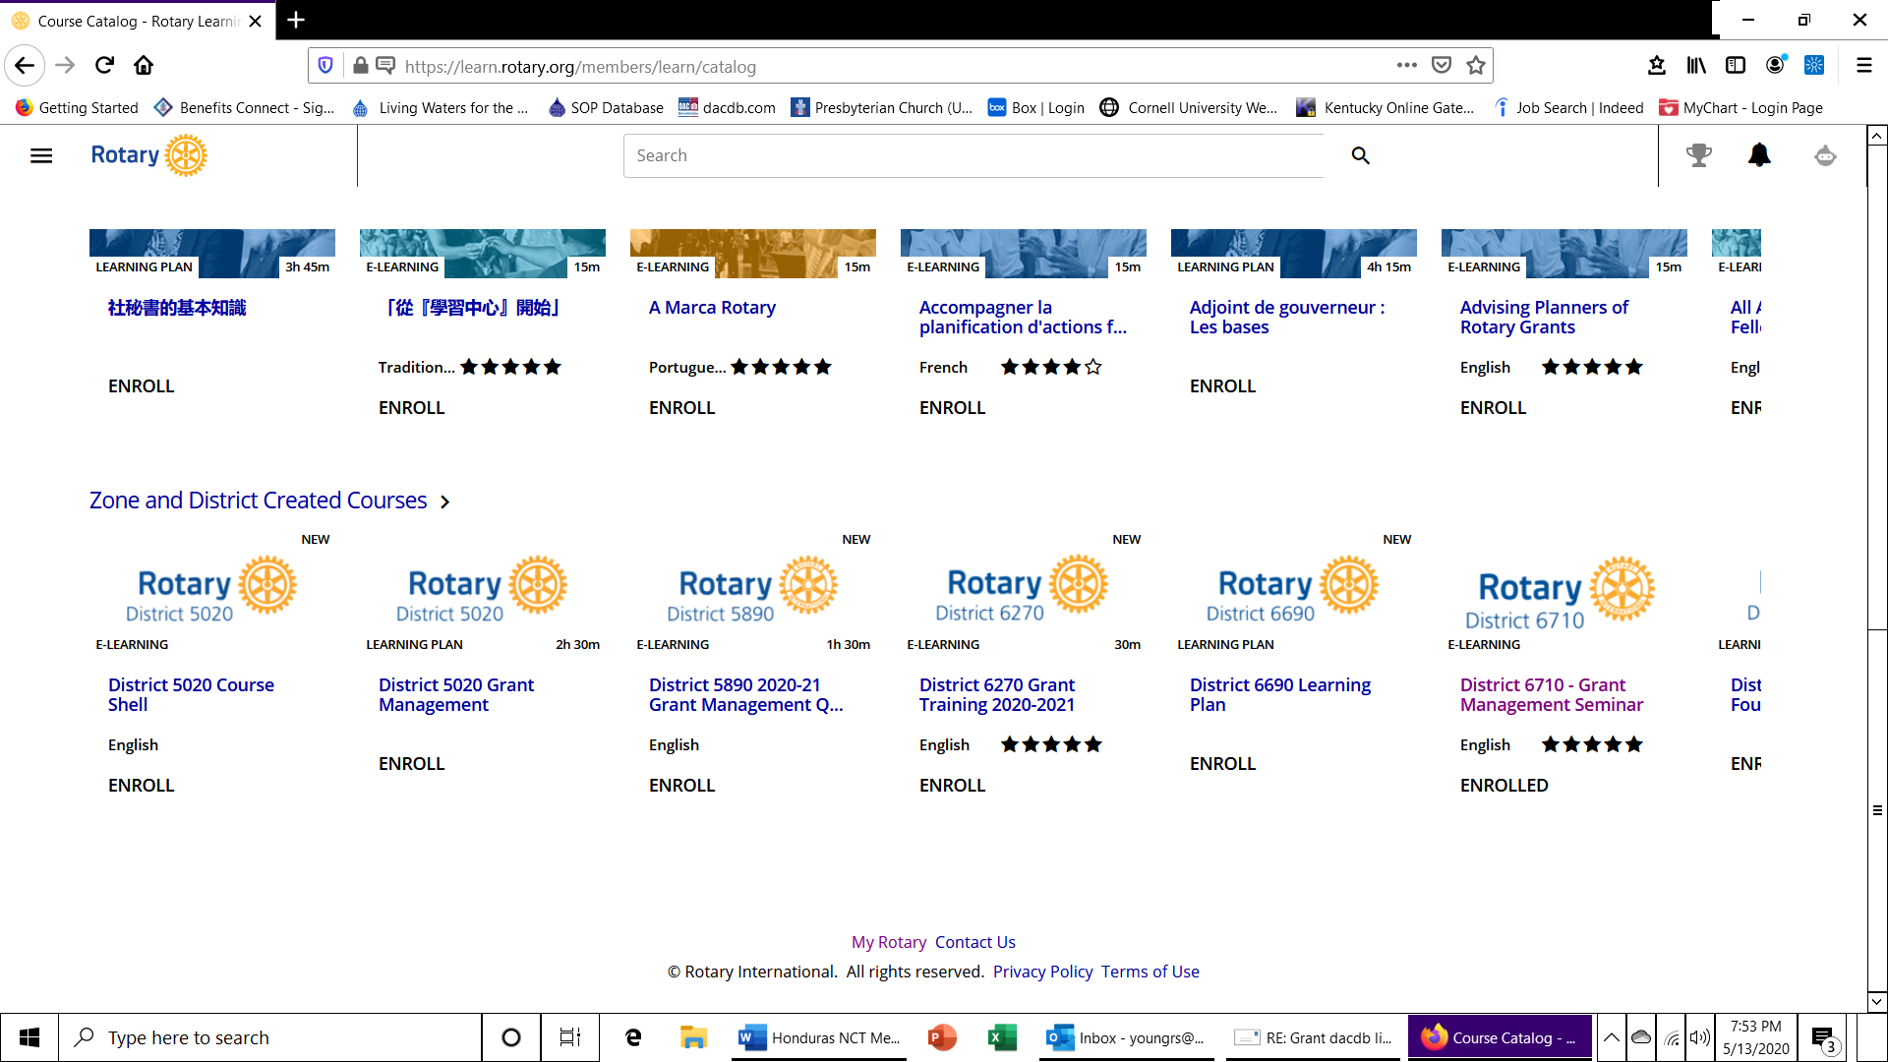

Good luck.

Ralph Young

