Phase II District 6710 Disaster Relief Grant Application - DACdb
Background
Phase II of the District 6710 Disaster Relief program will consist of grants that clubs can apply for just as they would a District Grant on DACdb. Because these funds will come from donations outside of The Rotary Foundation, the guidelines for District 6710 District Grants will be followed. The main difference is that Cooperating Organizations on projects will be able to submit invoices for payments. No payments will be made to individuals or disaster victims receiving assistance.
The limit on these grant projects will be $10,000 maximum. Clubs are encouraged to estimate the budget for a project as closely as possible for payment before the project starts. Clubs will not be expected to fund the project then apply for reimbursement. After the project is completed, clubs will be required to file a Final Report showing all invoices, receipts, and payments made for the project. Unused grant funds shall be returned to the District for use in other projects. Projects that go over budget and the $10,000 maximum will be the responsibility of the club to fund.
Disaster Relief Grant Process
1. Log into DACdb and click on the “My Club” tab. Follow the process for entering on new district grant on DACdb. Click “New Grant Request – Click here to Create Grant “.
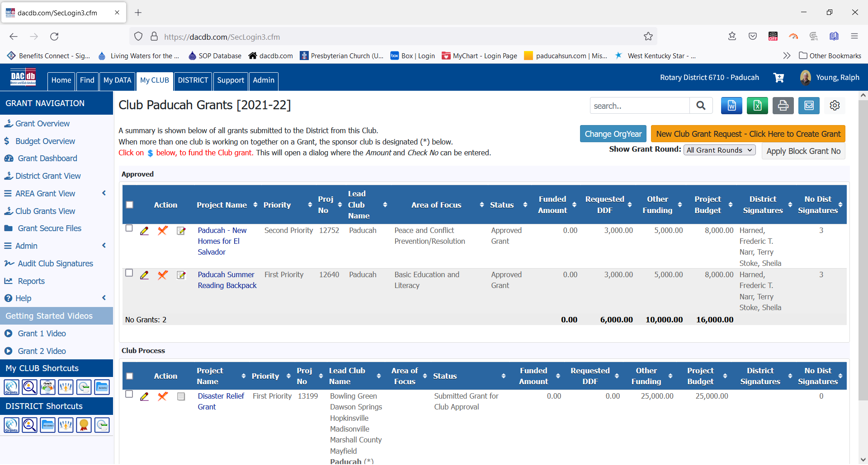
2. Fill out the grant application. The Title should start with the words – “Disaster Relief – Club Name – Name of project.” Please check the Disaster Relief area of focus.
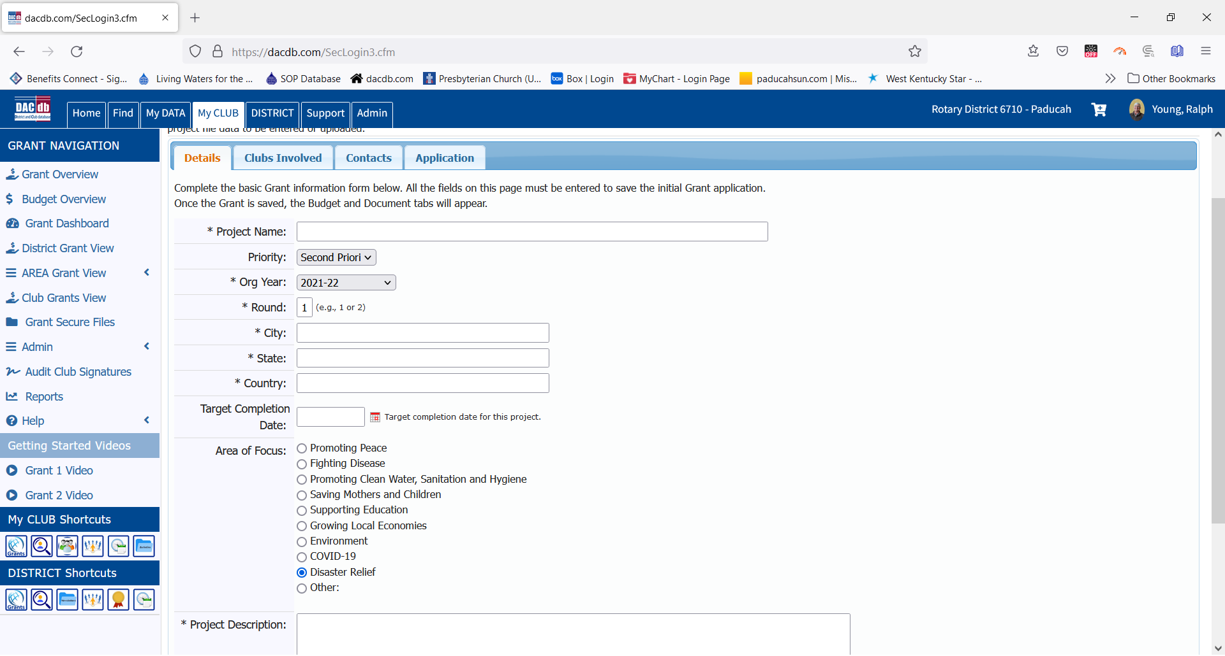

3. Fill in all the boxes for the application. Describe the Project Definition section.
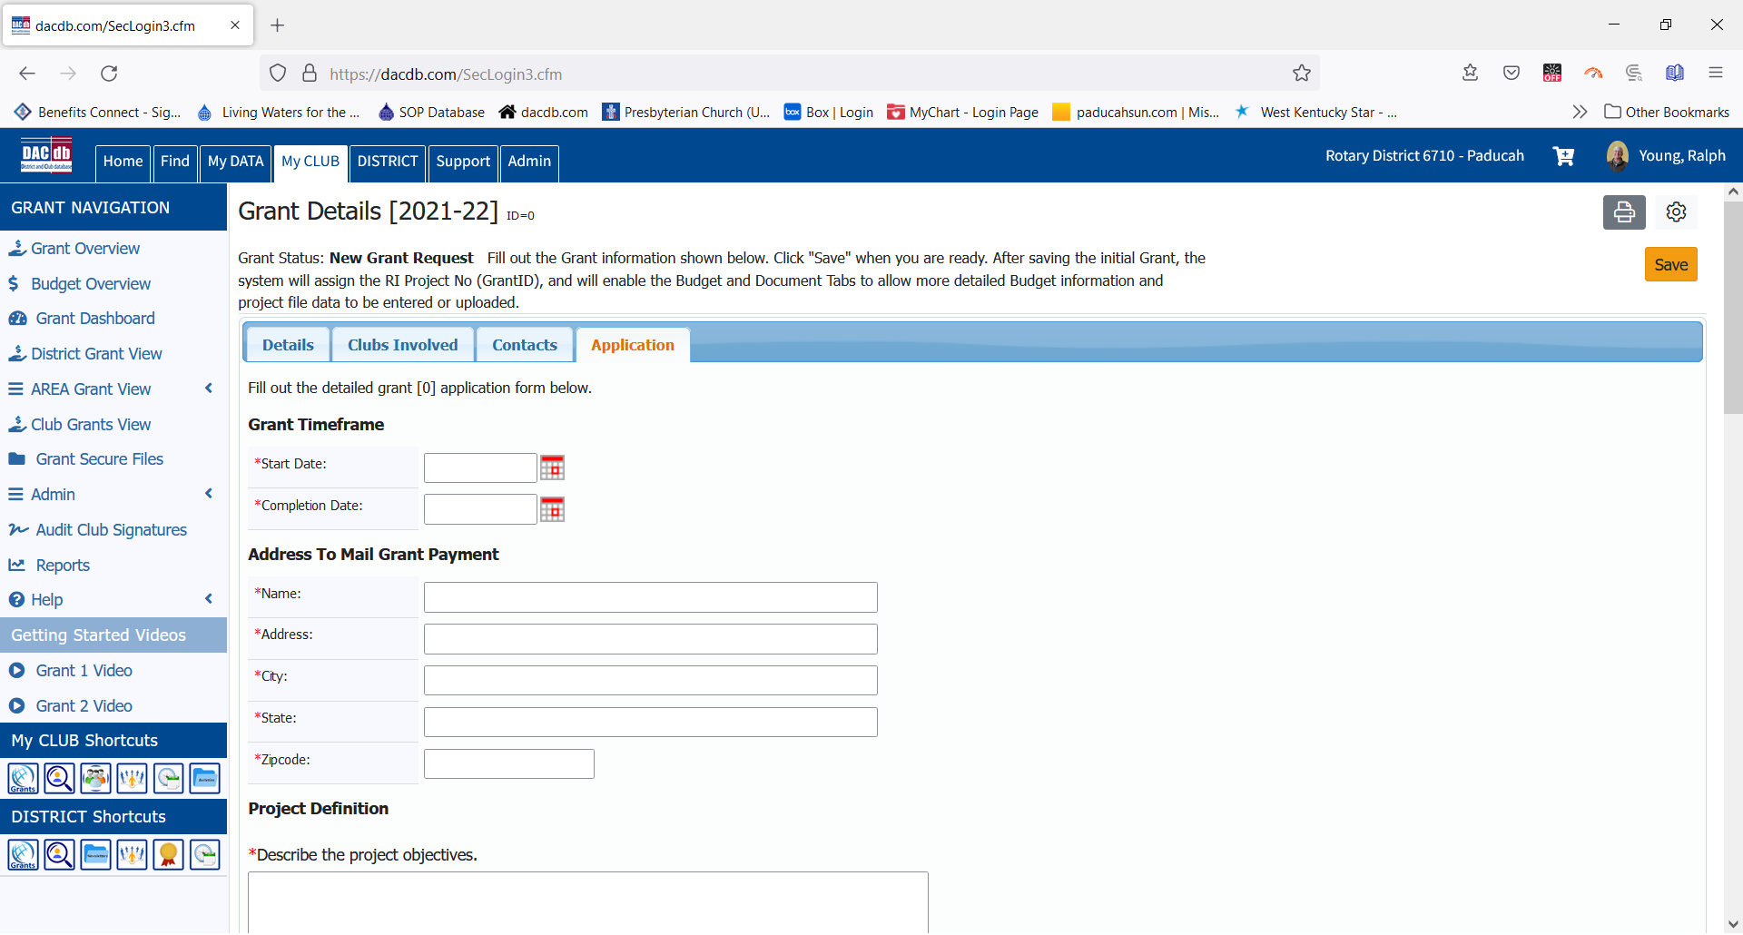
Project Definition
*Describe the project objectives.

*How did you assess the community's need for this project? Describe how the project will benefit the community and/or improve the lives of the less fortunate. Describe ways in which the project's benefits to the community will be long-term and sustainable in nature.

*Active Rotarian Involvement: Describe the nonfinancial, hands-on participation by Rotarians in the project.

*Publicity Plan: How will the general public know this is a Rotary sponsored project? How will Rotarians be actively involved in publicizing the project?

If the project involves a cooperating organization, please provide the name of the organization and attach a completed copy of the Cooperating Organization Memorandum of Understanding in the documents section.

4. Complete the certifications page checking all the boxes as appropriate.
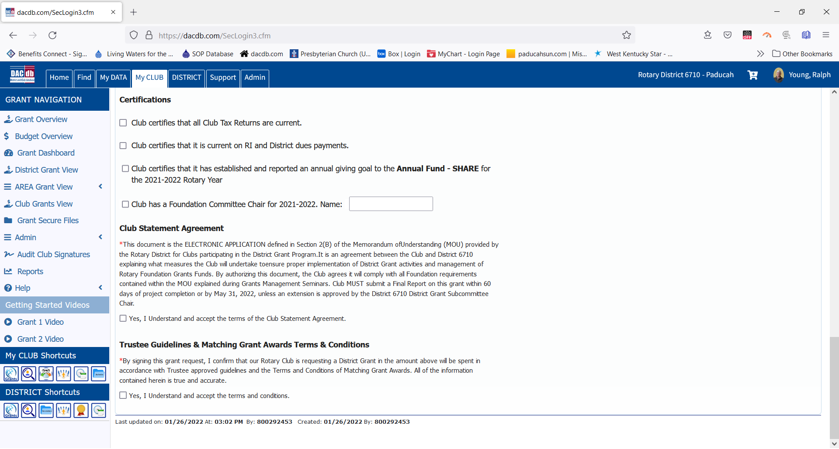
5. Once the project has been saved, the Budget tab will appear. Complete the budget information. No funds will be coming from the DDF. Income for projects will come from Disaster Relief funds donated and collected in the 671 Foundation account. The maximum amount per grant application is $10,000. Make sure that grant income equals grant expenses. The example below is for the TRF grant application. 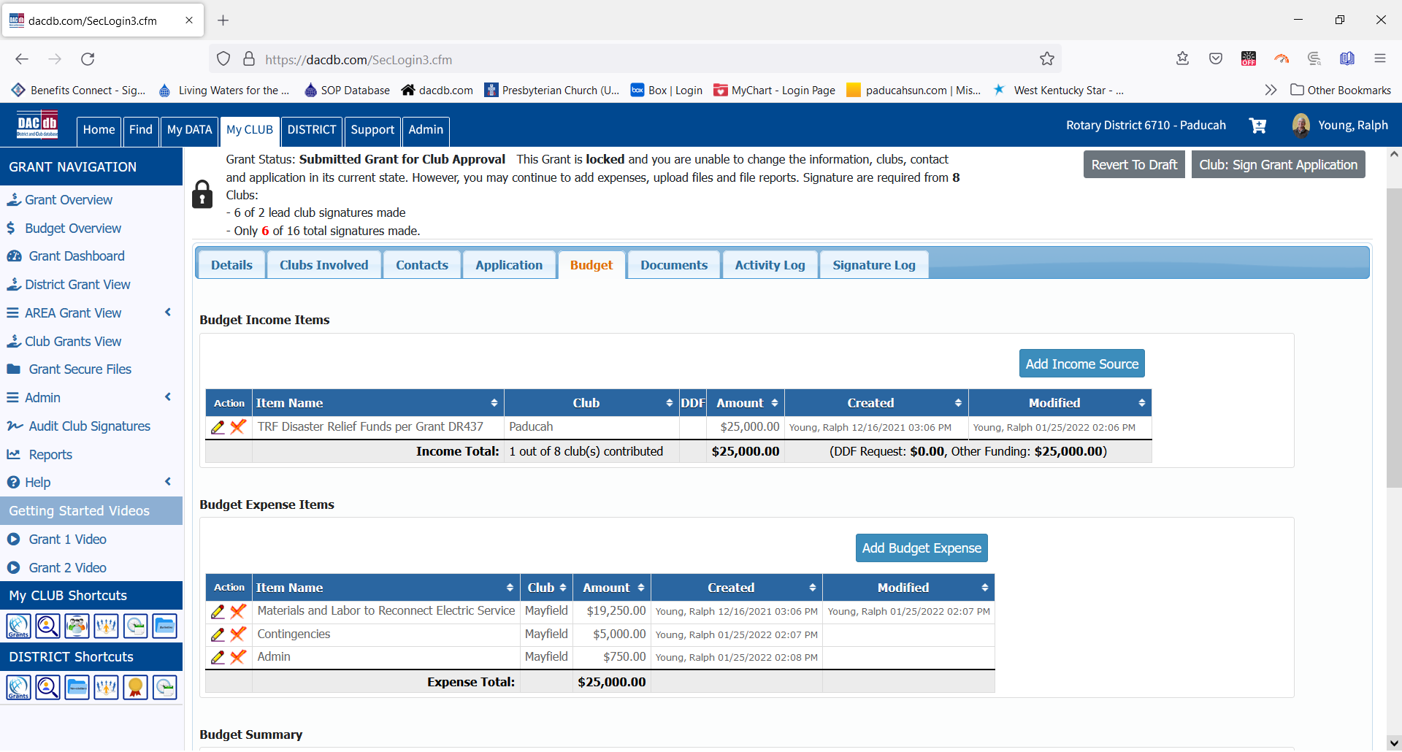

6. Once the budget has been entered, continue the process to save the grant. Invoices, project estimates, MOU’s for Cooperating Organizations, etc should be uploaded to DACdb under the Documents tab.
7. At this point, you are ready to pass the grant along for club approvals. The last club approval should forward the grant to the District Sub-committee for their approval.
8. Once the district approves the application, steps will be taken to have a check prepared and sent to the club. The Disaster Relief grants will be paid at approval not after the project has been completed.
9. Once the project has been completed, file a Final Report in DACdb. Upload any invoices, receipts, or other documentation to DACdb.
10. The District will approve Final Reports as they are finished in DACdb. There will be no other checks issued for projects after the initial payment. Make sure that invoices, receipts, and images of cancelled checks have been uploaded.
11. Pay special attention to Rotary publicity for a Disaster Relief project. Pictures, images of media reports, and other sources should be uploaded to DACdb for publicity purposes. In many cases it is best to insert a photo into a MS Word document so that the picture can be captioned to identify Rotarians.

