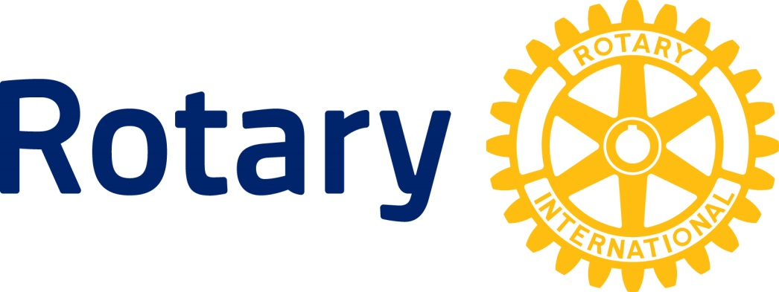
Rotary Club of Fairfield Speaker Guidelines
On behalf of the Rotary Club of Fairfield, we deeply appreciate your willingness to take the time to share your talent and expertise with our members. The Rotary Club of Fairfield is an organization of business professionals and executives committed to professional and ethical values, humanitarian service and the motto of “service above self.” For more information, we encourage you to visit our website @ www.fairfield-rotary.org.
The following guidelines are provided to assist you with your presentation:
Background Information
- The Rotary Club of Fairfield meets every Friday from 12:00 PM to 1:00 PM at the Fairfield Community Arts Center located at 411 Wessel Drive, Fairfield, OH 45014
- Rotary Club of Fairfield members are professional men and women with some retirees, approximately 60 members, with about 40 in attendance at weekly meetings.
- Your Rotary Host is the person who invited you to speak to the Club. In advance of the day of your presentation, please be sure to provide your Rotary Host with:
  - Information on any audio-visual needs you may have; and
  - A brief Bio
- Pamphlets or brochures related to your program may be distributed on tables prior to the meeting. Please arrange to have any extra brochures picked up following the meeting.
- Unless specifically asked to do so by the Club President, please refrain from:
- Marketing or sales talks;
- Direct solicitation for a charity, cause, or project; or
- Personal political or religious messages.
- Support for a ballot issue or candidacy.
Requests for Club support for service projects should be directed to the Club President.
- Rotary is a secular organization whose membership includes persons of all faiths, religions, and beliefs.

At the Meeting
- Proceed to the Rotary meeting room located on the second floor. (an elevator is available for ease and convenience)
- Introduce yourself as the guest speaker at the Club’s registration desk – you will be asked to sign in but your lunch is on the Club. The Club has a buffet lunch set up in the back of the room. Please help yourself.
- Your Rotary Host will invite you to lunch with them or the Club President. If you are acquainted with other Rotary members, you are welcome to lunch with them.
- The program portion of the meeting typically begins at 12:15 pm and the speaker would normally be introduced at about 12:30 pm. There is a maximum of 20 minutes (including Q&A) for the speaker’s presentation.
- There is Club business following the speaker presentation and the meeting will end promptly at 1:00 pm.

If you have any question, please contact your Rotary Host.

Again, thank you for sharing with the Rotary Club of Fairfield.

