As a Rotarian and supporter of Polio Eradication, Rotary's #1 priority, I wish to participate in this humanitarian endeavor as a member of the PolioPlus Society.
Therefore, I hereby commit to making an annual donation to the PolioPlus program of The Rotary Foundation as follows: (select one)
$100 per year (minimum amount to become a society member)
A contribution of $ per year to PolioPlus (more than $100)

RI ID # ______________________
Send application and check to Jim Gislason, 111 Hendron Hills Dr., Vincennes, IN 47591

- Society members will receive a PolioPlus Society membership pin and Paul Harris credit. Make your donation online at www.rotary.org/donate and select the Polio Fund or through your Rotary Club. If you make it online, you can set it up as a recurring donation.
POLIOPLUS SOCIETY
MEMBERSHIP
I pledge to contribute at least $100 each year
until the World Health Organization certifies
that Polio has been fully eradicated and the world is polio-free. I do this because
UNTIL THE LAST CHILD IS IMMUNIZED
AND THE WORLD IS CERTIFIED POLIO-FREE,
EVERY CHILD IS AT RISK.
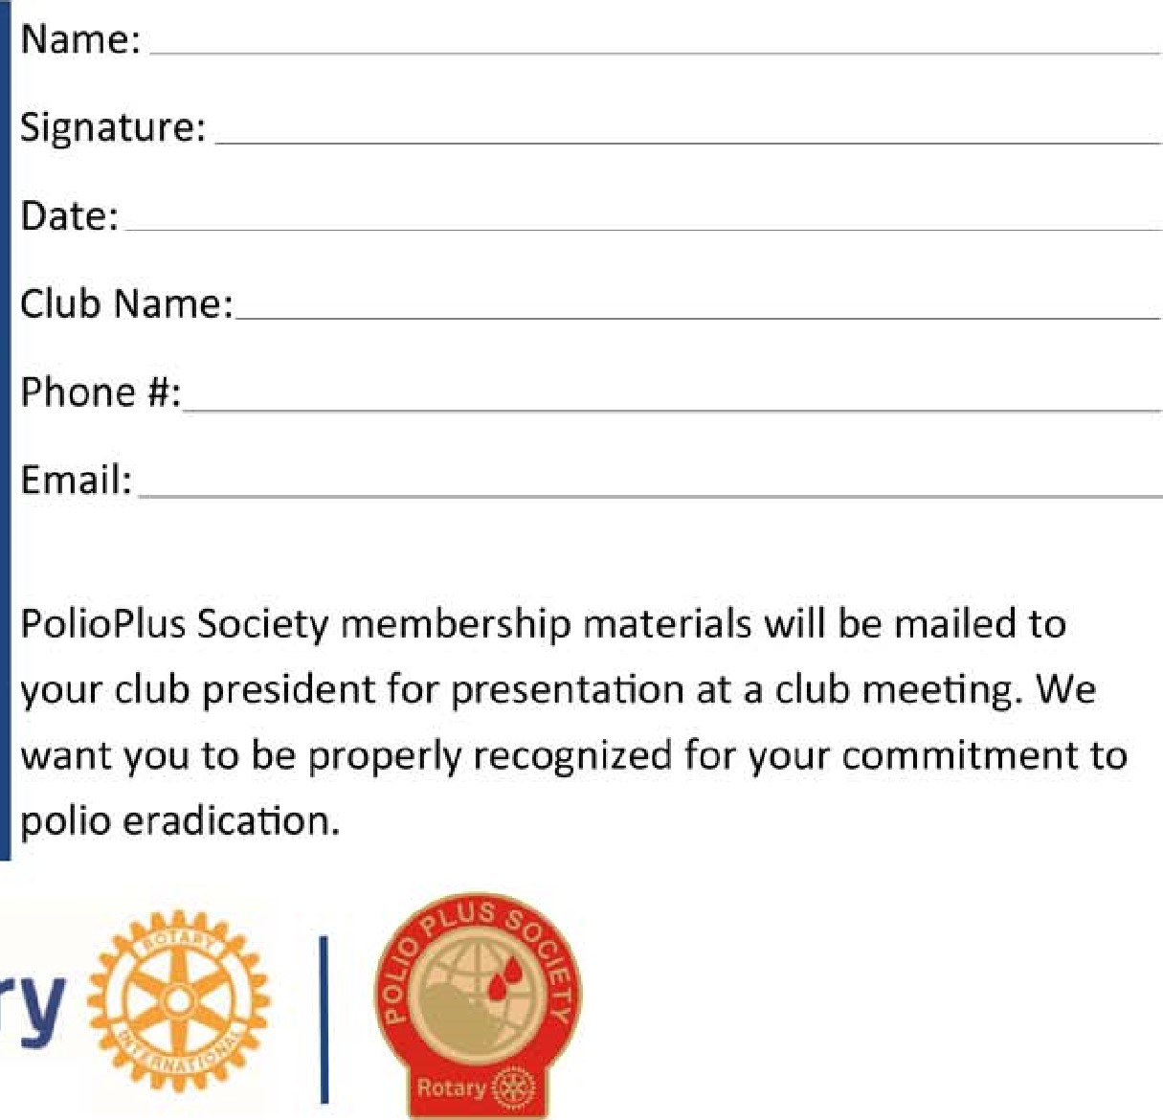
Please send this completed form to Jim Gislason, District 6580 Polio Plus Chair, jgis142@gmail.com
Rotary

