Board of Directors Meeting
February 8th, 2024
7:03 a.m.

- Meeting called to order at 7:02 a.m. 8th board meeting of 23-24 Rotary year.

Roll Call
There was a quorum present.

Role | Name | Present
President | Yolandea Wood | Yes
President-Elect | Lori Ehlers | Yes
Previous President | Libby Quinlan | Yes
Treasurer | David Gornstein | Yes
Admin | Kevin Gederman | Yes
Membership | Vacant | Vacant
International / Foundation | Mike Nowobilski | Yes
Service Projects | Mary Jo Nowobilski | Yes
Flags Committee Chair | Jim Burton | Yes
Exec Secretary | Catherine Taylor Yank | No
Youth Chair | Vacant | Vacant
Public Relations | Steve Stater | Yes
Secretary | Tim Sipes | No
Member at Large | Ray Rohr | No

- Introduction of Visitors/Club Members
  - None

- Announcements:
  - Leonor Branch was inducted into the club on 7 February 2024
    - She will assist Steve with publicity
    - Jim will assign her to a flag team
    - Yolandea is her mentor.
  - The 7 Feb meeting was a business meeting

- Review and Approval of Board Minutes from January 2024

Action: January board meeting minutes were reviewed and approved by the board
Motion: To approve the minutes
Motion made by: Kevin Gederman
Seconded by: David Gornstein
Motion: Approved

- Review and Approval of Financials for January 2024

- David distributed the monthly financial reports and reviewed them
- There is a request from Martha that the club pay the National Rotary Dues for the Rotaract Club ($105 total).
Motion: To pay $105 for our Rotaract Clubs National Rotary Dues
Motion made by: Mike Nowobilski
Seconded by: Jim Burton
Motion: Approved

- The Youth Exchange District Grant
  - $4,000 was approved for our exchange student ($4000 total with $1000 from our club and $3000 from the District grant).
- Nicaragua Water Project
  - See discussion in International Service section below
- Annual Budget
  - Yo passed around a Budget to Actual spreadsheet that shows what has been spent year to date and what is left in different categories
    - So far we are under budget
      - For example ahead on Happy Bucks; not spending as much on our food
  - Yolandea is also working on revising the Budget.
- David asked if he could have $40 in cash to make change at the meetings
  - We are losing 50/50 tickets sales due to a lack of the ability to make change
Motion: To have $40 in cash available to make change for 50/50 tickets
Motion made by: Kevin Gederman
Seconded by: Steve Stater
Motion: Approved

- 2 CDs are coming up for renewal in April
  - We need to have a plan for renewal
    - Do we roll them over, look at other options, and/or pull back interest earned
- Yolandea is going to talk to Carl Lurk about his dues
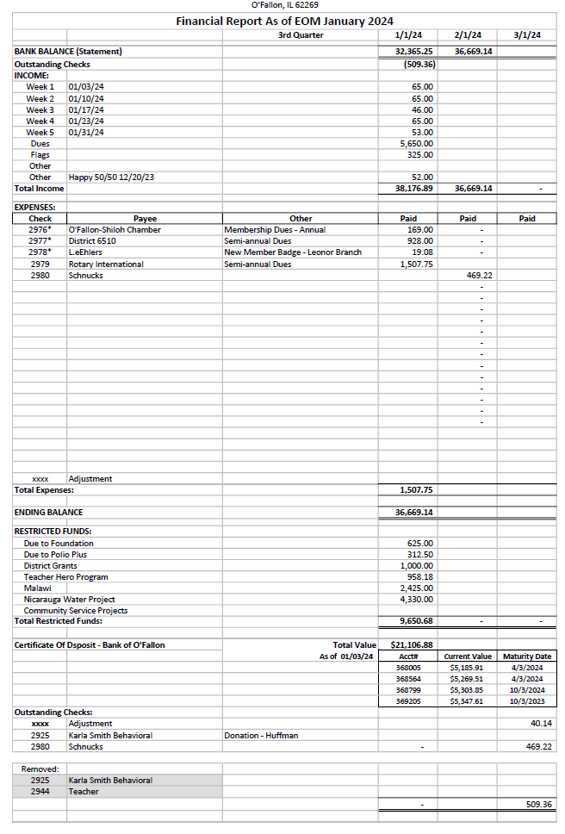
Motion: To approve the financial report with clarification on the formulas for the Dec total expenses
Motion made by:
Seconded by:
Motion: One board member left early so there was no quorum for a motion

- Past Presidents Report: Libby Quinlan
  - Libby and a few others are going to other Rotary clubs to pass out flyers and promote the golf tournament in May.

- Presidents Report: Yolandea Wood
  - Yolandea wants to get a team together for the Fairview Heights Rotary Trivia Night on March 2nd
  - The Belle Clair Rotary is have a Chili Day on March 27th at First Presbyterian Church on Royal Heights Rd. in Belleville; Cost $12
  - The Violence Prevention Center is hosting More Than Just Dessert on April 28th 6-10 PM at the Classic Cars Bldg
  - The O’Fallon Women’s Club is having their Empty Bowl Lunch on 2/14 from 11-1 at the Classic Cars Bldg

- President-Elect Report: Lori Ehlers
  - Lori said that she and Tim are attending the Pre-PETS on Zoom on Feb 17th and PETS in Effingham March16-17.
  - She also went over the calendar – there are speakers scheduled through March
  - Still working on the board for next year
  - Working on next years budget

- Committee Reports - Club Administration, Membership, International and Foundation, Community Service, Flag Report, Youth, YEO Report, Public Relations, Member-At-Large, Programs, and Calendar Review.

- CLUB ADMINISTRATION: Kevin Gederman
  - Kevin said the Anniversary Dinner was a nice evening even though it was sparsely attended.
    - Traditionally, it’s been on the weekend between the NFL playoffs and the Super Bowl but that may need reevaluating
      - Start planning in Oct to get a better feel for availability
    - Mike N, mentioned that in the past they had mouse races and they were a lot of fun and something the community can be invited to.
  - Kevin will talk to the mayor about adding welcome signs on the way into town and highlighting the different service clubs.

- MEMBERSHIP: Vacant
  - New Member Leonor Branch: See discussion above in Membership section

- INTERNATIONAL AND FOUNDATION: Mike Nowobilski
  - Nicaragua Water Project Restricted Funds:
    - Anticipated Nicaraguan Global Grant Project was discontinued. The club’s 11-01-2023 balance sheet listed $5330 in restricted funds for this initiative. The restricted funds included $1000 from O’Fallon, $500 from Swansea, $1000 Fairview Heights, and $500 from Waterloo Clubs.
      - The O’Fallon ($1000) and Swansea ($500) clubs asked that the funds be moved to the club’s Malawi restricted funds line item fund; total is $1500.
      - We are returning contributions received from the Fairview Heights ($1000) and Waterloo ($500) clubs; total is $1500.
      - Adjusting for the above leaves a balance of $2330, including $2000 that was allocated to the Restricted Funds line item from the International Committee’s budgeted amount.

- COMMUNITY SERVICE: Mary Jo Nowobilski
  - The YMCA picnic table project (to put together) will be scheduled for some time in March
    - We are giving them $500 for the purchase of the tables
    - Erin Darche will be the speaker on March 20th and the check will be presented then.
  - PCs for People Recycling event will be scheduled
    - Tim Sipes is working on finding a place to host it and provide storage for a few days until the items will be picked up.
  - Looking at options for a $1000 “hands on” project
  - A Rotary Garden Work Day is set for April 6th at 10am as a joint project with the McKendree Rotaract Club.
  - Sleep in Heavenly Peace will once again have a national build day in September and there will be delivery days available that we can help with.
  - The joint project with the Friends of Scott Club where Thanksgiving food boxes were prepared and delivered to the clients of the Violence Prevention Center was a success and will be repeated.

- YOUTH: Vacant
  - Rotaract (Martha) – Nothing to Report
  - Youth Exchange Officer (Catherine) – Nothing to Report
  - Youth Exchange Councilor (Mike Mojzis) – Nothing to Report

- FLAG REPORT: Jim Burton
  - Jim met with the Boy Scout Troop and they are interested in taking over a route for flags however school days will be an issue
    - Monetary consideration was not discussed
    - There are still a few things to work out such as reworking the existing teams
  - There will be a flag work day for the flag team captains either on March 23rd or April 20th
  - There was a discussion regarding invoicing and collection from sponsors. Having accurate emails is a problem.

- PUBLIC RELATIONS: Steve Stater
  - Steve set up a website for the Golf Tournament with a link to pay to play. The flyers also have a QR code so that payment can be made easily.
  - The First Responders will be honored on Feb 21st and Steve will get a photo and press release out.
  - Leonor Branch is already posting on Facebook, he will work with her to maximize our exposure.
  - PayPal has $1100 in our account.
    - Steve will get that over to Dave today
    - Because the interest rate varies based on the amount of the transaction, just to simplify the process, a 3.5% fee will be charged for all transactions that are processed with a credit card

- MEMBER AT LARGE: Ray Rohr
  - Not present

- FOR THE GOOD OF THE ORDER (around the room)
- Kevin – Nothing
  - Dave – Teacher-Hero Program needs a coordinator or the earmarked funds should be allocated elsewhere. Yolandea will ask the club.
- Mike – Nothing
- Mary Jo - Nothing
- Libby – Not present
- Catherine – Not present
- Tim – Not Present
- Lori – Nothing
- Jim - Nothing
- Steve – Nothing
- Yolandea – Nothing

Motion: No motion made, meeting ended at 0805
Motion made by:
Seconded by:
Motion:
Next Board Meeting is Thursday, March 7th, 2024 at 7:00 AM!!!

