Board of Directors Meeting
December 8, 2022
7:00 a.m.

- Meeting called to order at 7:00 a.m. 1st in-person board meeting after 30 consecutive Zoom board meetings

Roll Call
There was a quorum present.
Role | Name | Present
President | Libby Quinlan | Yes
President Elect | Yolandea Wood | Yes
Previous President | Karen Garst | No
Treasurer | Pat Ryan | Yes
Admin | Kevin Gederman | No
Membership | Lori Ehlers | Yes
International / Foundation | Mike Nowobilski | No
Community Service | Karen Garst | No
Flags Committee Chair | Tim Ros | No
Exec Secretary | Catherine Taylor Yank | Yes
Youth Chair | Catherine Taylor Yank | Yes
Public Relations | Steve Stater | No
Secretary | Tim Sipes | Yes
Member at Large | Tim Sipes | Yes

- Introduction of Visitors/Club Members
  - Dave Gornstein

- Announcements:
  - None

- Review and Approval of Board Minutes from November 2022.

Motion: To approve the November board meeting minutes as corrected
Motion made by: Libby Quinlan
Seconded by: Lori Ehlers
Motion: Approved

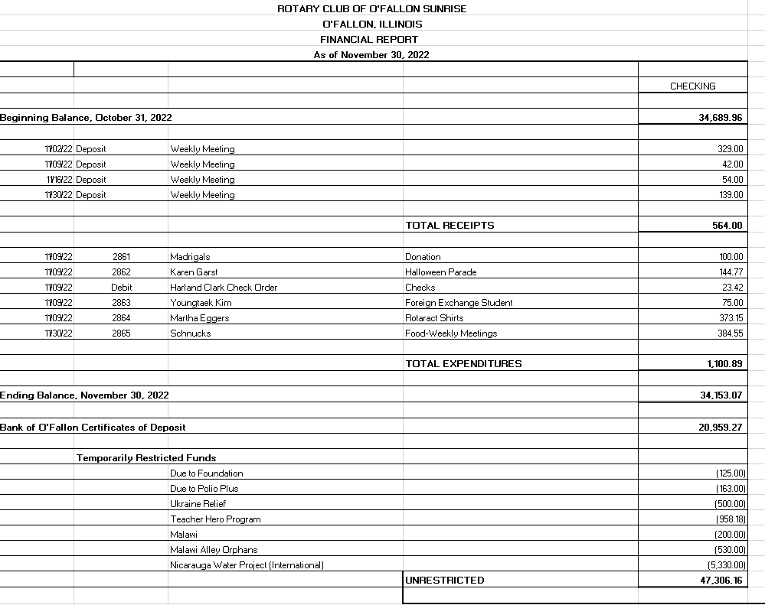
- Financial Report—Pat Ryan
Motion: To approve the financial report with corrections.
Motion made by: Lori Ehlers
Seconded by: Yolandea Wood
Motion: Approved

- Past President Report – Karen Garst– Not Present

- President Report— Libby Quinlan
  - By Laws (board decisions made at this meeting are to be presented to the club for approval)
    - Board Composition
      - Agreed to a total of 9 board voting members supported by non-voting committee chairs. Officers and Directors can be dual hatted as committee chairs
        - 7 Officers
          - President
          - President Elect
          - Past President
          - Treasurer
          - Club Administration
          - Executive Secretary
          - Club Secretary
        - 3 Directors – 3 (sits on the board to help guide the club)
        - 5 Committees
          - Community Service
          - Foundation / International
          - Youth
          - Membership
          - Public Relations
      - Decision was made to propose not including the “Sergeant at Arms” and “Member at Large” as board members
    - Elections
      - President Elect (Yolandea) with approach the club generally and some members personally about board positions in the coming year.
      - A ballot will be created with the names of interested club members, approved by the board, and presented to the club for a vote.
      - This should be done by the end of January
  - Projects
    - Libby was approached by a club member with the opinion that our club doesn’t do anything.
      - To address Libby built and presented a list of projects that the club is currently or has recently been involved in (see embedded file) to ensure the entire club is aware of our ongoing activities and how they are or could be supporting now and in the future
    - Proposed Future Project Process (Yolandea)
      - Project identification would begin via the passing out of “Post It” notes to members for project ideas for the next year (brainstorm, no obligation at this point)
        - Ideas would be discussed at a future board meeting
      - Project formalization would begin with completion of a form with specifics on cost, manpower required, etc.
        - Form adopted from another club (Dave G work with Dave Vale to modify the form to a Sunrise Rotary format)
    - Upcoming Project Discussion
      - Teacher Hero Program – Karen had agreed to lead resurrecting this program but was looking for some documentation from previous effort led by Shawn Hall
        - Catherine found the description and sent it to the board
        - Will present to Karen for her approval
      - All Abilities Playground – Discussion on supporting the Parks and Rec All Abilities Playground project.
        - Board agreed to commit $10K to sponsor a swing set
          - $5,000 up front (out of 2023 reserve funds)
          - $1000 per year for 5 years (out of the annual community budget)
          - Present community service opportunities to support to installation of the swing set and/or other playground pieces.
Motion: Motion to present to the club the sponsoring of a swing set, and community service support to the Parks and Rec All Abilities Playground project (as described above).
Motion made by: Yolandea Wood
Seconded by: Catherine Taylor Yank
Motion: Approved
    - Ponies for Polio
      - Catherine is leading this district wide event set for the end of April to raise money for Polio
        - Dice based game; more details to follow
      - This could be used as a club fund raiser in the future
    - Beer brewing contest
      - Catherine, Kathy Lannert, Tim can help support
    - Home Team
      - Dave attended to present a potential project involving Sunrise Rotary support to the “Home Team” effort. This effort involves volunteers help elderly and other individuals with common house or other repairs such as:
adjusting water heater temperature, GFI resets,
caulking, leaking faucets, loose handles, replacing light bulbs or batteries in smoke alarms, etc.
      - Board decided to accept the idea pending someone taking the lead of the project.

- President Elect Report— Yolandea Wood
  - Yolandea looking at possible nominees to be in next administration
    - These will be put on a ballot that the board presents to the club for a vote
  - Yolandea has developed a set of questions to get people talking within the club to help build a sense of community and generate ideas
    - Could be used as planned part of a meeting or to help fill unused time
  - Provided feedback on By Laws

- Committee Reports—Club Administration, Membership, International and Foundation, Community Service, Flag Report, Youth, YEO Report, Public Relations, Member-At-Large, Programs and Calendar Review.

- CLUB ADMINISTRATION: Kevin Gederman – Not Present
  - Looking for details on the annual/20 anniversary dinner in late Jan/early Feb
- MEMBERSHIP: Lori Ehlers
  - Met with Rich and Libby about membership goals
    - Membership is down district wide but they feel that some of this is from culling inactive members
    - Membership is everyone responsibility both in terms of recruiting new people and helping current but inactive members reengage
    - Need to do a better job of letting people know of the things this club does so they can both be informed on what the club is doing and what THEY are doing in support of those efforts
  - Monica Ybarra, has paid her dues but hasn’t been back since. We have yet to induct her and are reaching out to find out why
  - Updated list of speakers
  - Tim Ros ls leaving the club for personal reasons

- INTERNATIONAL AND FOUNDATION: Mike Nowobilski – Not Present

- COMMUNITY SERVICE: Karen Garst – Not Present

- YOUTH: Catherine Taylor Yank
  - Rotaract (Martha) – Libby went to a meeting. Martha is doing a great job with this program
  - Youth Exchange Officer (Kim Sabella) – Fred will be speaking in Feb
    - Board agreed to increase the allotment from $75 to $100 per month in next year’s budget
  - Youth Exchange Councilor (Mike Mojzis) –

- FLAG REPORT: Tim Ros – Not Present
  - Due to Tim’s departure we need to find a Flag lead replacement

- PUBLIC RELATIONS: Steve Stater – Not Present

- MEMBER AT LARGE: Tim Sipes
- NSTR
- This will become a director and not a board member

- EXECUTIVE SECETARY: Catherine Taylor Yank
- Dues are going up both international and district ($400, $370 advanced pay discount) for this year and discuss how much it might go up next year
  - Need to look at costs and determine needed increased then present to club

- PROGRAMS AND CALENDAR REVIEW: Libby Quinlan
  - No meeting on 28 Dec
  - Business meeting 21 Dec
  - Speakers and events, refer to the Sheet Lori built
Motion: Motion to adjourn
Motion made by: Tim
Seconded by: Yolandea
Motion: Approved
Next Board Meeting is Thursday, January 5th, 2022 at 7:00 AM!!!!!

