Board of Directors Meeting
December 7th, 2023
7:03 a.m.

- Meeting called to order at 7:02 a.m. 6th board meeting of 23-24 Rotary year.

Roll Call
There was a quorum present.
Role | Name | Present
President | Yolandea Wood | Yes
President-Elect | Lori Ehlers | No
Previous President | Libby Quinlan | Yes
Treasurer | David Gornstein | Yes
Admin | Kevin Gederman | No
Membership | Vacant | Vacant
International / Foundation | Mike Nowobilski | No
Service Projects | Mary Jo Nowobilski | Yes
Flags Committee Chair | Jim Burton | Yes
Exec Secretary | Catherine Taylor Yank | No
Youth Chair | Vacant | Vacant
Public Relations | Steve Stater | Yes
Secretary | Tim Sipes | Yes
Member at Large | Ray Rohr | No

- Introduction of Visitors/Club Members
  - None

- Announcements:

- Review and Approval of Board Minutes from Nov 2023

Action: November board meeting minutes were reviewed and approved as corrected by the board
Motion: To approve the minutes
Motion made by: Yolandea Wood
Seconded by: Steve Stater
Motion: Approved

- Review and Approval of Financials for November 2023
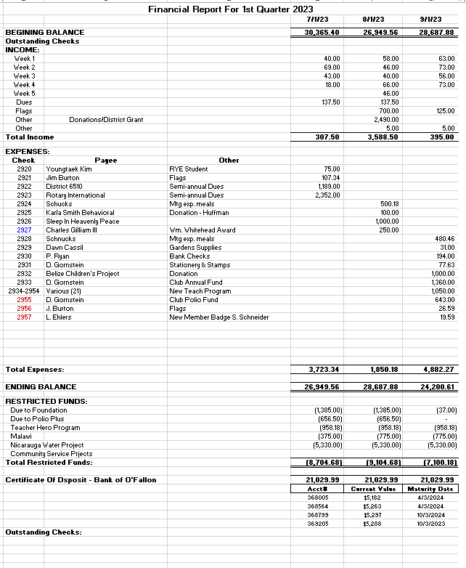
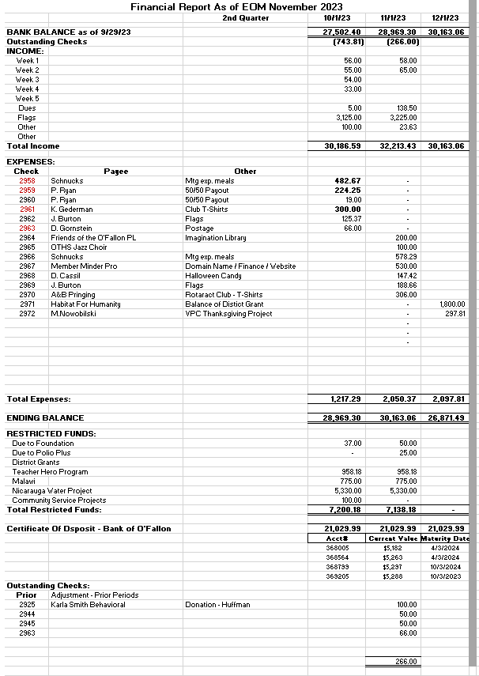

  - Discussion on the spreadsheet December column
    - Figures are not accurate as we have not received an account statement yet nor have executed anything for December as of yet
    - The December numbers included do not add up suggesting the formulas might be incorrect.
      - The board asked if the formulas could be checked and verified
      - A suggestion was made to not include the next month (e.g. Dec) column until after there were actual numbers to report to minimize any potential confusion from club members reviewing the financials
  - Discussion on annual vice quarterly due amounts
    - In the past people who paid for the entire year were given a discount of $30 off of the $400 annual fee ($370). Those who paid quarterly did not receive the discount ($100 x 4 = $400)
      - Decision was made to charge everyone $400 regardless of how they pay
        - Steve will update the website
    - The board will outline to the club what dues are made up of and what our operating expenses are
      - National Fee – $150 (Increased this year & will go up again)
      - District Fee – $51(Increased this year & will go up again)
      - Breakfast – $250 ($5/week for 50 weeks)
      - Club admin Fee – Board discretion to pay for items such as:
        - DacDB
        - Web

Motion: To approve the financial report with clarification on the formulas for the Dec total expenses
Motion made by: Yolandea Wood
Seconded by: Libby Quinlan
Motion: Approved

- Past Presidents Report: Libby Quinlan
  - Libby presented a flier and registration form for the Memorial Day weekend golf tournament (23 May 24)
    - Registration form will be updated to be a fillable .pdf and include a QR code will be added to reduce PayPal administrative costs
  - Libby will keep track of the who and the what; Dave will keep track of the money

- Presidents Report: Yolandea Wood
  - 28 “Speaking of Rotary” books in the closet for our use to help promote Rotary and build membership
  - Ray is going to talk to past presidents who are not renewing to get a feel for why and what we might be doing better
    - See membership section below
  - Still figuring out how to best use the $1000 donation from the Moose club

- President-Elect Report: Lori Ehlers
  - Not Present
  - Need to start looking for 2024/25 board members
    - Will need a new recording secretary to replace Tim who is moving to President-Elect
- Committee Reports - Club Administration, Membership, International and Foundation, Community Service, Flag Report, Youth, YEO Report, Public Relations, Member-At-Large, Programs, and Calendar Review.

- CLUB ADMINISTRATION: Kevin Gederman
  - Not Present
  - Looking for ideas on annual dinner location/venue

- MEMBERSHIP: Vacant
  - Kim Sabella has resigned
  - Discussion on how to keep members who are resigning due to inability to be active with the club; to remain affiliated with the club
    - Honorary membership
    - Keep them informed of service and social opportunities so they can participate when able

- INTERNATIONAL AND FOUNDATION: Mike Nowobilski
  - Not Present

- COMMUNITY SERVICE: Mary Jo Nowobilski
  - Sleep in Heavenly Peace delivery date 9 Dec
    - 3 signed up
  - We still need to donate $1000 to Habitat for Humanity
    - Working what day we are supporting
      - Yolandea and Tim available Thursday
      - Steve available Saturday

- YOUTH: Vacant
  - Rotaract (Martha) –
  - Youth Exchange Officer (Catherine) – No inbound students
    - Put in her YEO application
  - Youth Exchange Councilor (Mike Mojzis) –
    - Outbound - $3000 District Grant for outbound student (Mansa Bryant) has been approved
      - This will be added to the $1000 from our club
    - Inbound - District will likely get 3-4 students; our club will likely get 1
      - Need Catherine to complete YEO training to be eligible

- FLAG REPORT: Jim Burton
  - Still looking to replace the captain and members of one of the teams
  - Libby will talk to his Boy Scout troop about possible support

- PUBLIC RELATIONS: Steve Stater
  - Update Web page on Dues
  - Work with Libby on Golf Tournament
  - Will check on Sunrise sign at All Access park
  - When sending Steve pictures please include some details to help him with publications

- MEMBER AT LARGE: Ray Rohr
  - Not present

- FOR THE GOOD OF THE ORDER (around the room)
- Kevin – Not present
- Dave – Nothing
- Mike – Not present
- Libby – Nothing
- Catherine – Not present
- Tim – Nothing
- Lori – Nothing
- Steve – Nothing
- Mary Jo – Upcoming group “hands on” opportunities are YMCA table building, garden, flags; still looking for inputs on other opportunities
- Ray – Not present
- Yolandea – Biscotti party coming up!

Motion: Motion to adjourn 0750
Motion made by: Libby Quinlan
Seconded by: Jim Burton
Motion: Approved
Next Board Meeting is Thursday, January 4th, 2024 at 7:00 AM!!!

