Board of Directors Meeting
October 5th, 2023
7:02 a.m.

- Meeting called to order at 7:00 a.m. 4rd board meeting of 23-24 Rotary year.

Roll Call
There was a quorum present.
Role | Name | Present
President | Yolandea Wood | Yes
President-Elect | Lori Ehlers | Yes
Previous President | Libby Quinlan | No
Treasurer | David Gornstein | Yes
Admin | Kevin Gederman | Yes
Membership | Vacant | Vacant
International / Foundation | Mike Nowobilski | Yes
Service Projects | Mary Jo Nowobilski | Yes
Flags Committee Chair | Jim Burton | Yes
Exec Secretary | Catherine Taylor Yank | No
Youth Chair | Vacant | Vacant
Public Relations | Steve Stater | Yes
Secretary | Tim Sipes | Yes
Member at Large | Ray Rohr | No

- Introduction of Visitors/Club Members
  - None

- Announcements:
  - Budget Discussion
    - Invoices for Flags have gone out with a 30 day payment window
    - Concern over available funds led to a long discussion on how restricted funds are being accounted for in the financial report
      - Dave will rework the financial report for next month and the board we will reevaluate available funds status to determine if and where we need to free up some cash
        - (from Mike at end of meeting) It appears that, including CD and not including restricted funds we should have $38K of funds available – we should use these funds for as many projects as possible to get people excited about the good things that Rotary can do
    - Discussion to standardize accounting for the 50/50 drawing
      - From now on the person at the sign in desk will annotate the “Total collected” that day for the 50/50 drawing. Those funds will be validated added to the financials by the treasurer will disburse the 50% of the funds when someone wins.

- Review and Approval of Board Minutes from Sep 2023

Action: August board meeting minutes were reviewed and approved by the board on 10 September
Motion: To approve the minutes
Motion made by: Lori Ehlers
Seconded by: Jim Burton Motion: Approved

- Review and Approval of Financials for September 2023
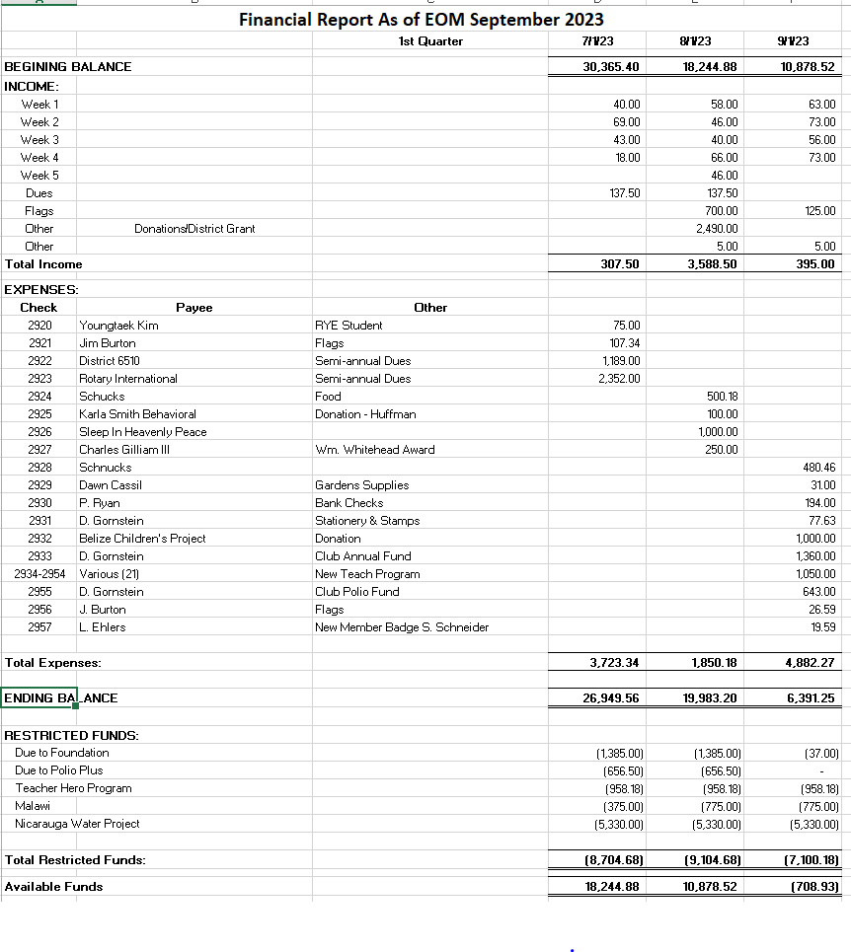
Motion: To approve the financial report as corrected. To be reviewed again next month
Motion made by: Lori Ehlers
Seconded by: Steve Stater
Motion: Approved

- Past Presidents Report: Libby Quinlan
  - Libby is working on a marketing message for the golf tournament
    - Concern that his desired date (Memorial Day weekend) will not draw either club support nor participants
    - Alternate date of 23 May proposed
    - Decision made to resolve the issue with Libby present after the next club meeting (18 Oct)

- Presidents Report: Yolandea Wood
  - District 6510 Rotarian of the year package submitted
  - We are a sponsor at the District Conference
    - We need a display – Mary Jo’s presentation (add library, flag pole)
      - Going to put the presentation on a loop and building a Tri-Fold
        - Yolandea will ask Martha if she is interested in putting together the Tri-Fold
  - Silent auction for District Conference
    - Tim agreed to make a Corn Hole set for Nov ¾
    - Put the New Rotary logo on the board
      - Mike will take a look at finding a decal

- President-Elect Report: Lori Ehlers
  - Working Nov/Dec schedule
    - No Madrigals this year
  - No meeting on 22nd Nov, 27 Dec
  - Holiday party on the 20 Dec
  - Business meeting on 6 Dec

- Committee Reports - Club Administration, Membership, International and Foundation, Community Service, Flag Report, Youth, YEO Report, Public Relations, Member-At-Large, Programs, and Calendar Review.

- CLUB ADMINISTRATION: Kevin Gederman
  - Rotary T-shirts are in will be sending a bill for $300
  - Looking to establish Admin committee at next business meeting to help with anniversary dinner planning
  - Sunrise at Sunset
    - Kevin will confirm this month will be sponsored by Rotaract at the Gasthaus in Lebanon
      - 26 Oct, all clubs including Lebanon club

- MEMBERSHIP: Vacant
  - Nothing discussed

- INTERNATIONAL AND FOUNDATION: Mike Nowobilski
  - Hit our $2000 goal and will be passing the hat for Malawi school club
  - Working with Fairview club on a hospital project in India
    - $330,000 Global Grant almost complete
  - Just started dialogue with other clubs on what to do with Nicaragua project funds

- COMMUNITY SERVICE: Mary Jo Nowobilski
  - Working with 3 other clubs for building Thanksgiving baskets
    - Proposed date of 18 Nov 1000-1200 conflicts with Scouting event but we should be able to do both
    - Each club will contribute $400 to fund; costs may come down
    - Will be collecting 3 different canned items from club members
    - Will look into the possibility of donating coats as well
  - 28 Oct Halloween organization
    - Need someone to take charge as Mary Jo will be out of town
      - Yolandea volunteered to take charge
  - Imagination Library – will donate $200 to support reading for 8 kids
  - District Conference Project
    - Rotaractors want to participate
  - YMCA picnic tables – looking for 6 tables at $200-300 each
    - Will gather more information on if they are just looking for funds and if we will get recognition

- YOUTH: Vacant
  - Nothing discussed
    - Rotaract (Martha) –
    - Youth Exchange Officer (Catherine) – No inbound students
    - Youth Exchange Councilor (Mike Mojzis) –

- FLAG REPORT: Jim Burton
  - Flags on 9 Oct Columbus Day
  - Losing 3 more people including a Flag Captain
    - Work load has not decreased
      - If customers do not pay their invoices by the due date we need to cut them

- PUBLIC RELATIONS: Steve Stater
  - Need picture and names of teachers
  - 2 expenses for the web site but Steve does not receive them; they go to club

- MEMBER AT LARGE: Ray Rohr
  - Not present

- FOR THE GOOD OF THE ORDER (around the room)
- Kevin –
- Dave –
- Mike – Nothing
- Libby – Not present
- Catherine – Not present
- Tim – Nothing
- Lori –
- Steve – Not present
- Mary Jo –
- Ray – Not present
- Yolandea - Nothing
Motion: Motion to adjourn 0807
Motion made by: Mike Nowobilski
Seconded by: Lori Ehlers
Motion: Approved
Next Board Meeting is Thursday, November 2nd, 2023 at 7:00 AM!!!!!

