Board of Directors Meeting
February 2nd, 2023
7:04 a.m.

- Meeting called to order at 7:04 a.m. 3rd in-person board meeting after 30 consecutive Zoom board meetings

Roll Call
There was a quorum present.
Role | Name | Present
President | Libby Quinlan | Yes
President Elect | Yolandea Wood | Yes
Previous President | Karen Garst | Yes
Treasurer | Pat Ryan | Yes
Admin | Kevin Gederman | Yes
Membership | Lori Ehlers | Yes
International / Foundation | Mike Nowobilski | No
Community Service | Theresa Raymond | No
Flags Committee Chair | Vacant | No
Exec Secretary | Catherine Taylor Yank | No
Youth Chair | Vacant | No
Public Relations | Steve Stater | Yes
Secretary | Tim Sipes | Yes
Member at Large | Tim Sipes | Yes

- Introduction of Visitors/Club Members
  - None

- Announcements:
  - None

- Review and Approval of Board Minutes from December 2022.

Motion: To approve the January board meeting minutes as corrected
Motion made by: Kevin Gederman
Seconded by: Lori Ehlers
Motion: Approved

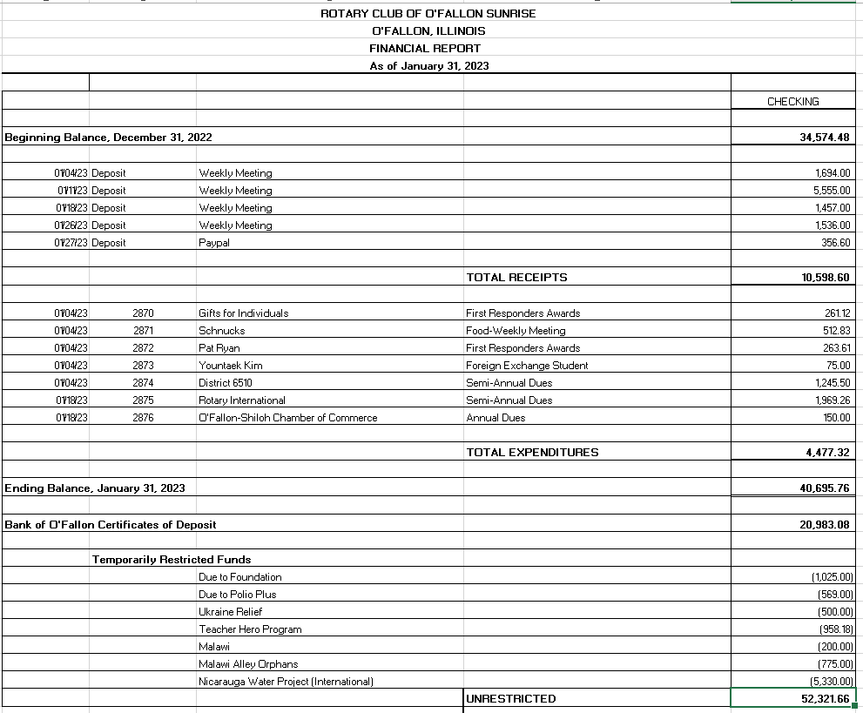
- Financial Report—Pat Ryan

  - Decision was made to write the check to the city for the All Activities Playground
  - Still waiting for Steeple Chase to pay for the rest of the flags
Motion: To approve the financial report.
Motion made by: Kevin Gederman
Seconded by: Lori Ehlers
Motion: Approved

- Past President Report: Karen Garst
  - NSTR

- President Report: Libby Quinlan
  - Anniversary Dinner, date (March 11th), place (Katy Cavins), and time (6:30 PM) have been determined
  - Ponies for Polio, - Catherine Taylor Yank is on a committee with the district
    - Held on the 5th of May at Knights of Columbus
    - A sign-up sheet for support coming
    - Monies above cost will be divided up amongst supporting clubs and go to annual Polio requirements first and then fund raising
    - Will build some power point description slides for presentation at next weeks (business) meeting.
  - Looking for people to support this year’s golf tournament on May 27th

- President Elect Report: Yolandea Wood
  - Needs suggestions for next year’s President elect
    - Names suggested are Kevin (he is available), Lori, Tim, Theresa

- Committee Reports - Club Administration, Membership, International and Foundation, Community Service, Flag Report, Youth, YEO Report, Public Relations, Member-At-Large, Programs and Calendar Review.

- CLUB ADMINISTRATION: Kevin Gederman
  - Will give sign-up sheets for support and attendance for the annual dinner at the next meeting
    - Jesse is working on a list of attending Charter members
      - We will pay for their costs (including guests they bring)
    - Discussion on alcohol inclusion; no decision made
  - Waiting to hear back from Garry Ollie (sp?) on monitor in the Township building

- MEMBERSHIP: Lori Ehlers
  - Monica Uberra is still interested but is very busy in the morning with school
  - Speakers lined up thru February, working on March

- INTERNATIONAL AND FOUNDATION: Mike Nowobilski – Not Present

- COMMUNITY SERVICE: Theresa Raymond – Not Present
  - Plant seed kits went out at the Wednesday weekly meeting
  - District Grant – (extra funds allow for the possibility of 2 Grants)
    - 1 - Supporting the garden club pavilion in work
    - 2 - Libby will send an email asking the club for Grant ideas

- YOUTH: Catherine Taylor Yank– Not Present
  - Rotaract (Martha) –
  - Youth Exchange Officer (Kim Sabella) –
  - Youth Exchange Councilor (Mike Mojzis) –

- FLAG REPORT: Position Vacant
- Jim Burton volunteered to take it over so Libby and Kevin will get with him

- PUBLIC RELATIONS: Steve Stater
- First Responder article was published in the O’Fallon progress
- Working to get weekly meeting out
- Will put together a set of slides to display at the annual dinner

- MEMBER AT LARGE: Tim Sipes
- Nothing to report as Member at Large

- EXECUTIVE SECETARY: Catherine Taylor Yank – Not Present

- PROGRAMS AND CALENDAR REVIEW: Libby Quinlan
- Business meeting next week
- Flags on 20 Feb

Motion: Motion to adjourn 0744
Motion made by: Pat Ryan
Seconded by: Steve Stater
Motion: Approved
Next Board Meeting is Thursday, March 2nd, 2023 at 7:00 AM!!!!!

