Board of Directors Meeting
January 5th, 2023
7:00 a.m.

- Meeting called to order at 7:02 a.m. 2nd in-person board meeting after 30 consecutive Zoom board meetings

Roll Call
There was a quorum present.
Role | Name | Present
President | Libby Quinlan | Yes
President Elect | Yolandea Wood | Yes
Previous President | Karen Garst | Yes
Treasurer | Pat Ryan | Yes
Admin | Kevin Gederman | Yes
Membership | Lori Ehlers | Yes
International / Foundation | Mike Nowobilski | Yes
Community Service | Karen Garst | Yes
Flags Committee Chair | Vacant | No
Exec Secretary | Catherine Taylor Yank | No
Youth Chair | Vacant | No
Public Relations | Steve Stater | Yes
Secretary | Tim Sipes | Yes
Member at Large | Tim Sipes | Yes

- Introduction of Visitors/Club Members
  - Dave Gornstein

- Announcements:
  - None

- Review and Approval of Board Minutes from December 2022.

Motion: To approve the December board meeting minutes as corrected
Motion made by: Pat Ryan
Seconded by: Lori Ehlers
Motion: Approved

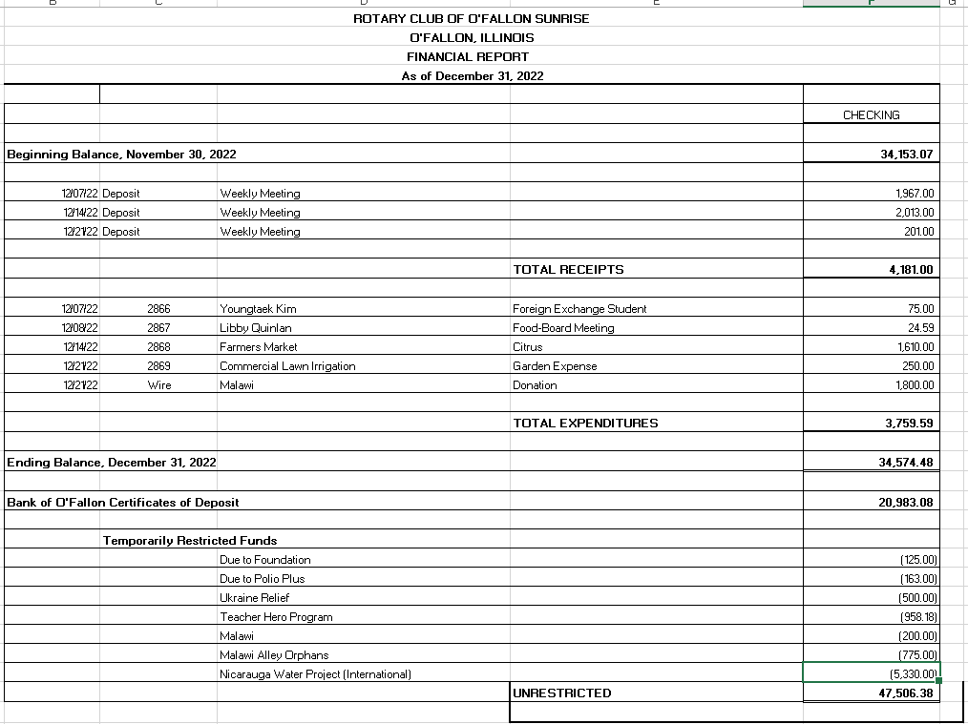
- Financial Report—Pat Ryan
Motion: To approve the financial report.
Motion made by: Tim Sipes
Seconded by: Karen Garst
Motion: Approved

- Past President Report: Karen Garst
  - Nothing to report other than input to By-Laws

- President Report: Libby Quinlan
  - Introduced Theresa Raymond will take over as Services Committee Chair starting 5 Jan 2023 replacing Karen Garst
  - Presented the updated By-Laws for discussion
    - Several inputs made to include:
      - Better definition of respective board members
      - Roles of directors/committee chairs
      - Since the committees have changed and/or reorganized we need to communicate how they will now operate to Directors/Committee chairs, sub-committee chairs, project leads and general membership
      - Sargent at Arms/Member at Large
      - Better define responsibilities of directors/committee chairs and sub-committees
    - Libby and Yolandea will update By-Laws based upon the conversation for board review
- President Elect Report: Yolandea Wood
  - Presented a Rotary Club Project Proposal form for review and approval
    - There is a separate Project Evaluation sheet Dave Gornstein will provide later
  - Reached out to individuals who are not renewing membership for feedback on the club
    - Joe McKay – Drop the Zoom
    - After discussion decided to keep Zoom to accommodate those members who use it properly (engaged with camera on) thru the flu season then reconsider
    - Ryan Brown – Too busy with personal life for regular attendance but still wants to be a member.
    - Board decided to allow him to be remain on our roles at a reduced rate ($165 for RI and District dues, no meals)
    - Concern was raised for how this might be implemented club wide
      - A separate policy document will be drafted and approved by the board
    - Zach – Will consider inputs on how to attract younger members
    - Jim Crone – No Reply
    - Leslie Davis – Did not reach out as she has not been an active member for some time
Motion: To draft a document outlining a short term membership category for reduced dues to coincide with reduced participation to be finalized and voted on by the board prior to the next board meeting.
Motion made by: Keven Gederman
Seconded by: Yolandea Wood
Motion: Approved

- Committee Reports - Club Administration, Membership, International and Foundation, Community Service, Flag Report, Youth, YEO Report, Public Relations, Member-At-Large, Programs and Calendar Review.

- CLUB ADMINISTRATION: Kevin Gederman
  - Annual/20 anniversary dinner
    - Need to get with Jim Crone for artifacts
    - Looking at Katy Cavins
    - Invite charter members
    - Should be in March (not the 18th)

- MEMBERSHIP: Lori Ehlers
  - Not heard back from Monica Uberra (Lori and Martha have reached out)
    - Lori will reengage with her to determine what is going on
  - Raj has not been for a while - Lori will reach out to him as well
  - Zach is leaving Sunrise Rotary and moving to B&I (business engagement organization) per request from his employer
    - Gene and Pat have committing funds to keep his membership active if that would help; status TBD
  - Speakers lined up thru the end of Feb 23
    - Pat is engaging with young business people and will consider asking about speaking

- INTERNATIONAL AND FOUNDATION: Mike Nowobilski
  - Pat sent $1800 to Malawi for primary school corn (78, 50 kilo bags)
  - $500 sent for Alley Orphans – food, seed, fertilizer
  - District Grant - Water well is up, the remainder is maintenance on existing wells
  - Global Grant - Nicaragua water project has lost energy so Mike and his committee to pick up a water project in Malawi

- COMMUNITY SERVICE: Karen Garst
  - $5000 to city for park, invite them, break out the big check
    - Put event in paper
  - Teacher Hero program
    - Google doc received but we need to create our own and test it.
  - Home Team – Needs someone to take ownership and might not be feasible due to current club participation levels
  - Yolanda is working a District grant for building a pavilion on the O’fallon garden club (State Street)
    - Benefit to the community and will allow for another location advertising Sunrise Rotary community support (plaque on a bench)
  - Yolanda another potential project is to provide some pre-seeding opportunities for our garden to provide an additional, easy way to participate
    - Participants would get seeds, 1 lb dirt, 6 containers for planting
    - Seedlings would be transplanted to the Sunrise garden at the beginning of the season, or sold or whatever the club determines
- YOUTH: Catherine Taylor Yank: Not Present
  - Rotaract (Martha) –
  - Youth Exchange Officer (Kim Sabella) –
  - Youth Exchange Councilor (Mike Mojzis) –

- FLAG REPORT: Position Vacant
  - Due to Tim’s departure we need to find a Flag lead replacement
  - Kevin will resume leading the Flag Program until a replacement for Tim Ros is found

- PUBLIC RELATIONS: Steve Stater
- Facebook and Instagram post of the 4 Jan First Responder meeting
- Working Newspaper articles
- Picture on the website
- The room projector is having problems that may impact future presentations
    - Working with township to fix

- MEMBER AT LARGE: Tim Sipes
- Nothing to report as Member at Large
- Need to determine Leads for
    - Flag Program
    - All Activities park
    - At Home, need to increase membership prior to taking it on
- Put out at next meeting that we are looking to leads of these projects

- EXECUTIVE SECETARY: Catherine Taylor Yank - Not Present

- PROGRAMS AND CALENDAR REVIEW: Libby Quinlan
- Speakers and events, refer to the Sheet Lori built
Motion: Motion to adjourn 0838
Motion made by: Tim Sipes
Seconded by: Yolandea Wood
Motion: Approved
Next Board Meeting is Thursday, February 2nd, 2023 at 7:00 AM!!!!!

