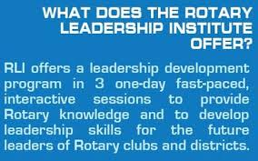

Curriculum Outline: Parts I, II, & III

Part I – The Rotarian
My Leadership in Rotary
As a Rotarian, I am, by definition, a leader. I will explore the characteristics of leadership, motivational techniques, and leadership styles. How do I best lead?
My Rotary World
As a Rotarian, I am part of a worldwide organization of like-minded people. I will take time to truly understand the purpose and structure of Rotary. Can these resources help me?
Ethics and Vocational Service
I am ethical, recognize and promote ethics in others, and seek opportunities to serve through my vocation. You can see that I am a Rotarian.
Foundation I: Our Foundation
I am “doing good” in my local community and around the world. I will learn the basic goals and programs of our Foundation. I am a force for good in the world!
Engaging Members
I make my club and Rotary stronger by my active participation. Engaged club members have fun, make friends, and effectively serve. This is why I joined Rotary!
Creating Service Projects
I am a vital part of a worldwide service organization of business, professional, and community leaders meeting needs in communities. I can build, run, and promote service.

Part II – The Club
Rotary Opportunities
As I further my Rotary journey, I can explore the many opportunities available within Rotary for personal, community, and professional growth and development.

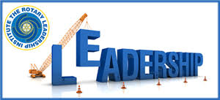
Effective Leadership Strategies
As I further my club members in their Rotary journey, I will engage in more complex and skillful use of my leadership skills and seize opportunities to lead.
Attracting Members
I can lead and promote my club‛s reexamination of its distinctive position in my community and the quality of members we attract. I want to work with the best people!
Club Communication
I can serve by leading and promoting effective communications to my club‛s internal and external audiences. Here, I refine and practice my skills.
Team Building
I can lead and promote my club‛s collaboration in effective and motivated groups to accomplish our goals of service … and harness the real power of Rotary clubs and Rotarians!
Foundation II: Targeted Service
I can lead and promote my club‛s participation in unique, significant, and targeted service opportunities through our Foundation. I extend my understanding of key concepts of Rotary programs!

Part III – My Rotary Journey
Strategic Planning
I can strengthen my club by promoting and leading insightful planning and analysis. Looking at my Rotary club, how can I help make improvements that will matter?
Foundation III: International Service
As I further my Rotary journey, I can build connections around the world, helping to meet needs, solve problems, and build peace.
Public Image & Public Relations
As I further my Rotary journey, I will identify opportunities to promote the image of my club and Rotary to the benefit of my community and world.
Building A Stronger Club
A new (and old) look at business-related activities in my club.
Making a Difference
As I further my Rotary journey, I will assess my own experience and growth through RLI and help improve the path for others to follow.

