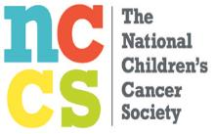
SUPPORT THE
NATIONAL CHILDREN’S
CANCER SOCIETY

Win One of Two Autographed Baseballs*
by Hall of Famers
Bob Gibson or Joe Torre!!

Tickets – 1 for $5 or 3 for $10
(Make checks to “Rotary District 6510 Charities”)
Winning ticket will be drawn at
District Leadership Change-Over Dinner
July 16, 2016

We’re only $3,000 short of the District Goal for this charity.
*Two winners drawn – same person cannot win both balls.

