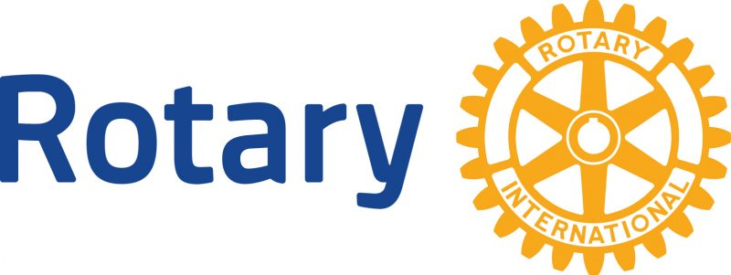

Rotary’s Diversity, Equity, & Inclusion Statement June 2021

At Rotary, we understand that cultivating a diverse, equitable, and inclusive culture is essential to realizing our vision of a world where people unite and take action to create lasting change.
We value diversity and celebrate the contributions of people of all backgrounds, across age, ethnicity, race, color, disability, learning style, religion, faith, socioeconomic status, culture, marital status, languages spoken, sex, sexual orientation, and gender identity as well as differences in ideas, thoughts, values, and beliefs.
Recognizing that individuals from certain groups have historically experienced barriers to membership, participation, and leadership, we commit to advancing equity in all aspects of Rotary, including in our community partnerships, so that each person has the necessary access to resources, opportunities, networks, and support to thrive.
We believe that all people hold visible and invisible qualities that inherently make them unique, and we strive to create an inclusive culture where each person knows they are valued and belong.
In line with our value of integrity, we are committed to being honest and transparent about where we are in our DEI journey as an organization, and to continuing to learn and do better.

