Disaster
PLAN
For
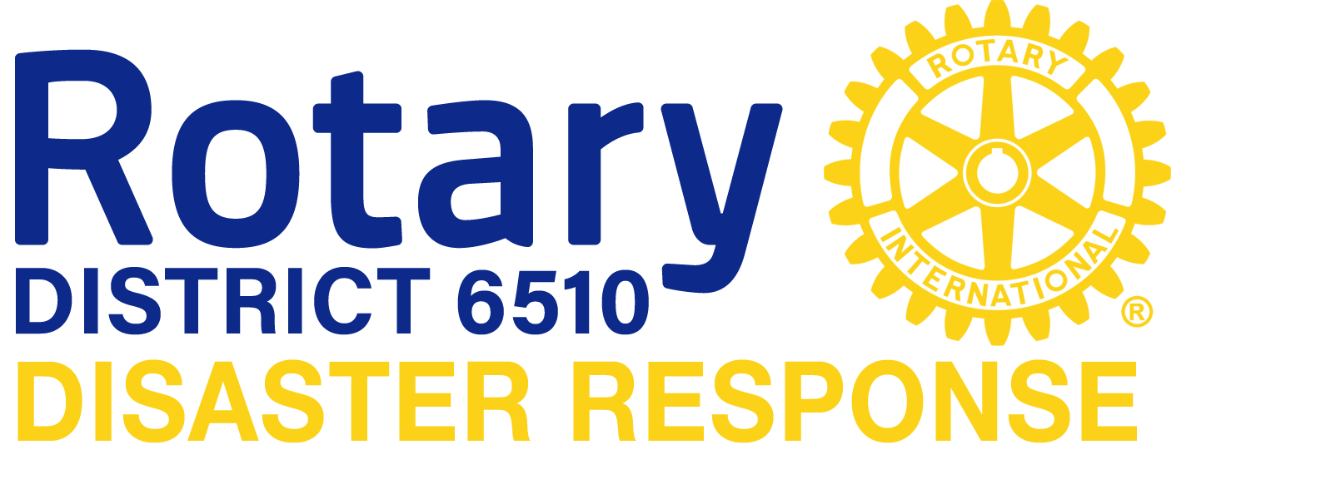

Joe Miller, Chairman

DISASTER PLAN

Rotary District 6510 • Disaster Response
Joe Miller, Chairman

Mission
The mission of the District 6510 Disaster Response Group is to encourage disaster preparedness on the part of individual Rotarians, to form partnerships at the local, regional and state levels to mitigation, response and recovery efforts under the direction of and when requested by the appropriate emergency operations center, and to provide funds, supplies and recovery operations to alleviate human suffering caused by disasters that may impact people locally, primarily, but also regionally or worldwide.

Purpose
The purpose of the District Response Plan is to provide general guidance for disaster activities and an overview of our methods of preparedness, response and recovery as is applicable to District 6510. The plan describes our disaster response operations and assigns responsibilities for various tasks. This plan is intended to provide a framework for who does what, when and how. District 6510 wishes to be an integral part of disaster response and relief within our District and whenever possible assist in disaster response and relief for events that occur outside the boundaries of our District. The plan also outlines guidance for district participation in response and relief efforts during disasters occurring outside of the District. Finally, this plan outlines steps that individual Rotarians and clubs should take to prepare for and respond to disasters.

Objectives
To achieve our objectives, we have developed the District Disaster Response Plan that integrates the efforts of all clubs within the District and serves as a regional resource for response and relief efforts. This plan is based on an all-hazard approach to disaster
response and relief. It addresses general functions that may need to be performed during
any disaster and is not a collection of plans for specific types of incidents.

Concept of Operations
In the United States disaster mitigation, response and recovery is managed according to the National Response Framework. On the Federal level the National Response Plan is the guiding document which implements the Framework. The basic premise is that all disaster efforts begin at the local level and remain local unless the scope of the event is beyond the capabilities of the local entities. Event exceeding local capabilities are then supported at the state level. In the state of Illinois events may be managed at a State Regional level. The
District 6510 Plan utilizes the same concerts in that individual clubs will need to coordinate with local (city and/or county) emergency management entities and then request assistance from the District 6510 when such assistance is requested or approved by local emergency management. The District 6510 Disaster Response Team will then coordinate that assistance. Under the Illinois Emergency Response Plan there may be occasions
when a request for assistance come from the Illinois Emergency Management Agency. In

those circumstances, the District 6510 Disaster Response Team will coordinate all Rotary response. In international situations clubs and individual Rotarians are urged to contact the District team so that efforts can be coordinated.

In the United States, the National Response Framework mandates that disaster response effort will be managed utilizing the National Incident Management System (NIMS). Under this system all responders will answer to a person in overall command of the response. This person is known as the Incident Commander. This assures that the response is planned and coordinated. All responders work within the chain of command established by the Incident Commander. Rotarians, like all responders will be expected to follow that principle. During the Recovery Phase of a disaster, efforts may transition in to other management systems but they will still be managed by a district organization.

There may also be situations in which individual Rotarians and/or Rotary Clubs are asked to contribute money to relief efforts. This plan also describes the process district 6510 will follow in handling such requests and donations.

Mission Areas
The National Response Framework discusses five mission areas. While Rotary and individual Rotarians can play a part in each of those areas, this plan deals with only three. They are:

MITIGATION:
The capabilities necessary to reduce loss of life and property by lessening the impact of disasters.

Response:
The capabilities necessary to save lives, protect property and the environment, and meet basic human needs after an incident has occurred.

Recovery:
The capabilities necessary to assist communities affected by an incident to recover effectively.

DISTRICT 6510

Disaster Response Committee (DRC)

General
The District Disaster Response Committee (DRC) will initiate disaster response and relief operations in response to a disaster, catastrophic incident, or incident of national significance that has impacted District 6510 or outside the boundaries of the District. The DRC will also coordinate District response to international events in cooperation with Rotary International.

Members of the District DRC will determine what types of aid will be initiated for the
identified disaster as requested by the Authority having jurisdiction.

Organization
The committee shall be composed of members appointed by the District Governor and/or the DRC Chairman. The District Governor, District 6510 Charities Administrator, and the District 6510 Charities Treasurer shall serve as ex officio members of this committee while they hold these district offices. The District Governor shall appoint a chairperson of the committee. The District 6510 Charities Treasurer shall establish a restricted disaster response fund for deposit of monies collected.

Activation of the Disaster Response Committee (DRC)
Activation of the DRC may be performed by the District Governor, Committee Chairman, or a member of the DRC. One or more of the following events may trigger activation of the DRC.

  - A disaster impacting an area within District 6510.

  - A disaster impacting an area outside the boundaries of the District with the possibility
of mobilizing the District’s Disaster Response operations.

  - A request for disaster response or relief assistance from another Rotary District or Club, or from Rotary International. NOTE: All assistance must be coordinated through the involved Incident Command or the Emergency Management organization having authority when either has been activated. Unsolicited assistance will duplicate other programs and often will interfere with assistance already being provided. When Incident Command and/or an Emergency Operations Center has been established, requests will be made utilizing the resource request system in place for the incident. Showing up at a disaster or sending items without a request is known as “freelancing” and is discouraged.

  - An event which presents a potential threat of significant damage and/or loss of life.

  - A request for funds or donation of funds to a disaster relief effort.

Duties and Responsibilities

  - The committee shall meet at least four times each year and shall be responsible
for planning and coordinating the districts response to disasters in District 6510 and elsewhere.

  - Developing a comprehensive disaster preparedness plan and revising as needed in order to be responsive to future disasters.

  - Considering disaster response assistance in the form of funds, supplies, equipment, volunteers or any other resource available to the District. The DRC may choose to provide relief assistance for a specific disaster in the form of a one-time monetary donation or it may choose to withhold disaster relief for any disaster.

  - Oversight, along with the District Charities Administrator and the District Charities Treasurer, of all funds to be used for disaster response and relief.

  - Writing grants so as to ensure that district funds are applied for within a specific time. Rotary grant applications must be completed within five days of a disaster.

  - Solicitation to individual clubs within the district for specific materials, monies or services needed to assist with the District’s disaster response efforts.

  - The District DRC will designate specific individuals within the committee who can
be contacted by the local clubs in the event of a disaster. These names, addresses, and telephone numbers will be provided to all clubs in the district. Likewise, each club with a DRC committee should provide appropriate contact information to the District DRC.

  - The District DRC will encourage each club in the District to appoint a Club Disaster Coordinator.

  - The District DRC will provide training to club coordinators and other interested members.

  - Members of the District DRC will be trained in the National Incident Management System (NIMS) to a minimum of ICS 200 level.

General
DISTRICT 6510
Club Disaster Response Chair

Because all disasters begin locally, it is the responsibility of individual Rotary Clubs to develop plan within the guidelines of the District Disaster Plan. The club president and the club board of directors are responsible for the club plan and appointing a “Club Disaster Response Chair”. The club president is responsible for coordinating the efforts of the club with local emergency management organizations if the event requiring a response remains local. In the event a Rotary Club or a group of clubs within a locale are asked by local emergency management authorities to assist, the club(s) involved should notify the District Governor or a member of the District Disaster Response Committee, which is found in the DAC database under District Committees.

In some cases, there may be two or more clubs within the same local jurisdiction that have agreed to participate in the disaster process. In this case, those clubs should work together to establish response protocols with local emergency managers.

The club plan should also include a provision to response to individuals who may need assistance following a personal disaster. For example, if a fellow Rotarian or other citizen has damage to his or her home, Rotarians should be ready to help.

As part of disaster preparation, each Rotarian should be prepared to take care of his or her own family during a disaster. This means the Club Disaster Response Chair should host at least one program annually that discusses individual preparation and planning.

Planning
The Club Disaster Response Chair should attend a training session provided by the District and encourage other interested club members and friends of Rotary to participate. This class will cover the material in the FEMA IC-100 Course and the District Disaster Plan. It would be helpful if a member of local emergency management also attends the class.

The Club Disaster Response Chair will maintain the resource list and make it available to local emergency management officials. If invited, the Club Disaster Response Chair should participate in one or more local drills and exercises.

Activation
When the plan is activated all Rotary resources will answer to the appropriate position within the Incident Management Organization. Reporting, check-in, check-out and demobilization will be done according to the Incident Action Plan established for the incident.

Handling of Funds
All funds will be sent directly to District 6510 Charities and earmarked for disaster response. These funds will be kept in and disbursed through a special sub-account within the District 6510 Charities 501(c)(3) in accordance with IRS regulations and Rotary International (RI) and District policies. It is important that proper procedures be followed. If more funds are received than are needed for a particular event, the District Disaster Response Committee may keep those funds in the disaster account, authorize their use for another disaster, or contribute them to an RI recognized partner like Shelter Box and Disaster Aid USA. Should that happen, clubs will be recognized for their contribution on a pro rate basis for those funds donated.

