**Rotary District 6510 Grant Training**

**Final Report Dacdb Screens**

**Deadline for submission: February 28!**

**After you have done these tasks:**

1. **Action photos transferred to your hard drive (then, rename each photo for description)**
2. **All bills, cash register receipts, internet receipts, copies of checks paid out, scanned as PDFs and saved (with an appropriate name) on your hard drive**
3. **Copy of letter of cooperation (school district, park district, library, whatever) scanned as PDF and saved (with an appropriate name) on your hard drive. A Thank You letter would be nice, too.**
4. **Fill out the FinalReportExpensesSummary spreadsheet, Save it on your hard drive**

**You are now ready for your work on Dacdb:**

**Log in to Dacdb**

**Click on District Grants**

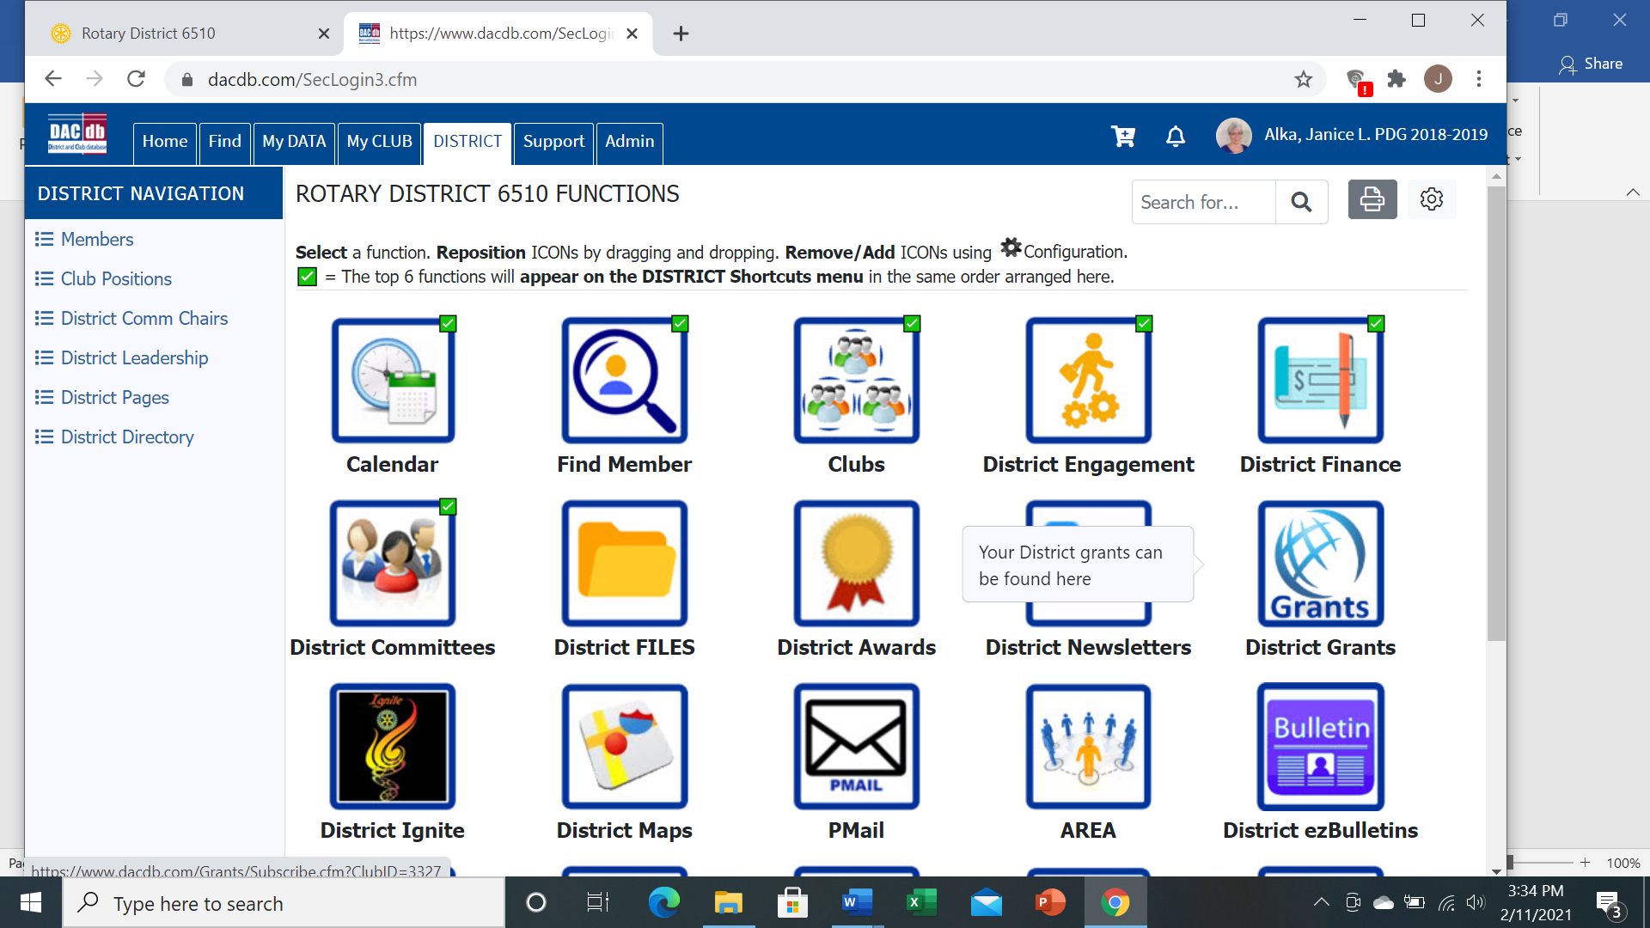

**Click on Club Grants View**

**Be sure you are in the correct year. Change OrgYear if needed.**

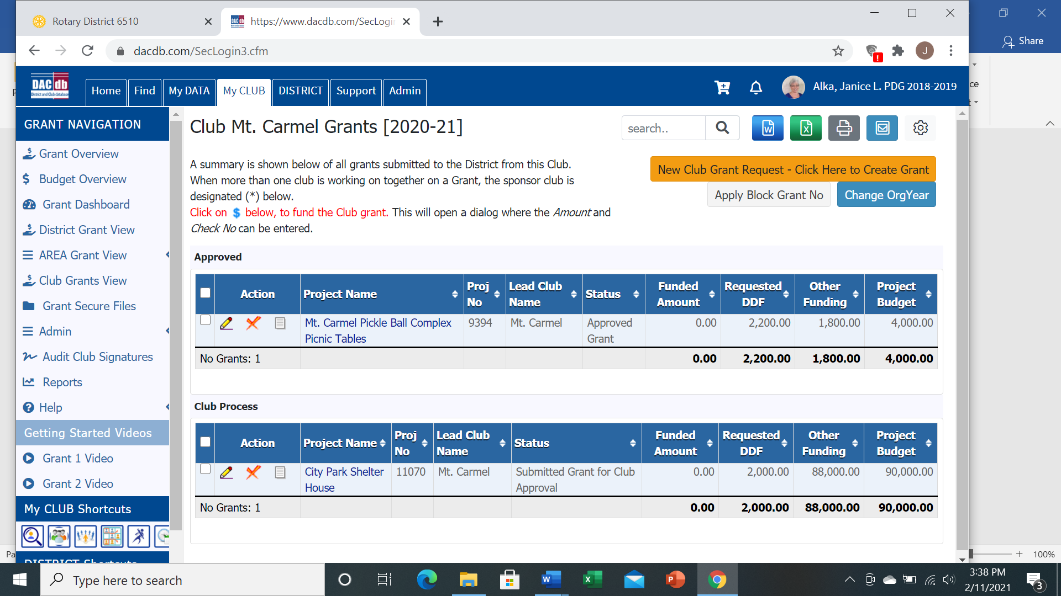

**Click the Pencil button in front of your Grant name**

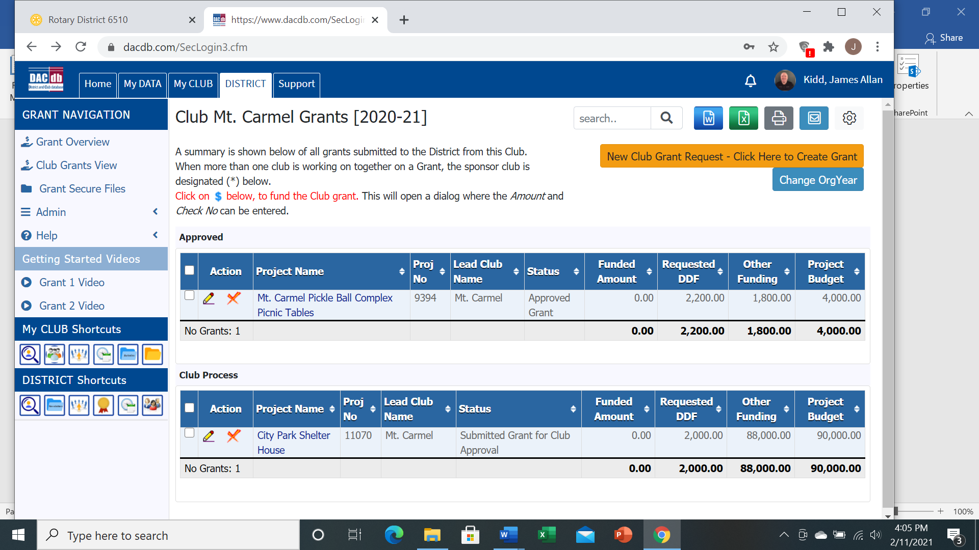

**Your work will focus on 2 TABs in your Grant: Documents and Final Report**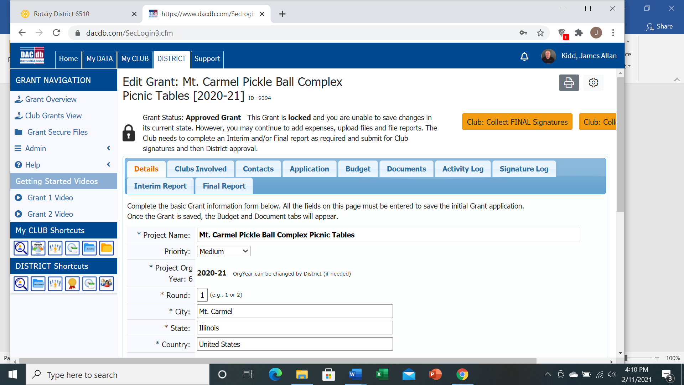

**Important: Do all the Documents work First! Click the Documents TAB; then**

**Click the Upload File button, browse to your saved receipts, checks, letters, pictures, etc**

**Keep using the Upload File button until all items have been uploaded**

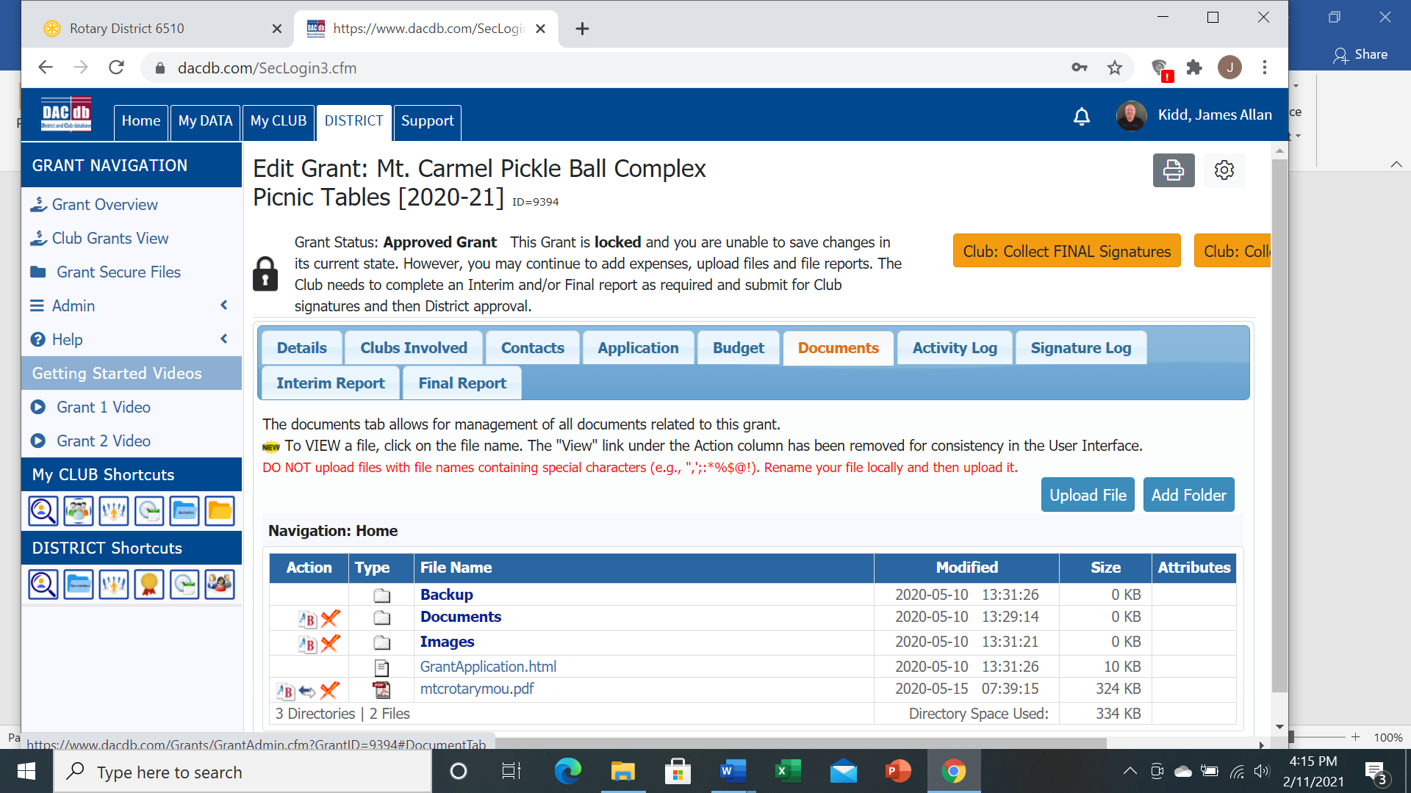

**After you are done uploading all document, you are ready for the Final Report TAB**

**There are 6 questions on this page. All 6 need answers:**

**Q1 will have typing from your original Application. You can add to/change this typing if necessary**

**Q2 must have a numerical answer. (Not like 30+, Not like Everybody)**

**Q3 will have typing from your original Application. You can add to/change tyis typing if necessary**

**Q4 must have a numerical answer. (Not The Whole Club, Not 35+)**

**Q5 must have an answer. Click your mouse in the box and type**

**Q6 must have an answer. If you installed park benches at the park--- list the Park District by name, or School District by name. Don’t let the word ‘cooperating’ get in the way. Hint: if your project happened on someone else’s property, you needed permission to do it, so they are a cooperating organization.**

**After all 6 questions/answers are done**

**You are ready for the last 4 steps:**

1. **Click the Club: Collect Signatures button (top right area). That will automatically send an email to your Grant Certified members.**
2. **Before you leave, Click the Sign Final Report button (top right area).**
3. **One of your other Grant Certified people must log in to the Grant and Click the Sign Final Report button (yes, you must have 2 different people sign the Final Report)**
4. **That second person, after doing the Sign Final Report, will have a new button. Click the Submit to District button. (That will automatically send an email to us to check your Final Report)**

**The Final Four Mantra:**

1. **Club: Collect Signatures**
2. **Sign Final Report**
3. **Sign Final Report**
4. **Submit to District**