The Rotary Foundation – Annual Fund
Training for Online entry of Your Club Goals
- You must log in to rotary.org. Be sure to set up your account/login before attending PETS.
  - If you don’t have your login at rotary.org, click on the My Rotary button on the home page;
  - Click on the Sign In/Register button
  - Click on the Create Account button
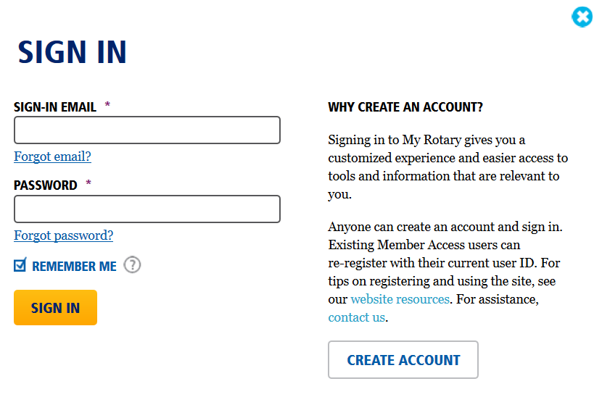
Continue next page

  - Fill in your name and email address in the blanks, and click the Continue button
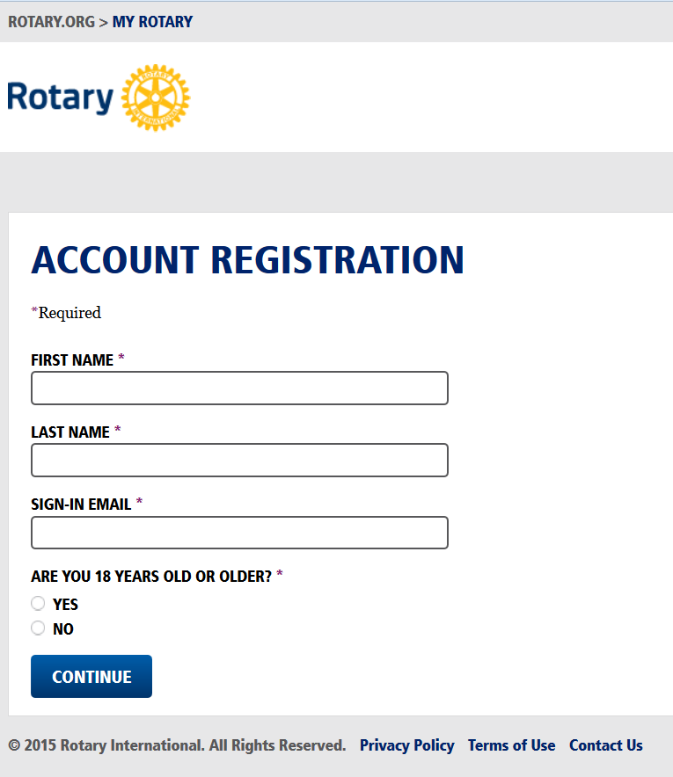
  - Fill in the blanks on the next page. Be prepared to select a good password for safety/security.
Rotary will send you an email with instructions to complete your registration.

If you already have your login, Click My Rotary, then Click Sign In/Register:
Then fill in your email address and password, and Click Sign In

