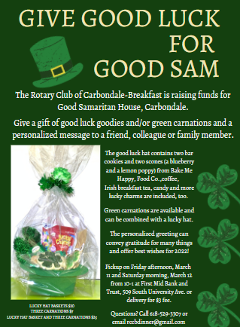
The Rotary Club of Carbondale-Breakfast is raising funds for Good Samaritan House in Carbondale. Give a gift of good luck goodies and/or green carnations and a personalized message to a friend, colleague, or family member.
The good luck hat contains two bar cookies and two scones (a blueberry and a lemon poppy) from Bake Me Happy, Food Co., coffee, Irish breakfast tea, candy and a few lucky. Green carnations are available and can be combined with a lucky hat.
The personalized greeting can convey gratitude for many things and offer best wishes for 2022!
Pickup on Friday afternoon, March 11, and Saturday morning, March 12, at the First-Mid Bank and Trust on South University … also available for local delivery for $3 fee.
Questions? Call 618-529-3307 or email rccbdinner@gmail.com.
Information on ordering can also be found at www.carbondalebreakfastrotary.org.

