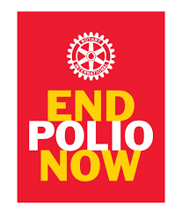
At the District Assembly on April 9,
exciting news for Polio was announced!

District 6510 set an “aspirational goal” to support Polio eradication.

BUT WAIT! – Here is a great opportunity for you to
“Do Good in the World”
by becoming a member of the
6510 PolioPlus SOCIETY

Joining the PolioPlus Society, you support making history by continuing to contribute at least $100 each year until the World Health Organization certifies that Polio has been fully eradicated … because until the world is polio-free, every child is at risk.
Society members receive a PolioPlus Society membership pin and certificate – PLUS your contribution qualifies for Paul Harris Recognition Points credit, and all donations will be matched by the Gates Foundation supporting the continued fight against Polio.
Make a donation online: At Rotary.org, click “Donate” in the upper right-hand corner to start your donation. Once you have given at least $100, send the Rotary receipt to lynnlenker@charter.net,
OR
fill out the membership form (attached) to start your annual giving until Polio is eradicated.
Note: This is an actual donation - points cannot be used for PolioPlus membership.

Questions? Please call …
Lynn Lenker
District Polio Chair
618-214-2873

