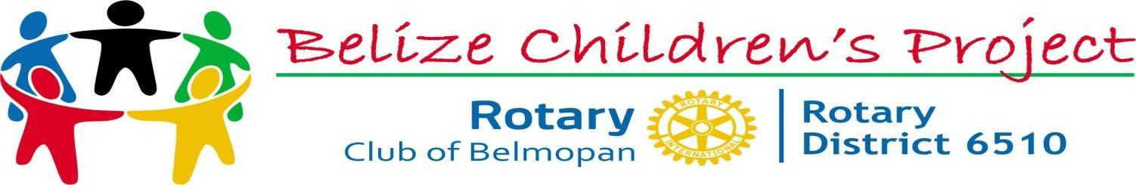
JUNE 2021
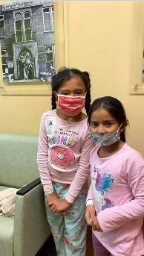
News:
Busy week for surgeries: Jasmin and Cristina sailed through their surgeries.
Both will soon be ready to get back our having fun with their amazing
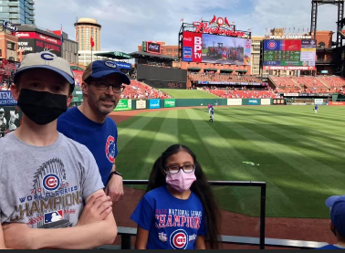
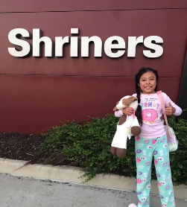
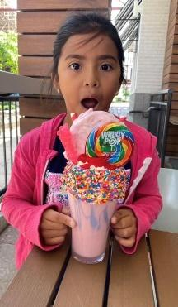
host families.

A HUGE THANK YOU TO THE MC MINN FAMILY OF BREESE AND THE MIERS FAMILY OF COLUMBIA FOR
THEIR CONSTANT WILLINGNESS TO BRING THESE GIRLS BACK INTO THEIR LIVES.

Henry, has arrived and will have his surgery on June 1st. He is with another of our wonderful repeating host families, the Dwyers in St. Louis.

Needs:

We are in need of a host family for Lashay H., 17 years old. She is scheduled for a total hip replacement on October 28th. She has been waiting to receive this surgery for five years. If you can open your home and heart to Lashay please contact either of the care coordinators for more information.

Also looking for clubs willing to write grants to assist a few of our families with their housing costs at
Ronald McDonald House. In some instances, a parent is asked to accompany their child. With our partnership with Ronald McDonald Charities of St. Louis, they can obtain housing at $15.00 per day.
For more information, please contact any of the coordinators listed below.

Five patients here and seven in the pipeline for later this year.
Please continue your support in any way you can.

For more information on how you can help please contact us.
Care Coordinators, Christine Lashley 618-691-9523 ,
Charlene Brennan 618-691-9120 or BCP Chairman , Tim Gutknecht 618-281-7626

