Future Focus
In This Edition

October 2021
October-November
Club and District events, training, & more
Tips on submitting items for the monthly newsletter

Next due date
Oct. 25 for
November 1 issue

SPECIAL OPPORTUNITY
The International Institute of St. Louis is preparing for the arrival – date uncertain – of as many as 1,000 Afghan refugees. Earlier, the Institute sought in-kind donations (household goods, clothes, etc.), but now is adequately stocked.
CURRENT NEED : Cash donations, including cash cards: Visa, Schnuck’s, Target, Walmart, Aldi, or by check to International Institute of St. Louis, 3401 Arsenal St., St. Louis, Missouri 63318.

District Conference Registration is Open!
Go to DAC “Calendar” – November 12-13

Now: The Rotary Club of Red Bud will hold a Homemade Apple Dumplings fundraiser for the month of October or until the delicious Dumplings are sold. For more info or to order > Club Secretary Carol Root, mimicr00t@gmail.com. Order Form: DAC > [District] > District Files*
Before Oct. 7: The Rotary Club of Marion announces a Dog House Raffle : 4’ X 4’ fully insulated, handcrafted by Rotarian Bill Shanks – drawing at October 7 club meeting - $10/ticket. Flyer: DAC > [District] > District Files*
Oct. 9: The Rotary Club of Carbondale -Breakfast is preparing Dinner for Dictionaries -- place your order by Oct. 9, pick up on Oct. 12. See DAC > [District] > District Files* Order form: https://forms.gle/JwnPLTxHfk1T89Po6.
Oct. 16: The Rotary Club of Marion and the City of Marion present the Little Egypt Fall 100, a team bike race, on Oct. 16. Special Invitation for Rotary teams. For details and to register: https://tinyurl.com/LEF00Bike. Flyer: DAC>[District]> District Files*
Oct. 23: Centennial Celebration – Rotary Club of Mt. Carmel
Oct. 30: The Rotary Club of Carbondale-Breakfast again presents the Great Carbondale Pumpkin Race. Website: www.carbondalepumpkinrace.com, or Facebook Event page. Flyer: DAC > [District] > District Files*

Reminders for Club Presidents’ Information/Action

- MEMBERSHIP GROWTH Contest: August 1 – December 31
- In Memoriam at District Conference: Info by October 30
- At Dist. Conference, recognition of Rotarian Veterans: Completed templates by October 20
- Club Display at District Conference: Request table by October 30
- 100 participants registered by November 1 for Rise Against Hunger event.
    - Register http://events.riseagainsthunger.org/RotaryInternationalDistrict6510 [< Ctrl-Click]
    - A CDC-compliant mask is required for the RAH event.
- Double Foundation Points for $$ contributions to PolioPlus: October 24 – Mid-November
    - Special focus at District Conference
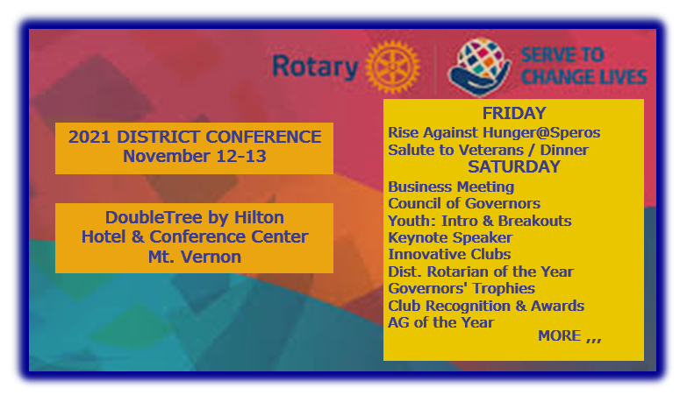
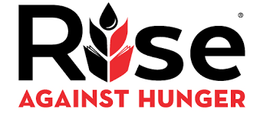
Nov. 12 – Rise Against Hunger (International Service Project)
Many inquiries about this! Scheduled for Friday afternoon!
100 participants needed!

Register http://events.riseagainsthunger.org/RotaryInternationalDistrict6510 [< Ctrl-Click]

------------------------------------------------------------------------------------------------------------------------------------------------------------------

Zones 30-31: Conversations that Matter!
Oct 6 Deep Dive on Membership
Oct 14 The Rotary Foundation - with Trustee Chair John Germ
Oct 23 Peace Project Incubator
Oct 27 A Look Back, A Look Forward: Future Directions
Needed: Newsletter Editor
focus on upcoming events, activities.
contact Terry Mathias
618-924-5655
Rotary6510Mathias@gmail.com
Clubs are invited to provide items by the 25th of each month for this newsletter,
highlighting events, projects, and other activities upcoming in the
4-6 weeks following the publication date of the 1st day of the month.
www.RIZones30-31.org/events

