Rotary District 6510 Grant Training
Final Report Dacdb Screens
Deadline for submission: February 28!
After you have done these tasks:
- Action photos transferred to your hard drive (then, rename each photo for description)
- All bills, cash register receipts, internet receipts, copies of checks paid out, scanned as PDFs and saved (with an appropriate name) on your hard drive
- Copy of letter of cooperation (school district, park district, library, whatever) scanned as PDF and saved (with an appropriate name) on your hard drive. A Thank You letter would be nice, too.
- Fill out the FinalReportExpensesSummary spreadsheet, Save it on your hard drive
You are now ready for your work on Dacdb:
Log in to Dacdb
Click on District Grants
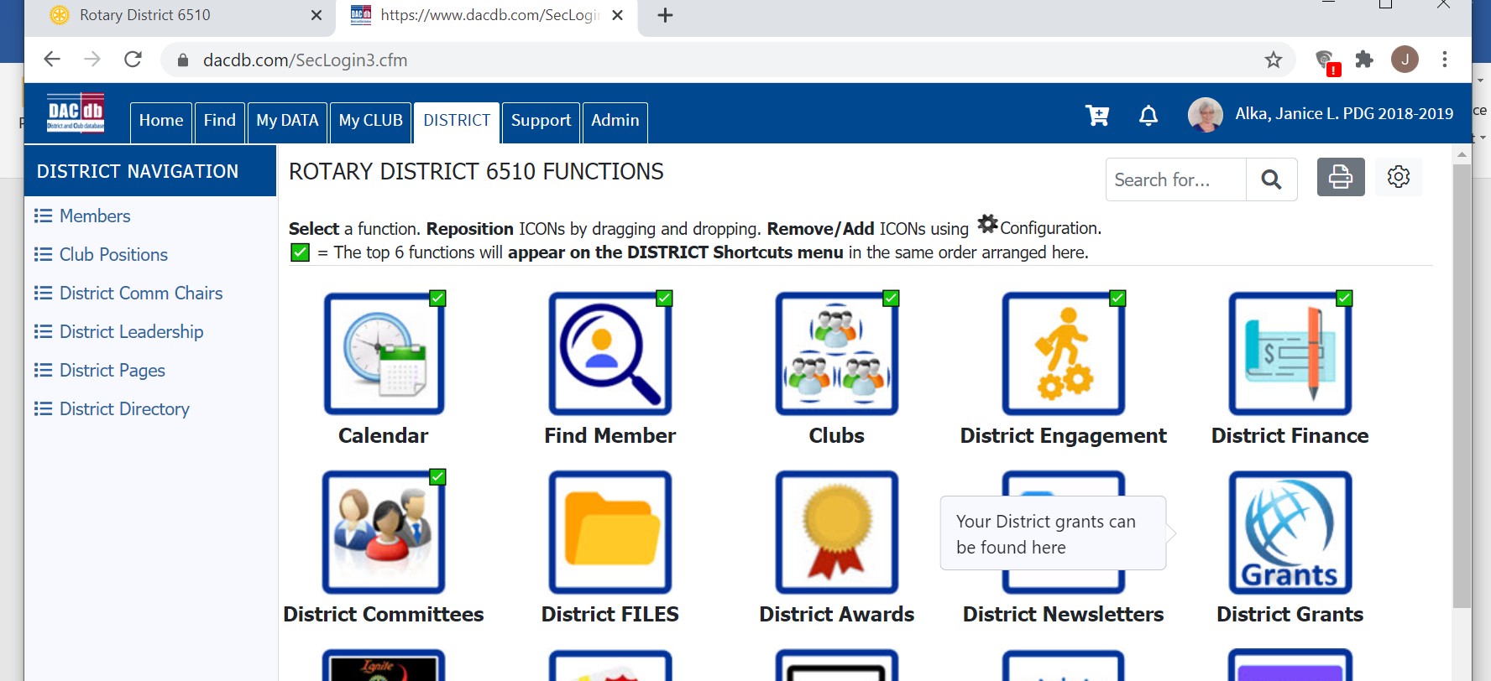

Click on Club Grants View
Be sure you are in the correct year. Change OrgYear if needed.
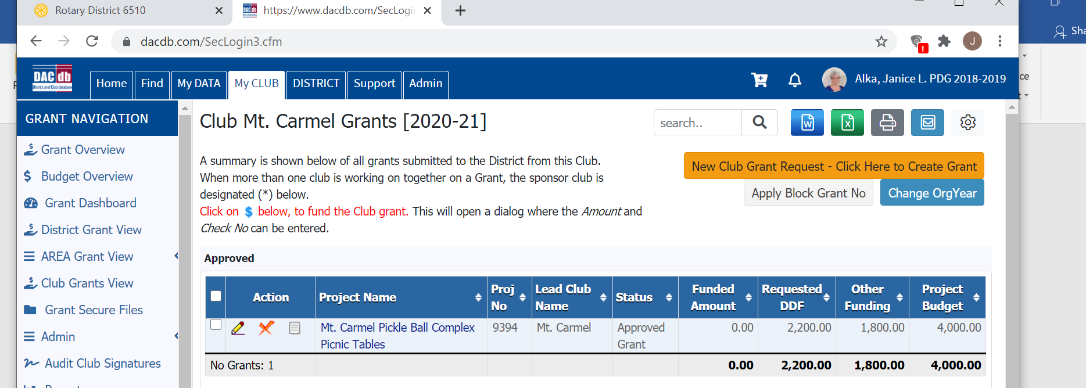

Click the Pencil button in front of your Grant name
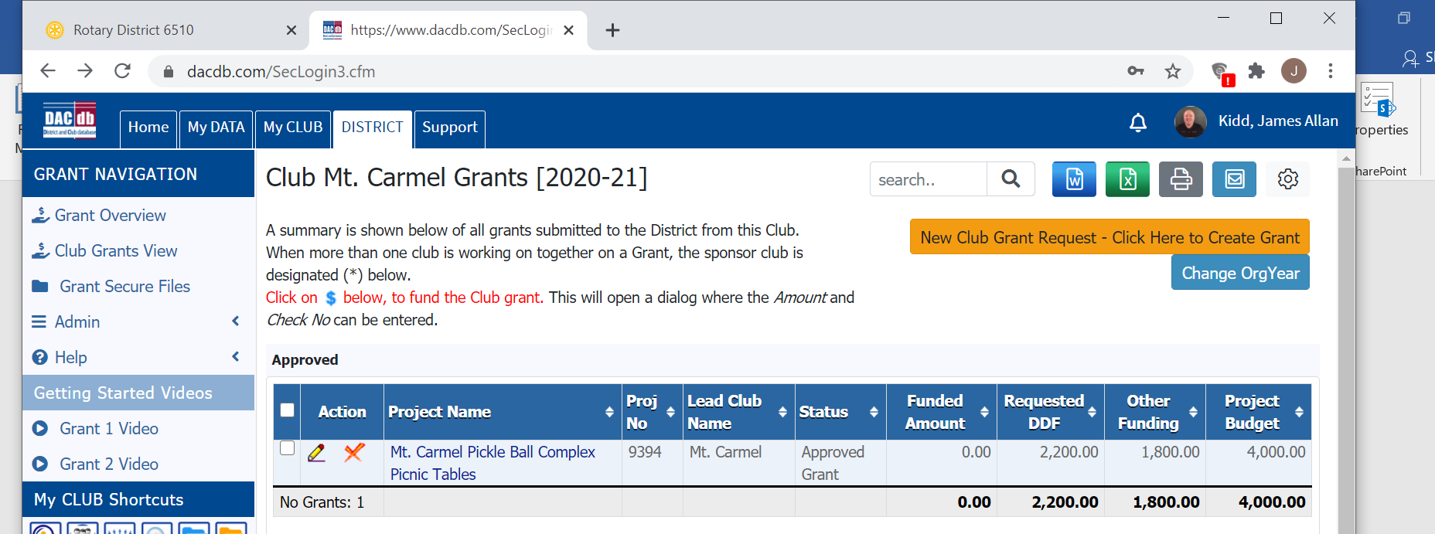

Your work will focus on 2 TABs in your Grant: Documents and Final Report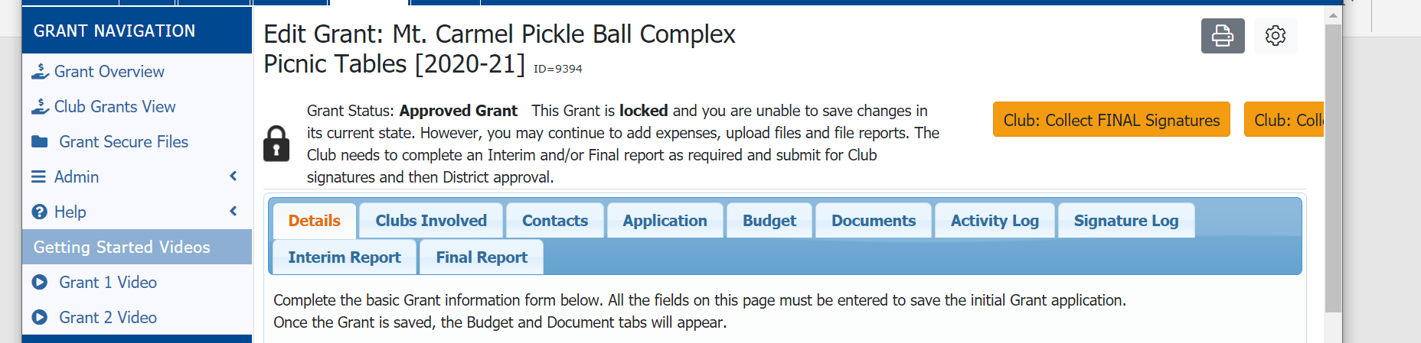

Important: Do all the Documents work First! Click the Documents TAB; then
Click the Upload File button, browse to your saved receipts, checks, letters, pictures, etc
Keep using the Upload File button until all items have been uploaded
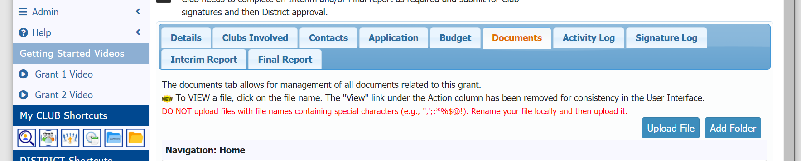

After you are done uploading all document, you are ready for the Final Report TAB
There are 6 questions on this page. All 6 need answers:
Q1 will have typing from your original Application. You can add to/change this typing if necessary
Q2 must have a numerical answer. (Not like 30+, Not like Everybody)
Q3 will have typing from your original Application. You can add to/change tyis typing if necessary
Q4 must have a numerical answer. (Not The Whole Club, Not 35+)
Q5 must have an answer. Click your mouse in the box and type
Q6 must have an answer. If you installed park benches at the park--- list the Park District by name, or School District by name. Don’t let the word ‘cooperating’ get in the way. Hint: if your project happened on someone else’s property, you needed permission to do it, so they are a cooperating organization.

After all 6 questions/answers are done
You are ready for the last 4 steps:
- Click the Club: Collect Signatures button (top right area). That will automatically send an email to your Grant Certified members.
- Before you leave, Click the Sign Final Report button (top right area).
- One of your other Grant Certified people must log in to the Grant and Click the Sign Final Report button (yes, you must have 2 different people sign the Final Report)
- That second person, after doing the Sign Final Report, will have a new button. Click the Submit to District button. (That will automatically send an email to us to check your Final Report)

The Final Four Mantra:
- Club: Collect Signatures
- Sign Final Report
- Sign Final Report
- Submit to District

