Bill KrzArrt-iMi—



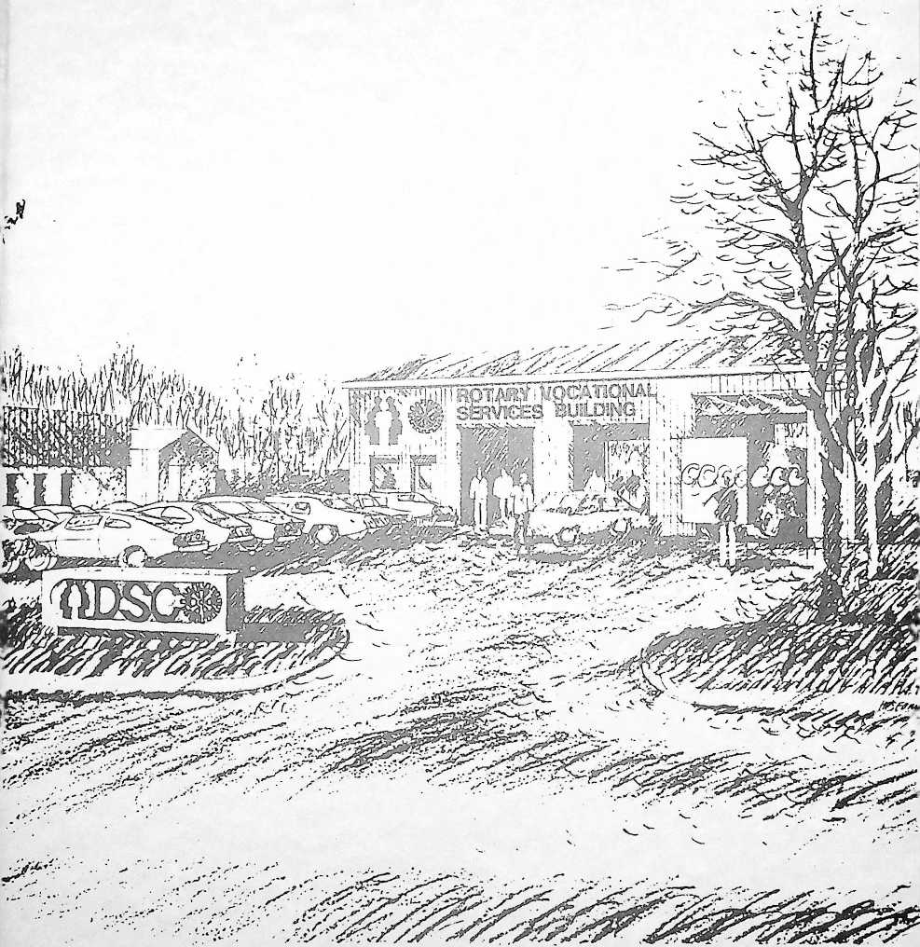

ROTARY VOCATIONAL SERVICES BUILDING

The Champaign Rotary Club is proud to present the

1986 ACTION AUCTION

Friday, May 30, 1986  
at the Chancellor Convention Center  
Champaign, Illinois  
5:45 Cocktails 6:45 Dinner  
followed immediately by the Action Auction

**Purpose and** Goals ©fi fthiis Year’s Auction

Proceeds from the 1986 Action Auction will be invested in thoughtfully chosen projects within the community.

The primary project is the renovation of an unused, 4-bay garage at the Developmental Services Center. To be known as the “Rotary Vocational Services Building," it will become valuable space for the vocational training and employment of some of DSC's hundreds of educable, post-school clients.

The mission of the Developmental Services Center. Inc. (DSC), a tax-exempt, not-for-profit corporation, is to provide a comprehensive spectrum of programs and services for the developmentally disabled individual. The direct and indirect services provided include, but are not limited to, prevention, rehabilitation, and residential services. DSC accepts and supports the principles of normalization and integration in the least restrictive environment, utilizing community-based services.

Other goals of this Auction include the following:

1. Construction of an emergency shelter at the Prospect Avenue location of the Salvation Army.
2. For Mercy Hospital, the purchase of LifeLine Emergency Call units for distribution to individuals who cannot afford them.
3. The purchase and equipping of a portable canteen unit for the Salvation Army.
4. Provision of materials for the construction of a cabin for the Boy Scouts' Order of the Arrow.
5. Purchase of an electric kiln for use in ceramic work at the Senior Citizens’ Center.

Open Bar during the Cocktail Hour

Cash Bar during the Dinner Hour and the Auction

MENU

Chilled Tomato Juice Cocktail  
Mixed Greens with Choice of Dressing

Roast Prime Rib of Beef au jus

Baked Potato Served with Sour Cream and Chives

Glazed Carrots Hot Rolls and Butter

Wine Coffee Tea Milk

Dear Mrozes

t^ules and Procedures ©f flhe Action **Auction**

1. The Action Auction will begin immediately after the dinner hour and continue until all items are sold.
2. Flags are placed on the tables to assist the Auctioneers and Spotters in identifying bidders. Please raise your Flag high when offering a bid.
3. Payment may be made by the successful bidder immediately following the auction of each item. An Auction Hostess will bring a purchase receipt which requires the signature of the bidder, and will escort the bidder to the cashier’s desk in the banquet hall.

■1. Payment can be made by cash, check. Visa, or Mastercard. All checks and credit card slips should be made payable to WGRC, Inc.

1. Values set forth for some items being auctioned or given as door prizes are estimates only and are not warranted for tax purposes or for general value.
2. Winners must be present at the time of the drawings to be eligible for door prizes.
3. All sales are final, and there will be no exchanges or refunds except as specified by the donor. AU auction items and services must be used within one year from the auction night. May 30, 1986, unless otherwise agreed by the donor and the purchaser. Trip items must be confirmed by the purchaser to the donor within thirty (30) days of the auction night. Special instructions pertaining to some items may be indicated on the bottom of the purchase receipt.
4. Items should be removed from the banquet haU by presenting your purchase receipt on auction night. Arrangements for pickup of items not displayed at the banquet haU should be made between the donor and the purchaser.

W.G.R.C. ACTION AUCTION

CATALOG OF FEATURED STEMS

**IT’S THE ERA OF THE IRA,** and here's your chance to get in gear with leveraged retirement. Each additional deposit will compound your earnings and confound the IRS. Of all the items up for bid. this is the only one certain to be worth more come Monday evening—and each day for as long as you hold it. Bob Wallace promises to project the payoff out to your retirement age—in dollars or rabbits. As Champaign National says: ■‘Watch it multiply . . .furryears.

**Value this minute: $500.00**

**Robert R. Wallace**

**Champaign National Bank**

**CLAIM ORANGE AND BLUE BLOOD** in your veins? Not until you have orange and blue underfoot, too. In true Illini spirit, sing out your bid for this custom orange and blue Illini Rug, with Block I insert. Chief say: "Custom How?" Here how: you can have orange with a blue I, or blue with an orange I. That should about cover it, Kemosabe, as well as a 3X5 space of your floor (or wall, or ceil­ing, who cares what kind of crazy fan you are)? Send up your smoke signal now, or forever hold your peace-pipe.

**Value: $420.00 Martin Smith Tile Specialists Inc**

' 1 . W' J ■ W! Spcidel has long had a good name for its quality timepieces; and Spritz Jewelers has had an equally notable reputation throughout the Champaign area as a "full service" jeweler. Team them and you have an Action Auction special: a Speidel gent's quartz analog watch from Spritz Jewelers. No more checking your watch with others to tell if it's correct. The quartz movement has been a revolution in the evolution of telling time, achieving extreme accuracy through utilization of a quartz crystal to control the frequency of alternating current supplied to the watch motor. Just as nice, when you strap on your watch, you can watch those nearby "ohh" and "ahh" at your savvy in selecting such a stylish and functional accessory. Practice by waving your wrist at the auctioneer to wear the opposition down.

**Value: $125.00**

**Spritz Jewelers**

**TRIM TIME? YAWN A-LAWN!** Aftei r the hard work of mowing your yard comes the easy part, keeping your feckless fescue in bounds and low down. Trim that tall grass . . . whack off those weeds . . . the source of your force is the Weed Eater XR 85, a gas-powered string trimmer that makes the master of the manse the guru of the grounds too. Pull out all stops to string out the bidding until you cut out the competitors to put your hands on the world's greatest trim­mer. This whirling dervish must be the greatest because the "world's greatest hardware store" wouldn't lie to the World's Greatest Rotary Club.

**Value: $250.00 Perry Kohn Champaign Ace Hardware**

**_ DON’T SETTLE FOR SECOND-BEST!** □ Honestly, wouldn’t you really rather

have a Buick? No matter the vehicle

regularly driven, treat yourself—or some­one you love very much—to the luxury of a 1986 Buick. From standard equip­ment that borders on the sensational to optional accoutrements that are strictly sumptious, the new Buick has looks, com­fort. engineering, and performance. Worden-Martin has the Buick, a week's lease, and 500 miles of city and country cruising for the person who buckles up the best bid. Shift into high gear at the Action Auction and hit the road to discover the elegant experience that driv­ing was meant to be.

**Value: S500.00 Wayne G. Weber Worden-Martin, Inc.**

**ALAS, POOR OPHELIA HATH TOO MUCH OF WATER—**and so hath Northern Illinois Water Corporation, which will turn on the spigot to supply your single-family residence with a year's free water service. Though the water's ex­pertly filtered, it seems the quality of NIWC generosity is not strained, but droppeth as the gentle rain upon your tender epidermis or parch-ed lawn. NIWC won't turn your water off before 12 months elapse—or until you've sponged up 8300 worth of Central Illinois' finest wet stuff, whichever comes first.

**Value: $300.00 at High Tide George A. Russell Northern Illinois Water Corporation**

**LAND AT THE LANDINGS.** In an ex­clusive section of Ft. Lauderdale, on the deepwater canal just 200 yards from the Intercoastal Waterway, an elegant three- bedroom home awaits your arrival. For a full week starting Saturday, September 20. you’ll also have a car at your disposal for those short jaunts to the beach, shops, restaurants, or one of the many golf courses in the area. In between, relax in the sun at your private swimming pool.

Use your Landings net to make sure this big one doesn't get away.

**Value: $1,000.00**

**Jim Gallivan**

**University Asphalt**

**HOME IS WHERE THE HEART IS.** It is also where the family portrait should be taken ... in a setting that means “home" ... on the back patio ... in the family room . . . around the hearth. Snap off the best bid for a gift certificate that includes a one-family home-setting and an attractive 11 X LI portrait (of course, you can purchase any number of prints in any desired size). The person who will snap the portrait is Larry Kanfer. a recognized artist whose creative camera­work has made him much sought after and his prints much treasured. Quite can­didly. you don't want to be negative in your approach or you will shutter off the chance to focus on your family's good looks.

Value: SI05.00

Larry Kanfer Photography, Ltd.

**DON'T BE A (SIC) EXECUTIVE!** Whatever concerns you have, they shouldn't include anxiety about your health. Let the friendly folks on Clark Street check you over with a complete Christie Clinic Executive Physical Examination—an alphabet soup that's much better than chicken soup for what could ail you. Ingredients include: EKG (electrocardiogram-heart/heart rhythm); BC Lab Test (18 blood chemistry tests of the blood); CBC Lab Test (complete blood count); UA Lab Test (microscopic urine analysis to detect infection); Chest X-Ray; and—if the examination recipient is a woman—Pap Smear. The only stipulation is that the person being ex­amined be more than 18 years of age. If you’re a Christie patient, you will be ex­amined by your primary care M.D.; if not

a Christie patient, you will be examined by a physician in Internal Medicine. Either way, the exam is coordinated by the Christie Clinic Occupational Health Service, all prescribed to keeping you fit for life. When the bidding starts, say “Ahhh" and you’ll get just what the doctor orders.

Value: $350.00

Christie Clinic Association

10

**THE EYES HAVE IT.** Why not look at the world through rose-colored glasses— or whatever it Lakes to look at your best? Treat your eyes—or those of someone you love—to a complete Christie Clinic general eye examination and. once you've been checked, one pair of eyeglasses. The only stipulation is that the person being examined be more than IS years of age, which makes sense since he or she will be going for 20/20 status. Pick (lie lime— anytime before May 1, 1987 — and WGRCer Vic Feldman, your friendly ophthalmologist and eye examiner ex­traordinaire. puts the tools of his trade to work insightfully. Fix your gaze on the auctioneer, loosen your grip on your wallet or purse, and grab an appointment rather than disappointment.

Value: $250.00 Christie Clinic Association

11

**HOP ON THE BUS, GUS.** No more excuses for putting off that group excur­sion you've always thought about. Here's a deluxe motorcoach for up to 46 people—yours for a full day and 300 miles. Take your class to New Salem; grab the old ladies and pick up the babies and translocate that tired ol' family re­union to Turkey Run or Starved Rock. Or how 'bout the Field Museum or the Art Institute—or those Monsters of the Mid­way (if you can talk somebody out of a busload of tickets)? Pick your destina­tion, then step to the rear and leave the

driving, fuel, and other details to the ex­perts. You've got a year to book, based on equipment availability.

**Value: $700.00**

**Bob & Dick Parkhill**

**Illini Swallow Lines & Parkhill Tours**

**WHO SAYS YOU DON’T KNOW BEANS?** If you don't, you sure will after speculating with these fifty bushels of Il­linois’ finest soy beans. Your winning bid buys you the beans—and the storage costs—as of Monday, June 2. But just think, you've endured neither flood nor drought, paid neither mortgage nor chemicals—you step in with net beans, ready to parlay your purchase into pro­fits. And thank you—thank you for lif­ting some of the nation's surplus off the bowed shoulders of poor ol' dirt farmer Dick Donor.

**Value: S250 or thereabouts (Market price at close today) Richard H. Burwash**

“READY WHEN YOU ARE, C.B.

That means get ready, “Cinema Buff,” to be entertained with $200 worth of film/video rentals, plus free use of a pro­jector or videocassette player, from the University of Illinois Film Center. This offer has drawn rave reviews at previous Action Auctions and is back on the bid­ding block by popular demand. Serving educational institutions, businesses, libraries, government agencies, and in­dividual clients throughout the United States, the UI Film Center will add you to its list of distinguished catalog re­cipients. Check out feature classics, documentaries, cartoons, short subjects, and children’s films/videos. Need counsel with so much to choose from? WGRCer Cal Owens, the Film Center director, will assign a film program coordinator to assist you in making your selections before the expiration date. You can sit

5

back and enjoy the shows after the Auc­tion . . . after you've answered the call for “Lights! Camera! Action!” by register­ing the highest bid.

**Value: $200.00 Calvin L. Owens University of Illinois Film Center**

**GOT THE BROADCAST BUG?** Take to the airwaves via WDWS Radio—AM and/or FM—with a series of 30-second and 60-second spot announcements. Talk about yourself, your products, your ser­vices, your interests—all subject, of course, to appropriate advertising codes and regulations —any time through December 31, 1986. You decide the days you want to go on air; the WDWS v.p. and general manager will determine the best times available . . . and that will determine the costs up to a total of 3500.00. It just happens that the v.p. and general manager is WGRCer Jim Turpin so you know you'll be getting some good times. The medium for your messages might be “J.M. in the A.M.” or “Penny for Your Thoughts" or “Stevie Jay" . . . maybe even “Saturday Morning Sports- line," providing the stars keep quiet long enough. Give the auctioneer the best bid and standby to take the mike to give the folks out in radioland a few pieces of your mind.

Thanks to past WGRCer Newton Dodds and First Illinois Construction, your finish carpenter is close at hand and ready for two days work. Don't mistake this for a Finnish carpenter; the Action Auction is an equal opportunity affair. Regardless of ethnic background, your certified finish carpenter is characterized by his work ethic and a dollar-or-more's work for a dollar paid. In short, he is as skilled a performer with a hammer as ever you saw. You woodn't be happy missing this help so nail it down bal’d and fast in the bidding.

Value: S480.00

Newton H. Dodds

First Illinois Construction, Inc.

EXTRA HANDS FOR THE HANDY is what you get when you mate your craftiness with this Black & Decker port­able multi-plane Workmate. It's a table- top workbench for home craftsmen that can be adjusted to five different work planes. When you need just one more hand when you're trying to make or repair something, the Workmate pro­vides it as an attached vise. If this device suits you to a T-square, devise a way to come up with the top bid.

Value: $79.50

Stanley C. Robinson

**Value: S500.00**

**Jim Turpin**

**WDWS Radio**

**THE WOODWORKER’S FRIEND.** Do you easily plan woodworking projects but have trouble doing the actual carpen­try? More specifically, are you far short of journeyman status, being closer to “jerrybuilt” classification? "When are you going to finish this. . . Mumble, mumble in response. “When are you going to finish that. . . More mumble, mumble. But happy days are here again.

**SHOW A LITTLE CLASS.** Or a Big / Class, for that matter. Be cool. Put this deal on ice and you will be hosting a class­action sit-in at a performance of the Ice Capades. When this slick extravaganza slides into the Assembly Hall in October, you'll bring your son's or daughter's en­tire school class as your guests. Or make it the scout troop, bowling team, bridge club, or simply the gang from the office, all because you are such a good skate. The Assembly Hall picks the Lime and seats, you say how many you're bringing—from the sorority, investment

club, union local, soccer team, home

room, . . .

**Value: $350, more or less Tom Parkinson Assembly Hall, U of I**

what we have said before: Oil’s well that ends well with you as the high bidder.

**Value: S200.00 H. R. Bresee P. K. Bresee Dick Foley**

**OFF YOU GO. INTO THE WILD BLUE YONDER** in a Navy T-34, piloted by C-U‘s own shy, retiring, but intrepid skymaster. He's restored this classic, reciprocating-engine Beechcraft Mentor to pristine condition, a flying exhibit of the Frasca Air Museum. To get your topsy-turvy tummy's worth, turn thumbs up for a taste of formation fly- ing and aerobatics. This is a Breakfast­in-Bloomington flight, so be sure to get your loops and rolls under your seat belt before you touch down for omelettes (or whatever) at Arnie's.

(81.000.00 in thrills) **Value: $200.00**

**Rudy Frasca**

**Frasca International, Inc.**

19

**PANTING FOR A PAINTING?** This could be your lucky evening when you ac­quire an original oil—in this case a floral still life—by Alicia Bresee. Most of her painting is done for commission—a re­cent one for Harvard Business School while two others hang in the Florida Capitol at Tallahassee. Alicia has her studio in Fort Lauderdale, where she teaches gifted children, but she has a na­tional reputation because of her impres­sionistic style and one-woman shows in Atlanta, Chicago, San Francisco, and Washington, D.C. WGRCers Tiz Bresee (her proud father), Paul Bresee, and Dick Foley—WGRC’s art smart set—assure you this *objet d art* will be a lifetime treasure of artistic worth, but you know that from brisk bidding for Bresees at previous Action Auctions. Don't give this painting the brushoff; we'll repeat

**INSIDE, OUTSIDE, ALL AROUND THE HOUSE . ..** Kitchen or laundry, yard or garage, this professional Home Maintenance Kit will keep your home or business gleaming. This is kit and caboo­dle too. with 73 separate items measured in more than 37 gallons and 100-plus pounds of top-quality products for floors, bath, windows, furniture, dishes—“you soil it, we shine it." From a $295 Henry Vacuum with all tools, to an $82 3M door mat, to 200 heavy-duty lawn bags, ex­perts have assembled this assortment to expunge the elbow grease from all your dirty jobs. Bid smart on this and you'll clean up—for a full year and more.

**Value: $846.45**

**Bud Rodericl**

**Chemical Maintenance Inc.**

**FEEL LIKE BEING TAKEN TO THE CLEANERS?** Here's a sporting proposi­tion from WGRCers Joe and Steve Ham­burg that all guys and dolls can ap­preciate. Roll a pair of dice and multiply the total by 30. That's the jackpot amount of dry cleaning you can claim at Garber's Modern Cleaners. A good roll wins $360, but it's a fix—you win. they lose: even if you roll snake eyes, through the beneficence of Joe and Steve, the die is cast at no less than $250. So let the good times roll! The only way you lose is if you sit with hands starched and fold­ed when you should be waving.

**Value: S250-S360 The Haniburgs Garber’s Modern Cleaners**

7

22

**FOR HEAVY ROLLERS ONLY:** four heavy-duty rollers. If you own a van or R.V., this should be right up your gasoline alley: 4 P235-75-80 R15 Firestone extra-load whitewall tires. Don't need 'em yourself? Half the world's drivers own vans (or so it seems)— including that baby-faced son-in-aw to whom you’ve been needing to build a bridge. Gift ’em or roll on ’em, these babies will dress up anyone's wheels.

**Value: S560.00 Willis & Cindy Whitesell Skip’s Sunoco**

25

23

**TURN ON YOUR TREE** to its most attractive best this Christmas. Start with your pick of a choice tree, each with its own particular beauty and benefits ... a freshcut pine that spreads its limbs to shake pleasant scents throughout the home ... or an artificial tree that never needs water and never drops its needles for many years to come. Proceed with more choices . . . the lavish lights and dazzling decorations that make your tree the crowning centerpiece for the celebra­tion of Christmas. True, these choices might be a bit difficult among the pro­liferation of possibilities at Prairie Gardens, which annually attracts visitors from across the state to browse and buy. But you have the advantage of WGRCer Jeff Wandell's wise-man counseling to shepherd you through the task. Bidding begins in branches so hang in there until the end to take the tree and all the trimmings.

**Value: 8300.00 Jeff Wandell Prairie Gardens, Inc.**

24

**HO-HO-HO, AND THIS IS NO JOKE!** Come next December, wouldn't it be nice to have a Santa up your sleeve? We mean a real, live, kindly and bewhiskered old gentleman in a fur-trimmed red suit. You

select the chimney, he'll slip down it and bring fun and warmth to those gathered—be it in a private home, hospital, nursing home, or at a Christmas party. How do you place a value on the Christmas spirit? Your bid will tell us how much a visit from your personal Santa Claus means to you.

Value: 8 ????

Arthur J. Skelton

THE POSTER MAN ONLY RINGS ONCE, so don't fail to answer the call to own your own billboard for a full month. Selling your house? Running for office? How better to showcase your products and expose your ambitions? If you have nothing to advertise, when was the last time you told your spouse (and the whole world) how much you love him/her/it? 300 sq. ft. (illuminated, if you like) ought to give you enough space to get your message across.

**Value: 8380-8480 Kip Pope C & U Poster Advertising Co.**

IT PAYS TO ADVERTISE! Got some­thing on your mind? Want to wish some­one a happy graduation, birthday, or an­niversary? Want to register your pride and promotion for a worthwhile com­munity activity or organization (we won't mention any names but the initials might be WGRC)? Want to do it with a big blast—large type, lots of white space, and maybe even a photo—or a number of little notices, "rifleshots" to reap the rewards of repetition? Hey, do it your way . . . but do it with $250 worth of advertising, retail or classified, in the Champaign-Urbana *News-Gazette.* And here’s a bonus . . . you can call on the counsel of WGRCer John Bowman, *News-Gazette* editor and general manager. When the press of bidding nears the final edition, yell “extra" one

more time and you’ve bought the tell-in- type opportunity of a lifetime . . . well, at least until the next WGRC Action Auction.

**Value: $250.00 John J. Bowman The Champaign-Urbana News-Gazette**

**PUT YOUR BEST PROFILE FOR­WARD!** Y ou know what a profile is, right? The outline of the human face, good looks often associated with a movie star. Not so fast. What we're talking about here is a Diagnostic Profile of 17 lab tests, X-rays, and the works to show the status of your health, an important presentation for you and your relatives. The Profile includes such essentials as CBC screen, urinalysis macro, and chem­istry profile in a complete production staged by Mercy Hospital, a ServantCor Human Services Family member whose list of credits include having the area's largest open-heart surgery program. Once you’ve cast the winning bid and made the necessary arrangements, head for the Mercy lot on Park Street and go inside for the role of your life. Think of the peace of mind you’ll have because of your Diagnostic Profile, a real Academy Award-winner. Yell “Roll ’em" when the bidding starts and you’re on your way to a starring career.

29

**Value: SL000.00**

**Mercy Hospital**

**A TASTE OF THE FAR EAST** here in the Midwest is something special to be savored—an evening of enlightenment and enjoyment—and you'll do it in the good company of friends of your choos­ing. Make your best-bid “reservation,” organize your party of six. and travel to Japan House on the University of Illinois campus. Your “tour-guide” hosts are WGRCer Ken Gunji and his wife, Kimiko, who is a member of the art

faculty, teaching Japanese art, flower ar­rangement, and the tea ceremony. They will orient you and your guests to the culture and cuisine of Japan, beginning with a traditional Japanese meal and con­cluding with the formal tea ceremony, a ritual regarded as the quintessential ex­pression of Japanese aesthetics. Say "sayonara” to an authentic Asian adven­ture if you’re too timid to try something new and nice.

Value: S180.00 Ken & Kimiko Gunji

**WHERE D’YA WANT IT, LADY?** What?? This truckload of ready-mix con­crete, that’s what: nine square yards of the strongest and best, enough for a 700 sq.-ft. driveway. Let's see, that’s 20 X 35; or if you have one car and a deep setback, 10 X 70; or if people keep driving on your lawn, how ’bout 700 linear feet of con­crete curbing? You point, we’ll pour, but it's not a new sofa lady—once we set it down, we ain't moving’ it.

**Value: S500.00**

**Central Material Co.**

**James S. Acheso**

**FAITH CAN MOVE MOUNTAIN** and so can you when you are at the con trols of an M-610 Bobcat. Haven't you always wanted to terrace your back yard? This compact front-loading, four- wheel-drive tractor is designed for dig­ging. backfilling, grading or simply mov­ing dirt, sand or gravel. It fits into places you won't believe, and it’s yours— including trailer—for a full day when you outbid other earth-movers. You need some machine operating experience to make this cat purr-form.

**Value; $175.00**

**Howie Kemper**

**Keith Kemper Rentals**

31

**HUGE AND SPREADING AND ROOTED** deeply in the hearts of local residents is the Osage Orange tree at the corner of University and Prospect. Now it can live forever in your home, as cap­tured on film by Larry Kanfer and titled “Climbing Tree." This 27” X 32" work of photographic art is professionally and ap­propriately framed by Becca Inc. It's people like you who most appreciate such renditions of things loved and familiar, so look alive, bidders, or go home wistful.

**Value: S300.00**

**Kanfer Photography Ltd. and Becca Inc.**

**Larry Kanfer Rebecca and Ralph Barber**

32

**TAKE THE A TRAIN!** Why bother with wear and tear on your family limousine ... or the inconveniences of a number of other ways to get from here to there? Engineer the swingingest bid for a Region 1 “All Aboard" AMTRAK Rail Ticket. Then take the A Train . . . AMTRAK. Lean back and listen to the music of the wheels on the tracks . . . watch beautiful mid-American landscape roll by . . . feel like royalty—a duke or something on the Occident Express—as you enjoy the easy way to go. Your con­ductor is the Mid-America Travel Agen­cy, an expert on advice and arrangements when it comes to AMTRAK'n it. The local firm has recently been named to a select band of travel agencies to receive AMTRAK's Golden Spike Award (honor­ing top revenue and service agencies) for 10 consecutive years. “All aboard!"

Value: $175.00 Mid-America Travel Agency

33

**HOME, JAMES!** Be a modern-day Cin­derella or Cinderfellow. For four hours, let Rotary’s fairy godmother transform you into a glamorous star. Go to the ball, the ballet, the ball game—wherever your

heart desires—in LaCar, your private lux­ury limousine. LaCar boasts the appoint­ments of a royal carriage, so sit back and relax (or whatever) with the company of your choosing. You can chat, enjoy TV or stereo, or quench your thirst with refreshments from your in-car bar­complete with champagne, naturally. As you roll gracefully along, be sure to wave to your public through the sun roof.

**Value: $150.00**

**Roger and Ramona Roberson LaCar Limousine Service**

**WE INTERRUPT THIS PROGRAM** for the most important package of adver­tising spots you'll ever have a chance to buy at auction. Even if you don't project the star quality of Mr. Discount or (Wild) Bill Rasmussen, haven't you always wanted to advertise your products or services on the Channel 3 News? Here's the deal: two 30-second spots in the 6 o'clock news and four 30-second spots in the 10 o'clock news, to be used between June 30 and September 14, 1986. To ignite your creative fires. WGRCers Guy Main and Jerry Johnson are standing by as your professional consultants.

**Value: $1,900.00 Jerry Johnson WCIA Channel 3**

**ACTION AUCTION ANTIQUE ALERT!** History flashes before your eyes . . . ar­tillery pounds away with deafening sound and swirling smoke . . . infantry advances resolutely through shot, and shell . . . cavalry skitters and gallops about the flanks . . . sunlight glints off the saber raised to direct and inspire the troops. Then it’s quiet. . . the battle over . . . the war ended . . . the nation reunited. More than 100 years later, the people are gone but history lives on in the saber— an 1860 Union Army Civil War light

*io*

cavalry saber, dated 1864, marked by the inspector (AGM|, and inscribed by the manufacturer, C. Roby & Co., W. Chelmsford, Mass. This saber has been a private collection prize for WGRCer Tod Dawson and will be equally prized by you as part of a collection or a one-of- a-kind treasure. No, we don't know where r or how or by whom the saber was used,

, but it is the real thing. Forge some fancy

fantasies of your own . . . strike a blow for the Walter Mitty in you by charging forward in the bidding.

**Value: $300.00 T. O. Dawson Insurance Risk Managers**

38

The President of the United States and the Chairman of the Supreme Soviets meet in splendor at Geneva—the Sum­mit! And in a diplomatic coup, you en­joy the benefits of then- power plays right here in Champaign. The Super Powers have agreed that the spectacular Moiseyev Dance Company, one of the world's great cultural attractions, will tour the U.S. for the first time in many years. It plays here October 21 and 22, and for your party of four, the Assembly Hall will provide prime seats. This event paves the way to the next summit, and you'll be there. The stakes are high in these negotiations, so upset the foreign trade balance: bid high out of respect to protocol and the price tag of these prized tickets.

**Value: $80.00 Tom Parkinson**

**U of I Assembly Hall**

**_ _ KEEP THE KIDS OFF THE** STREETS.

1 3/ They'll gather indoors at your home,

j elbowing you out of the way to claim

their time at the controls of the Coleco Vision Model 2400 video game. Pop in a cartridge, plug in the joystick, and pro­ceed to have a screenful of good times with this arcade-quality video game. We’re not sure what’s heads or tails for “Donkey Kong,” but that’s the game car­

tridge you’ll get for practice to become a proficient player who soon progresses to Empire State Building-like heights of fun and finesse. WGRCer Dave Kuhl vouches for the dividends of delightful diversion you’ll have when you invest the highest bid to deposit this item in your home. And he wouldn't kid you.

**Value: $99.95 P. David Kuhl City Bank of Champaign**

**ALL THAT GLITTERS** may not be, but this is: GOLD, in the unmistakable form of an 1881 U.S. $5 gold coin. Prices may wax and wane, markets may surge and swoon, but in an unstable world, certain standards remain stable. Rust doth not corrupt this metal, so lay this little treasure away, pending the pendulum’s swing. Just don’t bite her—she’s in ex­tra fine condition.

**Value: $200.00 Potential Value: Much more Gary G. Wackerlin First National Bank in Champaigi**

“NARTINICAN RED SNAPPER a ASPARAGUS, MEDOC.” If the title

alone doesn't tickle your taste buds, one glance will whet your appetite to own this intaglio print by David Bushman. The in­credibly skilled artist is on the faculty of the University of Illinois School of Art and Design, and presents in his art very realistic and rather hedonistic food set­tings. He expresses his own love for foods through his work, and shares it with us in stunning black and white imagery. This is #23 of a limited edition printing of 25.

39b

**“FRENCH CHOCOLATES, PIRAGAUX,  
PURSE, STAGE 1”** is the title of the

second framed intaglio print by David Bushman, this being print #24 of a limited edited of 25.

**Value: Each, $450.00 Mr. and Mrs. Scott Anderson, Jr.**

40

**THE LAST WORD IN LAMPS.** OK. if s not the last word, but you have to admit that a golf-bag lamp is one of the most unusual things you've seen. Brighten a corner of your den, spark illuminating conversation in your family room, or make it a donation to your favorite club or course. We don't have all the details, but there probably isn't much we need to tell power bidders except that this golfbulb thing operates on AC. DC, or DSC—the Developmental Services Center for which Action Auction '86 is being held. Don’t be stymied by your in­hibitions, unleash that long drive for “Service Above Self" to bag something different.

**Value: S90.00 Richard Breitenfeldt R&M Golf Supply**

41

42

**SUAVE IN SUEDE.** You too can be the epitome of debonair demeanor (sorry, just men, no miss). Take the sartorial splendor of handcraftsmanship . . . the ultimate luxury of ultra suede . . . the casual yet classic look of a sport coat. . . and put them all together. *Voila!* A custom-tailored sport coat by Man­chester Tailors of Champaign. Slip it on and step out in style, the envy of everyone who is anyone. Who says, “Clothes don't make a man?" The person who loses out in the bidding for such a fashionable feat of finery, that's who! Don’t let others needle you into sew-sew bidding; keep your head and hand up and you'll collar garb fit for a WGRCer.

**Value: S500.00 Charlie Fultz Collegiate Cap & Gown Company**

**WHY DRIVE WHEN YOU CAN FLY?** Anywhere that strikes your fancy, for business or pleasure, within a 300-mile round trip. That includes Chicago, In­dianapolis or anywhere in that radius that your private-use twin-engine Piper Aerostar can land. No, you don’t have to

fly it yourself, the pilot comes with. Fly­ing out of Midstate Aviation's facilities at Willard Airport, you will be Cozad Financial Planning Corporation's V.I.P. for a trip that’s worth your sky’s-the- limit bid.

**Value: $465.00**

**V. Dale Cozad**

**Cozad Financial Planning Corporation**

**FACE-TO-FACE WITH PACESETTERS.** The setting is Suite 304 at the 201 W. Springfield. Champaign, office of Devon­shire Realty Commercial Division: the gentlemen welcoming you are Tim and Tom Harrington: and the talk is about the intricacies of commercial real estate investment. It's your hour of consulta­tion with the “Pacesetters" and you are free to use it as you wish: questions, general information, specific investment possibilities, or what-have-you. The auctioneer—and WGRC— will be elated if you bid big to become commer­cially real estated.

**Value: <$300.00 Thomas E. Harrington Timothy P. Harrington Devonshire Realty Commercial Division**

TODAY’S ECONOMY RUNS ON SERV­ICES, and services are what we've got —a •$600 package of them, customized to meet the needs of the highest bidder. Your package can include one or a com­bination of these services: Microfilming— document preparation, filming, process­ing and jacket loading; Janitorial—light cleaning, stripping and waxing floors, shampooing carpets; Lawn—mowing, edging and trimming. All services are provided by developmentally disabled adults from DSC's Vocational Employ­ment programs. Their work is of high quality, under supervision of the DSC staff.

**Value: $600.00**

**William Gingokl Developmental Services Center**

**LOVE A CHEERY FIRE ON THE GRATE?** It's hard to imagine an easier way than this to take a load off your mind and the chill out of your house all next winter. The Developmental Services Center will deliver five ricks of seasoned hardwood, plus kindling and starter, to from one to five locations. No, you don't have to take it all at once, but don't be wooden-headed—redeem your deal this coming winter, or it'll go up in smoke.

**Value: S300.00** Richard J. **O’Neill** Marine American National Bank

**FLOWER”** is the understated title of this artistic print of a poster by Pat LaCroix, matted and framed to 24 X 36. The rich, deep red of the orchid-like flower contrasts vividly with the dark background and, in happy combination with the ultimate simplicity of the design, makes this poster virtually irresistible—doesn't it? Is that your hand we see waving?

Value: $125.00 Robert C. DeLong DeLong’s Framer’s Market

**CORNSIDER THIS YIELD!** First plant the winning bid for 10 bags (80,000 kernel count) of Lynks LX4355 hybrid seed corn; then harvest the certificate's yield anytime between May 30, 1986, and January 31, 1987; and you’ve qualified as a cornfield and cornyield colonel. The 114-day hybrid (single cross) is the pro­duct of Lynks Seed Company, Mar­shalltown, Iowa, covering the Corn Belt from Ohio to Nebraska. The proud parent company, notes WGRCer Dean Cavey, is United Agriseeds Inc., a worldwide leader in the seed business situated in Savoy. When quality hybrids are released on the market after successful yield trials, everyone stands to prosper. The auctioneeer wants to ’ear your bid as you stalk this opportunity to take part in the

49

agricultural cycle that makes America’s Heartland so great.

**Value: $730.00**

**Dean Cavey**

**United Agriseeds, Inc.**

**TAILGATE THE CHANCELLOR WAY!** No, we don’t mean John Chancellor will be attending but he probably would if he knew about the October 11, 1986 tailgate party for 50 people at The Chancellor Hotel two hours prior to the kickoff against Purdue. WGRCer Don Judy is your host and promises a scrumptious country brunch complete with orange and blue decorations, Bloody Marys and Screwdrivers, and special prices on all other drinks. What more congenial and convenient way for you and your fan friends to get psyched for a football after­noon? No set-up, no clean-up, no hassle, just felicity at the Illini victory to follow. Bid the highest on your own or as an organized brunch bunch and you bid well to have a tailgate that you and you’ friends will talk about for years to conu

**Value: $600.01 Donald Judy The Chancellor Hotel & Convention Center**

**WATT'S WRONG, CAN'T YOU HEAR THE MUSIC?** Love music but no speaka da lingo of the hip audio-video stores? Here's the rack stereo system you’ve always wanted, but keep resisting. Now’s the time to crank up the volume of your bidding and tune in to this state-of-the- art system: 30 watts of power per chan­nel, AM/FM stereo synthesized tuner, semi-auto turntable, and 5-band equalizer; cassette deck, two speakers, and the audio rack included. You know you want it—raise both hands in surrender.

**Value: S400.00 Donald E. Tilley J. C. Penney Co. Inc.**

52

**_ HEAP DEEP IN HEAT!** Today s kero- **50** sene heaters resemble old-fashion models about like supersonic jets resemble primitive prop planes. And you can't do better in a state-of-the-art kerosene heater than a Kero-Sun™ Portable that lets you focus heat where you want it when you want it... in the home ... on the job . . . and for recreation and emergencies too. Our specific Kero-Sun for bidding is the Radiant 36, rated at 9.600 BTU’s per hour with an operating capacity of 18 to 25 hours on 1.3 gallons (4.9 liters for the metric literate). Sport­ing sleek designer styling, the Kero-Sun is 99.9% fuel efficient, delivering the heat directly to the room you put it in. Dur­ing the long, cold winter, that means you can keep your room cozy and warm all evening while turning the thermostat down and saving BTU’s (Bucks To Use elsewhere) throughout the rest of the house. And in the spring and autumn, remove the chill by igniting the Kero- Sun, not by firing up the whole central heating system. Get hot in the bidding and begin to count the ways you’ll love your Kero-Sun.



Value: $150.00

Round Barn True Value, Inc.

**THE FUTURE OF THE WORLD** (series) **51** may ride on the Cubs-Cardinals clashes of September 26. 27 and 28—and YOU'LL BE THERE. A tumultuous cast of thousands will cheer as you saunter into Busch Stadium; at night you'll retire to your luxury hotel, accommodations free, just like your two tickets to each critical game. Whether your team wins or loses, you'll be the big winner Saturday night as you enjoy dinner for two at the Stadium Club, insulated from the madding crowd as you experience society sporting life, *a la* St. Louis.

54

**CHAIRMAN OR CHAIRWOMAN OF THE BORED.** Just when you thought there wasn't anything left in the world to turn you on or to lift you up, there is this special something for the person who has everything— or almost everything. Imagine coming home from a hard day’s work and slipping into something comfortable. No, not that. . . but something even better—a Penox Full-Power Medi-Lift Recliner Chair. You'll preside for peerless pleasure, scaling the heights of sitting satisfaction or reclin­ing relaxation. And when you've set a spell, Medi-Lift will boost you back to the balls of your feet, asking only that you exercise the muscle of your little finger. Make your best bid to join the ranks of the enjoyed.

**Value: $1,350.00 Susan Abbott Carle Medical Supply**

**FAMILY ROOM WALLS LOOKING SCRUFFY?** Soothe your eyes with this solution, and maybe take care of some other eyesores while you're at it. It’s hard to get some contractors to even look at small jobs, so here’s two man-days (two painters, one day) of professional service that may be just what you need. Give K & R your soil, your nicks, your gouges, your trim—they’ll restore the blush of youthful paint to your surroundings. You buy the paint, and schedule the work at a mutually convenient time.

**Value: $240.00 Ross E. Merkle K & R Painting Co.**

**Value: $350.00**

**(If Cubs win, $500) Bill McMahon McMahon Distributors**

THREE FOR FORE! Driving for long distance off the tee . . . stroking an iron shot nicely to the green . . . putting like a professional. Whatever your strengths and weaknesses, Champaign-West Rotarian Joe Burden will tell you exactly what you're doing right or wrong. That’s right, you'll have your very own private instructor—a former lllini great, Twin-City

57

champ, and still one of the leading lights around the links. He is yours for three 30-minute golf lessons at the University of Illinois Savoy Course at mutually con­venient times. Soar with eagles, don't bumble along with bogies. Your best bid just might bag this above-par item.

Value: $150.00 Joe Burden

**THE 80s BELONG TO THE ILLINI—** And to you. when you beat the competi­tion to these two season tickets to Illini Football '86. We're not standing pat: Mike While is wearing the Chief's regalia on the sidelines, the defense is carrying tomahawks, and when we have the ball, the chains will be nine yards long. Seriously, with Nebraska. Purdue and Iowa coming into Memorial Stadium, it's a great home season. Your package in­cludes the special bonus of two luncheons in the Varsity Room before each game, so catch this outstanding pass to a fabulous fall of fun and football.

**Value: $270.00 Vance Redfern U of I Athletic Association**

**DON’T LIKE FOOTBALL? HOW ABOUT BASKETBALL:** Yes, we have two season tickets for you indoor sports, too—no Varsity Room lunches, but lots more games. You'll need a scorecard to sort out all the new players Lou Henson will have on the court next season, and opponents should have their hands full with the new version of the Illini, too. But who needs a sales pitch, this room is full of fans, so show us your vertical jump before someone steals this one away from you.

**Value: $272.00 Vance Redfern U of I Athletic Association**

59

**A PAGE OF HISTORY,** a dream of yesteryear is this original watercolor en­titled "Covered Bridge—Lake of the Woods" by artist R. D. Franks. You can never take the "country" out of the boys and girls in this crowd, and covered bridges evoke the pastoral midwestern life we all love. Look closely and you’ll see your grandfather's horse and buggy in this lovely work. Be ready, now, you know you have the perfect wall just waiting for this painting.

**Value: $200.00 Dorothy and Bob Franks**

**OH! THE LURE OF THE NORTH WOODS ...** A crackling fire in the fireplace, autumn color at its best—still time for a round of golf at one of the outstanding courses in Northern Michigan, plus a great fishing lake close by. "The Kingdom of Schuss Mountain" is the place, and you can enjoy a chalet hidden in the woods for privacy, bu within strolling distance of a fint restaurant with entertainment. You’re close to Petoskey and Traverse City for that memorable shopping trip or antiqu­ing along the way. A week in this en­chanted chalet—it sleeps up to nine—is yours starting Friday, October 17—if only you break the spell by waving your wand at the auctioneer.

**Value: $995.00 Leonard T. Flynn Robert T. Parkhill**

**KINGDOM OF SCHUSS MOUNTAIN II.** "The moving finger writes, and having writ, moves on ..." time skips ahead three months, to find our enchanted northwoods chalet nestled cozily in the whitewashed winter wonderland of Mancelona. Michigan. It's the season for serious schussing, and with three bedrooms and two baths, we’re talking the ski lodge supreme. The available

IS

62

week is January 30 to February 6, 1987, and if you pass this one up, you’ve slid off the trail of a glorious winter break. Come on, now—it's the perfect Christmas present for your family (and yourself), so do your shopping early.

**Value: S995.00 Robert T. Parkhill Leonard T. Flynn**

**CHAINED TO A DESK? PLUGGED IN** to your vacuum cleaner? Burst your bonds, be earth-bound no more. Tomatoes do fly, and so do you when you're the winning bidder for a cruise through the clouds in nationally famous Flying Tomato balloon. No engine noise, no cramped seating or mini-windows, and definitely no hijackers. You'll float free and high, yet low enough to see a fascinating new face of the county you thought you knew so well. How do you want your in-flight meal—deep-pan or stuffed?

**Value: Not measurable in earthly terms, but let’s start at $175.00 Ralph and Joe Tomato Garcia’s Pizza in a Pan**

**KID ALL YOU WANT ABOUT SEAT BELTS,** but don't kid around with the kids. Protect those little loved ones with two infant car seats (birth to 20 pounds) and two children’s seats (20 to 41 pounds). The infant seats face the rear and are semi-reclining to support the in­fant’s head and critical body areas; the child seat (elevated for best vision) uses the car seat belt plus an anchor strap to hold firmly in case of sudden stops. These seats conform to all Federal Motor Vehi­cle Safety Standards, and may be your children’s first insurance policy.

**Value: $200.00 Jim Sullivan Sullivan Chevrolet**

64

**KEG O’ MY HEART, WHERE ARE YOU?** Wherever you want me, says one keg of Molson's Canadian, delivered and set up the day of your party. This is a premium example of the healthful, brew­ed thirst-quencher enjoyed by man (and woman) through the ages. Today we call it cold draft beer, and in this case it comes with electric refrigerated party box and LOO cups. Turn on the taps and let your bidding flow.

Value: $100.00 Stuart E. Clark Clark Distributing Co.

**DO IT AT DENNY’S!** Get a load off your mind and a load of dry cleaning out of your closet at the same time. You can do it time and time again with your three $100 certificates—that’s right, a total of $300—for dry cleaning at any or all of the locations of Denny’s Professional Cleaners throughout Champaign. Ran­toul. Tuscola, and Urbana. Take the hassle out of your hamper and dump it into WGRCer Denny Lincicome’s lap. It's summertime and the living is easy . . . especially if you wring out the win­ning bid while others wait and wash.

Value: $300.00 Denny Lincicome Denny’s Professional Cleaners

**STATE-OF-THE-ART TYPING** is the promise of this IBM Electronic Action­writer Personal Typewriter. It's light­weight and compact, but check the features: automatic carrier return, pitch selection, paragraph indent, decimal tabulation, automatic centering, relocate, repeat keys, automatic underscoring *and* —a full two lines of automatic error cor­rection memory. Perhaps your secretary can’t be replaced, but surely that out­dated, beat-up old manual can be.

**Value: $600.00**

**A. B. Dick Products Co.**

**Ed M. Ogen**

65

**“WOMAN WITH BOWL — IMAGE”** is the title of this fine art poster of muted tones by R. C. Gorman, a renowned and extremely popular southwest artist. This beautiful accent piece of wall decor is ap­propriately framed and exquisitely mat­ted to complement the graceful line and form, and will grace the wall of any home or office.

**Value: S200.00**

**Marilyn Van Buskirk Picture Framing Department of Bacon & Van Buskirk**

**LOOK, UP IN THE SKY!** The comet's come and gone, but there's a kaleidescope of colors . . . it's . . . it's STARS OVER CHAMPAIGN, the newest in Champaign-Urbana’s galaxy of hot air balloons. Pilot Max Mitchell promises an uplifting experience for two lucky bid­ders, and how's this for an idea: line it up with whoever bought the ride in the Fly­ing Tomato (item #60), and the donors will be happy to stage a tandem lift-off. As two great balloons sail grandly overhead, there'll be dogs a-barking and people a-pointing wistfully, wishing they had raised their hands . . . RIGHT NOW!

69

**Value: S175.00 but expands to fill your swelling heart. Max Mitchell, G.R.I. Devonshire Realty**

67

**YOU’RE FULL OF BEANS &** BUCKS! We're talking 50 bushels of soybeans and big bucks—maybe from $260 to $300 says one bean bigwig. You don't have to travel to Las Vegas or Atlantic City to gamble; you can do it in the comfort of your Midwestern home, betting on a rise in the market while knowing what goes up can also come down. A warehouse receipt will be issued in the buyer's name after the Auction; the ultimate value will be determined by your marketing skill

and perhaps a little bit of luck. Take it from the man in the know from Tolono, WGRCer John Edwards, who says you can't harvest this odds-on winner if you don't first plant a big bid.

Value: $275.00 John Edwards

**HAIL TO THE CHIEF!** No true Illini home is complete without this renowned photograph of Chief Illiniwek by Bob DeLong. The full-color enlargement is double-matted with a decorative V- groove and professionally framed to 20 X 24 finished size. The Chief raises his arms in supplication, entreating you to under­write your Illinois loyalty by singing out your bid.

**Value: S95.00**

**Robert C. DeLong DeLong Photography**

**THE BRUNCH BUNCH!** You are the leader of the pack ... a family affair . . a neighborhood klatch ... or an assort ment of friends—a dozen people all together for brunch before a football game. Don't worry about details; Co­Hosts Art and Audrey Skelton will take care of everything to welcome you to their new Savoy home and to make you the toast of the town (well, at least they and 11 others will think well of you). When it comes to menu, you will help select culinary concoctions from the thousands—maybe millions—of temp­tables in Audrey’s collection of more than 1,000 cookbooks. That veritable feast of food verbiage in itself is worth the price of bidding. And we’ve not even talked about the WGRC Executive Secretary and Rotary Ann's reputation as gracious hosts, earned as a Past District Gover­nor and exemplar Rotarian. If you opt not to bid, you deserve cold hot dogs and warm beer at home on a Saturday after­noon when the TV is busted. So there.

**Value: S150.00 Art & Audrey Skelton**

17

72

**VANITY, VANITY, ALL IS VANITY!** Excessive pride in one’s abilities and characteristics is one thing; justifiable pride in craftsmanship and financial acumen is another. Step to the head of the class in the latter when you have the Thompson Lumber artisans install an oak vanity cabinet in your bathroom. Measuring a full yard wide, the cabinet comes with a cultured marble top in your choice of colors and draws the water through a handsome Delta faucet fixture. You'll be so proud of the workmanship and worth of the new vanity cabinet that you might be tempted to make the bathroom a second family room. If so, come back the next auction and WGRCer Mike Thompson might be able to steer you right regarding a sauna, a whirlpool bath, or even a tanning bed. Great oaks from smaller oaks grow, so first flush this vanity cabinet.

**Value: S330.00 Mike Thompson Thompson Lumber Company**

71

**FIT AS A FIDDLE FAMILY-STYLE!** You and your kin can make the most of life’s good times by staying fit and together. How to do that? Quite easily with your Fitness Center Family Membership that includes 10 tanning sessions at Cabana Tan, located in The Fitness Center. The membership does not include Fitness Center monthly fees, but it does provide access to a wide range of fitness and recreational activities and amenities. These include Nautilus, aerobics, racquetball, karate, volleyball, computerized life cycles, supervised playroom, tanning beds, manicurist, masseur, carpeted locker rooms, whirlpools, saunas, towel-locker service, and personalized programming. The family that plays together, stays together. But first you’ve got to exercise determination to keep your hand up un­til it’s the last one the auctioneer sees.

**Value: S260.00 The Fitness Center & Cabana Tan**

73

74

**FRAMED FINE ART.** We bel you have been looking for that certain object to add a touch of continental dash to your favorite room. If you haven't been look­ing, look now. WGRCers Chuck Petry and Bill Kihne canvassed many possibilities before selecting a painting they think would be a welcome addition to your home ... or a magnificently generous house-warming gift for a friend. The subject of the U'/pXIO'/i oil paint­ing is very European in character—an in­terior scene with a man and a woman and a wine jug. The frame has considerable character of its own—ornate in style with gold leaf and a white wash. The good news is that the painting is signed. The bad news is that the signature is illegi­ble. The good news is that you can at­tribute the painting to whomever you wish. After all. one is entitled to a little latitude when it comes to being a "con- noiseur class" collector. Just don't gesso about bidding or not; go for it with great gusto!

**Value: $350.00 Charles A. Petry & William M. Kuhne The Petry-Kuhne Company**

**LOVE A GOOD MYSTERY?** Well, this is it. and while it may not prove to be the *piece de resistance,* it could be the one item that *yon* just can’t resist. If you're nodding off. you won't know what you're missing, so WAKE UP and NOW HEAR THIS!

Value: $$???.??

Donor: ???

11AVE A GOLF' BALL gamboling about he greens of the Point of Woods Coun- ry Club in Benton Harbor, Michigan.

You call the tune for six terpsichorean turfsters to take to the links of a "Top 30" course when you orchestrate the win­ning bid. The contributing WGRC twosome—Bob and Rob Eisner—has

scored a winning card of two days of golf with a number of "gimmes" thrown in. Hospitable Rotary Past District Gover­nor Bobby Eisner fuels the fellowship with a hospitality room at the motel . . . and you know the above-par nature of his style of enjoying fun. food, and friends. Think about getting six packed in the car for a great golf getaway and you'll pitch the high bid even if it takes 18 rounds.

**Value: $695.00 Robert Eisner Jr. Robert Eisner III**

**GET READY FOR BIG RED!** Nebraska storms into town .September 20 to match pigskin prowess with Illinois and it’s go­ing to Lake full fan support for the Illini Lo detassel the Cornhuskers. What bet­ter way to get charged up than a pre­game tailgate? All arrangements are through the generosity (attacks writeoff) of WGRCers Ron Bates, Tom Good, and Mike Martin, plus their McGladrey, Hen­drickson & Pullen colleagues. Cry "Open, Sesame" to your 20X20 striped tent ad­jacent to Memorial Stadium and feast your eyes and senses on a dazzling display of diverse delectibles—definitely a bevy of beverages too—designed to whet your appetite for the game that cheers. You select the menu items, hav­ing up to $350 worth of credit with the caterers. There's no accounting for the grief you'll take if you don't file the win­ning bid for this pigskin pow-wow party.

**Value: $500.00**

**Ron Bates, Tom Good & Mike Martin McGladrey, Hendrickson & Pullen**

**-y- SPRUCE UP FOR SPRING WITH A SPREE.** Well, for summer, maybe, but no matter, when the Big Store throws open the doors to its great little places to shop, it's time for you to throw cau­tion to the winds of whatever season. Everyone loves a shopping spree, especially when there's no clock to beat. You can saunter along, secure in the knowledge that $250 worth of merchan­dise patiently awaits your pleasure. Meanwhile, we're impatiently awaiting your bid.

**Value: $250.00**

**Alan Nudo**

**Robeson’s, Inc.**

**READY TO GO?** Probably so, and do we have the ticket for you. Well, two tickets, actually—round trip on Eastern Airlines to anywhere in the Caribbean o Continental U.S. that Eastern flies, an that's one terrific catalog of destinations Your departure point can be either In­dianapolis or Chicago, and Eastern (in this case) is ready when you are, anytime through September 30, 1986.

**Value: $1500-61900 (depending on destination) Greg Lykins & Jennifer Busey First Busey Corporation & Busey Travel**

**DSC AND WGRC THANK YOU!**

SPECIAL CONTRIBUTORS

Auctioneer

Gordon Hannagan

Gary Hannagan, assistant \\

Eddie Hannagan, assistant

Reception Entertainment

Dave Thies  
Ernie Hoffman

Auetion Hostesses

Tricia Russell

Judy Adams

Jeff Cornell

Amy Acheson

Betsy Knieriem

Joanne Shapland

Barbara Clark

Printing

Developmental Services Center

Graphics .Assistance

Jean Bettenhausen

**Auction Cashiers**

Jim Fink

Jim Lyon

**Decorations**

Jeff Wandell

**Auction Spotters**

George Russell  
Larry Adams  
Dick Knieriem  
Dave Lawrence  
Tom Cornell  
Jim Shapland

**Special Liaison**

Bud Roderick

**Catalog Text**

Bill Krahling  
Peter Tomaras  
Tom Parkinson

Action Auction Steering **Committee**

Big Steer — Peter Tomaras

Ramrods: Dick Foley, Jack Shepard, Deane Foote, Cal Owens Lou Simpson, George Russell, Don Moyer

Honchos: Harold Paulson, Vern Barkstall, Jerry Denen

Steers: Jim Acheson, Dean Cavey, Dick O'Neill, Bob Franks, Glen Wensch, Charlie B. Younger, Wayne Young, Bill Edwards, Gary North, Gary Engelgau, Tom Feller

WGRC, Inc. Board of Directors

Charles B. Younger, President William M. Kuhne, Vice President

Donald E. Moyer Jr., Secretary Richard J. O'Neill, Treasurer

John A. Edwards Clarence Thompson Charles B. Younger

Morris L. Hecker Jr.

Richard A. Knieriem  
William M. Kuhne

Arthur H. Perkins

Kyle Robeson William E. Staerkel

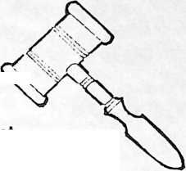

1985-1986 Champaign Rotary ©Uwb

Leonard T. Flynn, President Ken Gunji, President-Elect

J. Michael Martin, Treasurer William E. Stallman, Secretary

Donald D, Judy, Sergent-at-Arms Oscar H. Dodson, Historian

Arthur J. Skelton, Executive Secretary

Victor F. Feldman Leonard T. Flynn John T. Stier

Ken Gunji

Rolland W. Kelley

Gregory B. Lykins

Thomas D. Dawson (Ex-Officio)

Robert E. Herron

Edward E. Roderick

Richard J. Arnould



Oareetors

*Helping the Community Today  
To Prepare for Tomorrow*

FOR IMMEDIATE RELEASE

Champaign Rotary Club Donates Medical  
Equipment Locally and Around the World

The Champaign Rotary Club through its Foundation, WGRC, Incorporated, recently donated $5,000 to the Mercy Hospital Lifeline Project. The gift will be utilized to purchase twelve home communicator units which will be reserved for persons unable to pay for the service according to Leonard Flynn, President of Champaign Rotary Club and Charles Younger, Sr., President of WGRC, Inc.

Mercy Lifeline is a personal emergency response system which is used by senior citizens and the disabled to permit them to continue to live independently in their own homes. A help button worn on a pendant or wristband when pressed will signal the home communicator box to seize the telephone line to which its attached and to immediately dial Mercy Emergency Services Department. Mark A. La Brecque, administrative director of ambulatory services at Mercy Hospital suggested that "this kind of technical support can truly be life-saving in an emergency medical situation."

Champaign Rotary Club has also supported an eye clinic in Bogota, Columbia with the shipment of a used operating microscope provided by Zeiss Company in Germany. The "Club paid $2,600 for crating and shipment of the instrument which will, according to Rotarian Dr. Victor Feldman, a local opthomologist, improve eye care in that city.

Programs like the Lifeline Project in Champaign and the eye clinic are made possible by the chief fund-raising effort by Champaign Rotary Club's Action Auction. This year the Action Auction is Friday, May 30, with a goal of raising $30,000 from approximately 75 donated auction items. Aside from the grant to Mercy Lifeline, proceeds from this year's Auction will fund specific projects for the Developmental Services Center, Salvation Army and the Arrowhead Council of B.S.A. Previous Action Auctions have enabled Champaign Rotary Club to accomplish many community projects, the most visible being Rotary Hill Pavilion at Lake of the Woods Park and the Fitness Trail at Centennial Park.

For additional information call Calvin L. Owens at 333-1362.

The Auction is the Action

The spectacular Action Auction: immediately following dinner  
® All items valued $100.00 and more

° Door prizes

® Cash bar all evening

All proceeds go to the WGRC Foundation for Rotary spon-  
sored and tax deductible community service projects.

A Sampling of Items to be Auctioned

I

FOyfcg ©, ta®,

1986 Buick Drive a new car for a week-up to 500 miles. Wouldn't you really rather have this one?

Balloon Ride Wouldn't you like to ride in the donor's beautiful balloon? Cruise the clouds in a real flying tomato.

Garber’s Modern Cleaners

n □

A Japanese Experience Treat your party of six to a Japanese dinner prepared exclusively for you. After the meal enjoy a formal Japanese ceremony at Japan House.

Air Travel Your own Piper Aerostar twin engine plane with professional pilot, for 300 miles of round trip, luxury. Take a trip without worrying about traffic or meeting airline schedules.

Ski Lodge Retreat use of a three-bedroom, two- bath condo at Schuss Moun­tain in Mancelona, Michigan from January 30 to February 6,1987. Plenty of time to get in shape for this one.

IBM Personal Typewriter  
Let IBM's latest technology  
help you with your typing. This  
machine with the newest of  
features is portable and  
durable.

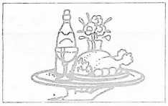

Gamblin’ Garbers

Garbers Cleaners is willing to gamble with your cleaning bill. Throw the dice and multiply the total by 30 and that's how much dry cleaning you can claim. All by the the roll of the dice.

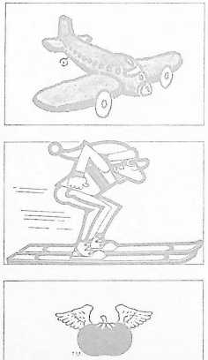

Lawn Trimmer Keep the edges trimmed with minimum effort and do it standing up with the Lawn Boy, gasoline- powered string lawn trimmer. If makes yard work seem almost like a party.

A Bus Ride-for 46 Take your closest friends on a one day trip anywhere for a maximum of 300 miles round trip. Great for a tail gate Maybe a Cubs game?

Mercy, Mercy, Mercy-  
Hospital, that is, offers 17 Diag-  
nostic Profiles including CBC  
screen, urinalysis macro and  
chemistry. Find out just how

healthy you are.

Mercy Hospital

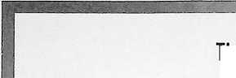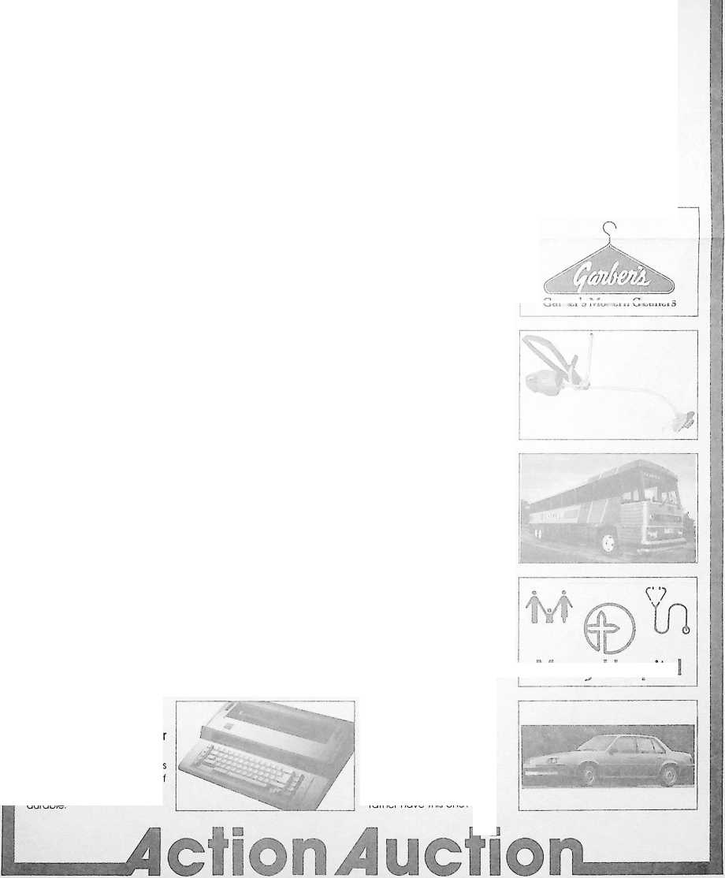

986L '08 AoiAl • J©|u©q uoijueAijoo JO||©ouoqQ

©ill 40

puo

j©uuip w©u©q

uoijopunoj. 0£J9/v\ p©josuodg

qn|Q Ajojo^j uSioduuoqo ©qj 04

pejiAUi A||oipjoo ©jo noA



!

Return the handy envelope for tickets to

Jetion Juction



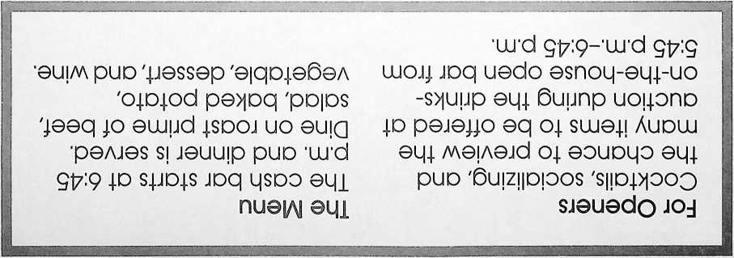

WGRC, INC.

ACTION AUCTION ’86

□ Yes, I will be on hand for the dinner and Action Auction on May 30,1986 at the Chancellor Convention Center.

□ Please reserve a table for 8 persons (a 21.00/person.

Their names are:

Please Make Your Reservation No Later Than May 16,1986

□ Check(s)for$

is/are enclosed.

Make Checks to WGRC, Inc.

□ Send tickets to:

□ Sorry, I cannot attend, but I enclose a tax deductible contribution.

PLACE

STAMP

HERE

Mr. Harold W. Paulson

# 3 Henson Place Champaign, IL 61820