PLAYBihL

**WGRC Inc., the Charitable Foundation of the Champaign Rotary Club**

Presents

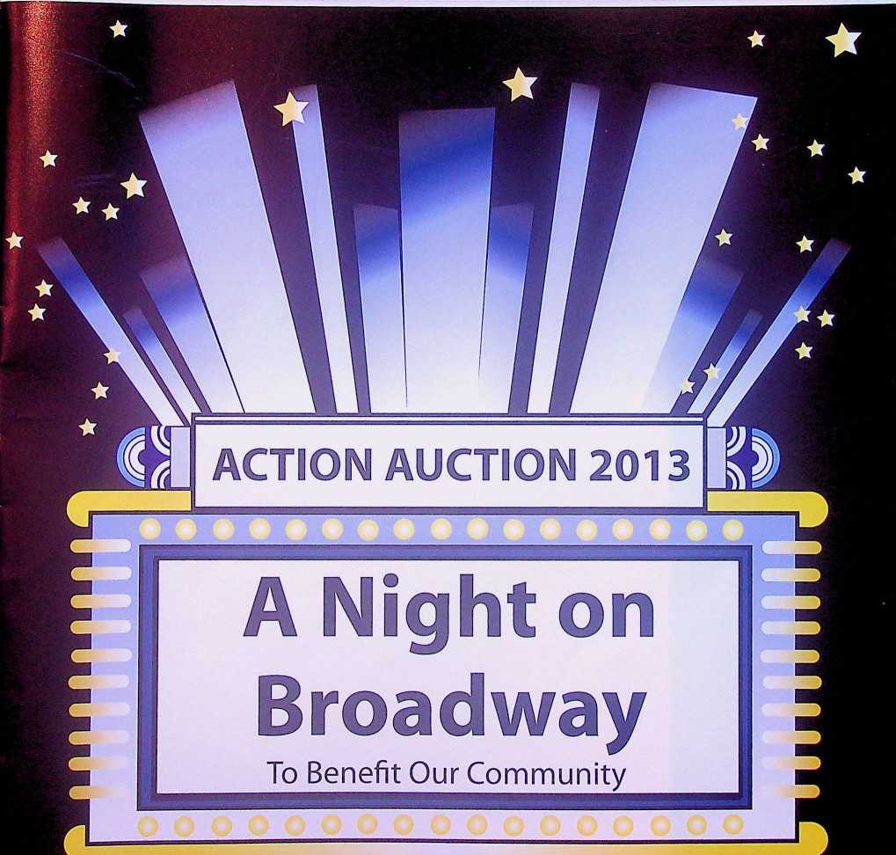

WGRC, Inc.

***Presents***

The Champaign Rotary Club

ACTION AUCTION 2013

Saturday, June 1,2013  
Krannert Center for the Performing Arts  
Great Hall

University of Illinois

5:00 pm Cash Bar 6:30 pm Dinner 7:30 pm Auction

SPONSORS

*GOLD*

*The News-Gazette including WDWS, WHMS, and WKIO radio*

(The News-Gazette

**Carle** *Carle*

*Horizon Hobby, Inc.*

**H 13 B Y**

*BRONZE*

*Harrington & Tock LLC* harrington&tockllc

*Verdant Partners LLC* VERDANT

***AUCTION SPONSORS***

*Busey*

*Hickory River Smokehouse*

*Kemper CPA Group  
Ted and Claudette Gonsiorowski*

*Wells Fargo Advisors - Jerry Laughlin and Scott Moe*

*DNDC Telephone Co.  
Meyer Capel Law Firm  
Foth Engineering*

*Mark Thies, Financial Advisor, Edward Jones  
Martin Hood Friese& Associates  
Premier Print Group*

Message From the President

Welcome Members and Guests:

Thank you for choosing to spend this evening with us. We are glad that you are here for our tri-annual Action Auction. This evening of fun, entertainment and camaraderie will "live on" for years, since all funds raised tonight are devoted to community projects that benefit the citizens of Champaign County for the next three years.

Our goal is to raise $100,000. Past Auction funds have supported the following community programs: The Boy Scouts and Girl Scouts, Cunningham Children's Home, Developmental Services Center, Don Moyer Boys and Girls Club, Eastern Illinois Food Bank, Salt and Light, CASA, Frances Nelson Health Center, Habitat for Humanity, and more.

We have supported educational needs in the community: Parkland College Scholarships, Central, Centennial, and Judah Christian High School Student Recognition, Jefferson Middle School Essay Contest Awards, Bottenfield School Smart Boards, Southside School piano, Read Across America, and the Garden Hills Literacy Project to name a few.

We have also supported local parks: The Skelton Park, Ka-Boom Project for new playground equipment at Hazel Park, and a First String Batting Cage for Martin Luther King Park.

These agencies need our support more than ever and we need you to continue to make our community the vital and dynamic place that it is. Please reach deep in your hearts and your wallet and outbid your friends tonight in the spirit of caring and giving.

I want to thank the Action Auction Team of The Rotary Club of Champaign. Under the outstanding leadership of Dean Cavey and Dan Wheatman, the team has worked for over a year to make this event happen. Much time, commitment, and effort has been involved. I am grateful for such outstanding Rotarians.

Ultimately, I thank you for your generous and selfless support this evening. Enjoy the evening and thankyou.

The best,

Fay Rouseff-Baker

President, 2012-2013

HOW TO BE A

Rotary Action  
Auction Professional

**PREPARING FOR THE AUCTION**

1. This is the catalog for the 2013 Rotary Action Auction. The difference between action and auction is **"U."**
2. Now is the time to form your buying/bidding syndicate. You can combine resources and gain buying power. Nice things happen to those who overbid!
3. Bring extra cash to the auction to buy raffle tickets.Tickets for the grand prize drawing will also be on sale the night of the auction. There are three grand prizes!
4. Don't forget to bring this catalog with you. It will allow you to follow the Auction and help record your bid price.

**The Night on Broadway begins in Krannert Center Great Hall with entertainment and cash bar at 5:00 pm on Saturday, June 1,2013. Be on time as you'll want to see your friends, preview silent auction items, and have plenty of time to stuff the raffle boxes.**

1. Your first stop upon arrival is the reception desk (north end). Here you receive your bid number and the location of your reserved table.
2. Now find your table, get something to drink, meet your friends, and enjoy the social time. The cash bar opens at 5:00 pm. Don't forget to select your raffle items and preview the silent auction items on display.
3. Dinner will be served promptly at 6:30 pm. Enjoy your fabulous meal.
4. Please refer to the rules and procedures of the Action Auction.
5. You are encouraged to pay for your successful bid (cash, check, Visa, or Mastercard) throughout the auction. Cashiers and their runners will be available to assist you throughout the auction. Of course, you may wait and pay for all your winning bids at the end of the auction. **Please pay before departure.**
6. You are requested to remove physical items after the auction or make arrangements with Scott and Donna Anderson.

page 2

Pick Your Prize Raffle

1. Each raffle item has a box for raffle tickets just for that item. You may place as many raffle tickets in each box as you like.
2. To have a chance at each item you must buy at least one ticket for each item. Obviously the more

tickets you put in each box the greater your odds of winning.

1. The raffle tickets are numbered and come in pairs. You keep one half of the pair (your claim ticket) and place the other half (same number) in the box of your choice. **DO NOT PUT BOTH HALVES IN A BOX OR IN DIFFERENT BOXES. YOUR CLAIM TICKET IS THE ONLY WAY TO IDENTIFY YOU AS THE WINNER.**
2. The claim ticket must be presented immediately to win. You may allow someone else to hold your tickets if you have to depart for any reason. If no one has the matching ticket, another ticket will be drawn until there is a winner.
3. Any raffle item which is opened and does not contain any tickets will be auctioned to the highest bidder.
4. **Raffle tickets are $20.00 for 10 tickets or $5.00 for one.**

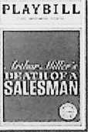

PLAYBILL

o BAREFoat • --park





PLAYBILL

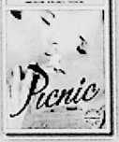

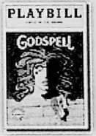

PLAYBILL

©

**Annie**

Summary

Any questions can be answered by Dean Cavey or Dan Wheatman, Co-Chairs of the Action Auction. Rotary hopes these instructions help you prepare for the auction, have a good time, and remember **YOU make the difference at Action Auction.** Please bid generously.

page 3

Rules and Procedures  
Action Auction 2013

1. The Action Auction will begin immediately following the dinner hour and continue until all items are sold.
2. All buyers will be assigned a buyer number. Please show your buyer number when bidding to assist the Auctioneers and Spotters in properly identifying you as a bidder.
3. Payment can be made by the successful bidder immediately following the auction of the item. A committee member will bring a purchase receipt to each successful bidder for their signature. Please settle up with the cashier prior to leaving the Auction.
4. Payment can be made by cash, check, Visa, or Mastercard. All checks should be made payable to WGRC, Inc.
5. Values set forth for items being auctioned, raffled, or given as prizes are estimates of general value.
6. All sales are final and there will be no exchanges or refunds except as specified by the donor. All auction items and services must be used within one year from the auction night, June 1,2014, unless otherwise agreed upon by the donor and the purchaser. Trip items should be confirmed by the purchaser within 30 days of auction night. Special instructions pertaining to some items may be indicated on the purchase receipt. Please read your purchase carefully and completely.

PLAYBILL



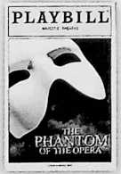

PLAYBILL



the [ion King



PLAYBILL PLAYBILL



page 4

Menu

Mixed Field Lreens Salad with  
Apple, Candied Nuts * Pried Cherries  
with White balsamic Vinaigrette

Pumpernickel with Solden Paisms, Three-  
Cheese Semolina bread, and Vinner Polls

Petite Filet with Cabernet Pemi-glace  
and

Peli-Spiced Salmon with Lemon-Pill butter  
with Lotham Sreen Whipped Potatoes and  
Seasonal, Local Poasfed Vegetables

Pesserts Served Alternating

Wicked Park Chocolate Marquise  
with Mango Coulis and Paspberries  
ioftee bottom big Apple Cheesecake  
with Calvados Anglaise

Vegetarian Option Available Upon bequest

page 5

Grand Prize Drawings!

The drawings for the grand prizes will take place following the last auction item. You need not be present to win. Just be sure your name and address are placed on any Grand Prize ticket you purchase the night of the auction.

• • • z

**Grand Prize**

r

A luxury Caribbean vacation for four persons to the Verandah Resort and Spa in Antigua. Seven nights of luxurious accommodations at this 4-star Caribbean beachfront resort. There are two rooms, each for two person. Includes airfare for four. Certificates are subject to a required supplement of $110-$125 per person, per day for an all-inclusive experience: dining, beverages, resort activities, service charges, and taxes.

*Thank you Elite island Resorts/Caribbean and WGRC, Inc.*

Second (Gramdl IPraze

Broadway in Chicago trip including theatre tickets for four persons, two night accommodations in a private condominium, and one dinner for four at a leading Chicago restaurant.

*Thank you Tai Et Donna Raine and WGRC, Inc.*

Third Grand Prize

$500 cash

page 6

LIVE AUCTION ITEMS

1. Spruced Up For a Year

You will be ready for the day with one free year of shirt laundry service. This package includes laundry service for up to 4 shirts per week for 52 consecutive weeks starting June 2, 2013 through May 31, 2013.

Starcrest Cleaners

Value $510

2.

An Evening with the Mayor of Champaign

Champaign Mayor Don Gerard invites you to spend the evening and experience City Hall without

having to run for office. This "Spend the Evening with the Mayor" package includes dinner and  
attending a community appearance with the Mayor. The length of time and transportation will be

decided at time of booking.

Don Gerard

**^SILENTAUCTION^**

Don't let it getaway  
you. Bid now'

Value Priceless

3.

A Hunting You Will Go

This guided two-day duck hunt for two experienced hunters is on a lake that is the duck equivalent of  
the Dan Ryan expressway on a Friday afternoon. This adventure in Southern Illinois includes overnight  
accommodations at Kevin Sullivan's house on Lake Egypt and a delicious dinner. The hunt will take  
place on a Thursday or Friday in late December 2013 or January 2014. Arrangements are to be made  
with Kevin Sullivan.

Sullivan-Parkhill Automotive

Kevin Sullivan

Value $1,000

(

4. Dancing with the Stars

Check out the universe in the second largest planetarium in Illinois! The Carl Zeiss Ml015 star projector at the Staerkel Planetarium puts you and up to 128 people beneath 7,600 stars and the visible planets. In addition to the one hour eye-popping parade of stars show, you also receive $500 for food and beverages to host a reception in the lobby.The new Digistar 4 digital projection system will immerse you and your friends in fulldome video. The planetarium event will be scheduled at least three weeks in advance.

William M. Staerkel Planetarium at Parkland College  
David Leake

Value $800



page 7

5. Stand Tall

You will have to stand tall when you spend the day with State Senator Mike Frerichs on a session day in Springfield. You will get a tour of the capital building, an inside look at how Illinois laws are made, and enjoy lunch with the Senator.

Senator Michael Frerichs

*LfX*

Value Priceless

**6.**

Abraham Lincoln Presidential Museum and Illinois State Capitol Tour

This terrific opportunity to get an up-close look at Springfield includes four tickets to the Abraham  
Lincoln Presidential Library and Museum and a guided tour of the Illinois State Capitol. Prior notice of

one week is appreciated for scheduling.

Friends of Senator Chapin Rose

***SILENT AUCTION***Don't *let it* get away  
from you. Bid now!

Value Priceless

**7.**

A Private Screening Hollywood Style

Take your seat, Mr. Scorsese. There's HD, there's DVD, and then there's having an entire movie theater to  
yourself! Invite 50 of your friends to a News-Gazette reel deal private screening on the gigantic screen  
at the Virginia Theatre. Your group will also receive free Pepsi and popcorn. The date and time must fit  
the Virginia Theatre schedule.

Champaign Park District

Bobbie Herakovich & Joe DeLuce



8. Best Tasting Water in the State

According to the Illinois Section of the American Waterworks Association, the best tasting water is right here in Champaign-Urbana and is produced by the Illinois American Water Company. We have a certificate for a non-refundable credit of $475 on a residential water service account in the Illinois America Water Champaign County District. This represents up to 4,500 gallons of water per month for twelve months.

*X Xu*

Illinois American Water Company L

Ronald L. Smith Value $475

**9. Schuss Mountain Michigan Resort - Your Escape for Skiing or Golf!**

This is your ticket for four couples to enjoy either winter or summer fun at Schuss Mountain, a great place to relax, have fun, and enjoy the great outdoors. Schuss Mountain is part of the Shanty Creek Resort just outside Mancelona, Michigan, just 50 miles south of Mackinac. This package includes seven days and seven nights commencing Friday and ending the following Friday; to be agreed upon with the donor. A beautiful four-bedroom free standing house that is absolutely ideal for four couples. This exceptional limited offer puts you in the middle of the action whether you ski or golf. You pick the season for this vacation!

Jerry Jahn Value $2,200

page 8

**110. Golf at Purdue**

Have you ever wanted to play a Pete Dye designated championship course? Or swing where both the men and women's NCAA Golf Championships were hosted? Here is your chance! Located at Purdue University, this course is a preferred choice in the Midwest. Two people will have lunch, play 18 holes, and enjoy a special pizza dinner at the most famous pizza parlor in central Indiana! Transportation, golf cart, and all related fees are covered. This item is redeemable for weekdays between June 15 and September 15, 2013 and must be arranged with the donors. ____ a

Carl Hudson Jr. & Dave Lawrence \ Value $400

\ RaffleT'cK \ /i A

ygS W

11. Historic Galena Territory Log Home '—

Just a pleasant drive west of Champaign near historic Galena, Illinois, imagine three days and three nights spent in the comfort of a four-bedroom, three-bath log home that has the year round comforts of air conditioning and central heat. This home is complete with a large great room, a recreation room with pool table and satellite TV, huge deck, screened-in porch, and outdoor fire pit. Included is access to the Galena Territory owners' amenities (green fees and horse rental not included). Availability of this opportunity for three or four couples (maximum of 10 people) is for most dates from June 12, 2013 to June 20, 2014 by mutual agreement with our gracious donors.

Tony & Joan Peressini

Value $900

12. Gourmands Fake Note

Chefs Scott Anderson and Jerry Laughlin will prepare and serve a gourmet dinner consisting of French and/or Italian dishes for ten people at your place or theirs. This meal of a lifetime begins with sumptuous hors d'oeuvres and ends with a palate-delighting dessert. Be sure to request the foie gras. The meal will have you talking food for weeks following. The successful bidder supplies the wine.

Scott & Donna Anderson and Jerome & Anne Laughlin

Value $1,200

13. Two Cottages on Beautiful **Glen Lake, Michigan**

Two of five newly-updated cottages at Brookhaven Resort on crystal clear, sapphire blue Glen Lake in the area voted "Most Beautiful Place in America" by viewers of *Good Morning America.* Gather around the shared fire pit for s'mores and spectacular sunsets overlooking Alligator Hill in the Sleeping Bear Dunes area. Canoes, kayaks, and rowboats, tennis courts, boating, fishing, and swimming - enjoy them all! Each cottage sleeps four (one queen and two twins each), full kitchen (no dishwasher), charcoal grill, and picnic table. Wifi, no TV, no phone, no worries at this peaceful location only minutes from the village of Glen Arbor. Linens provided. No air conditioning, no smoking, and, sorry, no pets. Time available: August 24-31,2013.

Brookhaven Resort

Kip and Janet Pope and Carl and Lisa Barnes Value $2,300

page 9

1. Play One of the World's Greatest Golf Courses with an Insider

This September, you and two of your golfing buddies (three total guests) could share a round of golf at the Alister Mackenzie designed Crystal Downs Country Club in Frankfort, Michigan. Green fees and cart rental are included in the package, and a member of the Crystal Downs Country Club will escort three golfers for a round of golf. Club rules provide a member must be in the foursome. The exact date in September 2013 will be at a mutually arranged convenient time based on schedules and club events.

Richard & AnneTryon

Value $1,000

1. WCIA 3 Studio - ciLiving Behind the Scenes

You and your guest will enjoy a station tour and dinner with the ciLiving's Heather Roberts, Matt Metcalf, and Joe Barlow. You will see firsthand how ciLiving comes together. You will enjoy a tour of WCIA/ciLiving studios before the 4:00 pm show. Then join Heather, Matt, and the rest of the ciLiving team for the live show. The day will wrap up with dinner at an area restaurant. Length of time: 3:00 pm

to 7:00 pm.

WCIA/CBS  
Nancy Foreman

***SILENT AUCTION****Don't let it* getaway  
from you. Bid now!

Value $400

1. Play Where the PGA Pros Play at the Innisbrook Resort and Golf Club in Tampa Bay

Voted one of the Top 10 golf destinations in Florida, Innisbrook is home to the PGATampa Bay Championship played every March during the PGA's Florida swing. Luke Donald and Jim Furyk are recent winners. The resort has four magnificent golf courses, 11 lit tennis courts, a water park with slides and a sand beach for the entire family, five pools, and three clubhouses all with dining facilities. It has recently added a first-class fitness center and a state-of-the-art spa for special pampering. You and your friends or family can enjoy the 1,000 acre resort as a guest of owner with a four-night stay in a luxurious three-bedroom condominium. This package is available most anytime for free use of the condominium from June 1 to December 15, 2013. We have added a special bonus to this year's offering. Four VIP 18-hole golf passes are part of the package. Each saves you $200+ greens fee to play at the famed Copperhead course or any of the other three courses for just the cost of a member's cart fee. It will make your visit to one of the country's leading resorts that much more memorable. Enjoy.

\ LzjoU

Bud & Sandy Leister Value $2,600

1. WCIA 3 Studio - ciLiving Appearance Package

You will receive a four-minute LIVE segment on ciLiving with up to three guests. Your business will be featured as a contributor. You will have the opportunity to showcase your product in studio. WCIA 3 will work with you to prepare for your segment that best serves your business.

WCIA/CBS

Nancy Foreman

PLAYBILL



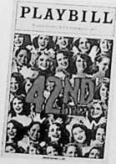

Value $500

page 10

18. Catered Dinner with the Coach

Enjoy cocktails and a catered dinner for 12 people with new lllini basketball coach John Groce and his wife Allison at the home of Dean & Susan Cavey. The catered dinner will be co-hosted by Bill & Jill Hobbs and will be at a date agreeable to Coach Groce, the hosts, and the buyers.

Dean & Susan Cavey and Bill & Jill Hobbs

Value $2,000

19. Play a Round of Golf at the Location of the 2007 U.S. Open

You and two guests will enjoy one of Chicagoland's premier golf courses with fellow Rotarian Greg Cozad. Olympia Fields has hosted the U.S. Open Championship, the U.S. Senior Open Championship, the PGA Championship, and will host the U.S. Amateur Championship in 2015. This course provides a picturesque and challenging layout with plenty of water, sand, and lush fairways. Lunch and dinner are included. —\ / /X)

Cozad Asset Management Greg Cozad

GetYour \

Turned in )

I Before  
\ Xd —

Value $1,000

20. An Indianapolis **500 Trip to Remember**

Gentlemen and Ladies, start your imaginative engines! Picture yourselves in the best seats on the house  
at the 2014 Indianapolis 500. Open your checkbook to a once in a lifetime experience of four Penthouse  
seats high above the Start/Finish line. Come early as you'll have a birds eye view of all the famous  
pre-race traditions. Then hold your breath as 33 cars take the green flag and charge past you into the  
heart-stopping excitement of the first turn. Watch the wheel-to-wheel racing down the straightaway  
and constant action in Pit Row. Finally, see the winner wheel into "Victory Lane" for the post-race  
ceremonies. All this is yours *plus* transportation to and from the track, and a late lunch or early cocktails  
and dinner at the famous Beef House in Covington, Indiana. , \

Terry O'Neill

Value $1,500

21. Time to Get Fit **at the Stephens Family YMCA**

The successful bidder receives two one-year family memberships to the new, beautiful Stephens Family  
YMCA. One membership may be used by the winner while the other membership is to be donated to

the YMCA's program, "Strong Kids Scholarship.'

Stephens Family YMCA Mark Johnson



Value $1,956

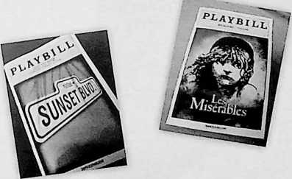



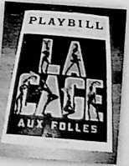

page 1J

1. Elegant Celebratory Tent Party

You name the celebration - anniversary, rehearsal dinner, special birthday, family reunion - and bring 20 of closest friends and family. Chef Adam will plan a special menu with wine and champagne. Entertainment appropriate to the occasion will be included. Your tent party may include white tablecloths, candles and flowers or croquet, horseshoes and barbeque - your choice! Date, time and activities to be negotiated with preferred dates between July and early October.

Marilynn Davis & Chef Adam Malone Value$1,500

1. Real-World Solutions to On-the-Job Challenges

Dale CarnegieTraining has over six million graduates from thousands of companies worldwide.

Successful bidder will receive one enrollment in choice of public courses offered in East Central Illinois  
including: The Dale Carnegie Course, Leadership Training for Managers, Sales Success, or High Impact  
Presentations.

Dale Carnegie Training  
Sandy Pistole

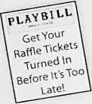

Value $1,650

1. Autumn Day in the Woods

Spend an afternoon and evening at Fay's home situated on 10 wooded acres in Urbana strolling the woods and meadow; enjoying cocktails by the fire; and relaxing with licensed massage therapists. This dinner party for six includes a menu designed by you. Sip cocktails and wine while a gourmet dinner is prepared for you.

Fay Rouseff-Baker & Connie Glazik-Pierce Value $800

1. Relax in Marbella

Located in Ft. Myers, Florida this three bedroom, two bath condo is at Marbella on Cypress Condo Community. Located near the airport, golf, beach and a six mile cypress preserve, the condo is close to the clubhouse with fitness center, movie room, pool, and hot tub. Successful bidder will stay for a week and pick a date of June 30-July 6; August 4-10; November 24-30; December 15-21; December 22-28; or December 29-January 4.

Susie, Todd & Spencer Atkins Value $1,600

1. Ultimate Sports Basket

Cheer on your favorite team as you travel to Chicago with four tickets to the University of Illinois men's 2013 basketball game at the United Center. This fantastic package includes a $300 Visa Gift Card for spending money, a $100 Gameday Spirit Gift Card to pick up some lllini orange, a Busey lllini hat, four Busey/lllini drinking glasses, two RuMe Cuffs, and one Toddy Cloth.

Busey Value $1,000

page 12



1. Mobile App Development StrategyWorkshop

Do you have a business that needs a mobile app, but you don't know where to start? The answer can be yours with the winning bid. This package includes a one-day Mobile App Development Strategy Workshop that will be conducted at your place of business or a mutually agreeable location for up to five of your staff. Workshops are interactive so be prepared to work together and think outside the box. You will receive a strategic recommendation 1 -2 weeks following the workshop. Included will be the results of the workshop, walking skeleton of your minimal viable product and release implementation plan. Minimum bid $600.

004Technologies USA, Inc.

Patrick MacKay j °n t let it get away I Value $1,500

Vrom y°u- Bid nowi *J*

1. Chicago Blackhawks Game

The winner of this item will have a once-in-a-lifetime opportunity for a special night on, well near, the ice! Includes two tickets to a Chicago Blackhawks game during the 2013-2014 season, parking in the players lot, and access to the Sonja Henie Room (owners lounge) for free drinks before, during, and after the game. Your car will be started and running when you exit the stadium after the game! Will coordinate with buyer to schedule the game.

The Downey Group, Inc.

Jay Downey



$500

1. Gourmet Dinner

Dinner will be prepared and served for up to 10 people at one of the donor's homes or the home of the successful bidder. This fabulous gourmet dinner will consist of French, Italian and/or Asian dishes. The evening also includes hors d'oeuvres with successful bidder providing the wine. Comedic comments optional!

Scott & Donna Anderson and Tom & Rose Costello

Value $1,200

1. Lunch with Robert Easter

This luncheon for four with University of Illinois President Robert Easter will take place at a time and place to be arranged based on President Easter's and guests'availability.

President Robert (Bob) Easter

Value Priceless

GS/O

1. Comprehensive Landscape Design

This is the perfect time of the year to spruce up the outside with a comprehensive landscape design for your home or small business. This package includes interview, site survey, measuring and scale drawing with all materials and plants listed. Also included is the planting of one 2 V?" caliper tree (12' approximately).

Ludwig Bros. Landscaping

Value $1,250

page 13

1. Cruising Down the Road in a Model T

Looking for a unique vehicle to ride in for a wedding or family reunion; giving rides at your next company picnic; or maybe just looking for a fun ride? The winning bid provides for six hour use of a 1923 Model T Ford Depot Hack (open air bus/taxi) with driver. Date and time to be arranged with owner/driver, and the event must be during dry weather as this fantastic vehicle is open air.

*(may auction twice if bids are high enough)*

Bill Malone

Value $750

1. Lunch Phyllis M. Wise

This lunch for six with University of Illinois Chancellor Phyllis M. Wise will be a time and place to be arranged based on Chancellor Wise's and guests'availability.

Chancellor Phyllis M. Wise

Value Priceless

1. Champagne Reception at the Theatre

Impress your friends with a backstage tour of the restored Virginia Theatre and a champagne reception on stage. Up to 10 people can enjoy a tour that includes high parts and organ chamber, all behind the scenes areas and a "tonal tour" of the Wurlitzer Organ. The champagne reception on stage is accompanied by a 30-minute concert on the Wurlitzer organ.

Buzard Pipe Orqan Builders \ „ ,r \

3 \ Get Tour l

John Paul Buzard I Ra^eTickets \ Value $500

\ Turned In I  
\ Before It's Too f

1. A Night to Remember at the Kalahari Resorts 1—3^ 1

Step outside your typical waterpark vacation and experience the ultimate waterpark adventure. The IndoorTheme Park features over 100,000 square feet of family fun and excitement. Take a ride on the six-story Ferris wheel, challenge yourself to the ropes course or climbing walls or blast your way through a game of laser tag. This package includes a one night stay in a Desert Room for four guests; IndoorTheme Park Passes; and a gift certificate for a waterpark party for 10 guests on your next visit to the Kalahari Resort.

Kalahari Resorts

Value $680

1. Fore! Get Your Foursome Together and Pack Your Clubs!

Trip to Point O'Woods Golf and Country Club.Trip includes two-night stay at the Point Cottage located inside the grounds of Point O'Woods. The cottage has four-bedrooms each with a private bath and was fully amenitized and completely remodeled in 2012. The Point is a three- hour drive with great nearby restaurants and is only 15 minutes from Lake Michigan.The trip includes two midweek night's lodging. Does not include greens fees, meals, or cart use.

Dave Barr

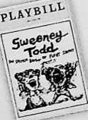



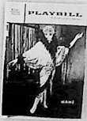

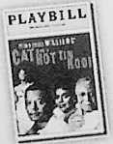

Value $1,800

page 14

1. Time for Personal Training (2 items at $465 each)

Receive the motivation you need to succeed, improve your overall fitness, reach or maintain healthy weight, exercise correctly, gain muscle mass, develop strength, or focus on your unique health concerns. This is your opportunity to work with a personal trainer who will help you reach your goal with your very own personalized program. Winning bidder will receive ten 45-minute personal training sessions at the Mettler Center in Champaign.

Elizabeth & David Krchak Value $465

1. A Better, Fitter You! One-Year Membership at The Mettler Center at the Crossing

The Mettler Center understands that Whole Life Fitness isn't just a personal philosophy - it's a way of life. Mettler offers more than a traditional gym. This full-use membership for one person includes complete use of the fitness center, orientation sessions, unlimited group fitness classes (excluding fee­based classes), and other services. This one-year membership starts from the date of presentment and must be presented by March 31,2014.

Elizabeth & David Krchak

Value $584

1. A Day with Lmcolln **(2 packages available with minimum $300 bid)**

Spend some time in Springfield with this package that provides overnight accommodations for two at the downtown Springfield Hilton; dinner for two (up to $150) at a private dining club, the Sangamo Club; and two tickets to the Abraham Lincoln Presidential Library and Museum. After your overnight stay, you may visit the Lincoln National Historic Site, State Capital or the Dana-Thomas House designee by Frank Lloyd Wright. Date must be coordinated two weeks in advance and used by October 1,2013. Starting bid $200.

Stanley & Elizabeth Herrin Value $400

1. Dessert All Year Long

Enjoy a homemade pie each month for the next twelve months. Or double up and get 2 or 3 pies at a time for a total of 12 pies. The choice is up to you! You choose the kind of pie and when you want it.

Debby Malone Value $360

1. Listen! You Can Enjoy **a Season at the Symphony**

The music and the atmosphere are absolutely beautiful. This package includes four season tickets to the 2013-2014 Champaign-Urbana Symphony Orchestra; a "Pictures at the Exhibit" DVD; a Champaign- Urbana Symphony Orchestra CD entitled, "Favorites & Carmina Burana"; and a Champaign-Urbana Symphony Orchestra Guild coverlet.

Champaign-Urbana Symphony Orchestra Value $700

page 15



1. Not Your Mother's Needlepoint

This romantic style needlepoint is 16"x 2O''and is a portion of a French tapestry that depicts two French noblewomen exchanging a quilt. In the background are symbols of the French aristocracy. The original hangs in the Cluny Museum in Paris.

Rick & Mary Ann Snyder Value $750

1. Evening with Hors d'oeuvres

You and up to 25 people can enjoy hors d'oeuvres at your home. Date, time and menu are negotiable.

Ed & Margaret Krol Value $400

1. Fighting lllini Home Football Game

Enjoy two Colonnade Section tickets to a University of Illinois Fighting lllini game. One of the seven home football games in the 2013 season to be determined by mutual agreement.

Carl Meyer

Value $1,000

1. Your Own Twin City Open: Golf at Champaign CC, Lincolnshire CC, Stone Creek Golf

Club, and Urbana CC

Your own version of the Pebble Beach Pro-Am as you and three guests (your very own foursome!) have the opportunity of playing 18 holes (golf cart included) at Champaign Country Club, Lincolnshire Country Club, Stone Creek Golf Club, and Urbana Country Club. Includes one hour of golf lessons from each pro.

Area Golf Courses

Value $1,400

**PLAYBILL**

Get Your  
Raffle Tickets

Turned In  
Before It's Too  
Late!

Value $1,500

1. Lodging for One Week at a Wyndham Vacation Time Share Property in the  
   United States, Canada, or Mexico during 2014

Over 75 locations from which to choose. Size of unit (one-four bedrooms or hotel room) based on  
resort location, season of travel, and availability at time of booking which can be done up to ten

months in advance. Maximum Wyndham points to use: 300,000.

Chet Alwes and Maryls Scarbrough

1. You and 200 Friends Living High on the Hog

Sounds like a country and western song but "life doesn't get any better than this." Our Rotarian donors have teamed up to cook a recipe for fun and good times with this hog roast BBQ for up to 200 people. The mouth-watering menu includes roast pig, baked beans, salads, sweet corn (in season), desserts, and you can wash it all down with ice cold beer, wine, and sodas. Entertainment for two hours from Diva and the Dude. The availability of this party will be determined at a mutually acceptable time and place with the donors. A great business party, a fun block party or one heck of a BBQ is just a bid away.

Kay Machula, Tom Costello, Zach Wetherell, Fay Rouseff-Baker, Bethany Hearn,  
Marvin Lacy, David Hood, Marjorie Williams, Jeff Livesay, Dan Wheatman

Value $2,500

page 16

48. Wine and Appetizer Reception at CityView

Don't miss an opportunity to spend an evening of cocktails and dancing with 74 of your closest friends at Illinois Terminal. This downtown Champaign banquet center has spacious windows offering great views of the city and university. Includes wine, beer, and hors d'oeuvres.

Dish Catering and lllinoisTerminal

Value $1,500

49. New York, New York

Imagine enjoying a play in New York City! This package includes four tickets to "Phantom of the Opera" on a date to be chosen by winning bidder and backstage passes to meet the cast.

Elizabeth Buckley

Value $700

50. Elegant Candlelight Dinner for Eight

Experience delectable cuisine in a romantic setting for you and your guests. Includes hors d'oeuvres and cocktails, wine, salad course and dessert with after dinner drinks and coffee. An agreed upon date before September 1,2013 at the home of Winifred and Don Moyer, 2102 Sugarbush Lane, Champaign.

Don Moyer and Marilyn Whitaker

Value $800

51. Ritz Carlton Weekend

Head to St. Louis or Chicago for a weekend to remember! This $1,000 gift card will cover two nights in a

luxury room, parking, and breakfast for two. Enjoy!

Marine Bank

52. PANAMA, LOS ESTABLOS **BOUTIQUE INN**

**PLAYBILL**

Get Your  
Raffle Tickets

Turned In  
Before It's Too  
Late!

Value $1,000

Up to three rooms, five nights. More information available the night of the Action Auction!

Mark Ballard

Value $2,700

53. TORTOLA, LONG BEACH **BAY BEACH RESORT & VILLAS**

Two rooms, five nights. Includes rental car and catamaran day sail. More information available the night of the Action Auction!

Mark Ballard

Value $2,000

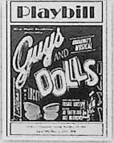







PLAYBILL .



*Announcements the night of the auction may modify auction item descriptions.*

page 17

THANK YOU!

Acheson, Jim

Ady, John Allen, Louise Alwes, Chet

Anderson, Scott & Donna

Atkins, Spencer, Todd & Susie Ayers, Steve

Bahr, Jan

Barnes, Carl & Lisa Barr, Dave

Blakeman, TJ.

Boigk, Herta Brockway, Jane

Buckley, Elizabeth

Busey

Bussell, Eric

Buzard, John Paul

Calderon, John & Sandra Carle Foundation

Carter, Donna

Carter, Steve

Cavey, Dean & Susan Champaign Park District Cornell, Jef

Costello, Tom & Rose

Cozad, Greg

Champaign-Urbana Symphony Orchestra

C-U Theatre Company Davis, Marilynne

Dish Catering

Developmental Services Center DNCD Telephone Co.

Downey, Jay Duitsman, Lisa

Easter, President Robert Feldman, Victor

Foley, Richard & Jo Foreman, Nancy Foth Engineering Frerichs, Michael Gerard, Don Glass FX

**DONORS**

Glazik-Pierce, Connie Gonsiorowski, Ted & Claudette Hall, Guy & Anne

Harrington &Tock

Hearn, Bethany

Herrin, Stanley & Elizabeth

Hilton Garden Inn

Hobbs, Bill & Jill

Hood, David

Horizon Hobby

Hickory River Smokehouse

Hudson, Carl

Illinois Terminal

Jahn, Jerry

Johnson, Mark

Kalahari Resorts

Kemper CPA Group

Krchak, Elizabeth & David

Krol, Ed & Margaret

Lacy, Marvin

Laughlin, Jerome & Anne

Lawrence, Dave

Leake, David

Lehmann, Martha

Leister, Bud & Sandy

Livesay, Jeff

Lopeman, Nancy

Ludwig Bros. Landscaping

Luedtke, Eric

Machula, Kay

MacKay, Patrick

Malone, Bill

Malone, Chef Adam

Malone, Debby

Marine Bank

Martin Hood Friese & Associates

Martin, Nancy

Meyer Capel Law Firm

Meyer, Carl

Morrissey, Dale

Moyer, Don

News-Gazette

Olsen, Bradley

Olson, Lance O'Neill, Terry

Parkland College Peressini, Tony & Joan Pistole, Sandy Pope, Kip & Janet Premier Print Group Rose, Chapin Rouseff-Baker, Fay Scarbrough, Marlys Smith, Ronald

Snyder, Rick & Mary Ann Spritz Jewelers Stallman, Bill

Starcrest Cleaners Stephens Family YMCA Sullivan, Kevin Taylor, Richard Thies, Mark Tomaras, Peter

Tryon, Richard & Anne Verdant Partners

WCIA3

Wells Fargo Advisors Wetherell, Zach Wheatman, Dan Whitaker, Marilyn Williams, Marjorie

Wise, Chancellor Phyllis

***Look for additional donors in our special information sheet the night of the Action Auction***

page 18

**COMMITTEE MEMBERS**

|  |  |
| --- | --- |
| **Chair**  Dean Cavey Dan Wheatman | **Spotters**  Tom Cornell Sarah Tufte |
| **Executive Committee**  Dean Cavey  Dan Wheatman  Tom Costello  Jim Acheson  Kay Machula  Carl Meyer | **Finance and Banking**  Bethany Hearn  Brady Allison  **Marketing & PR**  Amy George  Steve Main  Elizabeth Krchak |
| Acquisitions Committee  Carl Meyer  Connie Walsh | **Sponsorships**  Ken Buel Steve Carter |
| Tablies Committee  Jim Acheson  Kay Machula  Eric Bussell | **Catalog**  Tom Costello  Jan Kijowski  Savoy Rotary |
| Facilities ***8i***  Arrangements  Committee  Linda Myette  Pat Kovar  Connie Glazik-Pierce  Scott Anderson, Jr. | **Special Thanks to**  Krannert Center for the Performing  Arts  Champaign Rotary Club Volunteers  *AND All of Our Generous Donors Who*  *Make This Auction Possible* |

Raffle Committee

Jeff Lehmann

Jerry Laughlin

Have you entered the GRAND PRIZE RAFFLE?

Don't forget to check on your bids for the silent auction items!

100% of proceeds benefit OUR local community,  
so make our Night on Broadway a **BIG** success.

page 19



**2012-2013  
Champaign Rotary Ciub  
Officers**

Fay Rouseff-Baker - President  
John Calderon - President-Elect  
Bryant Evans -Treasurer  
Todd Salen - Executive Secretary

**2012-2013**

**Champaign Rotary Club  
Directors**

Connie Walsh - Membership Service  
Steve Carter - Membership Service  
Amy George - Public Relations  
Guy Hall - Service

Darcy Sementi - Service

Jeff Lehmann - Service

Dale Morrisey - Rotary Foundation  
Bill Malone - Past President

WGRC, inc.

Board of Directors

Officers

Dan Wheatman - President  
Connie Glazik-Pierce - Vice-President  
Claudette Gonsiorowski -Treasurer  
David B. White- Secretary

page 20

"Mr. Rotary"

Art Skelton

7922-2072

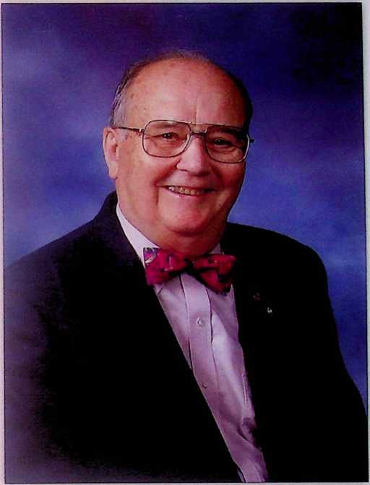

Past District Governor

Past President

Executive Secretary

Sargeant-at-Arms

OUR GOAL

$100,000

WHERE DOES THE MONEY GO?

**100% of funds raised at the Action Auction are donated to service groups and Rotary projects.**

Projects Funded and Organizations Assisted **2010-2013**

* Centennial High School Outside

Marquee

- Read Across America

■> Bottenfield School Smart Boards

* Skelton Park upgrades

° U of I Lemonade Day

* Ka-Boom Project at Hazel Park

» Parkland Scholarships

* Art Lewis Scholarships in

Education

* Carle Auditory Oral School
* Orpheum Children's Theater

Scholarship

* Shelter Box
* Center for Women in Transition

» Backpack Buddies

° Salvation Army

° Garden Hills Literacy Project

° Rotary International Water Well Projects

° Southside Elementary School

° Honor Flight for WWII Veterans

° Essay Contest Awards

• First String Little League

° Carle Expanding Children's

Hearing Opportunities

° Central High School Display Case

° Champaign Summer Youth

Employment Program

...and many more

**Item 52-53 in your book are now in the silent auction**

**Donated by Elite Vacations**

**Live Auction additions**

**53.You Are a Paul Harris Fellow!**

International recognizes the significant financial contributions ($1,000 to the Rotary Foundation) of its members by the awarding of Paul Harris Fellowships. Mark Ballard, President, BankChampaign is offering a Paul Harris Fellowship to the successful bidder. Your winning bid will help support Rotary programs!

Mark Ballard

Value $1,000

**54. $ 500.00 Gift Certificate**

$500 gift certificate from Brownes Fine Jewelry.

Valid for goods or services

Browne's Fine Jewelry Value $500.00

ss.Your contribution to Champaign Rotary

$500-$250-$100