

WGRC Inc. the Charitable Foundation  
of the Champaign Rotary Club

**Champaign Rotary Club  
“World’s Greatest Rotary Club"**



presents





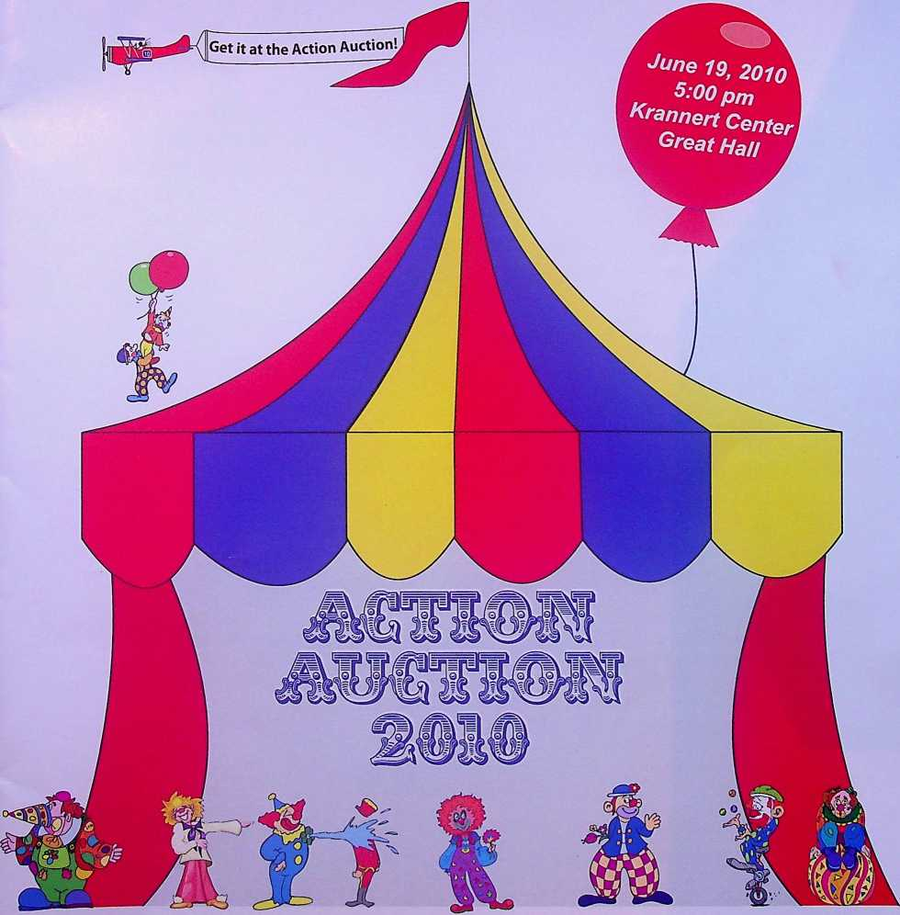

WGRC Inc.

presents

The Champaign Rotary Club



Saturday, June 19, 2010 \

Krannert Center for the Performing Arts  
Great Hall

University of Illinois

IT

5:00 pm Cash Bar 6:30 pm Dinner

7:30 pm Auction

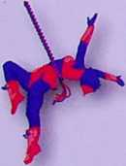

2009-2010  
Champaign Rotary Club  
Directors

2009-2010  
Champaign Rotary Club  
Officers

President  
Elizabeth Krchak

President Elect  
Robert Driver

Treasurer  
Bryant Evans  
Executive Secretary  
Chris Randles

Sergeant at Arms  
Arthur Skelton



Anh To - Membership Service  
Karla Peterson - Membership Service  
Susan Grey - Service Projects  
Todd Salen - Service Projects  
William Malone - Service Projects  
Jerry Laughlin - Rotary Foundation  
Joan Dixon - Past President



WGRC, Inc.

Board of Directors  
Officers

Pat Kovar - President  
Connie Walsh - President Elect  
David White - Treasurer  
Bill Stallman - Secretary

Connie Walsh

Jan Bahr

Steve Hamburg

Pat Kovar

Scott Anderson Jr.

Donna Greene  
Dean Cavey  
David Theis



Thank you for joining us for another special Champaign Rotary Action Auction. This evening of fun and camaraderie will actually “live on” for years, since all funds raised tonight are devoted to community projects that benefit the citizens of Champaign County over the next three years.

Our goal is to raise $125,000. Past Auction funds have supported community service programs sponsored by the Boy Scouts, Cunningham Children’s Home, Developmental Services Center, Don Moyer Boys and Girls Club, Eastern Illinois Food Bank, Frances Nelson Health Center, CASA, Habitat for Humanity and the Girl Scouts. Our Action Auctions also have enabled Champaign Rotary to support a variety of educational needs in the community such as the Booker T. Washington and Robeson schools reading programs, a Carrie Busey School audio system, a Learning for Life character development program, and Read Across America. Your support tonight will enable us to continue to make a difference in our communities.

Action Auction 2010 takes a team effort to be successful. I would like to thank our Auction Chair, Tom Costello, and his committee of Champaign Rotarians who have committed many hours to planning, organizing and staffing the Auction. But the Auction would not be possible if it were not for the generous contributions of our donor-attendees. In order to provide the necessary support to our schools, community service agencies, and public resources like our parks and libraries, we need your help. Please reach deep and outbid your friends tonight in the spirit of caring and giving that has always been the hallmark of the Action Auction.

On behalf of the membership of the Champaign Rotary Club, and of the citizens of Champaign County who benefit from the Action Auction, we thank you in advance for your support.

Sincerely,

Elizabeth Krchak

President, 2009-2010

Champaign Rotary

page 1



PREPARING FOR THE AUCTION

1. This is the catalog for the 2010 Rotary Action Auction. The difference between action and auction is “U.”
2. Now is the time to form your buying/bidding syndicate. You can combine resources and gain buying power. Nice things happen to those who overbid!
3. Bring extra cash to the auction to buy raffle tickets. Tickets for the grand prize drawing will also be on sale the night of the auction. There are three grand prizes!
4. Don’t forget to bring this catalog with you. It will allow you to follow the Auction and help record your bid price.

The evening begins Under the Big Top in Krannert Center Great Hall with entertainment and cash bar at 5:00 pm on Saturday, June 19, 2010. Be on time as you’ll want to see your friends, preview silent auction items, and have plenty of time to stuff the raffle boxes.

1. Your first stop upon arrival is the reception desk (north end). Here you receive your bid number and the location of your reserved table.
2. Now find your table, get something to drink, meet your friends, and enjoy the social time. The cash bar opens at 5:00 pm. Don’t forget to select your raffle items and preview the silent auction items on display.
3. Dinner will be served promptly at 6:30 pm. Enjoy your fabulous meal.
4. Please refer to the rules and procedures of the Action Auction.
5. You are encouraged to pay for your successful bid (cash, check, Visa, or MasterCard) throughout the auction. Cashiers and their runners will be available to assist you throughout the auction.

Of course, you may wait and pay for all your winning bids at the end of the auction. Please pay before departure.

1. You are requested to remove physical items after the auction or make arrangements with Scott and Donna Anderson.

page 2

1. Each raffle item has a box for raffle tickets just for that item. You may place as many raffle  
   tickets in each box as you like.
2. To have a chance at each item you must buy at least one ticket for each item. Obviously the  
   more tickets you put in each box the greater your odds of winning.
3. The raffle tickets are numbered and come in pairs. You keep one half of the pair (your claim  
   ticket) and place the other half (same number) in the box of your choice. DO NOT PUT  
   BOTH HALVES IN A BOX OR IN DIFFERENT BOXES. YOUR CLAIM TICKET IS THE ONLY WAY TO  
   IDENTIFY YOU AS THE WINNER.
4. The claim ticket must be presented immediately to win. You may allow someone else to hold  
   your tickets if you have to depart for any reason. If no one has the matching ticket, another  
   ticket will be drawn until there is a winner.
5. Any raffle item which is opened and does not contain any tickets will be auctioned to the  
   highest bidder.
6. Raffle tickets are $20.00 for 10 tickets.

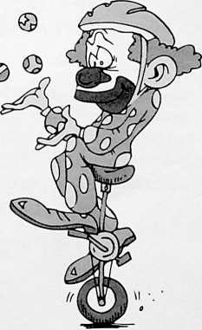



Any questions can be answered by Tom Costello, Chair of the Action Auction. Rotary hopes these instructions help you prepare for the auction, have a good time, and remember YOU make the difference at Action Auction. Please bid generously.

page 3

1. The Action Auction will begin immediately following the dinner hour and continue until all items are sold.
2. All buyers will be assigned a buyer number. Please show your buyer number when bidding to assist the Auctioneers and Spotters in properly identifying you as a bidder.
3. Payment can be made by the successful bidder immediately following the auction of the item. A committee member will bring a purchase receipt to each successful bidder for their signature. Please settle up with the cashier prior to leaving the Auction.
4. Payment can be made by cash, check, Visa, or MasterCard. All checks should be made payable to WGRC, Inc.
5. Values set forth for items being auctioned, raffled, or given as prizes are estimates of general value.
6. All sales are final and there will be no exchanges or refunds except as specified by the donor. All auction items and services must be used within one year from the auction night, June 19, 2010, unless otherwise agreed upon by the donor and the purchaser. Trip items should be confirmed by the purchaser within 30 days of auction night. Special instructions pertaining to some items may be indicated on the purchase receipt. Please read your purchase carefully and completely.

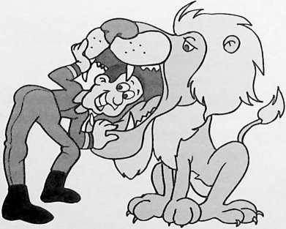

page 4



Mix^d field greens with heirloom tomato,  
fresh mozzarella, and basil vinaigrette

Parmesan rolls, sun dried tomato focaccia.

and olive-rbsemary breads

Petite filet and colossal shrimp duo with  
garlic-herb buttef

Green and white asparagus with caramelized  
shallots and Russian fingerling potatoes

White chocolate popcorn boxjdled  
with chocolate-caramel mousse and fresh  
raspberries  
of

Big Top lemon-str&wberFy bavarbis

Vegetarian option available upon request

page 5

The drawings for the grand prizes will take place following the last auction item. You need not be present to win. Just be sure your name and

address are placed on any Grand Prize ticket you purchase the night of the

auction.



JOS® FBISS

$5,000 Voucher - Cruise & Airfare with Princess Cruise Lines  
*Sponsored by Carle Foundation and Carle Clinic*



LG 50” Plasma Television

Sponsored in part by Geoff Poor Audio Video



Apple 16GB iPad with Wi-Fi









page 6



**\*1** *x ''' Pt*

I • “If I Were Mayor of Champaign for a Day, I Would...” 0 0

**£**

Now you can answer that question! Champaign Mayor Jerry Schweighart invites you to spend the day with him and make all of those top-level decisions. This “Spend the Day with the Mayor” package gives you the chance to experience City Hall without having to run for office. Imagine breakfast at Taffies, coffee at City Hall, meetings with the town fathers, and who knows Jerry may even let you cut a ribbon.

Jerry Schweighart

Value Priceless

1. A Hunting You Will Go

This guided duck hunt for two experienced hunters is on a lake that is the duck equivalent of the Dan Ryan expressway on a Friday afternoon. This adventure includes overnight accommodations and a delicious dinner. The hunt will take place in December 2010. Arrangements are to be made with Kevin Sullivan.

Sullivan Parkhill Automotive Kevin Sullivan

$3 5JW.S T-S) STD

S3S..SSSTJ

Value $400

1. lune Yourself Up: Personal Training Package from Carle Sports Medicine

Here’s your chance to make yourself, spouse, kids, or grandkids into a high performance athlete utilizing the latest techniques in sports training. This package offers basic diagnosis and intensive personalized training for a sport of your choice. The package includes 12 total sessions with a Carle Sports Medicine trainer. Go from good to great with this package!

/ SS’? \

Carle Foundation Sports Medicine / \ Value $540

/ i

**I 353**

\ SC 33 /

\ "" /

, \ unn /

1. You May Have to Answer the Alarm

You and three guests will join Champaign firefighters for lunch. You just never know what is cookin’ at the firehouse, but you know it will be good. Included with lunch is a great visit with our firefighters, which includes a tour of the fire station and an up close look at all the equipment. This is a wonderful time for boys and girls of all ages.

Champaign Firefighters Local 1260

Value Priceless

page 7

5. Dancing with the Stars

You will see any star you like as you host this star-studded gathering for 120 people at the Staerkel Planetarium. In addition to the eye-popping parade of stars, you also receive $500 for food and beverages. Have your friends join you on the red carpet. They may even invite the former planet Pluto back for a guest appearance. Date is set by mutual agreement.

Carl Meyer Parkland College

SS S’©

Value $1,200

6. A Golfing Do with Coach Lou

You can put together a threesome to join a round of golf, lunch, and refreshments at the Champaign Country Club. Talk about the Final Four, the secret of good defense, or how to sink a twenty-foot putt with legendary lllini Coach Lou Henson. Be real careful - some say Coach is a sandbagger in both golf and cards.

Carl Meyer

Parkland College Foundation

Value $500

BO 08 BO 08 BO 08 BO 08 BO 08 BO 08 08 BO 08 BO 08 JO 08 BO C8 BO CS BO 08 BO 08 BO 08 >0081 BO 08BO 08 .

7. Handcrafted Antique Fishing Creel from Lawrence Creel Company

Tod knows his dogs and he knows his fishing. This rare and unique antique is in prime condition and highly collectable. The antique wicker fishing creel is hand made with modern professional leather work. All in the Lawrence Creel Company tradition. This will be a show stopper in your home or fishing lodge! All you need to add is a creek and a few trout.

Tod Dawson

Value $800

8. Winter Fun for the Whole Family

The Champaign Ski Club will give your family a one-year membership. In addition, two people will join the rest of the club on their 2010-2011 New Year’s Ski Trip to Northern Michigan.

Jim Ayers



Value $835

page 8

9. Stand Tall

You will have to stand tall when you spend the day with Senator Mike Frerichs. You will get a tour of the capital building, an inside look at how Illinois laws are made, and take plenty of pictures with our state lawmakers. The Senator may even buy you lunch, while showing you pictures of his adorable young daughter.

Michael Frerichs

Value Priceless

■ 1 0. A South Siders Dream

These White Sox tickets are the kind you can only imagine getting. The two “scout” tickets get you so close to the game you can smell the pine tar. These are very rare and include food and beverage. With these tickets, any beef you may have with the umpire will surely be heard. A parking pass is included and lets you park right next to the gate. These tickets mean you have made it to the big show.

Atkins Group

Spencer Atkins Value $300

11 .Your Own Twin City Open: Golf at Champaign, Lincolnshire, Danville, and Urbana Country Clubs

Your own version of the Pebble Beach Pro-Am as you and three guests (your very own foursome!) have the opportunity of playing 18 holes at each of the Champaign, Urbana and Danville Country Clubs.

Area Country Clubs Value $1,000

*\*

1. A Private Screening Hollywood Style "

Take your seat, Mr. Scorsese. There’s HD, there’s DVD, and then there’s havinSan entire movie theater to yourself! invite 100 of your friends to watch a movie at a private screening on the gigantic screen at the Virginia Theatre. Your group will also receive free Pepsi and popcorn. The date and time must fit the Virginia Theatre schedule.

Champaign Park District

Bobbie Herakovich & Joe DeLuce



Value $1,000

page 9

1. Round Ball Romp! Illini vs. Mizzou Basketball Showdown in St. Louis

Join Head Coach Bruce Weber and the Illini basketball team in St. Louis with two seats to the “toughest ticket in St. Louis” for the annual Busch Braggin’ Rights Showdown between Illinois and Missouri at the Scottrade Center. This package also includes one-night lodging at the Illini team hotel. If you were any closer to the game you’d pull a hamstring!

Dana Brenner

Division of Intercollegiate Athletics

eo esc* io csboojkx# joc* iocssoc* ww io

1. Time to Shade Up

Value $500

Bill Malone and Green View Nursery will plant three, 3” caliper trees of your choice anywhere within 25 miles of Champaign-Urbana. No sore back planting these trees! While not exactly instant shade, it won’t be long before you are hanging in a hammock. Better yet, wait untill your wife is gone for a few days and show her how hard you work on the landscaping.

Green View Nursery Value $2,000

Bill Malone

/ \

/ \

*I* ti’d'isiliSXa I

I 3c-? ;

i iOiois *t*

\ 37 3S /

\ 7£>® /

\ 3»A7J8!/

1. Best Tasting Water in the State

According to the Illinois Section of the American Water Works Association, the best tasting water is right here in Champaign-Urbana and is produced by the Illinois American Water Company. We have a certificate for free water for a year usable by an existing customer of Illinois American Water Company, Eastern Division.

Illinois American Water Company

Value $475

1. Wine and Appetizer Reception at CityView

Don’t miss an opportunity to spend an evening of cocktails and dancing with 74 of your closest friends at Illinois Terminal. This downtown Champaign banquet center has spacious windows offering great views of the city and university. Includes wine, beer, and hors d’oeuvres. Enjoy the musical stylings of PBS, a critically-acclaimed trio featuring Robb Patton, Jack Brighton, and Lori Simon.

Illinois Terminal Value $1,500

page 10



17. Golf Clubs

Past president, past District Governor, and expert golf club creator Frank Keck offers a terrific set of handmade irons. Frank, who has year of golf club experience, lets you improve your game while looking very good at it. Check out these clubs out at the Auction. You are going to want them in your golf aresenal.

Frank Keck

SS SWJS IT® S3®

« sa&Em'

Value $1,500

1 8. Produce Your Version of the Real Housewives of Champaign-Urbana

Prairie Production Group will provide four hours of video/audio recording and four additional hours of audio/video editing for a television commercial. A truly professional organization that is capable of providing you with a first class image. (Does not include talent or special music licensing.) Production must be used by December 31, 2010.

Prairie Production

Steve Main



Value $1,500

1 9. Travel North America with the Help of a Pro!

How about two American Airlines/American Eagle/American Connection round-trip tickets to travel anywhere in the 48 contiguous states, Canada, Mexico, Bahamas, Bermuda or the Caribbean? The package also includes $500 in travel vouchers toward hotels, transfers, tours, and other ground arrangements from Adventure Travel, Inc. Donna Anderson is ready to assist you with your travel plans as Adventure Travel is the place through which your trip must be arranged. All you need to do is pick the destination and fill in the fun!

Suzi Davis Travel

Scott & Donna Anderson Value $2,000

1. Too Much Rain? Not Enough Rain? Play the Commodity Market

The Dick Burwash Soybean Experience returns to Action Auction. The Grand Prairie Co-Op will transfer 50 bushels of soybeans to the highest bidder. You take on the cost of storage after you buy the beans and decide when to sell. This is your chance to play the commodity market as farmers do every day. No need to head to Peoria or Las Vegas - you can gamble right here at home!

Dick Burwash Value $1,000

page 11



1. Black Diamond or Par 5 Schuss Mountain, Your Escape for Skiing or Golf!

This is your ticket for four couples to enjoy either winter or summer fun at Schuss Mountain, a great place to relax, have fun, and enjoy the great outdoors. Schuss Mountain is part of the Shanty Creek Resort just outside Mancelona, Michigan, just 50 miles south of Mackinac. This package includes seven days and seven nights to be agreed upon with the donor. A beautiful four-bedroom free standing house that is ideal for four couples. This exceptional limited offer puts you in the middle of the action whether you ski or golf. You pick the season!

Jerry Jahn Value $1,800

loos toes voiMiwctftoe’jBac’WJ

1. Golf at Purdue

Have you ever wanted to play a Pete Dye designated championship course? Or swing where both the men and women’s NCAA Golf Championships were hosted? Here is your chance! Located at Purdue University, this course is a preferred choice in the Midwest. Two people will play 18 holes and enjoy a special pizza dinner afterward. Transportation, golf cart, and all related fees are covered. This item is redeemable for weekdays between July 1 and September 30, 2010 and must be arranged with the donors.

Carl Hudson Jr. & Dave Lawrence WuC'/ Value $400

1. The Top Ten Reasons to Bid High at the Action Auction

Ok, so David Letterman won’t be here tonight. Can you think of a better excuse to take off to New York than having Letterman tickets? Catch a play, get some great deli, visit MOMA ,or just enjoy a few days in the Big Apple topping it all off with watching the taping of the show. Our contact can help you pick the right day to see Dave. Aren’t the lllini playing in New York this year? We have at least ten reasons to buy these tickets.

WCIA/CBS

Russ Hamilton

Value Priceless

1. Improve Your Game and Look Good Too

With the high bid, you will receive a set of Srixon-i701 Tour Irons (wedge through 3 iron). These are Mike’s own clubs that were provided by Srixon, but never used. The clubs alone are a $1,190 value in addition to the very limited edition bag (one of two made). So you have clubs, a bag, Mike Small’s logo, and the University of Illinois “I.” With a few lessons, folks might confuse you with our very successful golf coach.

Mike Small

page 12

SS 3^3 S’®  
®ai sansm1^®SS®53 3TO3S?

Value $2,000

1. Great Golf is Only a Stones Throw Away

A Stone Creek season pass for two including cart rental. Sharpen your game or just play for fun!  
This all you can eat golf buffet can be yours with the highest bid. Play as much as you want this  
season with your season pass. Did we mention carts are included? Win this bid and you may sneak  
in nine just about any time. A season of golf for two and a cart? Now, that is a deal. Perry may even

buy an occasional hot dog.

Perry Greene

WWWC3Oi VOCtf IO OJ VO Ctf SO Cd

26. ..And They’re Off!

**TME&ST.'S  
sra**

**3T 33**

**TO®**

Value $2,000

Churchill Downs, home of the Kentucky Derby, is the place to see the great ones run. This eight person box at the Downs is located right at the finish line. Photo finish? No problem. Your seats are so good you can spot the winner with your own eyes. Don’t miss out on your opportunity to be a part of the sport of kings. (Not available for Derby Day and Breeders Cup).

Joe Lamb

Value $1,000

1. More Flexible Than a Pair of Acrobats

Choose a destination in the U.S., North America, or across the globe! Staske Timeshares are an affiliate of RCI, the largest timeshare exchange company. Choose from a list of more than 3,900 destinations, in 100 countries, for a seven-night vacation. Don’t miss out on this opportunity to cherry pick your next holiday destination.

Stefanie Pratt A

Stefanie Pratt & Associates i

Coldwell Banker Devonshire Realty L Value $1,100

1. Historic Galena Territory Log Home c

Sounds like some place from an old Mel Gibson movie, but in fact it is just a pleasant drive west of Champaign near historic Galena, Illinois. This can be the site of a perfect mini-vacation to the winning bidder. Imagine three days and three nights spent in the comfort of a four-bedroom, three- bath log home complete with a large great room, a recreation room with pool table and satellite TV, huge deck, screened-in porch, and outdoor fire pit. This log home comes with full access to the Galena Territory owners’ amenities including swimming pool, tennis courts, boat docks, and riding stables. Availability of this opportunity for a family getaway is from June 19, 2010 to June 19, 2011 by mutual agreement with our gracious donors.

Tony & Joan Peressini Value $1,000

page 13

1. Music to Stir Your Soul

Want to add a special something to your party? Poor and Thies will team up to provide an evening of great musical and vocal entertainment. You can create an evening like no other with these two very talented Rotarians.

Geoff Poor & David Thies

$600 Minimum Bid

33 S-7J3SS T® 333

A33T3333 3TO3SJS?

1. Ruff! Ruff! Dog Sitting for a Week

Show your pooch the love! Wondering who will watch the dog now that you got the bid on a terrific vacation package? No need to call a kennel or travel with Fido. We’ll provide seven days of dog sitting including four walk per day, treats, a fenced-in yard, and lots of personal attention. Dates to be scheduled based on mutual agreement with the generous donors. Limit one dog per night.

Elizabeth & David Krchak

1003500310031003 50 0350031003 50 C3 500510055

iO05tS

055O035O035O0oJ 05100510 03 &■

Value $300

OC31O031O051O031O055O

1. Stay and Go

Enjoy two tickets to an lllini basketball game against the Ul Chicago Flames. Stay overnight at the lllini team hotel, while taking in the sights and sounds of the Windy City. Go lllini!

Dana Brenner

Division of Intercollegiate Athletics

Value $350

590310031003500510031003100310035003100^5'3031003100’3; ;C31'J0JLOC JL .

1. You and 200 Friends Living High on the Hog: Pork, Beans, and Beer

Sounds like a country and western song but “life doesn’t get any better than this.” Our Rotarian donors have teamed up to cook up a recipe for fun and good times with this hog roast BBQ for up to 200 people. The mouth-watering menu includes roast pig, baked beans, salads, sweet corn (in season), desserts, and you can wash it all down with ice cold beer, wine, and sodas. The availability of this party will be determined at a mutually acceptable time and place with the donors. A great business party, a fun block party or one heck of a BBQ is just a bid away.

Bob Aldridge, Kay Machula, Arnie Smith, Fay Rouseff-Baker, & Guy Hall Value $2,000

page 14

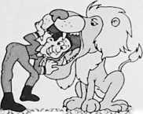

33. Ski/Golf in Beaver Creek

Six night use of a two-bedroom, three-bath condo in the Beaver Creek area of Colorado to be arranged with the generous donors. Sleeps four in two bedrooms (or six using the sofabed). You will be within walking distance of a ski lift or in the spring you can golf. In April, some folks ski in the morning and golf in the afternoon! In the summer, golf, fly fishing, and the Vail Music Festival are a must. In the fall, you can watch the aspen leaves change. The offer is for use of the condo. Recreational opportunities are available, but not included.

Marjorie Williams & Don Caspar $1,000 Minimum Bid, Value $2,200

34. Vacation Awaits

This Lakeland, Florida condo is located at the Grassland Country Club. The condo sleeps six and is located 45 minutes from Tampa and Orlando. Your one-week stay can be scheduled between May and November. Country Club privileges can be arranged, so plan on some great golfing or take advantage of the many Florida attractions within easy driving distance.

Rolland and Martha Kelley Value $1,200

35. Buon Appetito



Have a family event coming up? Need to impress some clients? Is it your turn to host a dinner party? Invite up to eight to enjoy a fabulous dining experience. A multi-course dinner will be served to your guests with an appropriate wine to complement each course. The author enjoyed such a meal and gave it five stars. Reservations required at least four weeks in advance, limited to Sunday or Monday availability, and not valid during December.

Biaggi’s

Value $800

1. Rocky Mountain High /

A one-week stay at the magnificent Meadow Ridge Resort in Fraser, Colorado. This exceptional, fully-equipped two-bath condo can sleep six in three-bedrooms and comes with full resort privileges. Enjoy your own fireplace or be outdoors and use the charcoal grill. The best part of this mountainous vacation site is that it is offered at any time by mutual agreement with the donor. You can be a skier or fisherman, just be ready to have a great time.

John Severns

Value $1,400

page 15



1. Rodney Won’t Be There, But it Will Be Very Fun

Looking for a very unique golfing experience? Perry Greene has lined up an outline like no other at “The Caddyshack Charity Golf Tournament” at the World Golf Village in St. Augustine, Florida. Join Bill, Ed, Andy, Brian, Joel, and John Murray for this celebrity pro-am tournament. This package includes one foursome to play in the event and two rooms for two nights at the Renaissance Resort at World Golf Village, eight party passes for the Thursday night auction and the Friday night awards ceremony. Every foursome has a celebrity play with them on the Friday of the tournament. The event generally takes place in March around spring break. Now this promises to be great fun!

Perry Greene /auunnuA Value $3,400

**I BSffOBK /**

1. The Football Insider Tour and Game \ ]

This package includes four tickets to the lllini vs. SIU Football game as well as a parking pass. But wait, there is more! You and your guests will also receive an insider tour of the stadium with Dana Brenner and the DIA staff. You can see where they tape up and lace 'em up. Take an up close look at the depth chart. I will bet we may even get you into the post game press conference.

Dana Brenner

Division of Intercollegiate Athletics

Value $300

1. Gourmands Take Note

Chefs Scott Anderson and Jerry Laughlin will prepare for your party of twelve a meal of a lifetime. Accompanied by their brides, these maestros of the kitchen offer a meal that begins with sumptuous hors d’oeuvres and ends with a palate delighting dessert. Be sure to request the foie gras. The meal will have you talking food for weeks following. The wines will be select and the after dinner drinks very special. Scott cooks even better than he takes pictures.

Scott Anderson & Jerry Laughlin

Value $1200

v

1. Indianhead Mountain Resort

One of the Midwest’s premier skiing destinations, Indianhead Mountain Resort in Wakefield, Michigan provides breathtaking beauty combined with dazzling ski runs. Nestled on a mountain in the far western corner of Michigan’s Upper Peninsula, Indianhead offers an incredible summer getaway, including world-class kayaking, breathtaking mountain biking, golf, tennis, big lake and small pond fishing experiences, and much more at Porcupine Mountain Wilderness State Park, the Apostle Islands National Shoreline, Lake Gogebic, and the Sylvania Wilderness Area. Go skiing in the UP and stay for a three-day weekend at this wonderful Swiss style Chalet that will sleep up to 16. This could be a great seven-day trip for two or three families who will enjoy the great outdoors, skiing and relaxation. This Chalet is available most weekends except between Christmas and New Years. You can party at the Red Dog Saloon or any one of the many great places at Indianhead.

Comet Families & Pepsi Cola Value $2,500

page 16

1. Refresh Your Life

How about a cold Pepsi? Our friends at Pepsi have allowed us to offer this 26” upright cooler filled with cool, refreshing Pepsi product. A great item for your office, your den, or even your garage. While we can’t guarantee it will always be filled, we can promise that with this item you can always look and feel very cool. Pepsi will deliver it to your home or office.

Pepsi-Cola Value $2,500

1. Fore! An Amazing Golf Trip to Point of the Woods, Michigan

You will not believe just how great the golfing experience is at Point of the Woods in Benton Harbor, Michigan. This is a perfect outing for the right foursome who will enjoy a four-day stay (Monday through Thursday) in a four-bedroom, four-bath golf cottage including two golf carts and use of the golf course. Point of the Woods is rated one of the top 100 courses in the nation and annually hosts the Western Amateur. Listen to the auctioning of this item for availability details.

Dave Barr Value $1,600

333 3*JM8 T® BTO  
CT? SS3SJ8HT  
OTTO® 333333?

1. Not Just Stringing You Along: A Concert at a Venue of Your Choice by Sherban Lupu

Romanian-born Sherban Lupu began playing the violin at age seven. He has performed throughou Eastern Europe on Romaninan radio and television. Professor Lupu left Romania to study in London at the Guildhall School of Music and took lessons and master class with such legendary violinists as Yehudi Menuhin, Henryk Szering, and Norbert Brainin of the Amadeus String Quartet. Professor Lupu has won prizes in numerous competitions including the Vienna International, Romanian National String Quartet, and Jacques Thibaud in Paris. He is also the founder and artistic advisor of the Indianapolis Chamber Orchestra and artistic director of the Gubbio Festival in Italy. You are bidding on an evening well worth remembering.

Sherban Lupu Value $1,500

1. Play One of the World’s Greatest Golf Courses with an Insider

This September, you and two of your golfing buddies (three total guests) could share a round of golf at the Alistair Mackenzie designed Crystal Downs Country Club in Frankfort, Michigan. Crystal Downs is ranked in the top 25 golf courses in the world. It is a true target golf course. Mackenzie is the designer of many of the world’s other premier golf courses, including Augusta National. This auction item includes green fees and cart rental. Host Dick Tryon will provide local knowledge and play the round with you. Club rules provide a member must be in the foursome. Afterward, you will be hosted for cocktails on the back deck of the Tryon home overlooking Lake Michigan and enjoy dinner prepared by Anne Tryon. The exact date in September 2010 will be mutually arianged with Dick based on schedules and club events.

Dick & Anne Tryon **4%^'** Value $800

page 17

1. A Rare Sport Souvenir Indeed

This Bruce Weber autographed 2005 Final Four chair will start the lllini conversation every time. One of but a very few, this chair was used in the Final Four game. The lucky bidder gets a great piece of lllini sports history. Wouldn’t this make a wonderful gift for that rabid lllini fan?

Dana Brenner

Division of Intercollegiate Athletics Value Priceless

1. Channel 3 News Team...and You!

There won’t be a limo to pick you up but you will be able to see first hand how the WCIA Morning Show all comes together. You and your guest will join the WCIA Morning Crew of Anne Dill, Rob Collins, Robert Reese, and Nichole Szemerei, on a Friday of your choice! You see all the behind the scenes action and we are sure there will be a few surprises. Our friends Rob and Anne will make the arrangement and Rob says, “Always pick a day when we cook!” Check out all the news, weather, and sports of the day and plan to get up early for a great time.

WCIA/CBS

Russ Hamilton



Value Priceless

*M* OJ SO OS cO

1. An Expert in Our Own Backyard

He created a successful business, he teaches NFL rookies about life, and now our own John Wright  
has offered to provide a half-day leadership training class. John travels across the country to  
provide his leadership training. You can have as many as ten individuals participate. The class  
includes an outdoor traning course as well as classroom training. This is a high power class that is  
sure to move folks in the right direction. Good organizations rely on great leadership. Here is an  
opportunity to help your organization thrive.

John Wright Value $8,000

**48 .** Catered Meal for Eight Served by L.A. Gourmet

Enjoy a catered evening for eight people provided by one of Champaign’s premier catering companies, L.A. Gourmet. The highest bidder wins a $1,000 gift certificate. You arrange the date (except for a Sunday), the location, and the company!

0 0 9

Joan Hardwick

0

0  
P

Value $1,000, Minimum Bid $500

page 18

1. Play a Round of Golf at the Location of the 2003 U.S. Open

Three people can golf at the legendary Olympia Fields Country Club with Greg Cozad. Restored in 2008, this course was ranked 43 in Golf Digest’s Top 100 Courses in the United States.

Greg Cozad ® Value $1,000

1. Impress Your Friends, Impress a Client, Impress Yourself

Eight luxury suite tickets for the Illinois vs. SIU football game can be yours with the highest bid. This includes food and drinks in the suite. On that day, you can pretend you have the suite for the season! We won’t tell your father-in-law or client. This is sure to be a high-quality fun time.

Busey Bank Value $5,000

T® 33® -W S3S.3SS7

1. Play Where the PGA Pros Play at the Innisbrook Resort and Golf Club in Tampa Bay

Voted one of the top 10 golf destinations in Florida, Innisbrook is home to the PGA Transitions Championship played every March during the PGA’s Florida swing. Jim Furyk was this year’s winn. The resort has four magnificent golf courses, 11 lit tennis courts, a water park for both kids and grand kids, and three clubhouses. Within the last year, it has added a new first class fitness center and a state of the art spa for special pampering. You and your friends or family can enjoy the 1,100 acre resort with a four-night stay in a luxurious three-bedroom condominium. The deal is open for free use of the condo from June 20 through December 15 of 2010. We promise you will have a magnificent time.

Bud & Sandy Leister Value $2,000

Announcements the night of the auction may modify auction item descriptions.

Have you entered the GRAND PRIZE RAFFLE?

Don’t forget to check on your bids for the silent auction items!

100% of proceeds benefit OUR local community, so make our night Under the  
Big Top a **BIG** success.

page 19

Anderson and Laughlin Spencer Atkins, Atkins Group Jim Ayers

Bank Champaign

Bo Bargmann

Dave Barr

Firefighter Local 1260

Fitness Center

Doug Forsman, Champaign Fire Chief

Mike Frerichs, State Senator

Ted and Claudette Gonsiorowski  
Russ Hamilton, WCIA Channel 3

Tony and Joan Peressini

Geoff Poor and Dave Thies

Stefanie Pratt, Pratt & Associates

Provena Foundation

John and Maureen Reed, M.J. Reed

Jewelers

Becky Beach, Lincolnshire Country Club

Boltini

Browne's Fine Jewelry

Dick Burwash

Joan Hardwick & LA Gourmet  
Stanley Herrin

Mike Hosier, Champaign Telephone  
Carl Hudson, Jr. and Dave Lawrence

Savoy Recreation Center

John Severns

Mike Small, Ul Golf Coach Bill Stallman

Busey Bank  
Dana Brenner, DIA  
Kevin Buskirk  
Eric Bussell  
Ann Carroll, Mesirow Financial  
Carle Foundation and Clinic  
Steve and Donna Carter  
Champaign Country Club  
Champaign Park District  
CityView at Illinois Terminal  
John Comet, Pepsi Cola  
Tom Cornell  
Tom Costello

Country Squire/Garber’s

Illinois American Water Co., Bacry-Sarts  
Illinois Terminal

Jerry Jahn

Tom Kacich, News-Gazette

Frank Keck h

Rolland and Martha Kelley

Joe Lamb

Sherbip^Bipu, Ul School of Music

Kevin Sifluvan, Sullivan Parkhill

Kleen Rite

Elizabeth Krchak

Bud Leister, Carter’s Furniture

Bob Aldrich and Kay Machula

Steve Main, Prairie Production Group

Stone Creek Country Club, Perry

Greene

Suzi Davis Travel

Jerry Schweighart, Mayor

Tre Evan

Donna Tresslar

Dick and Ann Tryon

Brad Uken, Champaign Co. Farm

Bureau

Urbana Country Club

Diana Williams

Marjorie Williams and Don Caspar

John Wright

Carol Zuhone

Greg Cozad, Cozad Asset Management  
Danville Country Club

Marilynne Davis

Tod Dawson

Debora Fell

R.T. Finney, Champaign Police Dept.

Bill Malone, Green View Nursery  
Carl Meyer, Parkland Foundation  
Modern Nails

Parkland Business Training Center  
Pepsi Cola

Piccadilly

*Look for additional donors in our  
special information sheet the*

*night of the Action*



|  |  |  |  |
| --- | --- | --- | --- |
| Chair | Scott Moe | Jerry Laughlin | Raffle Prize and Ticket Sales |
| Tom Costello | Fay Rouseff-Baker | Kay Machula | Kay Machula |
| Acquisitions Committee | Connie Walsh  Dan Wheatman | Karla Peterson  Vicki Phillips | Cashier |
| Eric Bussell  Donna Greene | Event Planning and | Stefanie Pratt Darcy Sementi | John Kempen  First State Bank Crew |
| Sue Grey  David Lawrence | Operations Committee  Jim Acheson | Arnie Smith  Sarah Tufte | Special Thanks to |
| Carl Meyer Scott Moe | Brady Allison Scott Anderson, Jr. | Catalogue | Krannert Center for the Performing Arts |
| Stefanie Pratt | Donna Anderson | Drew Bargmann | Don Block and lllini Union |
| Todd Salen | John Calderon | Tom Costello | Catering Staff |
| Darcy Sementi | Sandra Calderon | Jan Kijowski | Champaign Rotary Club |
| Marjorie Williams | Jef Farlow-Cornell | Amy Snyder | Volunteers |
| Raffle Committee | Tom Cornell  Tom Costello | Event Ticket Sales | C-U Mass Transit District Volunteers |
| Jan Bahr | Steve Hamburg | Jim Acheson | Piccadilly |
| Steve Carter  Joan Dixon | Joan Hardwick Rolland Kelly | Rolland Kelly Kay Machula | *AND All of Our Generous* |
| Guy Hall | Pat Kovar | Sarah Tufte | *Donors Who Make This* |

Auction Possible

page 20



Past President  
Past District Governor  
BOBBY EISNER

One of Champaign Rotary’s  
All-Time Great Performers!

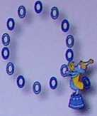

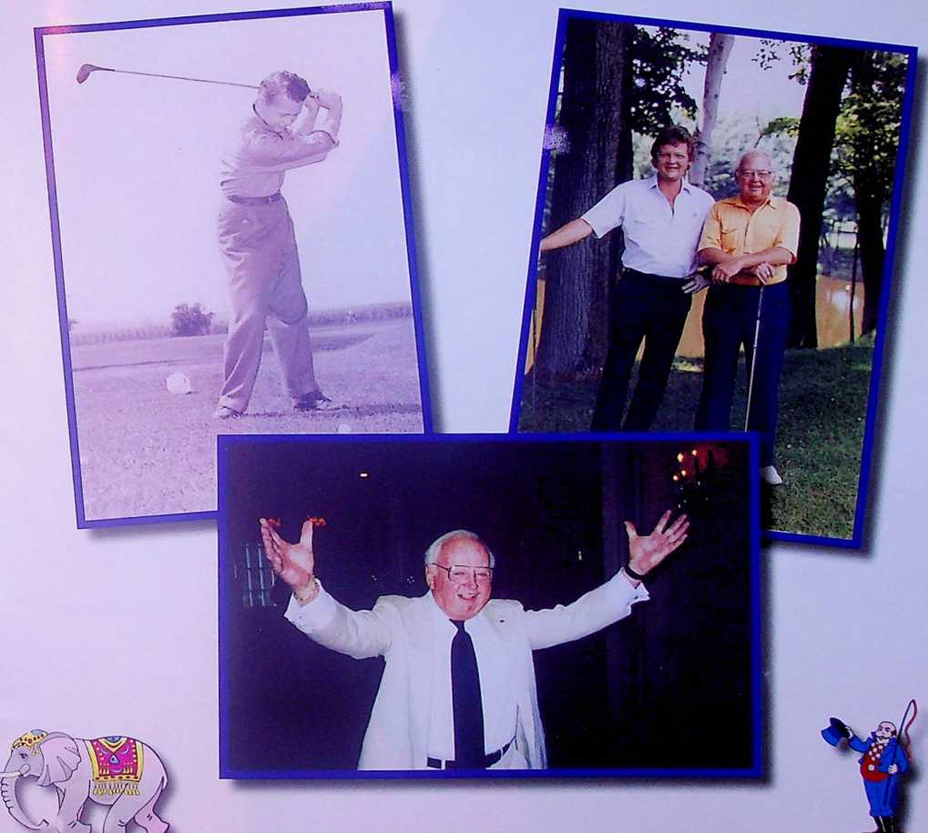

In Memoriam



100% of funds raised at the Action Auction are donated to service groups and Rotary projects.  
Past beneficiaries include...

**COMMUNITY SERVICE GROUPS**

|  |  |  |
| --- | --- | --- |
| BT Washington School | Boy Scouts - Prairielands Council | Don Moyer Boys & Girls Club |
| Carrie Busey School | Canaan Development Foundation | Eastern Illinois Food Bank |
| Golden Apple Foundation | The Center for Women in Transition | Frances Nelson Health Center |
| Interact Club | Girl Scouts - Green Meadows Council | Champaign County YMCA |
| Learning for Life | Court Appointed Special Advocate | Habitat for Humanity |
| RYLA | Crisis Nursery | University YMCA |
| Parkland College Foundation | Champaign Public Library | Cunningham Children’s Home |
| Read Across America | Champaign Park District - Skelton Park | “Students of the Year” Awards |
| Robeson School | Developmental Services Center | **AND MANY MORE!** |

**INTERNATIONAL SERVICE GROUPS**

Associata Club Rotary Brasov

Associata Club Rotary Onesti

Disaster Relief (various)

MAP International (medical supplies)

Rotary Club Bucuresti

Rotary Youth Exchange Consortium

Shelter Box Project