WGRC

*Champaign Rotary*

*Investing in Kids and Community*

Carls Mobile

Health Clinic t

**2019 Action Auction**

**May 31,2019**



Message from the President

Welcome to the 2019 Champaign Rotary Club Action Auction Gala. This once-every- three-year event is a special effort by our Rotary Club members to raise money that will go to charitable organizations in our community that are impacting lives that need it most. The theme of tonights gala is, “Investing in Kids and Community.” With your generous participation in tonights silent and live auction opportunities, our club will invest in the medical, physical, counseling needs and more that many kids in Champaign Urbana are missing.

For the first time the gala will feature a Lifetime Achievement Award presentation. We are honored to present the first award to Illini football great, NFL player, successful businessman, philanthropist, and longtime Champaign Rotarian John Wright. Job:’-, commitment to family, career and community, exemplify our Rotary motto of “Service Above Self.”

Thank you for joining us tonight. I hope you’re up for an evening of fun, food, and bidding on the many fine silent and live auction items! Most of all, I want to thank you for investing in kids and charities in our community who need your generosity and Champaign Rotary to make a positive impact on their lives.

Your Investment Makes a Difference!

Sam Banks

President, 2018-19

Lifetime Achievement Award

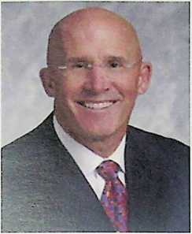

**John Wright**

The Rotary motto of “Service above Self” is intended to be the  
foundation of what Rotarians think, say, and do, in all aspects of  
life. In his family life, as a business owner and entrepreneur, and as  
a community mined philanthropist, John Wright has given “service  
Above Self” in every aspect of his life.

John has a favorite saying that, “everyone can be a champion”. As  
a standout athlete, he brought that “champion” attitude and com-  
mitment to his studies and on the football field at the University of

Illinois. Graduating in 1968, John not only was named to the Big Ten Football All American team, he was also bestowed the honor being selected to the Big Ten Academic All American

team.

Leaving the U of I, John was drafted into the NFL and his football career continued in the professional ranks. He played for both the Atlanta Falcons and Detroit lions, before a career ending injury took his passion from sports, to the business world.

With a spirit of “service above self” he went on to build a nationally known reputation in the insurance and financial services industry. He took over and built a Northwestern Mutual regional organization from 750 million dollars, to over 9 billion dollars in assets managed over his 26 years tenure as managing partner. To build a nationally recognized organization, Johns plan was not to build a business, but to build “people”.

With building people as his passion, he left the financial world to commit his time and focus on helping others to perform at their best in the business world, on the athletic field, or in whatever aspect of life they want to excel. Through his Greyfield Legacies, executive coaching and training company, today John is a highly sought after performance coach and mentor for professional athletes, corporate executives, and individuals from across the country. His work touches the lives of individuals from the NFL, NBA, Olympic Gold medalist, and CEO’s of fortune 500 companies.

John’s commitment to family and community is rooted in his often shared belief that purpose and hope lead to a meaningful life. His community work and support of local charities, his devotion to the University of Illinois, and his commitment to Champaign Rotary, has demon­strated **his life purpose to serve** his family and his community; and has **given hope** to the many people touched by his generosity and involvement.

The Rotary Club of Champaign’s

2019 Action Auction Schedule

May 31, 2019

I Hotel

**Reception & Social Time**

5:15 pm

5:15-6:30 pm

5:15-7:15 pm

6:30-7:15 pm

6:30 pm

6:40 pm

Doors Open

Open Bar

Silent Auction Open For Bids

Open Bar in Dining Room

Dinner Begins

**Dinner and Program**

Welcome & Introductions, Sam Banks, President Champaign Rotary

Master of Ceremonies, J Leman

Raffle Drawing

Introduction of Mr. David Goodman

Live Auction Begins

Paddle Raise

Rotary Thank You for Investing In Kids & Community

Presentation of Lifetime Achievement Award

John Wright Remarks

Sponsor Recognitions, J Leman

Final comments, Sam Banks

Champaign Rotary 2019 Live Auction Packages

**Value: Priceless**

**Four diehard Illini football fans will  
have an experience never available to  
the general public!**

This game day experience starts prior to  
the Illinois vs. Eastern Michigan football  
game on September 14, 2019. Four Illini  
fans will get a Memorial Stadium media  
facilities tour (including the press box,  
broadcast booths, photo tent, and TV  
truck), participate in the pregame all you

#1 Illini Football Media Experience for 4

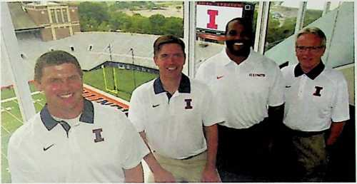

can eat media buffet, have field access during pregame warm-ups for the Illinois vs. Eastern Michigan  
football game, with photo opportunity of players and coaches. For the game, you’ll have seats in the  
press box; in-game visits to radio and television broadcast booths, with opportunities to meet on-air  
talent. This experience is topped off with access to the postgame press conference!

**Value: Priceless**

#2 VIP Broadway Tour for Two

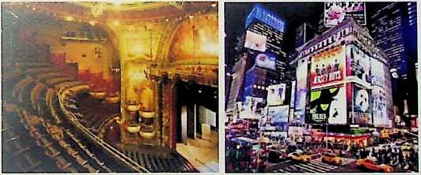

**Two Theatre Lovers will have Two  
Remarkable Days in the city that  
never sleeps - New York City!**

Joe Rosenberg, New York’s foremost  
expert in theatre and architecture, and  
Alejandro Almaguer, New York’s most  
personable tour guide, will be your  
guides for this **very *personal tour!***

On your first night, we will arrange ***Front Orchestra Seats*** to the Broadway show of your choice, from such greats as ***Beautiful: The Carol King Musical, Dear Evan Hansen, Aladdin, Waitress, and others.***

***A Private Performance*** in one of the most beautiful apartments in the Fashion District will be arranged with a featured cast member from a hit Broadway show, who will sing for you and with whom you will have an intimate discussion about the life of a Broadway artist, its challenges and rewards. ***(We have 38 artists to choose from for this private performance!)*** Your entertainer will be accompanied on the piano by Paul Loesel, the keyboardist and Assistant Orchestra Conductor from “Wicked,” who is also a com­poser of an award-winning Off-Broadway musical, “KLMNOP.” Paul will share the life of a composer and Broadway musician with you.

***The New Amsterdam Theatre,*** home to the world premiere of “The Lion King” in 1997 and current home to Disney’s “Aladdin” ***will open its doors just for you!***

Joe Rosenberg will discuss the history and secrets of this beautiful Art Nouveau theatre. Next, Joe will lead you on a walking exploration of the lights, excitement, history, and theatres of the Times Square Theatre District. ***You will have a birds-eye view, looking down on the lights and excitement of Times Square.*** He and Alejandro will give you an expert-led introduction to the fascinating New York City Subway System and the ***rare opportunity*** to walk inside Gramercy Park, New York’s only private park!

You will visit the theatre worlds most prestigious private club, located in the lovely townhouse of Edwin Booth, the greatest American actor in his day. You will have lunch with ***unlimited house wine*** and soft drinks, at the National Arts Club, one of New York’s most beautiful Victorian Interiors located in ***our country’s most prestigious private club for people in the visual arts.***

The trip is complete with a two-night stay for two at a premier hotel in New York City’s Theatre District.

Restrictions: This auction package can be redeemed until June 30, 2020. The date for redeeming this package will be dependent upon the mutual availability of the auction winner and VIP Tours of New York. You will be asked to choose three shows in order of preference VIP Tours will make every effort to obtain tickets to your first choice show. Depending on availability and on the Broadway show selected by the auction winner, the cast member for the private performance will be selected from one of 25 current Broadway shows.

#3 Fighting Illini Basketball Experience for 10

**Value: Priceless**

**Ten Illini basketball fans will experience something never offered to the general public!**

This experience will be held early in the season, likely a November 2019, non-confer- ence men’s basketball game.

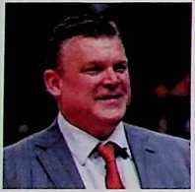

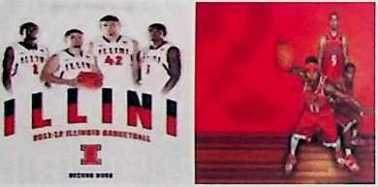

Your group will be given a ***re-  
markable, behind-the-scenes tour*** of the State Farm Center and ten seats in Athletic Director Josh Whit-

man’s Suite. Your time in the suite will include a reception for the group that will include AD Whitman and drop in’s by Coach Brad Underwood, Deon Thomas and other former Illini stars! This experience includes ***incredible courtside access*** during the pregame warm-ups, with photo opportunities. Your group will enjoy the game from the comfort of the AD Suite along with game programs, food and bev­erages to your liking. You’ll end the experience with attendance at the ***postgame press conference and* each member of your group will also receive a complimentary, Illini swag bag.**

**Value: Priceless**

#4 Napa Valley Exclusive Wine Tasting for 4

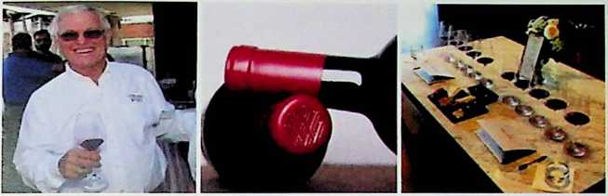

***If you love football,  
and you love wine, this  
experience for four is  
for you!***

Each couple will receive  
a bottle of wine upon  
arrival at the Napa  
Valley Lodge. You will

spend two nights at this luxury hotel, with king-size beds and a beautiful, vineyard view and fireplace.

Super Bowl Great Dick Vermeil, former Head Coach for the National Football League’s Philadelphia Eagles, St. Louis Rams, and Kansas City Chiefs will open his Calistoga Wine Tasting Room and giving a personal tasting of his wines just for you! This will take place during grape harvesting season between September 1 and September 14, 2019. Come hear about the wine making process and ask this great coach any questions you have about football!

Tire next day, a champagne continental breakfast will be delivered directly to your room. You will then be given a private, chauffeured, 5-hour winery tour in a luxury vehicle. ***Wow!***

Restriction- Participants must be 21-years-old. Vie wine tasting with Dick Vermeil should be arranged between September 1-14, 2019.

#5 The Ultimate Illini Fan Golf Experience for 6

Value: Priceless

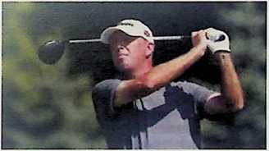

A ***golf getaway for 6 with Big Ten Golf Coach of the Year Mike  
Small and Illini Men’s Basketball Coach Brad Underwood -***The day starts boarding ***a private jet,*** where you’ll stretch out  
and enjoy refreshments and relax before landing in Memphis,  
Tennessee. Upon landing in Memphis, you’ll head to ***TPC  
Southwind Golf Club, the Professional Golf Association Tour’s  
only private golf club*** in the state of Tennessee. TPC South-  
wind is home to the PGA Tour’s World Golf Championship

FedEx, St. Jude Invitational, and has been ranked number 23 in Golf World Magazine’s Exclusive PGA  
Tour Course Rankings.

Each golfer will enjoy playing nine holes of golf with both Coach Small and Coach Underwood. After the round, you’ll have time to enjoy a meal and conversation about Illini sports with your hosts. Then you’ll head back to the jet to enjoy a smooth ride back to Champaign, arriving home before bedtime.

#6 Heads or Tails



#7 World Class 2-Day Leadership Camp for 8

**Value: Priceless**

***Eight business people will have the unique opportunity to  
spend 48 hours at Greyfield’s WORLD CLASS LEADERSHIP  
CAMP!*** John Wright started Greyfield's Leadership Camp in  
2003 with the 12 draftees of the Chicago Bears. All 12 draft-  
ees made the team, which is almost unprecedented, and they  
led the Bears to the Super Bowl in February 2007! Greyfield’s  
objective is helping people look at their lives and those that they  
lead, through a new lens. Change your lens, and you change  
your life! Over two-days, you’ll spend time on: the regulation  
football field, Central Illinois’ finest high ropes course, a world  
class sporting clays range, a 9-hole golf course, archery course,



and two fishing ponds! Each of these provide experiences that will impact and accelerate your growth!  
It will be 48 hours of learning and growing. We go to school, and the subject is you! Accommodations  
and all meals are provided. Over 800 executives from all over the United States have attended these  
camps. Locally, Kraft Foods, Heinemann and Associates, Sullivan-Parkhill, Provena, along with many  
Illini teams, have taken advantage of this experience. ***This camp will have a special bonus of two of our  
most successful Fighting Illini coaches*** to help facilitate: ***Head Men's Tennis Coach, Brad Dancer, and  
Head Men's Gymnastics Coach, Justin Spring.*** This is a lifetime experience for a team of 8 people!

Value: Priceless

#8 Illini Football Road Game for 2

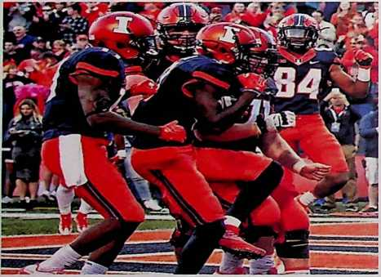

**Two Illini football fans will have the unique  
opportunity** to fly with the University of Illi-  
nois football team to Minnesota on October 4,  
2019. You’ll stay at the team hotel and be the  
guests of Illini Athletic Director Josh Whit-  
man for dinner on Friday night. Other guests  
may include donors and senior staff. On game  
day, you’ll participate in the pregame meal  
with the team and ride in a bus motorcade to  
the game with a police escort. You’ll have field  
access during pregame warm-ups, with photo  
opportunities, and seats in the Athletic Direc-  
tor’s Suite during the game. You’ll fly home  
with the team celebrating an Illini win!

#9 House of Dreams for 10

Value: Priceless

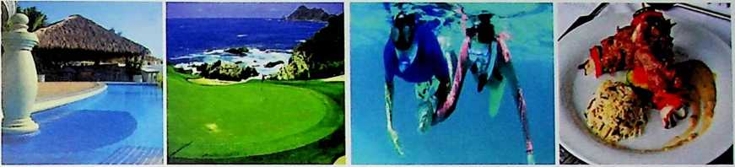

TEN people, TEN THOUSAND square feet, SEVEN days, FIVE master suites, FIVE staff, FOUR sundecks, THREE golf courses, ONE spa, and ONE private beach. PRICELESS!

Mexico’s best kept secret is La Punta, Manzanillo; a quiet, gated, and secure residential community nestled at the tip of a rocky peninsula jutting into the Pacific Ocean. This totally private, beautiful, and exclusive neighborhood is considered one of the most successfully planned luxury developments in Mexico.

At this striking, luxurious estate villa nestled on a cliff only meters above the ocean spray of the Pacific, you will find 10,000 feet of marble splendor melded into Etruscan Architecture...**five unbelievable, sea-facing, private master suites.** ..two swimming pools with cooling waterfalls...three sunning decks and a fourth with sun chairs actually in the cooling pool. ..a shaded palapa bar...outside living and din­ing areas with sunset views that are simply, “Too Awesome for Words!”

Your party of 10 will feel like kings and queens with a one-week stay in this multi-tiered, majestic mansion. Everywhere you look, unobstructed, breath-taking views of the Pacific Ocean and Santiago Bay greet the eye, while warm ocean breezes sooth the mind and body. And to really make you feel like royalty, this home is **complete with your personal chef,** who will prepare daily meals on-site to your taste, a manager, houseman, and maid, who will provide five-star daily housekeeping.

Enjoy all Manzanillo has to offer with golf just steps away, beautiful beaches, horseback riding, snor­keling, fishing, and wonderful restaurants and boutiques! Or, simply chill out at the home, sipping a margarita at the edge of one of the pools watching the crashing waves below.

Your villa is located in a gated community with round-the-clock security, stylishly manicured gardens, winding paths shaded by tropical trees, a tennis club, private beach and beach club.

Your villa also includes access to LaPunta’s private beach where you may choose to snorkel the crystal blue waters of the Pacific or lounge one beachside chaises among stunning coves and the shade of small palapa.

Truly a one of a kind experience!

Restrictions: This package docs not include air or ground transportation, spa services, food and drinks, laundry, gratuity, golf, deep sea fishing and personal purchases. Weeks are based upon availability at the time of the request, with selected available weeks in 2019 and availability in 2020. Christmas and New Year's are not available for booking. Package must be redeemed within one year of purchase at auction.

#10 The Ultimate Wine Package: Instant Wine Cellar Collection for Your Home Value: Priceless

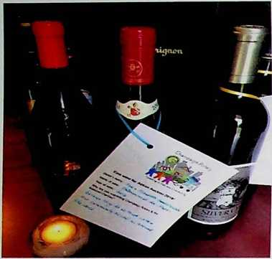

**100 bottles of premium fine wine can be yours!** These  
wines were donated by members of the Champaign Ro-  
tary Club and local celebrities, like Jim Turner and Mike  
Ross. Each bottle has a personal note from the donor  
about why the work of Champaign Rotary is so import-  
ant. There is a nice mix of French and California wines  
in this collection, **including a 2009 bottle of Dom  
Perignon,** a 1996 bottle of Clos du Vai Estate Cabernet,  
and a 2009 bottle of Rotem & Mounir Chateauneuf-du-  
Pape Omnia.

This package also **includes a wine tasting experience**by Riley McCulley II, sommelier at Naya Restaurant,  
in your home for up to 10 people, with **hors d’oeuvres  
provided by Michael’s Catering!**

Restriction: Must be 21 to purchase this package and participate in the wine tasting.

**Value: Priceless**

**Tuscany, Italian home for 10 with  
a Private Chef! *“Vacation in a  
Renaissance painting!”***

Your group of 10 will enjoy privacy,  
serenity, and spectacular views in a  
Sixteenth Century home immersed  
in an oasis of natural beauty. This is  
the perfect experience for families  
and friends, a romantic getaway,  
and an ideal retreat!

For one week, you will enjoy the

#11 Tuscan Experience Getaway for 10

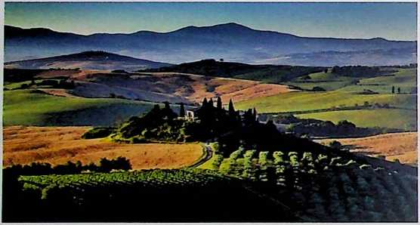

surrounding countryside, which offers stunning valley and mountain views, many walking trails, an  
exquisite pool, and hundreds of miles of country roads for bicycling or touring by car. Here, you will get  
a taste of Italian traditions and customs, while enjoying breathtaking views over Cortona’s mountains  
and valley, in the utmost privacy!

**You** will live like Etruscan Royalty, as you will have a **private chef for the entire week** prepare your breakfast each morning and spectacular dinners every evening, featuring amazing dishes and the price of food is included in this package! Each time you sit at the table will become a memorable experience in itself! Here you will taste the real flavors of Tuscany’s traditional food. One of your days, we have even arranged for a cooking class with your chef. This class is not only about executing recipes, but you will discover the authentic traditional Tuscan cooking the way it was in the past, when families were self-suf­ficient thanks to their own farms.

Complete your adventure with a **private tour** in the charming countryside of Cortona where you will learn the secrets behind some of the world’s finest wines. Afterward, you will have the **exclusive oppor­tunity to join the vineyard’s owner for lunch at his private home.**

Once here, you will not want to leave!

Restrictions: Travel must be booked within one month of the auction and must be completed by May 31, 2020.. Booking is based on availability. The week must be reserved within one month of the auction. The offer is good for one year from the time of purchase. There is no refund for unat­tended or guest-canceled services. This is for a Saturday to Saturday stay.

**#12 Paddle Raise - Champaign Rotary’s Action Auction  
Supporting Kids and Community**

**Value: Priceless**

*Champaign Rotary*



*Investing in Kids and Community*

During the Live Auction, you will have an opportunity to raise your paddle and join others in donating to WGRC, Inc/the Champaign Rotary Foundation to support our three featured charities (Cunning­ham Children’s Home, the Martens Center, and Carle Mobile Health Clinic) and other worthy causes in Champaign County over the next three years.

**100% tax deductible! Everyone goes home a winner!**

WGRC, Inc.

**Presents**

**Action Auction 2019**

Pillar Sponsor

Busey

Gold Sponsor

News-Gazette

TV" MEDIA

Print l Radio l Digital

**Silver Sponsors**

**1978-2018**

HARRINGTON LAW LLC

**Bronze Sponsors**

Thomas, Mamer & Haughey, LLP

VERDANT

**PA R T M E R S ~**

**Auction Sponsors**

’1OTEL

and conference center-

**Commerce Bank**

**Member FOK**

Challenge Accepted.

SOSF

Broadcasting

Healthcare Foundation



COLDWELL

BANKER COMMERCIAL

Northwestern

Mutual'

DEVONSHIRE REALTY

Anonymous Rotarian

Thank You to Our Donors!

Jennifer Aggio

Chet Alwes

Scott and Donna Anderson

Art Mart

Bob and Jennifer Gunji Ballsrud Sam Banks

Harry Baxter

Baxter’s American Grill

Danda Beard, in honor of Joseph Baldwin

Danda Beard, in honor on

Niala Boodhoo

Rob Bedows

Bell Racing USA

Amy and Tim Born

Brian Branhart

Ken Buel

Scott Burge Busey Bank

John Paul Buzard

John and Sandra Calderon

Gary and Diana Carlson Steve and Donna Carter

Dean and Susan Cavey Champaign Park District

Chicago Blackhawks Foundation Tom Costello

Greg Cozad and Cozad Asset Management, Inc.

Barbara Dalheim

Dan Baker

Brad and Haylie Dancer

Jen Davidson

Joe and Jayne DeLuce Developmental Services Center Tom Dillavou

JeffFullilove

Joshua Gallagher

Connie Glazik-Pierce Bill Gleason

Claudette and Ted Gonsiorowski

Habegger Corporation

Mike Haile

Guy Hall

Tom Harrington and

Allied Capitol Title

Leon and Jean Hinton

Illinois Brick Company

J Leman

Jacksonville Jaguars and

the Kahn Family

Jerry and Helen Jahn

Jim Rossow

Chancellor Robert and

Dr. Lynn Hassan Jones

Kalahari Resorts

John Kelley

John Knoblett

Pat Kovar

Ed Krol

Lanz, Inc.

Jeffery Lehmann

Brandi Lowe

Ludwig Bros. Landscaping

Kay Machula

Bill and Deborah Malone

Marilyn Marshall

Nancy Eisner Martin

Carl Meyer

Eric and Donna Meyer

Michael’s Catering

Miga, Sakanaya, and

Naya Restaurants

Dale Morrissey

Nando Milano Trattoria

Doug and Janet Ellis Nelson

Abbie Osterbur

Chad and Renee Osterbur

Parkland College

Community Foundation

Geoff Poor

Kip Pope and Brookhaven, Ltd.

Atron Regen

Nancy Reinertsen

Shelly Romack

Joe Rosenberg

Mike Ross

Craig Rost

Marlys Scarbrough

Anita Schwartz

Mike Small

Justin Spring

Steamatic of

Champaign-Urbana, Inc.

Winnie and Jay Stortzum

Sun Singer Wine and Spirits

The Reading Group

David Thies

Mark Thies

Mabel Thurmon

Ray Timpone

Anh To and Marine Bank

Peter Tomaras

Jeff Troxell

Jim Turner

Brad Uken

Brad Underwood

University of Illinois Athletics

Dick Vermeil

Tracy Wahlfeldt

Pat and Connie Walsh

Zach Wetherell

Dan Wheatman

Josh and Hope Whitman

William M. Staerkel Planetarium

Bill and Diana Williams

John Williamson

John Wright

John Wright II

_Jf'

Action Auction Committee Members

Chairs

Dean Cavey

Marlys Scarbrough

Janet Nelson

Executive Committee

Dean Cavey

Marlys Scarbrough

Sam Banks

Janet Ellis-Nelson

Leon Hinton

Connie Walsh

Scott Burge

Tom Costello

Dan Wheatman

Eric Meyer

Acquisitions Committee

Sam Banks

Leon Hinton

Eric Meyer

Tables Committee

Jan Bahr

Michael DeLorenzo

Facilities & Arrangements Committee

Eric Meyer

Abbie Osterbur

Raffle Committee

Pat Kovar

Jeff Lehmann

**Spotters**

Chris Moore

Anthony Corapi

**Finance & Banking**

Vanessa Bechtel Joan Dixon Connie Walsh

**Marketing & PR**

Atron Regen Rebecca Ries

**Sponsorships**

Sam Banks

Bob Ballsrud

Eric Meyer

Jeff Troxell

**Photography & Video**

Bill Malone

Harry Baxter

**Design & Printing** Bill Williams

Scott Burge

**OneCause**

Connie Walsh Janet Ellis-Nelson Joan Dixon