007

**2007 Actior^AUCTION**

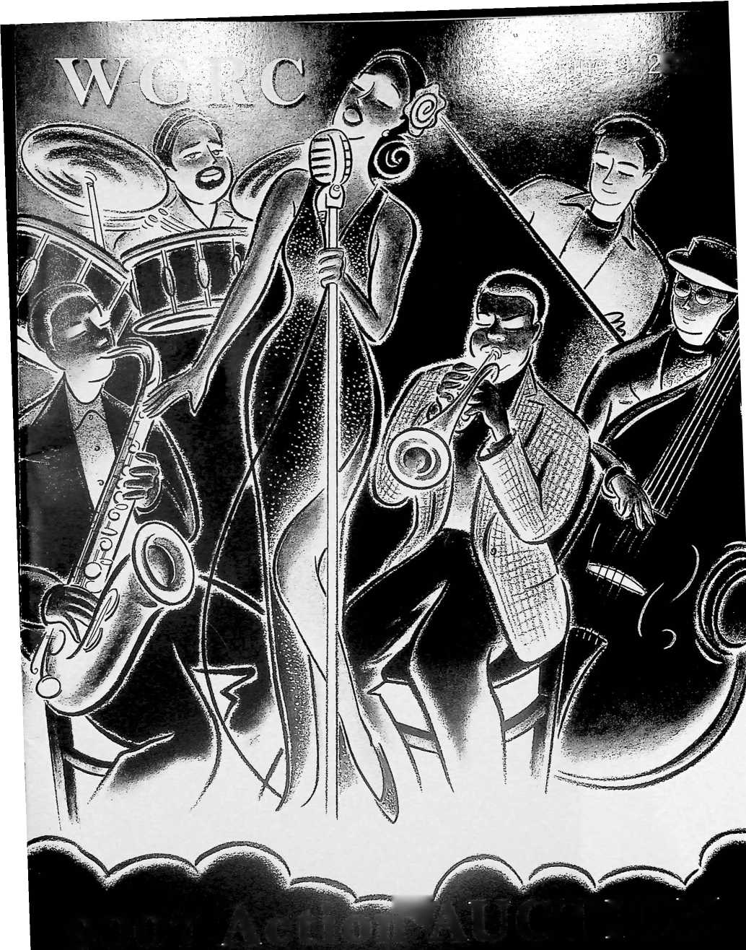

Qhampa'9

**Dori Moyer Boys & Girls Club**

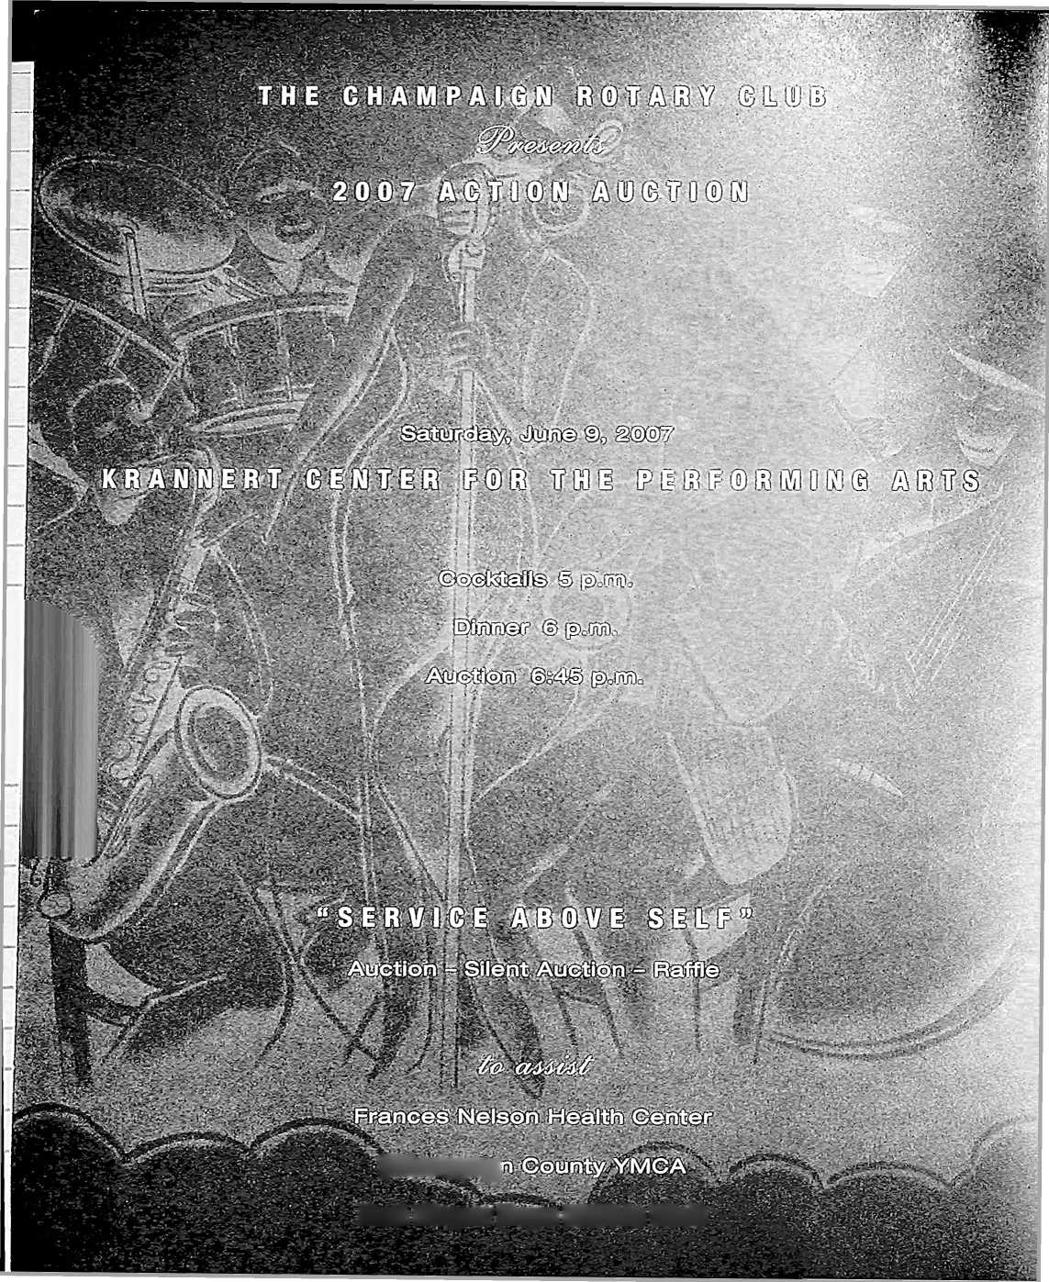

Welcome

I to the 2007 Action Auction!

The Action Auction is one of the most exciting philanthropic events in East Central Illinois. Held every three  
years, this attraction has been drawing close to five hundred people for the past twenty-five years.

1 am deeply humbled to have the opportunity to host this event during my tenure. Our challenge is to reach our goal of $150,000. Through corporate sponsors and other special friends, we have that chance.

Our committee through the chair leadership of Dave Johnson has displayed a special savvy and reaching the goal  
appears realistic. A special thanks to the entire Action Auction committee for their year-long commitment and  
planning for this event, including Bob Aldridge, Scott Anderson, Dana Brenner, Tom Costello, Greg Cozad, Joan  
Dixon, Robert Driver, Donna Greene, Kay Machula, Darcy Sementi, Arnie Smith, Sarah Tufte,  
and Gary Wackerlin.

We hope that you will assist us by generously bidding on some wonderful and very useful items.

The three key benefactors of this year’s event are Frances Nelson Health Center, Don Moyer Boys & Girls Club,  
and the Champaign County YMCA for the purchase of a new “Fun Bus.” These three organizations provide some  
special life enhancements for our community.

Again, my warmest thanks for your participation.

Enjoy

THE EVENING,

Carl R. Meyer  
President  
Champaign Rotary Club

2006-2007  
Champaign Rotary

Club

Carl Meyer, President  
Dan Wheatman, President Elect  
John Ady, Immediate Past President

J. Bryant Evans, Treasurer  
Justin McCarthy, Secretary

Arthur J. Skelton, Executive Secretary

Directors

Dean Cavey  
Joseph C. DeLuce, Jr.  
Joan M. Dixon  
Stephen D. Hamburg  
Terry P. Harter  
Patrick J. Kovar

WGRC, Inc.

Donna Anderson, President  
Robert C. Aldridge, President Elect  
David B. White, Treasurer

Board of Directors

Carl Meyer, ex officio  
V.B. Leister, ex officio

John Ady  
Dave Janson  
Darlene Johnson  
Jerome R. Laughlin

Gary Wackerlin

Lin Warfel  
Bill Williams

**A Big Thank You  
to OUR  
Action Auction  
2007  
Corporate Sponsors**

**Cozad Asset Management**

**Meyer Capel**

**FELMLEY-DlCKERiS^ffiS^  
Busey Bank**

**Main Street Bank**

**PersonalCare**

**Provena Covenant Medic**

**Center**

2

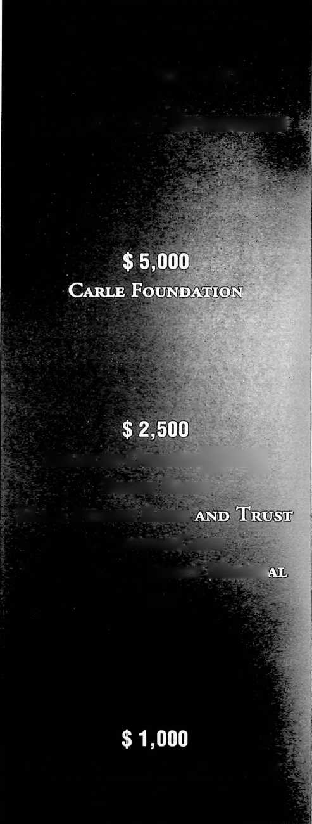

CASH BAR

**AT CONVENIENT LOCATIONS**

**THROUGHOUT THE EVENING**

Entertainment

Fellow Rotarians Geoffrey Poor and David Thies

Menu

Mixed Field Greens Salad with Yellow Teardrop Tomatoes & Starfruit  
Pan-roasted Ribeye of Beef

Jumbo Shrimp Scampi

Roasted Yukon Gold, Baby Red & Purple Peruvian Potatoes

Haricots Vertes with Red Bell Pepper

Dinner Rolls & Assorted Breads

Chocolate Chantilly Cream Charlotte

Hot & Cold Beverages

3

**RULES AND PROCEDURES FOR ACTION AUCTION 2007**

**Win $ 2,500 In Cash - Raffle Tickets are now on Sale!**

**You MUST BUY A TICKET iS wiN!**

1. There are three separate events occurring during the evening, a LIVE Auction, a SILENT Auction, and two Raffles, one for the $ 2,500 Cash Prize (Green Tickets - pre-sold and night-of-event) and $ 2 raffle tickets that can be placed in the boxes next to the Raffle Items on display.
2. The LIVE Auction will begin immediately following the dinner hour and will continue until all items are sold.
3. The SILENT Auction will begin promptly at 5 p.m. and will continue through the 2nd break in the LIVE Auction, as announced by the Auctioneer. The SILENT Auction items can be bid on by signing up with a name and dollar amount or can be purchased outright by signing the "Buy It Now" portion of the sheet at the prescribed price.
4. All buyers will be assigned a buyer number. Please show your buyer number when bidding to assist the Auctioneers and Spotters in properly identifying you as a bidder.
5. Payment should be made by the successful bidder following the auction of each item. A committee member will bring a purchase receipt to each successful bidder for their immediate signature. You may choose to be escorted by the committee member to the cashier’s table for settlement at that time or settle up with the cashier prior to leaving the Auction.
6. Payment can be made by cash, check, Visa, or Mastercard. All checks should be made payable to WGRC, Inc.
7. Values set forth for some items being auctioned or given as prizes are estimates of general value.
8. All sales are final and there will be no exchanges or refunds except as specified by the donor. All Auction items and services must be used within one year from the Auction Night, June 9, 2007, unless otherwise agreed upon by the donor and the purchaser. Trip items must be confirmed by the purchaser to the donor within 30 days of the Auction Night. Special instructions pertaining to some of the items may be indicated on the bottom of the purchase receipt. Please read your pur­chase receipts carefully and completely.
9. Items should be removed from the Krannert Center by presenting your purchase receipt on Auction Night. Arrangements for pickup of items not displayed at the Banquet Hall should be made between the donor and the purchaser.

4

Action Auction Committee 2,007

Jim Acheson, Bob Aldridge, Scott Anderson, Dana Brenner, Tom Costello, Greg Cozad, Matt Deering, Joan Dixon,  
Robert Driver, Donna Greene, Dave Johnson, Kay Machula, Carl Meyer, Scott Moe, Darcy Sementi, Arnie Smith,  
Sarah Tufte, Gary Wackerlin

Special Thanks for Action Auction  
Acquisition Committee members

Bill Hobbs, Dave Lawrence, Carl Meyer, Greg Cozad, Jane Bernthal, John Wright, Marjorie Williams,  
Matt Deering, Scott Moe, Stefanie Pratt, Sue Grey, and Terry Harter

Special Thanks

° Krannert Center for the Performing Arts

° Rotarian Arnie Smith and BankChampaign for hosting Action Auction Committee  
meetings

0 Geoffrey Poor and David Thies, Musicians

0 The lllini Union Catering Staff

0 Rotarian Kay Machula and UpCIose Marketing & Printing for the Programs

0 Tony Clements, Emcee

° Mike Namoff, Auctioneer

° Champaign Rotary Club Volunteers, Bid Spotters, and Runners

o Champaign Centennial Interact Club for setup and tear down

0 All of our generous donors!

**WGRC Action Auction Goal $ 150,000**

Ere goal of this year’s Action Auction is $ 150,000. This auction allows the Champaign Rotary Club to continue its service to the community. Many community agencies have benefited from the Action Auction during the last 30 years. The three

J agencies listed below are major recipients of this year’s auction proceeds. They join more than 50 local agencies that the Champaign Rotary Club, through its charitable foundation, WGRC, Inc., has assisted during the past three years. The contin­ued ability of the Champaign Rotary Club to support these and other community services depends upon the success of this auction. We thank you for your help and allowing us to live our motto of "Service Above Self.”

**Don Moyer Boys and Girls Club**

**YMCA “Fun Bus”**

**Frances Nelson Health Center**

5

**How TO LOOK LIKE A ROTARY**

Action Auction Professional

Preparing for the auction:

1. This is the catalog for the 2007 Action Auction. Now is the time to form your buying/bidding syndicate. Talk to your Rotarian friends, send e-mails during the week, and form your strategy for the big ticket items. You can combine your resourc­es and increase buying power.

Nice things happen to those who overbid! Remember, the Auction is our primary fund-raiser for charitable organizations for the next three years!

1. Bring **CASH** to the Auction (or stop by the ATM) to buy raffle tickets. We have 2 raffles - The $ 10 green ticket raffle is for $ 2,500 in CASH! The traditional $ 2 raffle tickets will be for the raffle items displayed next to your seat.

Action Auction Night:

We begin with cocktails in the Krannert Lobby at 5 p.m. with entertainment provided by our very own Rotarians, Geoffrey Poor and David Thies. Be on time and you’ll want to get to work buying raffle tickets, forming a buying syndicate, having a drink with your friends, and bidding on Silent Auction items!

1. Your first stop upon arrival is the Reception Desk at the North End of Krannert Center's spacious lobby (by the Intermezzo). Here you’ll receive your bid number and find out the location of your reserved table/seat.
2. Your next stop (after the bar) should be to purchase raffle tickets. Raffle items are listed in the last category in this booklet. Here’s how the Raffle works:
3. Each Raffle item has a box next to it for raffle tickets. You can place as many raffle tickets in each box as you’d like.
4. There are plenty of Raffle items. To have a chance, you must buy enough Raffle tickets to place at least one ticket in each box. Plan accordingly. Buy more tickets!
5. Once we begin the **LIVE** Auction, we’ll be drawing Raffle tickets during the course of the evening. Pick your Raffle prizes early and make sure you place your tickets in the boxes before you sit down for dinner!
6. The raffle tickets are numbered and come in pairs. You keep one half of the pair (your claim ticket) and place the other half (same number) in the box of your choice. **DON’T PUT BOTH HALVES OF EACH**

TICKET IN A BOX OR IN DIFFERENT BOXES. YOUR CLAIM TICKET IS HOW WE CAN IDENTIFY YOU AS THE WINNER!

1. The Claim Ticket must be presented immediately to win. You may allow someone else to hold your tickets

6

if you have to leave the Auction, but why would you want to leave early? If no one claims a winning ticket, another ticket will be drawn until there is a winner.

1. Any Raffle box which is opened and does not contain any tickets will be auctioned to the highest bidder.
2. Raffle Tickets cost $ 2 each.
3. The SILENT Auction contains many outstanding items and will open as soon as the cocktail hour begins at 5 p.m. Stop by the SILENT Auction items early and make your initial bids! Here are some simple rules:
4. Each SILENT Auction item includes a bid sheet. In order to make your bid, place your name on the appropriate price line below the current “leader.”
5. See something in the SILENT Auction that you want to buy outright? We have a “Buy It Now" line with an established price. You can take the drama out of the SILENT Auction by purchasing the item immediately at the established price and signing your name on the “Buy It Now" line.
6. The SILENT Auction will be open until the 2nd break during the LIVE Auction. Mike Namoft, our Auctioneer will continue to make announcements during the LIVE Auction, including a timed countdown, allowing you plenty of time and notice to place your bids on SILENT Auction items.
7. Once Mike Namoff announces the close of SILENT Auction items, all sheets will be collected and prizes wi be awarded. If you're a winner, please proceed to the cashier to pay for your item.
8. Find your table, enjoy a few cocktails, meet your friends, and make your plans during the cocktail hour! Don’t forget to visit the Raffle Table and Silent Auction Table during the cocktail hour.
9. Dinner will be served promptly at 6 p.m. Enjoy your Surf & Turf!
10. We’ll start the LIVE Auction at 6:45 p.m. - With fewer LIVE Auction items this year and the new category of SILENT Auction items, please plan to stay for the entire event!
11. Please refer to the Rules and Procedures in this Catalog for any questions during the LIVE Auction, SILENT Auction, RAFFLE, and Cash RAFFLE.
12. You are encouraged to pay for your successful bid (cash, check, Visa, or MasterCard) throughout the evening to avoid long lines at the end of the night! Of course, you can collect all of your winning bids and pay at the end at the evening if you wish!
13. Cashiers will be on hand to collect payment for items throughout the evening. In True Rotary Spirit, please pay your tab before you leave the Krannert Center! You are requested to remove physical items and take them home with you that evening!

QUESTIONS? Ask any Rotary Action Auction Committee Member. We’re looking forward to another great event and will be able to provide thousands of dollars to charitable organizations during the next 3 years!

7

**LEND A HAND**

Live Auction Items

1. A Golfing do with Coach Lou

You can put together a threesome and join a round of golf, lunch, and refreshments at the Champaign Country Club. Talk about the Final Four, the secret of good defense, or how to sink a twenty-foot putt with legendary lllini COACH LOU HENSON. Be real careful - some say Coach is a sandbagger in both golf and cards.

Carl Meyer

Parkland College Foundation

$ (pjj

1. Fore! An Amazing Golf Trip to Point of the Woods, Michigan You will not believe just how great the golfing experience is at Point of the Woods in Benton Harbor, Michigan. This is a perfect outing for the right foursome who will enjoy a 4-day (Monday-Thursday) stay in a 4-bedroom, 4-bath golf cottage including two golf carls and the use of the golf course. Point of the Woods is rated one of the Top 100 courses in the nation and annually hosts the Western Amateur. The cot­tage is available between October 2007 and May 2008.

Dave Barr

1. Black Diamond or Par$ Schuss Mountain your Escape for Skiing or Golf!

This is your ticket for four couples to enjoy either winter or summer fun at Schuss Mountain, a great place to relax, have fun, and enjoy the great outdoors. Schuss Mountain is part of the Shanty Creek Resort just outside Mancelona, Michigan, just 50 miles south of Mackinac. This package includes 7 days and 7 nights for the week commencing Friday, December 28, 2007 or Friday, June 13, 2008. A beautiful 4- bedroom free standing house that is ideal for four couples. This exceptional limited offer puts you in the middle of the action whether you ski or golf. You pick the season lLj[ (VE

**Jerry Jahn**

1. Dancing with the Stars

You will see any star you like as you host this star studded gathering for 120 at the Staerkel Planetarium. In addition to the eye popping parade of stars you also receive $500 for food and beverages. Have your friends join you on the red carpet. They may even invite the former planet Pluto back for a guest appearance. Date is set by mutual agreement. T

Carl Meyer Parkland College

1. Gather your friends for a week in beautiful Hilton Head

This is a great golf-oriented location in the heart of Hilton Head Island’s Palmetto Dunes Resort. This three-bedroom, three full bathroom villa sleeps eight people with a sleeper sofa. The villa is located on the first green of the Robert Trent Jones golf course with free daily tennis and swimming pool in immediate vicinity. The beach, great restaurants, and shopping are only minutes away by foot or car. You are bidding on a week beginning September 30, 2007 and ending October 7, 2007. Subject to availability, alternative October, 2007 dates are possible. This will make for a great group bid and a great vacation.

**Ronald & Lucia Deering**

**Ronald Jr. and Suzy Deering**

**Matt & Kate Deering**

8

**LEND A HAND**

1. Fly like Hugh Hefner, Tiger Woods and Madonna!

That's right. The use of your own private plane, a King Air 200, for travel for up to eight people at a mutually agreed upon date and time based on aircraft availability in coordination with Flex-N-Gate and Flightstar. You can travel an estimated 1200 miles round trip for a day using this certificate or extend your trip using the certificate as a down payment. Pick your destination and forget about the hassles of long drives, traffic, and crowded airports. Have a nice tripl

Flex-N-Gate, Shad Khan

Horizon Hobby, Rick Stephens

1. Rocky Mountain High

A one-week stay at the magnificent MeadowRidge Resort in Fraser, Colorado. This exceptional fully equipped 2-bath condo can sleep six in three bedrooms and comes with full resort privileges. Enjoy your own fireplace or be outdoors and use the charcoal grill. The best part of this great vacation site is that it is offered at any time by mutuaj agreement with the donor. You can be a skier, fisherman, just be ready to have a great time. -q /

John Severns

1. Party at the Arch! Illinois Football trip to St. Louis

Travel to Si. Louis and root on the Fighting lllini football team on this exclusive Rotary Action Auction item. No one gets access like this without a helmet Two tickets to the Illinois-Missouri football game at the Edward Jones Dome on September 1, 2007 with one-night hotel lodging at the team hotel in downtown St. Louis for either Friday, August 31 or Saturday, Septepiber 1.You know this would make a very special present for the true lllini fan. <94 (jT

**Dana Brenner - Division of Intercollegiate Athletics**

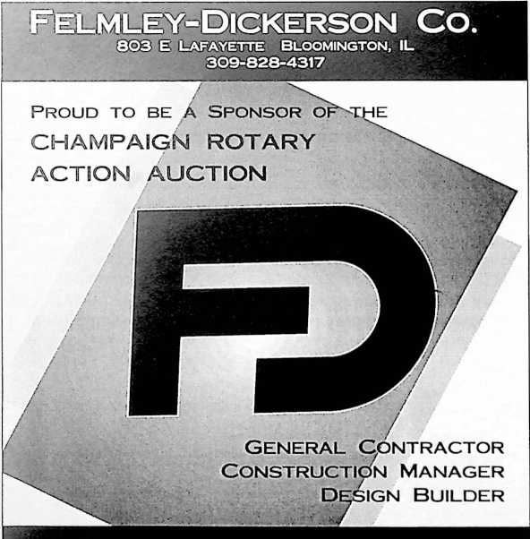

1. Round Ball Romp! Illini vs. Mizzou Basketball showdown in St. Louis

Join Head Coach Bruce Weber and the lllini basket­ball team in St. Louis with two tickets to the “toughest ticket in St. Louis" for the annual Busch Braggin’ Rights Showdown between Illinois and Missouri at the Scottrade Center. This package also includes one-night lodging at the lllini team hotel. If you were any closer to the game you’d pull a hamstring!

Dana Brenner

Division of Intercollegiate Athletics

1. Baby Zebra! Illinois Men’s Basketball game day

Celebrating **70** years  
of Proven Performance

experience

Want a real “game day” experience at Illinois basketball? This package includes two tickets to a 2007-2008 Illinois home men’s basketball game of your choice with two credentials, a complete arena tour of the Assembly Hall, and a parking pass. There is no better way to experience an Illinois basketball game than with this exclusive Rotary Action Auction signature pri^e.

**Dana Brenner**

**Division of Intercollegiate Athletics**

9

DON’T FORGET ABOUT THE GREAT SILENT AUCTION ITEMS

1. The Foundation of Rotary! A Paul Harris Fellowship

Rotary International recognizes the significant financial contributions ($ 1,000 Io the Rotary Foundation) of its members by the awarding of Paul Harris Fellowships. The Champaign Rotary Club is offering a Paul Harris Fellowship to the successful bidder. Your winning bid with help support Rotary programs! c? T)

**Champaign Rotary Club**

1. Enjoy the World Champion St. Louis Cardinals in a Private Luxury

Box

You and three guests will enjoy the July 3 St. Louis Cardinals vs. Arizona Diamondbacks game at Busch Stadium in the comfort of a luxury box, providing an unlimited buffet, beer, and soda with air-conditioned seats or outside box seats. Food, refreshments and a great ballgame this is the stuff dreams are made of. This is better than having money 1 l

**Dave & Laurie Johnson**

**The University of Illinois College of Law**

1. You and 200 Friends living high on the Hog: Pork, Beans and Beer Sounds like a country and western song but ‘‘Life just doesn’t get any better than this.” Our Rotarian donors have teamed up to cook up a recipe for fun and good times with this hog roast BBQ for up to 200 people. The mouth-watering menu includes roast pig, baked beans, salads, sweet corn (in season), and desserts and you can wash it all down with ice cold beer, wine and sodas. This great party is available in the Summer or Fall 2007 al a mutually acceptable time and place with the donors. A great business party, a fun block party or one heck of a BBQ is just a bid away. '—

**Bob Aldridge Kay Machula Darcy Sementi Dave Johnson Eric Albin**

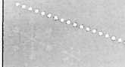

PersonalCare

14. Family and friends Fun Fest!

Westin Innisbrook Resort in

Tampa Bay

One of the premier golf destinations in the world, the Westin Innisbrook in Tampa Bay is home to a PGA tour stop and four magnificent golf courses, along with great weather, 12 tennis courts, and three clubhouses. You can enjoy this four-night stay in a luxurious three-bedroom condominium at the Weslin Innisbrook. This deal is open for the free use of the condo. You pay for any activities, including green fees, but you're already on the grounds! You can even make a quick trip to Busch Gardens.

**Bud and Sandy Leister**





**11 SKEWS CRC 5/07**

*Acf,°” Auction.*



-Ike,

*and #17 nationwide!*

PersonalCare ranked #17 out of more titan 130  
commercial health plans nationwide in recent  
rankings from *U.S.Ncws & World Report “Americas Best  
Health Plans 2006.”* We achieved this by outscoring  
other health care competitors in a wide variety of  
Health Plan Employer Data and Information Set  
(HEDIS*) and Consumer Assessment of Healthcare  
Providers and Systems (GAHPS°) categories.

**HEDIS* is a registered trademark of NCQA. UAH PS* u a registered trademark of  
the Agency of Healthcare Research and Quality (AHRQ). -America’s Best Health  
Plans 20<xr is a trademark of U.S.News & World Report.**

www. *PersonalCare. arg*

10

DON’T FORGET ABOUT THE GREAT SILENT AUCTION ITEMS

1. Indianhead Mountain Resort

One of the Midwest's premier skiing destinations, Indianhead Mountain Resort in Wakefield, Michigan provides breathtaking beauty com­bined with dazzling ski runs. Nestled on a mountain in the far western corner of Michigan’s Lipper Peninsula, Indianhead offers an incredible summer getaway, including world-class kayaking, breathtaking mountain biking, golf, tennis, big lake and small pond fishing experiences, and much more at Porcupine Mountain Wilderness State Park, the Apostle Islands National Shoreline, Lake Gogebic, and the Sylvania Wilderness Area. Go skiing in the UP and stay for a three-day weekend at this wonderful Swiss style Chalet that will sleep up to 16. This could be a great weekend trip for two or three families who will enjoy the great outdoors, skiing and relaxation at the Indianhead Mountain Resort in Michigan’s upper northwest peninsula. This Chalet is available most weekends except between Christmas and New Years. You can party at the Red Dog Saloon or any one of the many great places at Indianhead.

**Comet Families & Pepsi Cola O**

1. Your own PGA preview at Olympia Fields Country Club

You and two guests will enjoy one of Chicagoland’s premier golf courses, Olympia Fields, with fellow Rotarian Greg Cozad. Olympia Fields has hosted PGA and Senior PGA tour events for many years and provides a picturesque and challenging layout with plenty of water, sand, and lush fairways. G'W

Greg Cozad - Cozad Asset Management

1. Play like a champion at Medinah Country Club

You and two guests can play one of Chicago's most historic golf courses. The home of the 1999 and 2006 PGA Championships, both

won by Tiger Woods, Medinah provides a remarkable golf challenge on one of America's best-known and historic golf clubs. Medinah has

hosted three U.S. Opens, two PGA Championships, and will host the 2012 Ryder Cup.

**Carl Meyer**

1. Nascar Weekend in Bristol

Get ready to start your engines when the green flag drops at the Bristol Night Race - the Sharpie 500! You and a guest can enjoy two days of action-packed racing at Bristol Motor Speedway, voted NASCAR fans' favorite track by NASCAR Scene readers. Named one of the “Top 10 Hardest Tickets to Get" in all of sports by ESPN, this incredible Rotary Action Auction exclusive package includes two tickets to the NASCAR NEXTEL Cup Race, the Sharpie 500; two tickets to the NASCAR BUSCH Series race, the Food City 250, three days and two nights hotel accommodations at a local Tri-Cities area hotel, and a Sharpie prize package provided by eyeryone's favorite permanent marker.

**Donna and Jennifer Greene**

1. Travel North America with the help of a pro!

How about 2 American Airlines/American Eagle/American Connection round-trip tickets to travel anywhere in the 48 contiguous states,  
Canada, Mexico, Bahamas, Bermuda or the Caribbean? The package also includes $ 500 in travel vouchers toward hotels, transfers, tours,

and other ground arrangements from Adventure Travel, Inc. Donna Anderson is ready to assist you with your travel plans, as Adventure

Travel is the place through which your trip must be arranged. All you need to do is pick the destination and fill in the “fun!"

Adventure Travel - Scott and Donna Anderson

1. Indian Lake in Northern Wisconsin

Located outside Rhinelander, Wisconsin, the vacation condo offers easy access to an incredible vacation area on the Eagle River and Indian  
Lake. This four-season cabin in Northern Wisconsin can be used for one full week subject to availability to be mutually decided with the

owner. The beautiful Northwoods setting with a great view out of the living room window includes a secluded lake front with dock. The cabin  
includes a dishwasher, oven and refrigerator, washer/dryer, two baths, fireplace, 6-person Sauna and sleeps 10-12 people. Close to snow  
skiing, snowmobile trails, great fishing, and water sports! Pick your season! , 7 /g\

**Scott & Cathy Moe**

11

SERVICE ABOVE SELF

1. Keep on Ticking!!! You give to the community from your heart

— Let’s make sure your heart is strong so you can keep giving!

The 64-slice CT scan is capable of capturing a detailed picture of your heart and coronary vessels in five seconds with no invasive proce­dures. You can have real peace of mind with this latest technological revolution. The 64-slice CT is the first scan that calibrates with heart rhythm in a way that allows physicians to see significant detail quickly. It doesn’t just do it faster-it does it better and with more comfort. Your comfort zone is just a heartbeat away...(Not recommended for persons with pacemakers or atrial fibrillation and pending medical approval). I APT)

**Carle Clinic Associates**

22. Historic Galena territory log home

One of the most beautiful places in the state of Illinois, the Galena Territories are the site for this four bedroom, three bath spacious log  
home that includes a huge deck, pool table, satellite TV with DVD, a screened porch, and fire pit. The Log Home condo comes with full  
access to Owner’s Club amenities, including swimming pool, tennis courts, boat docks, and gym. Flexible availability between 6/07 and

6/08 with mutual agreement with the owners.

**Tony & Joan Peressini**

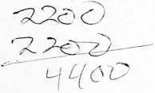

23. Ski/Golf in Beaver Creek

Six nights’ use of a 2-bedroom, 3-bath condo in the Beaver Creek area of Colorado to be arranged late Feb. 08 through October 08. Sleeps  
4 in the two bedrooms (or 6 using the sofabed). You can SKI (walking distance to a lift) or GOLF in the spring. In April, some folks ski in the  
morning and golf in the afternoon! In the summer, golf, fly fishing, and the Vail Music Festival are in order. In the fall, you can add watching  
'he aspen leaves change. The offer is for use of the condo - recreational opportunities available but not included. Minimum bid $ 1,000

**Edward & Margaret Krol**

24. Weekend getaway at the Wright Family Cabin

Take a much needed weekend vacation and it only takes fifteen minutes to get there. Tucked away in the trees with a beautifully landscaped yard and a private lake is the Wright Family Cabin. Stay Friday through Sunday and enjoy a variety of sporting activities, including a fantas­tic fishing experience, (the fish are always biting) or just a quiet weekend just a few minutes away between St. Joseph and Ogden. Great for two couples and the kids! Make arrangements with John Wright for your private resort weekend. You will want to go back for more!

**John W. Wright**

25. A PRIVATE SCREENING HOLLYWOOD STYLE

Take your seat Mr. Scorsese. There’s HD and DVD then there’s having an entire movie theatre to yourself! Invite 100 of your friends to watch a movie of your choice at a private screening on the gigantic screen at the Virginia Theatre. Your group will also receive free Pepsi and Popcorn. The date and time must fit the Virginia Theatre schedule. There is nothing Like "Singing in the Rain” on the big screen!

**Champaign Park District  
Bobbie Herakovich  
Joe DeLuce**

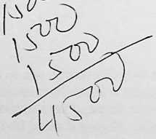

12

SERVICE ABOVE SELF

26. RCI Worldwide Resort  
Exchange Certificate

Stay anywhere in the world.. .how that’s for flexibility? This gift  
certificate allows you to stay for 7 nights at an RCI affiliated resort  
with more than 3,900 to choose from in nearly 100 countries. RCI  
is the world's largest timeshare exchange company and you'll find

the right spot in the world with this great gift.

**Stefanie Pratt**

**Stefanie Pratt & Associates**

**Coldwell Banker Devonshire Realty**

27. If **YOU HAVE THE RV, WE HAVE TWO MONTHS IN PARADISE!**

Now this is a real vacation! Two months (November and December, 2007) in a 5-star RV Resort in Naples, Florida. This provides a beautiful setting on a lake surrounded by palm trees with free hookup and cable television for a Class A (or greater) motor coach. The purchaser assumes all personal injury liability. If you have an RV, this is the prize for you! jfT)

Proud to be a sponsor  
of this year’s

**Action Auction**

Busey

Busey Bank *J*

**Chuck anti June Van Vorst**

Serving Champaign, Ford, McLean,  
Peoria and Tazewell Counties

**[www.busey.com](http://www.busey.com) • Member FDIC**

28. A **NIGHT TO REMEMBER AT THE**

Kalahari Resort

Wisconsin Dells has been a premier Midwestern vacation destination for nearly a century.Jn the last 20 years, Wisconsin Dells has also

become the home to some of the world's top water parks, including the Kalahari Resort. This package includes one night stay for two peo-

ple including gourmet dinner and breakfast and full use of America's largest indoor water park with the Master Blaster water roller coaster.

Dan & Joanie Wheatman

1. St. Louis Rams Fan Pack

A classic NFL rivalry - Rams vs. 49ers on September 16, 2007 with a Noon kickoff at the RCA Dome in St. Louis. This should be **a great** matchup. Though both teams finished in the middle of the pack last year, this is a heated division rivalry with a colorful history and both teams will play hard for the win. The seats are in Section 430, row C, seats 5 and 6 (third row of upper deck, end zone - a great vantage point for watching plays unfold). / }

Scot Dahman

And.. .How about a jersey to wear to the game? One of the all-time great NFL running backs, Marshall Faulk has rushed for more than 12,000 yards and 100 touchdowns and has also caught 36 touchdown passes during his 12-year career with the Indianapolis Colts and St. Louis Rams. Faulk rushed for 1,000 yards in five consecutive seasons and is a sure Hall of Fame selection when he retires. This authentic jersey will increase in value as the awards pile up for this future Hall of Famer.

**Dan & Joanie Wheatman**

13

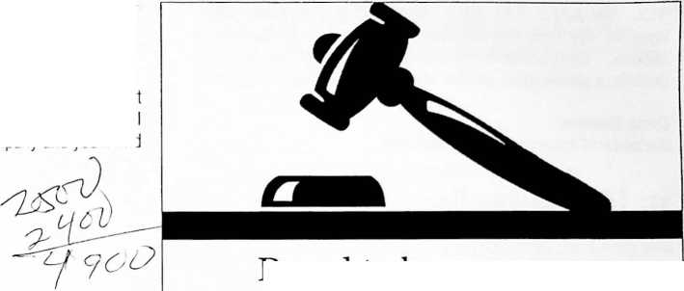

**HAVE YOU PURCHASED YOUR RAFFLE TICKETS?**

1. Want to see what’s going on at Memorial Stadium...Up Close? What are they doing with all that heavy equipment at the Stadium? What will it look like? Now you can find out.. .and go to a game on the same day! This package for the true lllini football fan includes two tickets to a 2007 home game of your choice, along with two media cre­dentials, a parking pass, and the behind-the-scenes and complete Stadium tour! You might even get to wear an lllini hard hat!

**Dana Brenner**

**Division of Intercollegiate Athletics**

1. Hey Bears Fans, How about Brian Urlacher in your home?

Well, at least his authentic autograph on an official Chicago Bears helmet. That’s right, the NFL's best linebacker and the leader of the NFC champion Bears, Brian Urlacher, signed this Chicago Bears helmet just for you and it comes with a certificate of authenticity. This prize belongs on your mantle next to the TV! *r* A

Dana Brenner

Division of Intercollegiate Athletics

1. Dave Hunting?? No - hunting with the Daves

A hunting you will go with Dave Lawrence and Dave Casstevens. Enjoy this auction tradition of a day of quail hunting. Bird dogs Maggie and Belle do most of the tough work while you enjoy the outdoors. This package includes meals, transportation and the very important bird preparation and cleaning. This offer is for a Friday during hunting season and will be enjoyed by a pro or rookie hunter.

Dave Lawrence

Dave Casstevens

1. Too much rain? Not enough rain? Play the Commodity Market

The Dick Burwash Soybean Experience returns to the Action Auction. The Grand Prairie Co-Op will transfer 50 bushels of soybeans to the

high bidder. You take on storage costs after you buy the beans. Decide when to sell. This is your chance to play the commodity market as  
farmers do every day. No need to head to Peoria or Las Vegas - you can gamble right here at home!

**Dick Burwash**

1. Your own Twin City Open: Golf at Champaign, Lincolnshire, and Urbana Country Clubs

Your own version of the Pebble Beach Pro-Am, as you and .three guests (your very own foursome!) have the opportunity of playing 18 holes at each of the Champaign-Urbana Country Clubs. MJ

1. A Five Couple Ultimate Illinois Football Tailgate

Enjoy the Illinois-Western Illinois season opener on September 8 at Memorial Stadium with 10 tickets on the 50-yard line (west side) with the famous Steve Hartman pre-game tailgate beginning two hours before kickoff and serving the best in food and adult beverages. This is the perfect way to kick off the 2007 season! Go lllini!

**Steve Hartman**



1. Antique fishing creel from Lawrence Creel Company

Tod knows his dogs and he knows his fishing. This rare and unique antique is in great condition and is highly collectable. The antique

wicker fishing creel with hand made and modern professional leather work is in the Lawrence Creel Company tradition. This will be a show  
stopper in your home or fishing lodge! All you need to add is a creek and a few trout.

**Tod Dawson**

14

**HAVE YOU PURCHASED YOUR RAFFLE TICKETS?**

1. Ruff! Ruff! Dog Sitting for a week

Show your pooch the love. Wondering who will watch the dog now (hat you have bid on a terrific vacation package. No need to call the

Kennel or travel with Fido. We'll provide 7 days of dog sitting, including *4* walks per day, treats, a fenced-in yard, and lots of personal atten-  
tion. Dates to be scheduled based on mutual agreement by May 30,2008/timit one dog per night.

**Elizabeth & David Krchak**

1. Tune yourself up: Personal Training Package from Carle

Sports Medicine

Here’s your chance to make yourself, spouse, kids, or grandkids into a high performance athlete utilizing the latest techniques in sports training. This package oilers basic diagnosis and intensive personalized training for a sport of your choice. The package includes 12 total sessions with a Carle Sports Medicine trainer. Go from Good to Great with this package! zL/zTD

**Carle Foundation Sports Medicine**

**PROCEEDS FROM THE 2007 ACTION AUCTION WILL BENEFIT THE FRANCES NELSON HEALTH CENTER,  
THE CHAMPAIGN COUNTY YMCA, AND THE DON MOYER BOYS AND GIRLS CLUB.**



15

**YOU CAN PAY FOR YOUR ACTION ITEM AS SOON AS YOU BUY IT!**

Silent Auction Items

1. Rejuvenation Station from Kane & Company

Manicure, Pedicure, Massage - oh it has to feel soooo good. You will feel like a new person. You may even become a new person.

Kane and Company

1. Heavy and Hard: 1,000 Square Feet of Asphalt

Let the Pros do it right. You can get that big job done with 1,000 square feet of Asphalt at any location you direct. They will even let you wear a hard hat just like working people do.

Joe Lamb

Champaign Asphalt Company

1. All Things Musical and Marching! Marching Illini Gift Package Everyone loves the Marching Illini performance at Memorial Stadium! Here is an exclusive Rotary Action Auction offering that includes the following:

* A "guest appearance" by the Orange and Blues Band at a pre-game tailgate party

(Date and time by mutual agreement)

* Your chance to “guest conduct” the Marching Illini performing “Illinois Loyalty" at a
* 2007 post-game performance in Memorial Stadium
* 6 tickets to the popular Marching Illini in Concert at the Assembly Hall
* Marching Illini CD
* Marching Illini Sweatshirt
* Marching Illini Baseball Cap

A unique package for you or for your very special musician

James Keene

University of Illinois Marching Illini

1. A Better, Fitter You! One-year Membership to the Fitness Center

This full-use membership for a family (up to 3 people) includes everything the Fitness Center has to offer, including group fitness classes, cardio equipment, weights, racquetbail, and basketball, spacious locker rooms equipped with dry sauna and whirlpools and showers. The Fitness Center has a free supervised playroom including infant care and much more! G

Rich Ruthenberg The Fitness Center

1. Family fun at the Sholem Aquatic Center

The newly-renovated Sholem Aquatic Center offers one of Central Illinois' finest family fun facilities. There are multiple pools, water slides, and plenty of brand-new areas to relax and enjoy the summer sun! It’s new, it’s fun, and it can be for you. This gift certificate is good for a family pass for up to 3 people.

**Bobbie Herakovich**

**Champaign Park District**

16

**YOU CAN PAY FOR YOUR ACTION ITEM AS SOON AS YOU BUY IT!**

1. Tailgate Starter Kit! Illinois Football Season Parking Pass Getting close to Memorial Stadium is one of the key ingredients to a great day of college football. Enjoy the benefits of a Season Parking Pass in the exclusive Orange Lot, right across the street from the west side of the Stadium. You can tailgate right up to kick off you will be so close. What is a spot like this worth? Only you and the big donors know for sure.

Dana Brenner

Division of Intercollegiate Athletics

1. Work Better, Smarter, Faster! Parkland Business School Training

Training is the crank to start positive attitudes. Motivate your staff for greater performance through courses offered by the Parkland Business Development Center. A well-trained and motivated workplace leads to great productivity. You may send four people to one course or one person to four courses or two people to two courses. A smart investment in your business for future growth!

Parkland College

Business Development Center

1. Paint the Town Red or Your House any color with K & R

House Painting

This is your opportunity to get the house painted, without having to do it yourself! K & R Painting will take care of the scraping, sanding, drop cloths, buckets, ladders, brushes, and painting for you - up to 16 hours worth! That’s two painters for one whole day.

K&R Painting Company

, beat strong at [www.carle](http://www.carle).

Learn how Carle Foundatioq'Hospital helps your heart

Im/hospital.

When it conies to helping hearts beat strong, Carle Foundation Hospital sets the pace.

Carle was recently rated Best in Region for Cardiology* by HealthGrudes'1" 2007 - with 5 stars for die treatment of heart failure and atrial fibrillation. We offer the area's most specialized cardiovascular medicine and advanced technology- designed to make sure that you don’t miss a heal.

**Carle Foundation Hospital**

**•Markets iiichJe Champcugn-Urbam, Bloomington-Normal anJ Pevna**

17

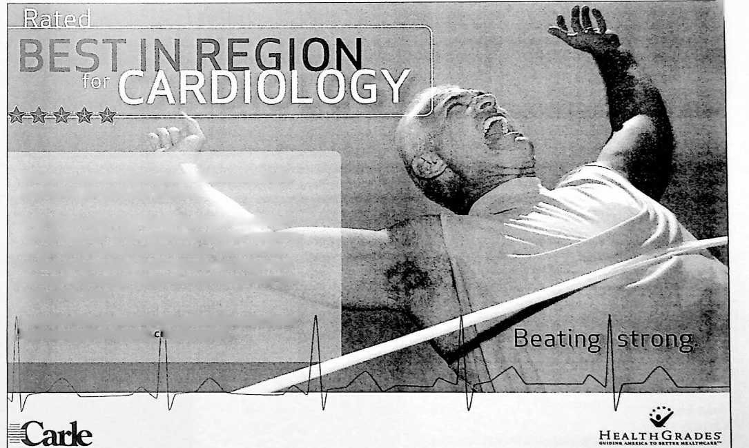

LEND A HAND

*cf.* There’s Nothing like a Classic Lounge Chair

Kick up your heels and RELAX with this classic lounge chair and ottoman from Natuzzi, the world’s leading manufacturer of fine Italian Leather Furniture. This beautiful lounge chair features lightly glazed burnished brown leather with walnut linished legs.

**Bud Leister**

**Carter’s Furniture, Inc.**

**Carter’s Moving and Storage, Inc.**

1. Nothing says “I Love You” like Browne’s Fine Jewelry

Neil Browne and our friends at BankChampaign have teamed up to provide a $600 gift certificate at Browne's Fine Jewelry. You can pick out that perfect pendant, earrings, or use the gift certificate as a down payment on an even bigger piece of “ice."

Browne’s Fine Jewelry

BankChampaign

1. Make your Next Party a Classic with a Classic Events Party

Certificate

Put together a great party anywhere, including your backyard, dining room, or tailgate with $ 750 gift certificate from Classic Events

Catering. -V

John & Sharon Ady

Dave & Jane Bernthal

1. Stone Creek Golf experience

Get a foursome together for a great golfing experience this summer at Stone Creek Golt Club. You’ll enjoy 18 holes on one of Central Illinois’ finest courses and, if you lose any golf balls, it won't bother you as much because this package includes one dozen Titleist golf balls.

Clifford-Jacobs Forging Company

Justin McCarthy

1. Dog House Preventer! Flowers for a Year

Want to stay out of trouble? A nice bouquet of flowers delivered to that special someone. Every month. Just like clockwork and you don't even have to remember. Buy this for someone else or buy it for yourself and enjoy fresh flowers and peace on the home front.

1. Some say Chocolate is an Aphrodisiac - Imagine a Nice Big

Godiva Chocolate Tower

Umm, does anything soothe your mind and please your taste buds like Godiva chocolate. How about a Godiva chocolate gift certificate that you can redeem at any Godiva Boutique, Godiva store or online at Godiva.com. That’ll keep you happy!

1. Flu Shot Express!

Provide a great service for your employees by bringing the Christie Clinic Flu Shot Van to your business. Keep everyone healthy during the next flu season by bringing this service right to your door.

**Joan Dixon**

**Christie Clinic**

18

**LEND A HAND**

1. “Road to the Sun Singer” A Limited Edition

"Road to the Sun Singer" by artist Larry Ziemer is a signed and numbered limited edition print. The original watercolor was painted during a New Year’s Eve celebration on the night of December 31, 1999. Allerton Park has always had a personal collection and special meaning for Larry and his wife, Carol. As a high school student, Larry twice received a scholarship to attend art camp at Allerton Park and later worked as a “house boy" in the mansion. Carol was fortunate to live on the grounds since her father worked in the main house for 33 years. Larry, a self-taught artist, has had over 30 one-man exhibits and his work has been accepted in numerous group shows across the country. He and his wife have owned and operated Ziemer Gallery in Monticello for more than 26 years.

Steve & Marilyn Ayers

1. South American Experience, Dinner at Escobar’s Restaurant Enjoy a romantic and delicious dinner for 2 with a $100 gift certificate at Escobar's Restaurant in downtown Champaign. The coconut flan is heavenly.

**Justin & Middy McCarthy**

1. Foursome Showdown at Stone Creek Golf Course

Get your three pals and make a day of it at Stone Creek Golf Course. Here is one of the most enjoyable 18-hole public championship golf courses in downstate Illinois. The beautifully manicured bent grass fairways, soft smooth slopes and subtle elevation changes make Stone Creek Golf Club a true golfer’s experience. When you visit Stone Creek Golf Club you will quickly realize where it got its name. With numer­ous lakes and stone-laden creeks, Stone Creek is a true delight to golfers. This Stone Creek package includes full green and cart fees for four golfers, along with 4 Titleist lllini golf hats. Fore!

Slone Creek Golf Club  
Perry Greene

1. Audrey’s Secret Cookbook  
   Collection Viewing

Can’t find that recipe that Mom used to make? Wondering just what made  
that pie taste so good? The live in person equivalent of the Google of  
recipes is available to you. This offering is from the home of one of the  
most fantastic collectors around. You can spend an afternoon reading or  
copying recipes from Audrey Skelton's collection of approximately 1,500  
cookbooks. Now that’s a lot of recipes!

Audrey Skelton

1. Clean Joke of the Day Dry  
   Cleaning - You Roll the Dice!

An Action Auction tradition - You roll the dice to determine the value of  
your dry cleaning gift certificate courtesy of the Hamburgs and Garber's  
Cleaners. Joe and Steve provide the dice and multiply the number you get  
when you roll by 100. The resulting number will be the value of dry clean-  
ing services you are entitled to. The maximum is $ 1,200 and regardless  
of what you roll, the minimum is $500. Tell Steve a clean joke and if you  
roll low he may let you roll again.

**Joe and Steve Hamburg**

**Garber’s Cleaners**

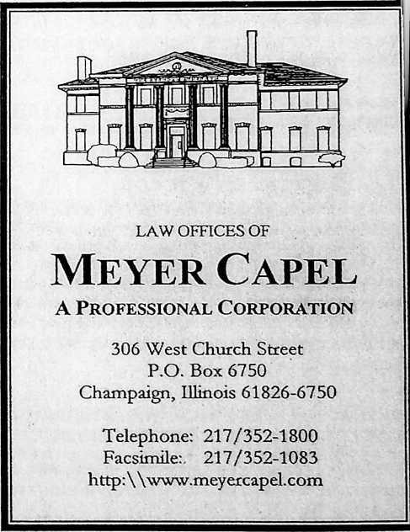

19

**DON’T FORGET ABOUT THE GREAT SILENT AUCTION ITEMS**

1. Teens drive right at M&M

Driving School

Now here's a great prize - Driving Lessons! This complete “Teen Driver Program" includes a complete 30-hour classroom and behind-the-wheel instruction or just the behind-the-wheel course with fellow Rotarian Tony Martin.

M&M Driving School

Tony Martin

1. Benefit Planning

Consultant

$500 in services from BPC, Inc. towards the setup and adminis­tration of your company's Cafeteria Plan, Flexible Spending Plan (Flex), or a Health Reimbursement Arrangement (HRA) for your employees.

Habeeb Habeeb

***This*** is Main Street

**Thank you to Champaign Rotary  
for all of the community service  
projects you sponsor!**

**Congratulations on another  
successful Action Auction!**



1. Radio Advertising Works

Wonders!

Give your business the exposure it needs and deserves with a  
$1000 advertising campaign on your choice of C-U Radio Group  
stations, including 105.9 WGKC, 96.1 WQQB Q96, 93.5 WEBX  
The Rock or 95.3 WMYE My95. Reach your customers through

the power of radio!

Corey Berkemann

Champaign-Urbana Radio Group



100 West University Avenue, Champaign

217.351.6500

[www.mainstreettrust.com](http://www.mainstreettrust.com)



Member



1. Pottery by Victor

Four beautiful pieces of hand-crafted pottery by WGRC's own Victor Feldman. An unusual bowl 8-inches in diameter, 4-inches deep is in brown tones finished with a scalloped edge and a beautiful glazed pattern. A lovely pot and lid measuring /-inches wide and 11-inches high, in tans and browns and blacks would enhance any decorative setting. A superb tan pitcher with light blue dripping patterns could be used for wine or as a vase on your dining table. It measures approximately 8-inches wide by 8-inches tall. A 7-inch wide, 6-inch tall pot with lid in blues and grays completes the group. Victor's pottery pieces are becoming collectors items for those who love hand-thrown pot­tery of professional quality.

Victor Feldman

Tom & Jef Cornell

1. Wine Tasting Party with the Ladies of Rotary - Amie, Darlene, Sue and Joan!

You'll enjoy a delicious and diverse selection of wines and a great evening of conversation with these ladies of Rotary: Amie Smith, Darlene Johnson, Sue Grey, and Joan Dixon. A great way to spend a summer evening or even a winter evening!

**Amie Smith Sue Grey I 0**

**Darlene Johnson Joan Dixon /**

20

**DON’T FORGET ABOUT THE GREAT SILENT AUCTION ITEMS**

1. “One cannot Think Well, Love Well, Sleep Well, if one has not Dined Well” Virginia Woolf, *A Room of One’s Own.*

We invite you to treat yourself, your special someone, and six of your closest friends to an elegant seven-course Holiday Dinner on Saturday, December 15, 2007 in the new home of Rotarians Tom and Jef Cornell. Relax with cocktails by the fire before moving to the table for a gourmet experience guaranteed to remove from your minds the hustle and bustle of Holiday cares through a memorable meal, musical entertainment and a personal gift presented to you with a flair only WGRC chefs and waiters Tom and Jef Cornell, Jerry and Anne Laughlin, and Marilynne Davis can provide. Bon Appetite!

**Tom & Jef Cornell Marilynne Davis Jerry & Anne Laughlin**

1. Golfers - Time for a Lesson from Illini Coach Mike Small

This Rotary Action Auction exclusive features a one-hour personal golf lesson with Illinois men's golf coach and former PGA pro Mike Small and Dave Pezzino and a tour of the new state-of-the-art Demirjian Indoor Golf Facility. There's golf lessons and then there's a REAL golf les­son from Mike Small. Get in line to bid on this one!

Dana Brenner

Division of Intercollegiate Athletics

1. If I were Mayor of Champaign for a Day, I’d...

Now you can answer that question. Champaign Mayor Jerry Schweighart invites you to spend the day with him and make all of those top- level decisions. This "Spend the Day with the Mayor" package gives you the chance to experience City Hall without having to run for office. Imagine breakfast at Taffies, coffee at City Hall, meetings with the town fathers and, who knows, Jerry may even let you cut a ribbon.

**Mayor Jerry Schweighart**

Raffle Items

1. Petula Clark says Go Downtown - to the Boltini Lounge

This gift certificate will let you make a night of it as you go downtown and host your friends at the very “in” Boltini Lounge. The next round can be on you all night long.

1. Papparazzi Wannabe

Whether you want to be a professional photographer of just want to be able to take better family photos this is your chance. Renowned local photographer Karyl Wackerlin is offering a four hour lesson. You learn digital or film photography. The real bonus is that your lesson includes a field trip and Gary is not invited.

1. Fit as a two fiddles, Two 6-month free memberships at Mettler Center The Mettler Center provides you with a complete fitness experience, including an initial personal assessment and personal training sessions designed just for you. Members are also welcome to participate in group aerobic and cycling classes. Two 6-month free memberships will get you on the right road to fitness!

**Miles Mettler**

**The Mettler Center**

21

**SERVICE ABOVE SELF**

1. Fore! Some More DSC’s i8th Annual Golf Classic at  
   Lincolnshire Fields Country Club

One of Central Illinois' most enjoyable golf outings, the 18th annual DSC Golf Classic is scheduled for May, 2008 at Lincolnshire Fields  
Country Club. Your foursome will enjoy lunch, 18 holes of golf, all beverages and snacks. Following the outing is a cocktail party and  
awards ceremony with a light dinner and desserts. All items are free to the winning bidder! Dale Morrissey will give you his mulligans. What

a deal!

Dale Morrissey

Developmental Services Center

1. Get Fit at the Y—YMCA Fitness Membership

A full one-year adult membership at the Champaign County YMCA gives you the opportunity to improve your wellness while supporting the community through YMCA programs and activities for families, youth, and teens. Enjoy the opportunity to have Rotarian Wade greet you for your morning workout

Wade Hampton

Champaign County YMCA

1. Content, Context and Style - Professional Editing

So you have this cogent concept to share with a waiting world, but struggle to put your perspectives into publishable form? Simply want to get something off your chest, but are stymied by the complexities of sound syntax? Let a professional document doctor treat your muddled manuscript (up to 3,000 words). Once he edits for organization and malapropisms, your essay will effectively express what you wanted to say all along.

Peter Tomaras

1. Schnuck’s Party for 50

Get the whole gang together for an lllini football tailgate, backyard party, or family get-together, and let Schnuck's Catering handle the food. That's right, a Schnuck's Party for 50 people includes the main courses and side dishes. You just provide the people and the appetites.

Dan Wheatman

1. “Being Matters” Krannert Center Performances

Enjoy world class musical and theatrical performances without having to leave your own community. Some of the world’s top entertainers visit the Krannert Center for the Performing Arts and you can, too. This gift certificate provides a season pass for Krannert events.

1. Ebertfest Tickets

The last weekend in April in Champaign has become a popular destination for moviegoers, producers, actors, and Hollywood's finest at the annual Roger Ebert’s Overlooked Film Festival. You and a guest will enjoy the show up close!

1. Two Ice Cream Cakes are Better than One

Cold Stone Creamery will provide you with two delicious Ice Cream Cakes to enjoy during the hot summer months. Ummm! Forget the calo­ries; think of all of the combinations. A very cool idea.

**Eric Bussell**

**Cold Stone Creamery**

**SERVICE ABOVE SELF**

1. You will be Riding on a Cloud with this Aerial Photo Display Legendary local stunt pilot Rudy Frasca shares fantastic aerial photographs, suitable for framing in your home. You'll always have a story to tell when your friends check out Rudy's world-class aerial photography of some of the world’s most famous aircraft.

Rudy Frasca

1. A Family Smile by Tureski Photography

Now is a good time to get that new family portrait or to get a jump on this season's Holiday Photo! Tureski Photography will provide a pro­fessional photo sitting for your family and a $ 250 gift certificate good for purchase of photographs.

Tureskis Photography

1. Chiropractic Gift Package

Is your back still bothering you? Why not let a professional take a look? Dr. Stringer will provide a free examination and initial treatment to get you on the road to recovery with this Healthy Back and Neck Gift Basket, including a cervical pillow, various aromatherapy items, bio­freeze, gift certificate for chiropractic examinations and x-rays, hot/cold pack, and various relaxation items.

Dr. Matt Stringer

Stringer Chiropractic Clinic

1. Savoy Recreation Center

An all-inclusive package includes three $25 gift certificates, six family weekly passes, and 16 group fitness passes for the Savoy Recreation Center. Use the gift certificates for membership, program or fitness classes! The weekly passes allow the entire family to use the gym, walking track, and weight and cardio rooms. And the group fitness passes allow you to join a group fitness class! If you need encouragement, call Village Board Member Mr. Rotary Art Skelton fora fitness pep talk.

Savoy Recreation Center

1. Be a Swinger in your Own Home with this Personal Driving Range The Golf Swing and Auto Ball Return Putter Practice Device will turn your home, garage, or backyard into your own private driving range and golf academy. Work out the kinks in that swing, tune up your putting, and improve your golf game with this miracle device!

John Ady

1. Listen! You can Enjoy the Champaign-Urbana Symphony The music and the atmosphere are absolutely beautiful when you and a guest purchase 2 sets of 2 tickets to any Champaign-Urbana Symphony performance (excluding the April 6, 2008 Special Benefit Performance) at the Krannert Center for the Performing Arts.

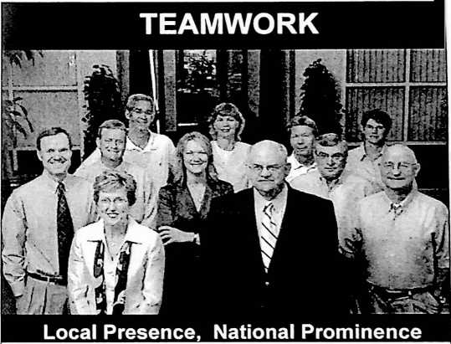

**Cozad Asset Management, Inc.**



**Champaign-Urbana Symphony**

2501 Galen Drive Champaign, IL 61821  
217-356-8363 or 1-800-437-1686  
[www.cozadassetmgmt.com](http://www.cozadassetmgmt.com)

**Sccunbcs offered through FSC SECURITIES CORPORATION. A registered troker.Ueaier. Member NASD S SIPC.  
Investment advisory services offered through Co»d Asset Management. Inc., a registered investment advisor.**

23

**HAVE YOU PURCHASED YOUR RAFFLE TICKETS?**

1. Have you Played Golf at Ironhorse in Tuscola?

Another great golf course in Central Illinois is the challenging and multi-terrain Ironhorse Golf Course just north of Tuscola. The Ironhorse layout provides an excellent test with undulating fairways, hills, doglegs, and plenty of water. This challenging and beautiful course will make for a delightful afternoon for your foursome. A great course that is fun to play

Jerry Williams

Ironhorse Golf Club

1. Clean it Up like the Pros! Car Detail Service from Worden Martin

Now is the time of year to roll down the windows and show off your ride. Let Worden Martin pamper your car with a complete car detailing service.

1. Complete Auto Detailing from Triple T

Your car deserves a bumper to bumper detailing treatment from the Triple T Car Wash, Lube & Detail Center. Your car will look and feel like new!

**Greg Tyner**

**Triple T**

1. New York Giants Fan Pack Follow former lilini Dave Diehl (Geoff and Ann Poor's son-in-law) with the New York Giants with this auto­graphed football and New York Giants helmet.

**Geoffrey and Ann Poor**

**David Diehl**

**New York Giants Football Club**

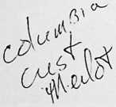

**PROCEEDS FROM THE 2007 ACTION  
AUCTION WILL BENEFIT THE FRANCES  
NELSON HEALTH CENTER, THE  
CHAMPAIGN COUNTY YMCA, AND THE  
DON MOYER BOYS AND GIRLS CLUB.**

KEEPING YOU

YOUNG AT HEART



**Heart Center**

**A service of Carle Clinic Association  
and Carle Foundation Hospital**

Having a strong, healthy heart is one of the best ways to ensure the life you're enjoying will be as long and fulfilling as possible.

The dedicated physicians and staff at the Carle Heart Center can provide expert diagnoses and care, while offering a full range of inpatient and outpatient services.

Choosing care from Carle Heart Center may just keep you young at heart.

**To schedule an appointment, call 217.383.3200.**

v •<  
**1**

I ■

24

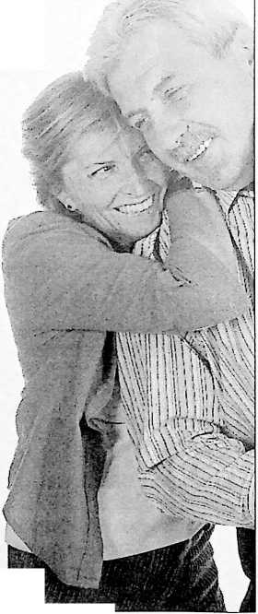







**Action Auction 2007 supports projects in the community, including:  
Frances Nelson Health Center  
Champaign County YMCA  
Don Mover Bovs X Girls C.hih**