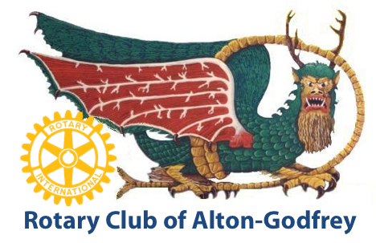

**Officers:**

President

Antione Williams

Vice President-President Elect

James Claywell

Secretary-Treasurer

Donna Bemis

Past President

Steve Schwartz

Directors:

3rd Year:

Patrick Loechl

Steve Thompson

Dennis Wilson

2nd Year:

John Keller

Ron Mayhew

Larry Thompson

1st Year:

Arthur Fahrner

John Hopkins

Myles Yanta

Executive Secretary:

Katie Sabolo

[altongodfreyrotary.org](http://altongodfreyrotary.org)