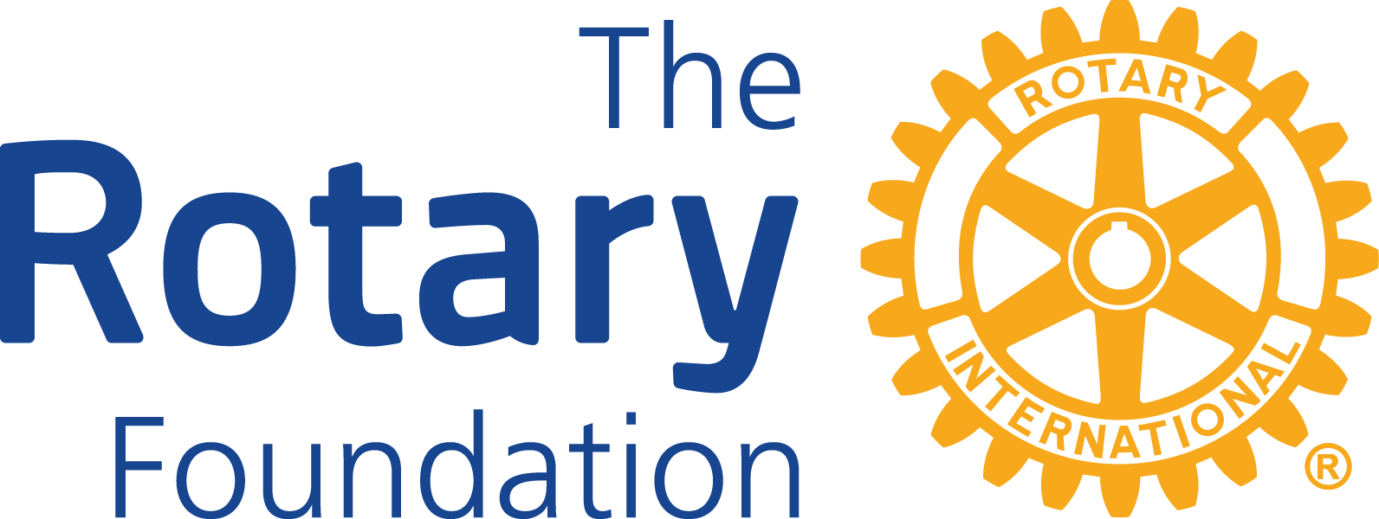 | THE ROTARY FOUNDATION  DISTRICT COMMUNITY GRANT  SINGLE CLUB APPLICATION
The Rotary Foundation funds district community grants that pay for scholarships, travel, and projects that all align with our mission to help Rotarians contribute to world understanding, goodwill, and peace by improving people’s health, supporting education, and alleviating poverty. The grants are funded from the District Designated Funds (DDF).
The application deadline is May 31 of the current Rotary year for projects to be completed in the next Rotary Year.
- Rotary Clubs may submit one single club application per year.
- Rotary Clubs must be qualified and must have contributed USD $100 per capita to the Rotary Foundation Annual Fund (Share). The contributions must have been received by June 30 of the current Rotary year.
- The grant amount awarded will be at least $1,000 and no greater than $2,500 matched on a dollar-for-dollar basis against the Club donation. The Club may contribute more than the grant match and other non-Rotary contributions are welcome.
- Rotary Clubs must not start the project until given approval by the District Rotary Foundation Committee.
- Rotary Clubs will receive the grant funds after project completion and after an acceptable grant report has been received. The reimbursement check must be cashed as soon as possible.

APPLICANT (PROJECT COORDINATOR) INFORMATION
Name: | (Highlight and over-type here.) |  | Club: | (Highlight and over-type here.)
Email: | (Highlight and over-type here.) |  | Phone: | (Highlight and over-type here.)

PROJECT NAME: | (Highlight and over-type here.)

Please check the appropriate box | This is a local project |  | This is an international project

Grant Request: | (Highlight and over-type here.) | Club Match:  (Must be at least the Grant Request) | (Highlight and over-type here.)

PROJECT PROPOSAL: Please provide a summary of goals and deliverables.
(Highlight and over-type here. The box will expand as necessary.)

PROJECT IMPLEMENTATION: Please give an outline of the project.
(Highlight and over-type here. The box will expand as necessary.)

PROJECT START DATE: This must be after the final approval to be given by the District Rotary Foundation Committee which is estimated to be by mid-July of the next Rotary year.
(Highlight and over-type here. The box will expand as necessary.)

PROJECT COMPLETION DATE: Please give the estimated completion date of the project. This must be before May 31 of the next Rotary year.
(Highlight and over-type here. The box will expand as necessary.)

OTHER PARTICPATING ORGANIZATION: If the project involves another non-Rotary organization, please give the name of the organization, and provide a letter from that organization confirming their willingness to cooperate with your club on this project.
(Highlight and over-type here. The box will expand as necessary.)

PROJECT OWNERSHIP: Please state the final owner of any project equipment / materials / supplies that will be provided by this grant. This cannot be a Rotary Club or Rotarian.
(Highlight and over-type here. The box will expand as necessary.)

BUDGET EXPENDITURES. Include a list of all expenses and items to be purchased, the name of the supplier and the amount in USD. If purchases are made in Canadian dollars, use the current RI Exchange rate.
(Highlight and over-type here. The box will expand as necessary.)

BUDGET REVENUE: Include the source of all project revenue. The total revenue must be equal to the total expenditure.
(Highlight and over-type here. The box will expand as necessary.)

ROTARY CLUB PROJECT COMMITTEE: A Project Implementation Committee of at least three Rotarians must be established for the project. It is the Project Committee's responsibility to (a) coordinate the project, (b) monitor funds, (c) provide reporting and (d) financial accounting to the District Grants Committee. The Project Committee Chair (Primary Contact) will be responsible for successful project completion and compliance with District Grant reporting requirements. The committee list should include 2 additional names in this section. Do not list the Project Committee Chair (Primary Contact) as one of these 2 members. The additional 2 committee members are as follows
Second Committee Member
Name: | (Highlight and over-type here.) |  | Club: | (Highlight and over-type here.)
Email: | (Highlight and over-type here.) |  | Phone: | (Highlight and over-type here.)
Third Committee Member
Name: | (Highlight and over-type here.) |  | Club: | (Highlight and over-type here.)
Email: | (Highlight and over-type here.) |  | Phone: | (Highlight and over-type here.)

TERMS AND CONDITIONS FOR THE DISTRICT COMMUNITY GRANT

- Program Requirements
  - Use of all grant funds must comply with these Terms and Conditions.
  - Grants must respect the wishes of the receiving community and strive to understand and appreciate its traditions and culture.
  - Grants require the direct involvement of Rotarians to:
    - Assess community needs and develop a project plan.
    - Establish a committee of at least three Rotarians to oversee the expenditure of funds.
    - Oversee grant funds.
    - Implement project.
    - Provide evidence of community involvement and ownership.
    - Organize meetings with local service providers, local officials and/or recipients.
    - Promote the project in the local media.
- Policies
  - Projects must be initiated by the Rotary Club making the application.
  - Grant funds cannot be used for:
    - Salaries (other than instructional salaries), stipends, or honorariums.
    - Operating expenses of another organization.
    - Personal or professional development. If you have questions or concerns regarding this issue, please contact the District Grants Chair.
- Guidelines
  - The District Grants Committee will accept applications until May 31 of the current Rotary Year. Grant award reimbursement will be provided upon the submission of complete final project report. If this guideline presents a hardship for an application, please note in the application and the District Grants Committee will consider other arrangements.
  - Incomplete applications will be returned to the Club and may or may not be considered depending on availability of funds.
  - The District Grants Committee will review a Club's application only if that Club's District 6400 and Rotary International dues are current.
  - BaThe District Grants Committee will award the District Community Grants based on (a) project merit, (b) amount of request and (c) the submitting Club's past contributions to The Rotary Foundation. Clubs that did not meet past grant reporting deadlines might not be considered.
  - The District Grants Committee will entertain all requests of $1,000.00 USD but may choose to approve an amount less than the requested amount depending on the number of applications and the availability of grant funds.
- Reporting Requirements
The sponsoring Rotary Club must submit a final report to obtain the grant payment reimbursement. The final report must include:
  - An electronic report that provides detail of all expenses. The Total Income Budget must equal the Total Expense Budget. For auditing purposes, please retain all original receipts and submit copies for reimbursement.
  - Documentation of Rotarian participation in the implementation of the District Community Grant which (a) reflects the required Rotarian activities and (b) includes a minimum of three photographs (i.e., JPEG, PDF, etc.) appropriate for publicizing the completed project; and
  - A narrative that includes information on the implementation of the project and how experience gained from it will inform/guide the district for the next Rotary year.

The following signature of the sponsoring Rotary Club President for the next Rotary year, i.e., the president for the period during which the project will be undertaken confirms that:
- All information contained in this application is true and accurate to the best of your knowledge.
- This application meets the criteria that is set out above for Terms and Conditions for the District Community Grant.
- The Club has agreed to undertake this project as an activity of the Club and organization(s) (if any) involved.
- We understand and will comply with the required Rotarian activities and reporting requirements as stated.
- We agree that all reports will be provided within one month after project completion and no later than May 31 of the next Rotary Year.

SIGNATURES: So that we can process electronic documents, your name typed in italics and within quotes count as a signature.
Club President for next Rotary Year (Current Club President-Elect): |  |  | “Type your name between the quotes”
 | Name |  | Signature

Please send the completed application form and all attachments by email to:
Richard J. Caron, District Grants Chair
rjjmcaron@gmail.com
519-819-0100

Date Received by the District Grants Chair:
Date Approved by the District Rotary Foundation Committee:

