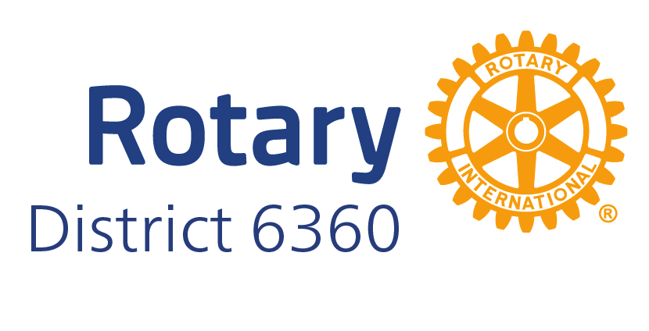

**ROTARY D6360**

**Rotary Administrative Assistant**

**Job Description**

The Rotary Administrative Assistant plays an important role in giving the best first impression of the welcoming, engaging, servant-mentality of District 6360. Since this position reports to the District Governor, the primary responsibility of this job is in providing administrative support to the District Governor. The secondary focus of the job is in supporting District leadership. The final and most visible responsibility is in operating as an information resource for District Rotary Clubs.

**ESSENTIAL RESPONSIBILITIES**

* Administrative Support to the District Governor, covering all event coordination, communication and ensuring proper documentation for Rotary International, District & Club
* Support District Leadership, including liaison to Rotary International (includes DGLine - PDGs, DGE, DGN, DGND, District Board and District Staff)
* Information resource to Clubs, including District giving input on events, point persons and communication resources (MyRotary, Rotary Club Central and DACdb)

**SPECIFICS**

* + Communication
    - Provide communication support on behalf of the District Governor
    - Send District members notices of events and registrations
    - Serve as District DACdb (District and Club Database) coordinator
    - Maintain District calendar
    - Coordinate and publish Monthly District Newsletter
    - Coordinate incoming District communication
    - Assist in sending District-wide Pmail, as requested
    - Forward solicitations to appropriate District Leader (includes, but not limited to District Communications (DACdb), Membership, Public Image, Rotary and District Foundations, and Youth Programs)
  + Administration (Documents, Meetings, Electronic systems)
    - Maintain electronic and hardcopy master file of event attendees, agendas, brochures and programs
    - Maintain electronic and print copies of Manual of Procedure and ByLaws
    - Work with clubs to assure update of membership data in DACdb
    - Assure all Clubs Goals are entered into Rotary Club Central for Membership, Foundation and Polio Plus
    - Support Clubs in reporting goal achievement for Rotary Citation
    - Assist District Governor with official visit schedule
    - Scheduling and hosting virtual meetings, as requested
    - Take minutes of District Board Meetings when District Secretary is not present
    - Cataloging and categorizing historical archives - physical and electronic
    - Providing spreadsheet information, as requested, by the District Governor
    - Ensuring all District files are accessible and shareable
    - Maintain physical and shareable electronic District archives
  + Meeting & Event Coordination
    - Coordinate DG schedule, including confirming Club visits and special events
    - Provide assistance coordinating all District-related events (District Conference, Pre-PETS, PETS, OneSummits, Club Leader Assembly, Leadership Transition and other District Training or District Events), including sourcing and securing venues, sending out registration notices, setting up signage, welcoming guests in-person at registration and coordinating handouts and materials (including, pre-loaded name badges and pre-collated welcome packets)
    - Coordinate District Awards (submissions, ordering, distribution)
    - Assist Committee Chairs with securing dates, locations, meals & swag

# QUALIFICATIONS

* Team-oriented, willing to work collaboratively, open-minded, sharing ideas and taking input
* Strong interpersonal, verbal and written communications skills
* Trained and well-informed on Rotary International and Rotary District 6360 database and communication software (MyRotary, Rotary Club Central and DACdb)
* Experienced managing multiple projects efficiently
* Highly-organized, responsive and able to problem-solve

# EDUCATION & TRAINING

* College or training preferred in Business, Communications, Management or Marketing
* 5+ years experience in customer service, program management or philanthropic groups
* Competency in various communication medias - DACdb, Facebook, Google Apps, Instagram, LinkedIn, Microsoft, WhatsApp and Zoom
* Proficient in multiple electronic software formats for word processing, spreadsheets, online registration formats (Google forms, Microsoft Word, Excel, etc.)

Sept 25, 2024, JH/TL/MO/TBrandell