**Rotarian of the Year Plaque (Russell Hampton - #34745) –   
Waterfall Jade Crystal Award (8”)**

**ROTARIAN OF THE YEAR  
2022  
Presented to**

**WANDA BLOOMQUIST**

**In Recognition and with Appreciation  
For Your Service and Unselfish   
Dedication to**

**WILLIAMSTON SUNRISE  
ROTARY CLUB**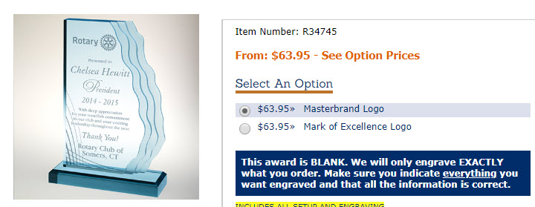

**President Plaque (Russell Hampton - #** **R34105 - Master Brand w/Black Plate) – Traditional Walnut Gavel Plaque (8x12”)**Solid American walnut plaque features full wooden gavel, antique gold-plated metal emblem and satin brass or black brass engraving plate. 12" x 8"

**Presented to**

**WANDA BLOOMQUIST**

**For Your Outstanding Leadership as   
President 2021-2022**

**WILLIAMSTON SUNRISE ROTARY CLUB**

