**Rotarian of the Year Plaque (Russell Hampton - #34745) –   
Waterfall Jade Crystal Award (8”)**

ROTARIAN OF THE YEAR  
2019  
Presented to

NORM SHINKLE

In Recognition and with Appreciation  
For Your Service and Unselfish   
Dedication to

WILLIAMSTON SUNRISE  
ROTARY CLUB  
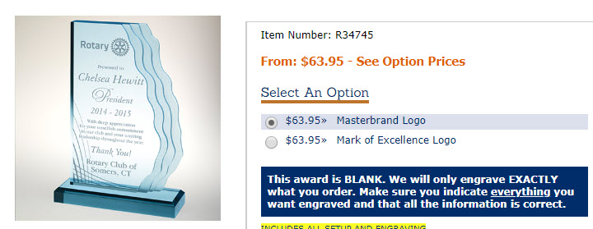

**President Plaque (Russell Hampton - #** **R34105 - Master Brand w/Black Plate) – Traditional Walnut Gavel Plaque (8x12”)**Solid American walnut plaque features full wooden gavel, antique gold-plated metal emblem and satin brass or black brass engraving plate. 12" x 8"

Presented to

NICK HORSTMAN

For Your Outstanding Leadership as   
President 2018-2019

WILLIAMSTON SUNRISE ROTARY CLUB

