* Open DACdb
* Select the Engagement/Attendance module

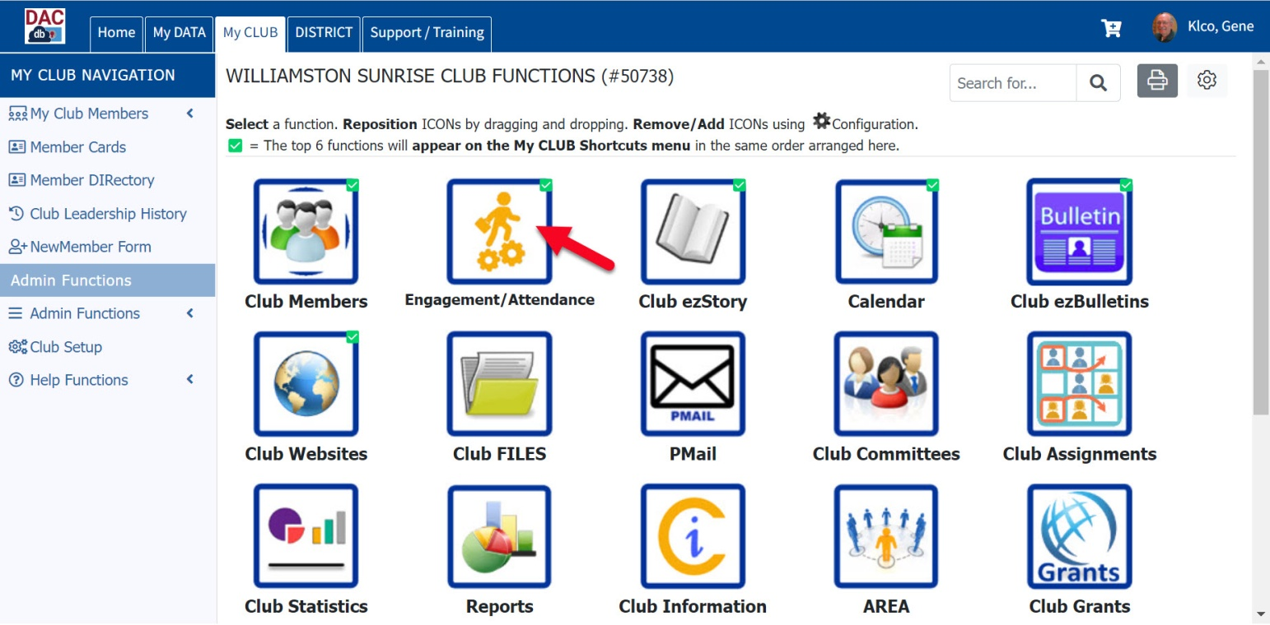

* Select **Manage Meetings**

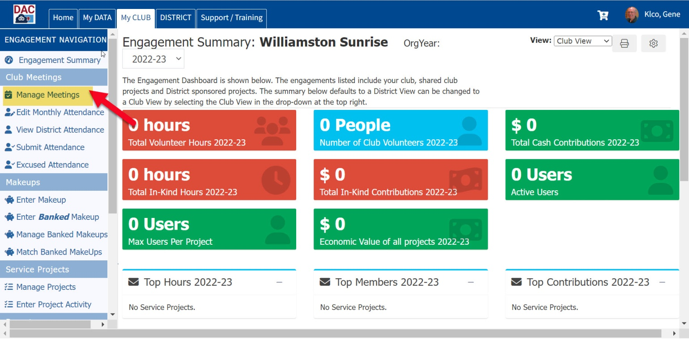

* **Select Add Club Meeting**

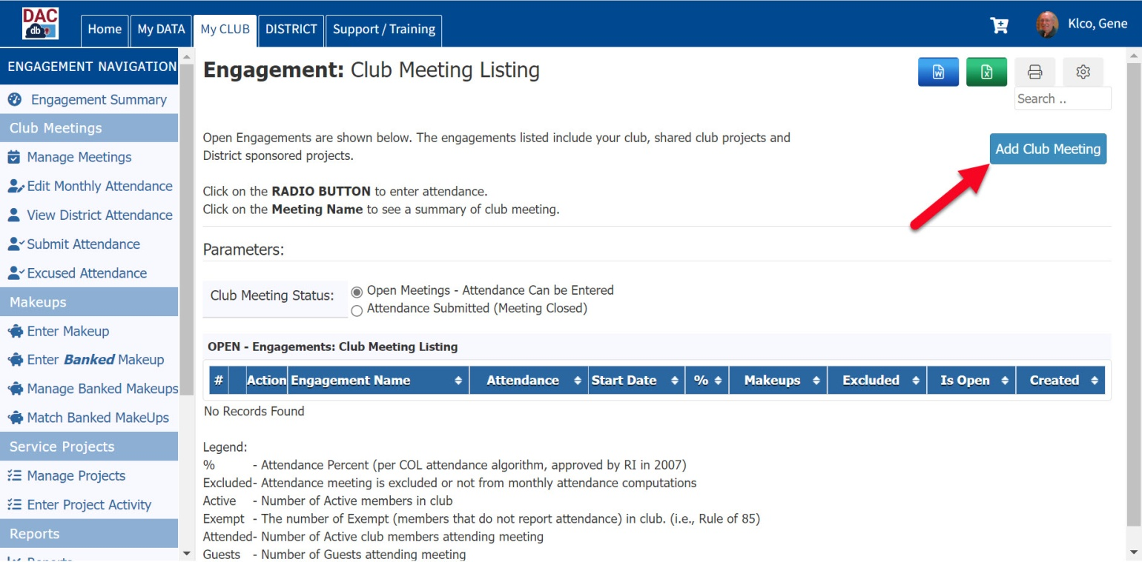

* Make sure the date of the meeting is correct
  + You can change the date by picking the calendar
  + Also the title for the date can be edited
* Select **Save**

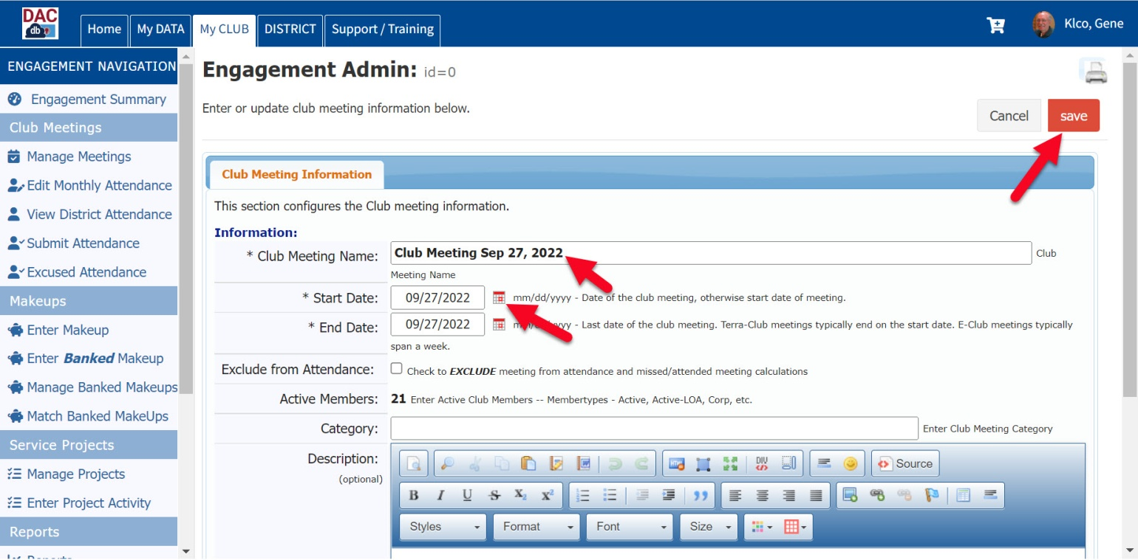

* When you see club meeting listed, select the ‘**Radio’ button** to select the members that attended the meeting

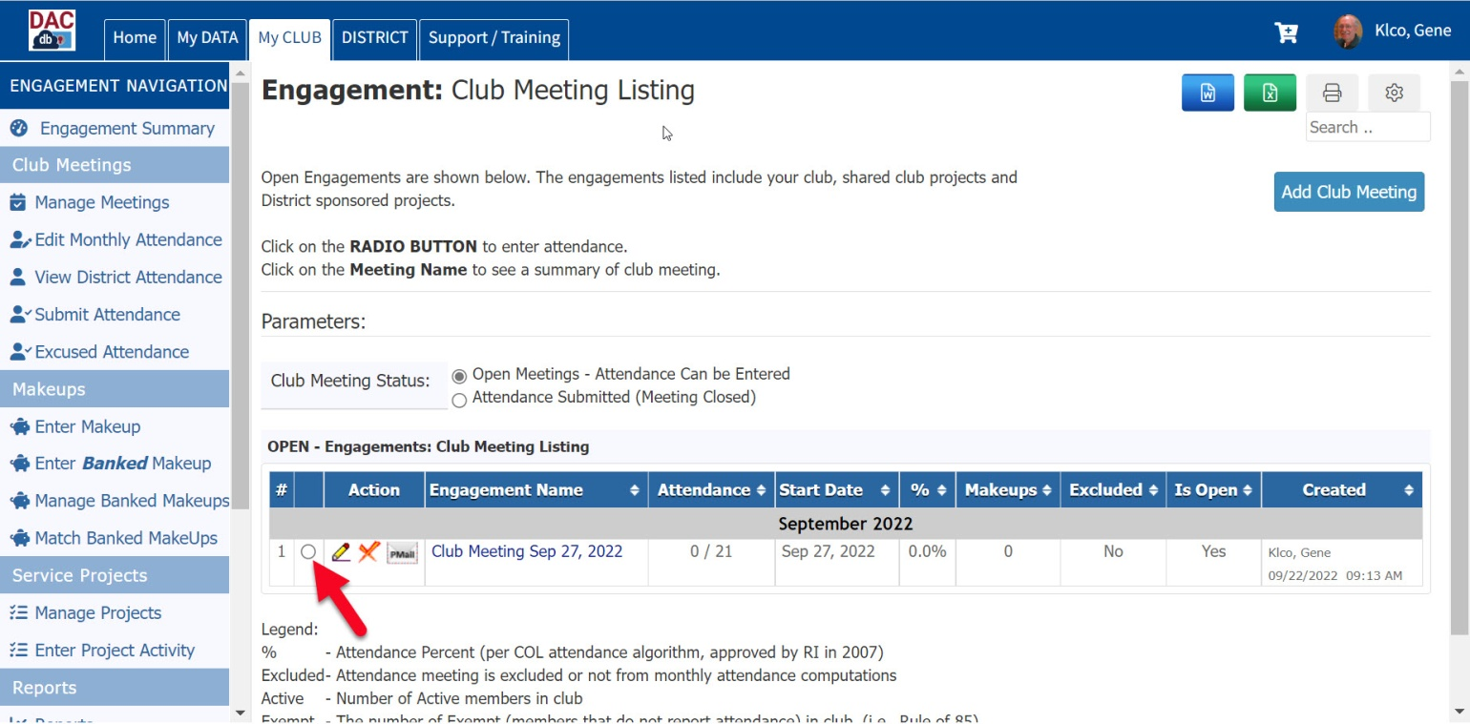

* You should see a list of YOUR members (this shows the regular Rotary members)
* Select the box for all the members in attendance at the meeting

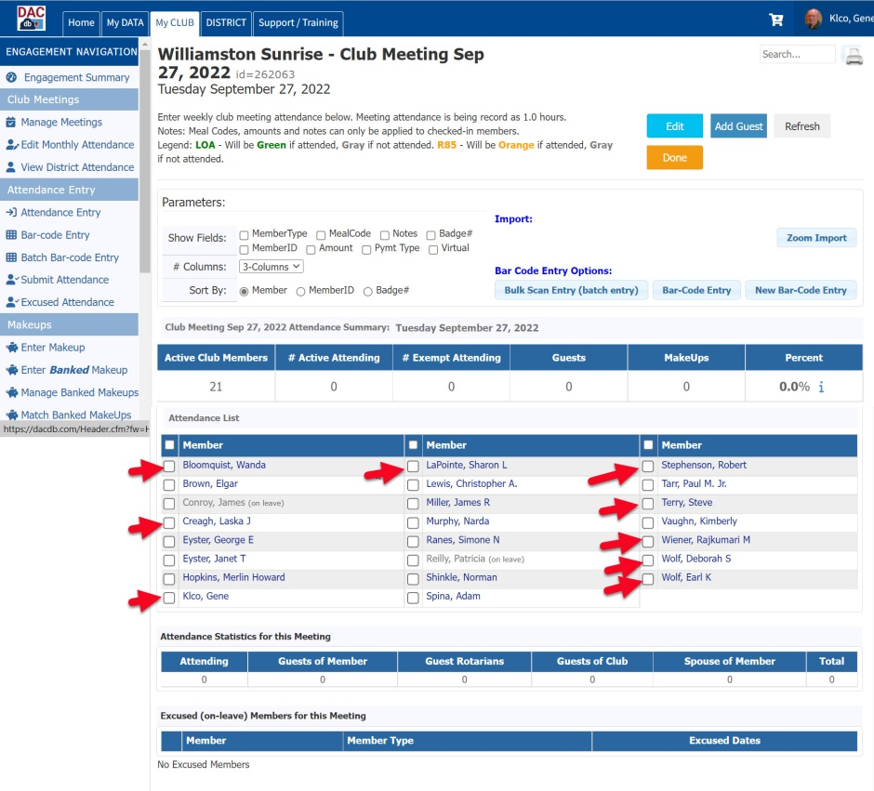

* When you select the member, the system will highlight that member
* When you have all members selected, select **Done**

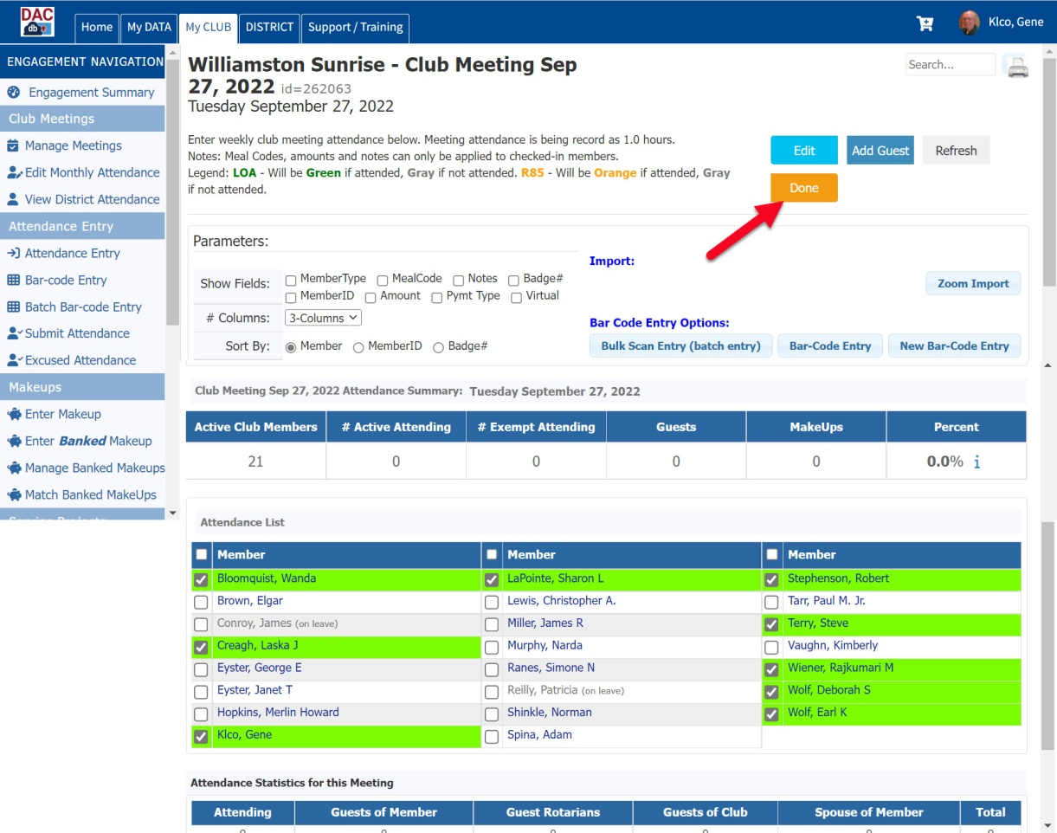

* Now select the pencil for that meeting date

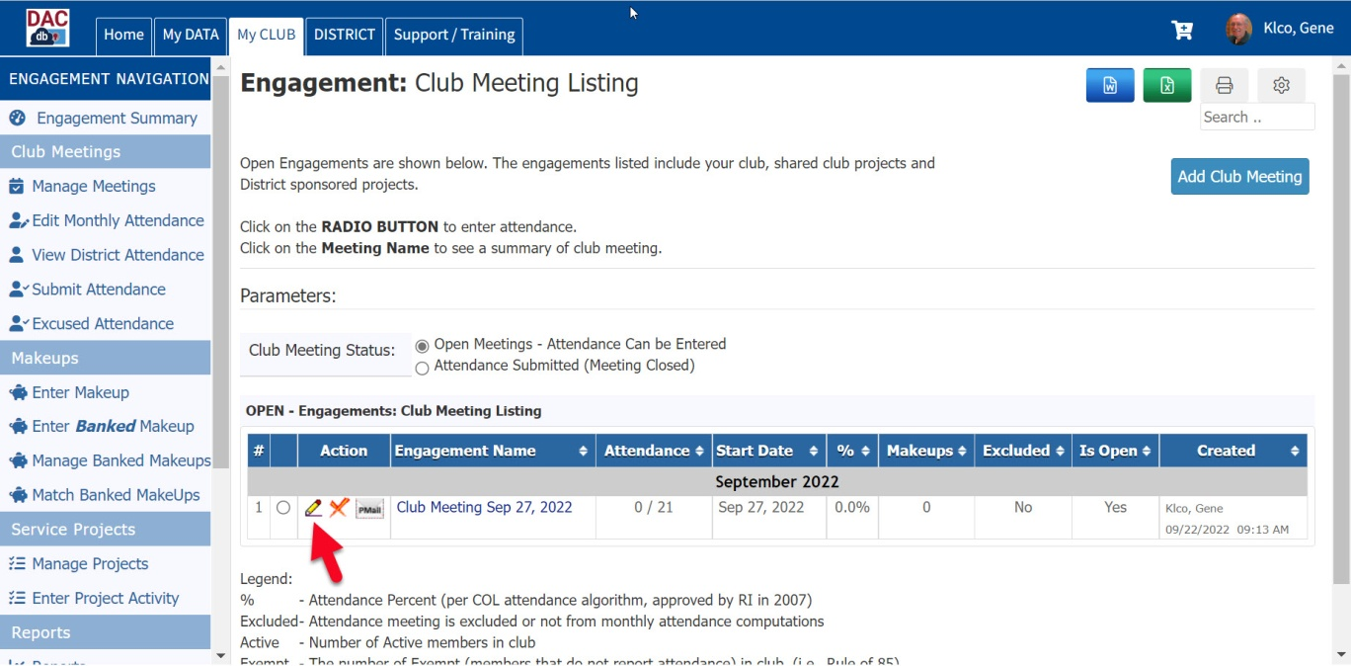

* Select the drop down **Attendance Submitted** – from **No** to **Yes**
* Select **Save**

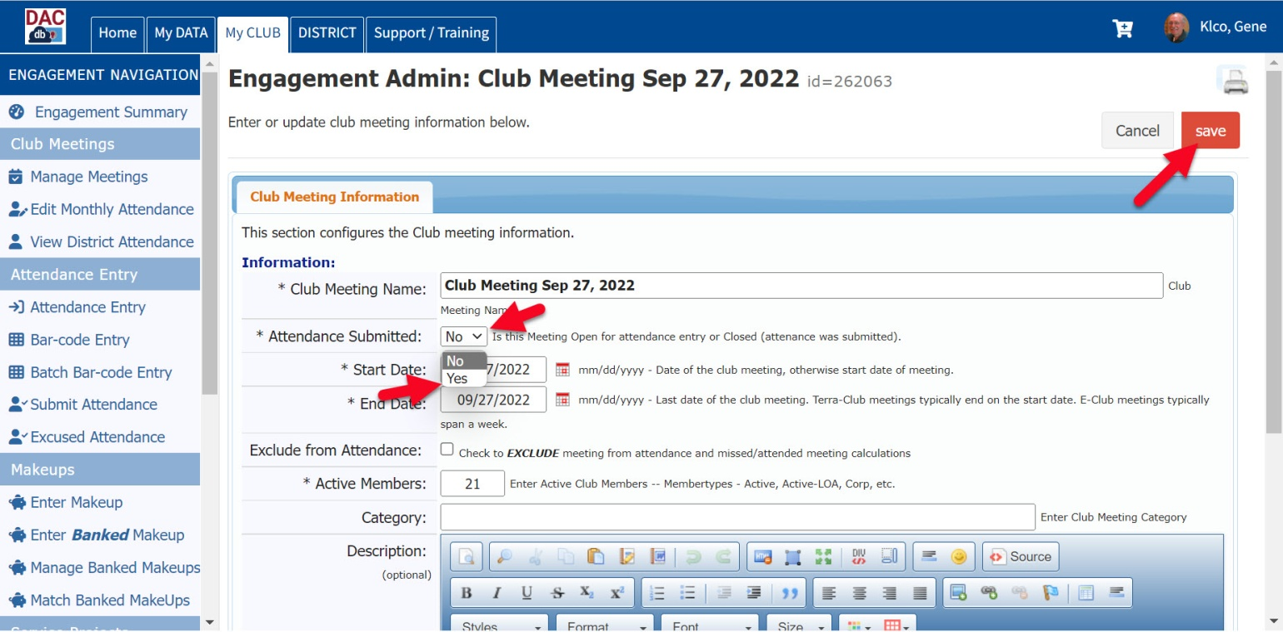

* Your meeting will now show up as **Attendance Submitted**

