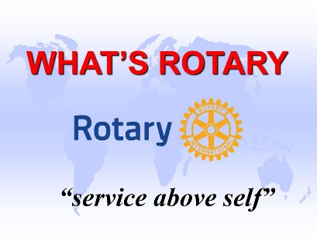

**TOP 10 REASONS TO JOIN ROTARY**

1. **Friendship / Fellowship / Fun**: In an increasingly digital and detached world, Rotary provides the most basic of human needs: the need for friendship and fellowship. Working together with other community leaders to enrich our society makes Rotary a fun and exciting place to be!
2. **Opportunity to Serve**: As a service club, Rotary's business is mankind, and its product is service. This is perhaps the best reason for becoming a Rotarian: *the chance to do good living by the motto,* ***“Service Above Self*”.**
3. **Business Development/Networking:**  Everyone needs to network. Rotary’s members come from all walks of life and include some of the top movers and shakers in the community.
4. **Personal Growth and Leadership Development**: Membership in Rotary ensures continuing growth and education in human relations, personal development and leadership. As they say, “iron sharpens iron”. Being around some of the best leaders in the area will help you be the best you can be! At the same time, serving in Rotary will equip you also to motivate, influence and lead leaders and future leaders.
5. **Continuing Education**: Each week at Rotary, there is a program designed to keep members informed about what is going on in the community, nation and world. Each meeting provides an opportunity to listen to different speakers on a variety of timely topics.

1. **Citizenship in the World**: There are few places on the globe that do not have a Rotary club. Every Rotarian is welcome – even encouraged – attend any of the 30,000+ clubs in 200 nations and geographical regions. This encourages new friendships in both local and world communities.
2. **Family Programs**: Rotary provides one of the largest youth exchange programs in the world, as well as high school and college level clubs for future Rotarians.
3. **Public Speaking Skills**: Many individuals who joined Rotary were uncomfortable about speaking in public. Rotary develops confidence and skill in public communication and the opportunity to practice and perfect these skills.
4. **The Development of Ethics**: Rotarians practice a 4¬Way Test that governs their ethical standards. Rotarians are expected to be ethical in business and personal relationships.
5. **Cultural Awareness**: Rotary is a racial and cultural cross section of the world's most prominent citizens who have developed a love for working with people everywhere.