**District Governors**

**District Governor 2019-2020 (DG)**

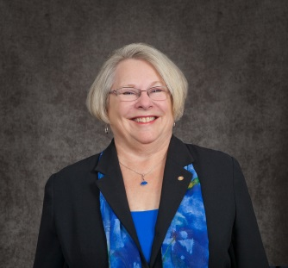 **Margie Haas** (Gene)

Hastings Rotary Club

214 Calgary

Hastings, MI 49058

H: 269-945-2941

C: 269-838-3392

haasmargie@gmail.com

**District Governor Elect (DGE)**

**Nathan Triplett** (Sarah)

East Lansing Rotary Club

647 Virginia Ave.

East Lansing, MI 48823

C: 517-719-6499

ntriplett@gmail.com

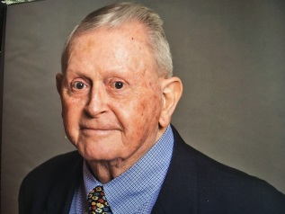**District Governor Nominee (DGN)**

**Larry Adams** (Sharon)

Charlotte Rotary Club

1511 N. Clinton Trail

Charlotte, MI 48813

C: 517-231-1061

larryladams@yahoo.com

**Immediate Past District Governor (IPDG)**

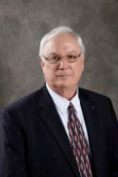**James “Jim” Cupper** (Chris)

Kalamazoo Rotary Club

9800 W. Gull Lake Drive

Richland, MI 49083

H: 269-629-4967 C: 269-348-1526

jimcupper@gmail.com

**District Office**

**District Administrator/Chief Financial Officer**

**Ingrid Nova** (Roger Policht)

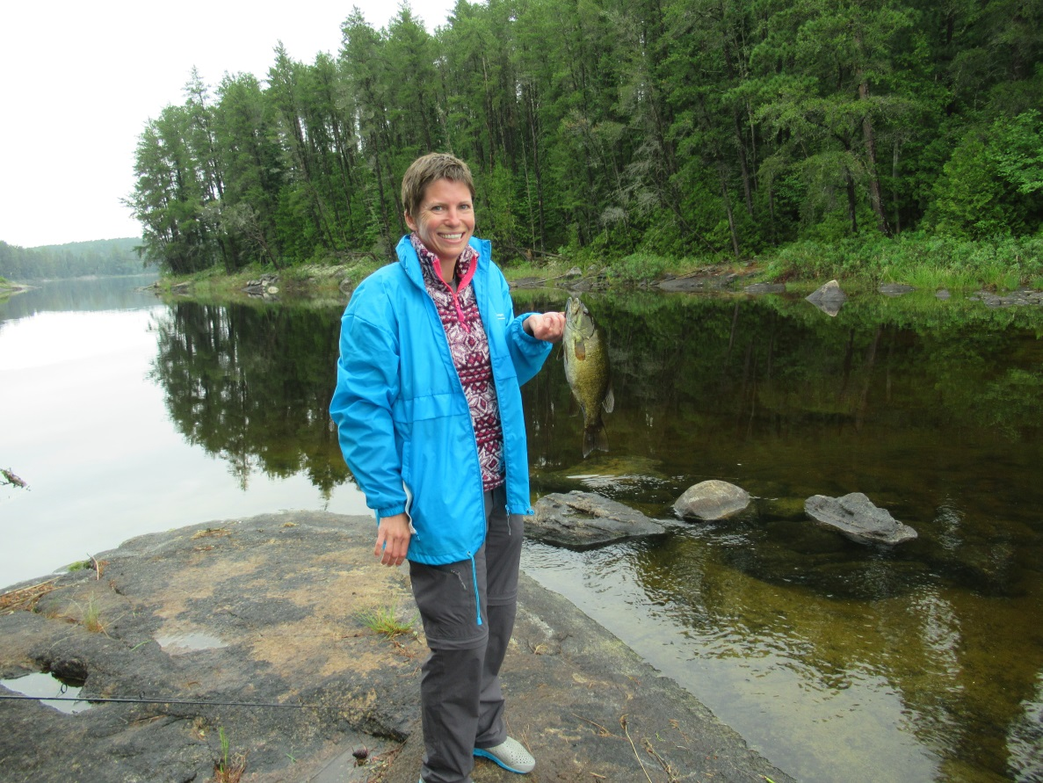Mason Rotary Club

741 Wolverine Road

Mason, MI 48854

O: 517-604-6360

C: 734-475-0340

Rotary6360@gmail.com

**District Secretary**

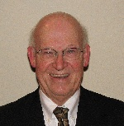**Edward Schaadt** (Ronda)

Gull Lake Area Rotary Club

7669 Richland Woods Court

Richland, MI 49083

C: 269-760-5598

edschaadt@gmail.com

**District Treasurer**

Tina Spanos

Constantine Rotary Club

22898 Spring Haven Dr.

Centreville, MI 49032

C: 269-720-8158

Tinagmtb1@aol.com

**DISTRICT 6360 ASSISTANT GOVERNORS**

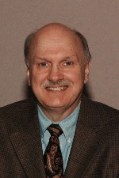**Area #1**  **Berrien Springs/Eau Claire**

**Gary Campbell** (Karen) ‘21 **Dowagiac**

Lakeshore Rotary Club **Lakeshore**

471 W. Shawnee Road  **Harbor Country**

Baroda, MI 49101

C: 269-422-2767

garycampbell@qtm.net

**Area #2**  **Benton Harbor Sunrise**

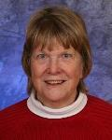**Dyann Chenault** ‘21 **Paw Paw Area**

Benton Harbor SR Rotary Club **Paw Paw Lake**

665 Pipestone **St. Joseph/Benton Harbor**

Benton Harbor, MI 49022 **South Haven**

C: 269-861-0052

dchenault647@yahoo.com

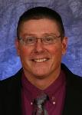**Area #3 Constantine**

**Mike Zolen** (Heather) ‘19 **Sturgis**

Three Rivers Rotary Club **Three Rivers**

1204 Shiawasee River Rd. **White Pigeon**

Three Rivers, MI 49093

C: 269-816-1752

mikezolen@imedtr.info

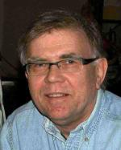

**Area #4**  **Kalamazoo**

**Petur Gudlaugsson** (Pat) ‘21 **Kalamazoo Sunrise**

Oshtemo Rotary Club **Oshtemo**

1147 Tanager Lane **Portage**

Kalamazoo, MI 49009 **Kalamazoo Area Rotaract**

C: 269-998-0387

petur@gudlaugsson.com

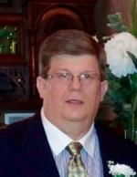**Area #5 Allegan**

**Dale Charters** ‘19 **Otsego**

Plainwell Rotary Club **Plainwell**

5020 Coopers Landing Dr. #2D **Saugatuck-Douglas**

Kalamazoo, MI 49004

C: 269-377-0042

dcharters78@hotmail.com

**DISTRICT 6360 ASSISTANT GOVERNORS**

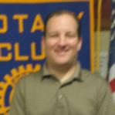**Area #6 Delton Area**

**David Stoll** (Kathi) ‘21 **Gull Lake Area**

Delton Area Rotary Club **Hastings**

423 Midlakes Blvd. **Middleville**

Plainwell, MI 49080

C: 269-267-5884

dstoll@mei.net

**Area #7**  **Battle Creek**

Vacant as of July 1, 2019 **Cereal City Sunrise**

**Climax**

**Vicksburg**

**Area #8 Bronson**

**Terra Depew** (Mic) ‘21 **Coldwater**

Coldwater Twp. SR Rotary Club **Coldwater Twp. SR**

37 Carlyle Ave. **Quincy**

Coldwater, MI 49036 **Union City**

C: 517-227-2257

tdepew@chcbc.com

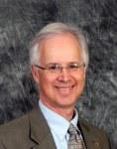

**Area #9 Hillsdale**

**Kirk Hoffman** (Jeanine) ‘21 **Jonesville**

Jackson Rotary Club **Litchfield**

1100 South Grinnell

Jackson, MI 49203

O: 517-750-2727 C: 517-474-8416

khoffman@guidestream.com



**Area #10 Albion**

**Mark Baker** (Lorina) ‘21 **Jackson**

404 Hibbard **Jackson Breakfast**

Jackson, MI 49202 **Marshall**

C: 517-414-0267

jacksonbakers2010@gmail.com

**DISTRICT 6360 ASSISTANT GOVERNORS**

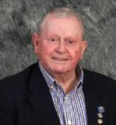

**Area #11**  **Charlotte**

**Larry Adams** (Sharon) ‘19 **Eaton Rapids**

Charlotte Rotary Club **Mason**

1511 N. Clinton Trail **S. Lansing/Holt**

Charlotte, MI 48813

C: 517-231-1061

larryladams@yahoo.com

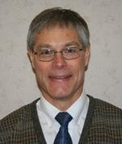

**Area #12**  **Grand Ledge**

**Gary Lenneman** (Sandy) ‘21 **Ionia**

St. Johns Rotary Club **Lansing/DeWitt SR**

8017 Lehman **St. Johns**

DeWitt, MI 48820

H: 517-626-2482

C: 517-930-3531

glenneman@frontier.com

**Area #13**  **Delta/Waverly**

**POSITION VACANT** **East Lansing**

**Haslett/Okemos**

**Lansing**

**Williamston**

**MSU Rotaract Club**

**DISTRICT COMMITTEES**

**MEMBERSHIP ATTRACTION & ENGAGEMENT**

**AG Dale Charters, Chair**

**NEW CLUB DEVELOPMENT/EXTENSION COMMITTEE**

**PDG Jim Cupper**

**YOUTH SERVICES COMMITTEE**

**Chairperson**

**Carl Schoessel**

Hastings Rotary Club

747 Terry Lane

Hastings, MI 49058

C: 269-838-8407

coachschoessel@hassk12.org

**Youth Exchange Subcommittee Chair**

**Position Vacant**

**Youth Exchange Inbound Co-Coordinators**

**Doug Buck**

Charlotte Rotary Club

1775 E. Clinton Trail

Charlotte, MI 48813

C: 517-652-1173

dougbuck@att.net

**Sally Ernst**

Lakeshore Rotary Club

1387 Lupine Dr.

St. Joseph, MI 49085

C: 773-991-6059

Alexa891@aol.com

**Youth Exchange Outbound Coordinator**

**Position Vacant**

**Interact Subcommittee Chair**

**Kirk Hoffman**

**Rotaract Subcommittee Chair**

**Kirk Hoffman**

**Rotary Student Mentoring Program Subcommittee Chair**

**Kevin Roney**

St. Joseph Benton Harbor Rotary Club

2835 Kevin St.

St. Joseph, MI 49085

C: 404-307-2861

theroney@msn.com

**RYLA (Rotary Youth Leadership Academy) Subcommittee**

**Connie High**

Delton Area Rotary Club

4581 South Shore Dr.

Delton, MI 49046

C: 269-377-3216

Connie.high@dkschools.org

**YOUTH PROTECTION OFFICER**

**William Doherty**

Hastings Rotary Club

1020 E. Woodlawn Ave.

Hastings, MI 49058

C: 269-986-5600

wdoherty@barryco.org

**PUBLIC IMAGE COMMITTEE**

**T.R. Shaw, Chair**

Cereal City Sunrise Rotary Club

935 Hillbrook Drive

Battle Creek, MI 49015

C: 269-209-5555

trsbcmi@gmail.com

**DISTRICT ROTARY FOUNDATION COMMITTEE**

**Kathy Gallagher, Chair**

Battle Creek Rotary Club

10670 Wildwood Dr.

Richland, MI 49083

C: 269-209-5949

kgallagher@bcacs.org

**The Rotary Foundation, Stewardship**

**Mark Christensen**

Hastings Rotary Club

421 W. Woodlawn Ave.

Hastings, MI 49058

C: 269-967-3974

Markd.christensen@edwardjones.com

**PolioPlus Subcommittee Chair**

**PDG Ed Foster**

**Charlotte Rotary Club**

316 Beech St.

Charlotte, MI 48813-1006

H & F: 517-543-3041 C: 517-230-7998

[ed@fosterdvm.com](mailto:ed@fosterdvm.com)

**District Grants Subcommittee Chair**

**Betty Mercer**

Haslett-Okemos Rotary Club

2350 Barnsbury Road

East Lansing, MI 48823

O: 517-861-7831

mercerconsulting@comcast.net

**Rotary Foundation Committee Treasurer**

**Shari LaBrenz**

Kalamazoo Sunrise Rotary Club

198 W Crooked Lake Dr.  
Kalamazoo, MI   49009

C: 269-808-2475 sklabrenz@icloud.com

**OTHER DISTRICT COMMITTEES**

**W.A.S.H. Committee Chair**

**R. Lee Sanchez**

Gull Lake Area Rotary Club

321 Pratt Road

Kalamazoo, MI 49001

C: 269-967-8119

Rlee.christensen@gmail.com

**District Trainers**

**Jim Goodwin, Co-Chair**

Jackson Breakfast Rotary Club

7425 Eckert Rd.

Concord, MI 49237

H: 517-524-6676

[jgoodwin@frontiernet.net](mailto:jgoodwin@frontiernet.net)

**Renée Merchant, Co-Chair**

Jackson Noon Rotary Club

5621 Somerset Drive

Brooklyn, MI 49230

H/W: 517-592-5463

C: 313-949-2658

rmerchant@dmci.net

**Rotary District 6360 Foundation**

*(Independent of the District)*

**OFFICERS**

**President**

**Karl Kincade**

Berrien Springs– Eau Claire Rotary Club

838 Wisconsin Ave., St. Joseph, MI 49085

C: 269-235-9269, karlkincade@usa.net

**Secretary**

**Gene Svebakken**

Harbor Country Rotary Club

215 E. Ash, Three Oaks, MI 49128

H: 269-756-2052

gsveb@comcast.net

**Assistant Secretary**

**Ed Delisle**

Union City Rotary Club

650 Dunks Road, Union City, MI 49094

C: 517-227-0403, edsautoinc@frontier.com

**Treasurer**

**Jose Lopez**

Delta Waverly Rotary Club

5011 Grape Arbor Lane, Lansing, MI 48917

C: 517-290-6019, jlopez5011@ameritech.net

**Assistant Treasurer**

**Bill Dimond**

Kalamazoo Sunrise Rotary Club

6240 Nantucket Lane, Kalamazoo, MI 49009

H: 269-375-1504, bill3127@aol.com

For updated District Leadership positions, your Club information,

other Rotary Club meeting locations, directions and maps and more, go to ***www.district6360.com***

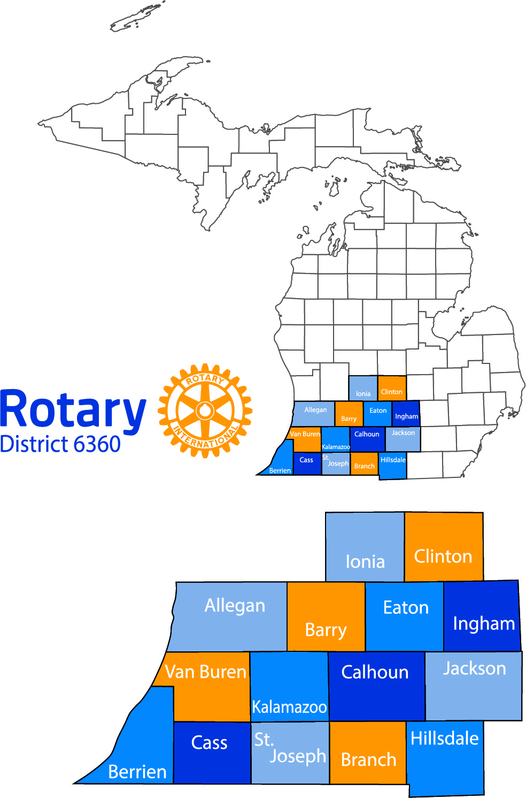

**Questions? Contact District Administrator Ingrid Nova at 517-604-6360 or**

**Rotary6360@gmail.com**