Rotary Retractable Banners Proposal

To increase our public image within our community, and to provide better consistency and education of what our club represents I am requesting that we purchase 2 retractable banners. The first banner would be “The Four-Way Test” (Style 2 -R45400) with the second being our “Rotary Vision” (Style 2 – R45402). They are priced at $195.95 through Russell-Hampton and are 33” wide by 80” tall.

These banners can be utilized for the numerous events that we host and attend within in the community including Duck Race, Taste of Williamston, Tom Clay Golf Outing, Farmers Market, and Club Meetings to name a few. They are easy to transport and require little effort to set up as well.

Four Way-Test Retractable Banner (Style 2 – R45400)……………………….$195.95

Club Retractable Jet Banner (Style 2 – R45402)………………………………….$195.95

Subtotal……………………………………….$391.90

Discount for Bulk ($10 each when you buy two)………………………………… $20.00

**Total $371.90**

*\*\*\*\*\*\*Can be customized for $20 each*

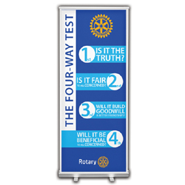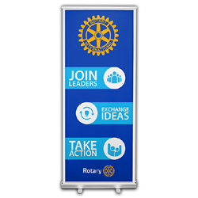

R45400 R45402