**Weekend Survival Kits Program**

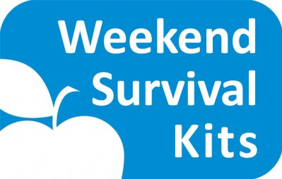

**2015-2016 Food Kit Packing and Delivery Schedule**

**Packing Schedule:** **Delivery Schedule:**

Thursday, October 8, 2015 (**FIRST PACKING SESSION**) Friday, Oct 9 & Friday, Oct 23

Thursday, November 5, 2015 Friday, Nov 6 & Friday, Nov 20

Thursday, December 3, 2015 Friday, Dec 4 & ***Thursday, Dec 17***

***\*\* PLEASE NOTE: we would like to deliver Thursday because of the Holiday break (subject to change)***

Thursday, January 7, **2016** Friday, Jan 8 & Friday, Jan 22

Thursday, February 4, 2016 Friday, Feb 5 & Friday, Feb 19

Thursday, March 3, 2016 Friday, March 4 & Friday, March 18

Thursday, ***March 24, 2016*** Fri, April 1 & Friday, April 15 & ***Friday, April 29***

***\*\* PLEASE NOTE: We will have THREE deliveries in April (subject to change)***

Thursday, May 5, 2016 (**LAST PACKING SESSION**) Friday, May 6 & Friday, May 20& ***Friday, June 3***

***\*\* PLEASE NOTE: We will have THREE deliveries after May 5th packing (subject to change)***

**PACKING** will take place at the **OKEMOS COMMUNITY CHURCH** located at

4734 Okemos Rd., Okemos, MI 48864

9:30am-10:00am: unload food and set up

10:00am-12:00pm: pack WSK kits ☺

We will be **STORING** the bags directly after packing at **FIRST BAPTIST CHURCH OF OKEMOS** (just a few blocks around the corner from Okemos Community Church). First Baptist Church is located at

4684 Marsh Road, Okemos, MI 48864

**FOOD PICK-UP** will take place immediately after packing and on the delivery dates as noted in the Delivery schedule. If picking up on the Delivery Schedule dates then Pick-up will be at **FIRST BAPTIST CHURCH OF OKEMOS**

Please visit [WWW.MANYHANDSMI.ORG](http://WWW.MANYHANDSMI.ORG) for more information! **Thank you!!**