**From:** [Rick Delaney](mailto:rickdelaneycpa@outlook.com)

**Sent:** Sunday, January 03, 2016 6:25 PM

**To:** [Gene Klco](mailto:gmklco@att.net)

**Subject:** FW: Rotary

Hi Gene.  Happy New Year!  Hope the holidays were good for you.  All except New Year’s Eve I guess.  But hey, they got to the Final Four!  Came up short but had a great run.    Alabama is an awfully good team and they appear to be on a mission.

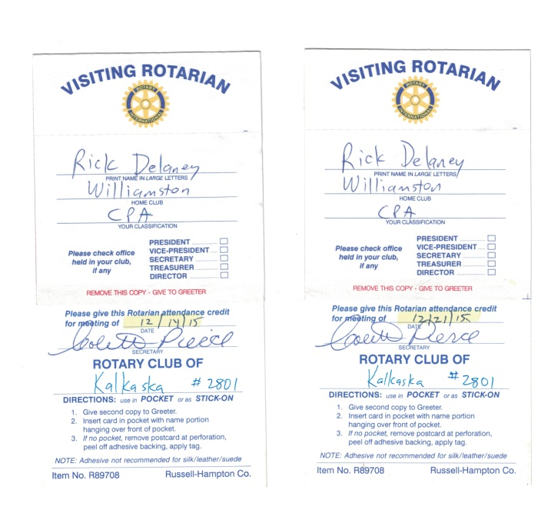**I have decided to join the Kalkaska Rotary Club**.   The e-mail below is from the Secretary of the Kalkaska club, Colette Pierce.   I have also attached a couple make-up slips which have our club number (#2801) on it.  Thought it might help.

So I’m wondering what the next step is.  I know you went through this when you transferred from Petoskey to Williamston.

Let me know what you think.  Thanks Gene.

Rick Delaney

517 881-6952

[rickdelaneycpa@outlook.com](mailto:rickdelaneycpa@outlook.com)

**From:** Colette Pierce [mailto:ColetteP@AmericanWaste.org]   
**Sent:** Monday, December 21, 2015 2:08 PM  
**To:** rickdelaneycpa@outlook.com  
**Subject:** Rotary

Rick,

Just a quick note to welcome you to our little corner of the world.  So glad you are planning to join our efforts in helping to make positive changes in our community and in the world!

Thanks so much,

Colette Pierce

Administrative Assistant

[American Waste](http://www.americanwaste.org/) / Northern A-1

Direct: 231-258-7154