**Former Jackson businessman continues commitment to Philippine children**

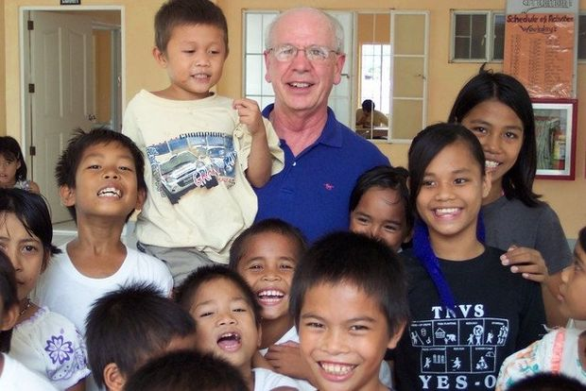

John Drake smiles with some of the wards he provides for through the Lingap Center. (Photo courtesy of John Drake)

**[Merinda Valley](http://connect.mlive.com/user/MerindaValley/index.html)**By **[Merinda Valley](http://connect.mlive.com/user/MerindaValley/posts.html)**  
[**Follow on Twitter**](https://twitter.com/merindaleana)   
on July 15, 2014 at 8:00 AM, updated July 16, 2014 at 11:02 AM

|  |
| --- |
|  |
|  |
|  |

**[http://ads.mlive.com/RealMedia/ads/adstream_lx.ads/www.mlive.com/news/jackson/2014/07/former_jackson_businessman_con.html/178666681/StoryAd/MICHIGANLIVE/default/empty.gif/6246596c6446504734366b41444e3946?bt=7050&bt=7049&bt=7051&bt=7052http://ads.mlive.com/RealMedia/ads/adstream_lx.ads/www.mlive.com/news/jackson/2014/07/former_jackson_businessman_con.html/178666681/StoryAd/MICHIGANLIVE/default/empty.gif/6246596c6446504734366b41444e3946?bt=7050&bt=7049&bt=7051&bt=7052](http://ads.mlive.com/RealMedia/ads/click_lx.ads/www.mlive.com/news/jackson/2014/07/former_jackson_businessman_con.html/178666681/StoryAd/MICHIGANLIVE/default/empty.gif/6246596c6446504734366b41444e3946)**

JACKSON, MI – At a municipal landfill for Manila, the capital of the Philippines, dump trucks unload trash throughout the day. Kids jump onto the trucks and pick through piles looking for metals and other materials to salvage, and scrounging for food scraps.

The waste ferments and smokes in the tropical heat, an occurrence that invited the mound's moniker "Smokey Mountain."

More commonly, the dump is known as "Payatas," which translates to "promised land."

Maybe it is a promised land for some. With food, livelihood and shelter in villages there, it provides the bare necessities, no matter how deplorable.

To John Drake, it is a stark contrast to the church beside it — a hell next to a sanctuary.

Drake is the president of the Lingap Children's Foundation, which supports impoverished and neglected children through the Lingap Center in Toledo City, Philippines. He first witnessed conditions in the Philippines during business trips for Jackson-based CMS Energy and Consumers Energy. Drake traveled there for 10 years, and from the beginning, disparities defined his connection with the island nation.

White sand beaches, high-rise buildings, and other tourist attractions surrounded Metro Manila. But on the opposite side of a concrete wall blanketed by bougainvillea flowers, people were starving.

"Other people get to see the resorts, I get to see the horrors," Drake said.

In 2002, CMS Energy sold the Philippine plant Drake worked in, and he thought he would be done with the country.

But after numerous challenges and denials of what he eventually came to understand as his calling, Drake opened the Lingap Center and its governing foundation in 2006. That same year, he left his job as a senior vice president of human resources and administrative services for CMS Energy to operate Lingap full time.

Drake now manages the nonprofit from Jackson with his wife, Judy. He travels to the Philippines about six times a year and has a board of directors in both countries. [**In 2012, the Lingap Children's Foundation was ranked a top nonprofit in the United States**](http://www.mlive.com/news/jackson/index.ssf/2012/11/lingap_childrens_foundation_fo.html).

**About Lingap Center**

More than a safe haven, Drake sees the center as a place where children can find resources they need to become dignified, productive individuals.

"There's a lot to this, it's not just feeding them," Drake said.

**How to help**

Donate online at[**lingapcenter.org**](http://www.lingapcenter.org/)

Mail donations to: The Lingap Children's Foundation  
P.O. Box 1553  
Jackson, MI 49204

The center provides children education, catechism and skills training through house parents, social workers and other staff members who take care of them.

Lingap Center's first wards were taken from an existing orphanage of the same name — a place that once functioned as a slaughterhouse and had an open sewer running through the floor when Drake visited.

Drake built a new facility for his Lingap Center, which still houses about 100 children today. Since its opening, it has provided residential services to 309 children.

Aileen Bantolinao is one among the hundreds. She was brought to the Lingap Center at age 7 or 8 after her mother died of pneumonia and her father was unable to support her and her siblings.

Bantolinao recently graduated from the Philippine University of San Carlos with a bachelor's degree in tourism management and is interning at the Baltimore Country Club in Maryland.

Three former Lingap wards are college graduates, and 16 are in college.

Bantolinao sees the Lingap Center as the reason she was able to pursue her education and avoid marrying young.

**Poverty in the Philippines**

In the Philippines and other developing countries, problems like sex trafficking ensnare women and prevent them from leading successful lives.

According to 2013 data from the Philippine Statistics Authority, poverty incidence in the country was around 25 percent.

"It imprints on your heart," Judy Drake said of seeing poverty. "You can't imagine people living like that, but they do."

Bantolinao is thankful for the Drakes' empathy and the foundation's support.

"If not for them, I don't know — where would I be?" Bantolinao said.

She feels she owes her life to Drake. And Drake is not faltering in his efforts to help youth like Bantolinao.

**Center developments**

Over the last few years, there have been a number of developments at the Lingap Center.

To spur entrepreneurial interest and give wards a skill with real-world value, Lingap's cook instructs a commercial cooking class. The center also has a set of outreach programs including lessons for street children, and a monthly event that combines mass and a community feeding.

But chief among the changes is a social shift.

Lingap children who were once unwelcome distractions in the local church now make up the choir.

After the children cultivated a garden and continued to maintain it, the Toledo City government asked Lingap wards to represent the city at an agricultural fair.

"The outcasts are now the ambassadors of goodwill," Drake said, noting another contrast of his experience in the Philippines.

And according to Drake, the community's acceptance of the children has boosted their own sense of self-worth.

**Widespread support**

The Lingap Children's Foundation has a donor base that stretches across the globe, but fundraising efforts really started in Jackson, Judy Drake said.

Individuals from other areas also contribute to Lingap. Reina Pantaleon, a native Filipina who lives in Georgia, is a virtual volunteer for the foundation, managing administrative and communication tasks, as well as social media. She heard a presentation from John Drake at a Catholic church near Marietta, Ga., and was shaken by his mission.

"I was very blessed. I lived in a very comfortable upbringing, very different from what these children are going through," Pantaleon said. "That could've been me."

After that realization, Pantaleon began advocating for the center and praised Drake for the work he's doing in her home country.

Drake said he almost feels guilty about commendations because he enjoys his work so much.

"The big winner is me," he said.

Though he tries to crop himself out of the center's philanthropic image, he can't escape praise. Just the other day, Drake received and email of thanks from one Lingap ward who is now in college. It was wrapped in a promise to work hard and make him proud.

A line he's heard several times from the children he's helped is, "I want to be just like you."

More than any award, financial statistic or developmental benchmark, that may be the best indicator of what Drake has accomplished.