Tim Allard Receives Rotary Community Service Award
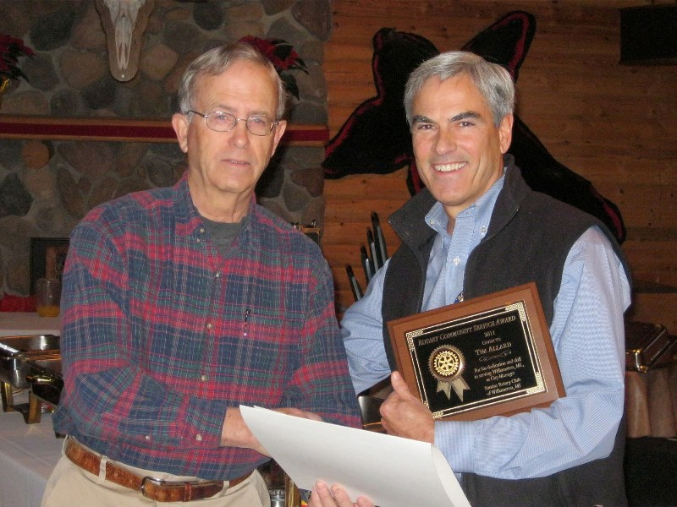
At their December 6, 2011 meeting, Williamston Sunrise Rotarian, Tim Allard, was presented with this year’s Rotary Community Service Award by President Fred Campbell. Fred read some of the accomplishments that the City of Williamston benefited by during Tim’s tenure as City Manager (as obtained from the City Treasurer).
City of Williamston Highlights under City Manager Tim Allard’s Tenure
- Effective-partnerships with DDA, TIFA/EDC, Williamston Community, Library Foundation, City Boards and Commissions, local service organizations, Chamber of Commerce, the business community, residents, Federal and State agencies, and County and Township units.
- Development of multi-year Capital Improvement Plan adopted by Planning Commission and City Council.
- Obtained and administered $1.3M in grants.
  - Ph 1 N Williamston Rd - $90,000
  - Ph 2 N Williamston Rd - $345,000
  - 109 Building Redevelopment - $190,000 MEDC grant
  - CDBG — WPI - $276,000
  - Wellhead Protection Grant - $12,000
  - Targeted Neighborhood ~ $150,000 with Ingham County Housing Commission/MSHDA
  - Category MDOT Grant— S Putnam -$245,000 (to, possibly, $379,000)
  - Miscellaneous Donations $15,000
- Construction of Industrial Park Progress Court $800,000 roadway and utility project utilizing $400,000 EDA Grant.
- Construction of McCormick Park $800,000 improvement project with $391,00 DNRE Grant.
  - Incorporated grant amendment providing for improvement of the High/Putnam parking lot.
  - Converted insect-invested Ash trees into ten tree sculptures incorporating successful winter Tree Sculpture Festival.
- 781 Progress Court property purchase at 1/3 the cost of the real estate listing as future home for departmental operations.
- 835 B Grand River Avenue property purchase at nominal cost providing:
  - High Street water main loop
  - Easy access by bicyclists and pedestrians to Memorial Park via the Red Cedar River Bridge.
  - Road option connecting High Street and East Grand River Avenue.
- Downtown Rental Rehabilitation projects through partnership with Ingham County Housing Commission/MSHDA Grant.
- Establishment of successful recreation program in conjunction with Meridian Township when dropped by Williamston Community Schools as sponsor.
- DDA South Putnam Streetscape Project - $390,000.
- USDA RD Loans for $8.3M Water/Sewer Projects, including Williamston’s first Water Treatment Plant and replacement water well at historically low interest rate.

