WILLIAMSTON SUNRISE ROTARY CLUB
MINUTES
BOARD OF DIRECTOR’S MEETING
May 22, 2012

MEMBERS PRESENT: Fred Campbell, Gene Klco, Steve Terry, Merlin Hopkins, Tom Clay, Carrie Thorburn (Absent: Julie Pfeifle, Mark Steinberg)

President Fred Campbell called the meeting to order at 8:30 am.
Agenda – Agenda reviewed & approved (M/S/P)
Prior Board minutes – Reviewed & approved (M/S/P)
Review Treasurer’s Report (Steve)
- Steve will email the Treasurer’s Report – printer not working
- We will have a deficit heading into next year

Duck Race Planning:
- Sponsors:
  - Matched last years dollars - $4000
- Duck Race application to be made to the Lottery Commission
  - Application received
- Brochure is ready to go to the printer
- Cash Prizes - $1000, $250, $100
- Duck Pen planning as backup
  - Use old banners as sides – hexagon
  - Fred & Merlin to check on banners
- Sound equipment (PA system)
  - Peter Clay will MC and bring his sound system
  - Get a generator – preferably a quiet one
    - Merlin to check on his cousin

Poker Night – May 21-23, 2012
- Going OK, with a few last minute changes
  - Norm had to back out (Monday – mid shift)
  - Andy can’t do Wed –mid shift - conflict
- Good take on Monday

Other Business:
- Honoring Tito
  - Name on Duck Race Brochure as “Tito Reyes Memorial Duck Race”
    - Gene talked to Nancy Reyes to let her know of the ticket addition
  - Carrie suggested make it the “Tito Reyes Student of the Quarter” Award
    - Moved by Tom, 2nd by Steve - Approved
- Rotarian of the Year
  - Rick gathered all past winners
    - Vote was unanimous for Howard Dahlstrom
    - Gene ordered plaque
- Community Service Award
  - Normally done in Fall – Fred: Delay till Fall?
    - Do it now
  - One nomination – Stan Takis (by Merlin)
    - Carrie motion for Stan, 2nd by Tom – Approved
    - Plan to get Stan to June 19th meeting
    - Gene to order wooden plaque
- Plan for transition to new officers
    - Any issues? none
- Sell Ducks to Debbie Brehm-Oesterle in Kansas
  - Need to count ducks to see if we can sell any
- No meeting June 26th (after Duck Race)
- Membership
  - Merlin is talking to some young people
  - See what would work for them?
  - Setup a youth Rotary here
    - Maybe require attend one meeting per month
    - Meet by selves other times
    - Connect with email
There being no further business before the Board, the meeting was adjourned at 9:05 am.

The next Board meeting is set for Tuesday, June 12, 2012 after the regular Club meeting.

Respectfully submitted,

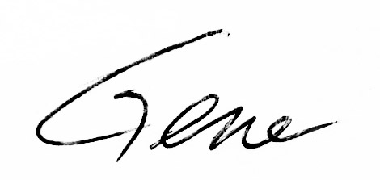
Gene Klco, Club Secretary

