WILLIAMSTON SUNRISE ROTARY CLUB
MINUTES
BOARD OF DIRECTOR’S MEETING (Non-scheduled)
May 1, 2012

MEMBERS PRESENT: Fred Campbell, Gene Klco, Julie Pfeifle, Merlin Hopkins

A quick meeting was had after the regular meeting at 8:40 am.

Duck Race Ticket review:
- Gene presented a suggestion for a revision to the Duck Race ticket
  - Moved the “Who Benefits” section (previously on back of ticket form kept by club)
    - Moved to side with prizes (making prize info squares smaller and rearranging
  - Want to add info on Tito below that (1st Club President, started Duck Race, …)
    - Let me know what else I can add there
    - Also put “Tito Reyes Memorial” in arc over Duck Race symbol on cover
  - Julie suggested we move the ‘disclaimer’ on prizes (have to be claimed by …)
    - To Prize side as well
    - Add under “And many more prizes”
  - Gene to make revisions and send PDF with these minutes

Email from Bill Penn:
- Email from Bill to Gene on April 26, 2012 – forwarded to board
  - “I told someone, Tom maybe, some time ago that you probably need to take me off the membership as I do not believe that I will be coming back as an active member.”
- Voted to approve his wishes and remove Bill from active membership
There being no further business before the Board, the meeting was adjourned at 8:50 am.

The next Board meeting is still set for Tuesday, May 22, 2012 after the regular Club meeting.

Respectfully submitted,

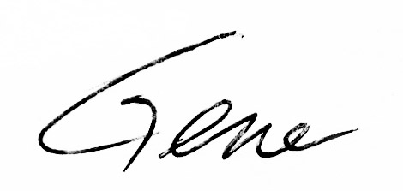
Gene Klco, Club Secretary

