WILLIAMSTON SUNRISE ROTARY CLUB
MINUTES
BOARD OF DIRECTOR’S MEETING
April 17, 2012

MEMBERS PRESENT: Fred Campbell, Gene Klco, Steve Terry, Merlin Hopkins, Tom Clay, Mark Steinberg (Absent: Carrie Thorburn, Julie Pfeifle)

President Fred Campbell called the meeting to order at 8:35 am.
Agenda – Agenda reviewed & approved (M/S/P)
Prior Board minutes – Reviewed & approved (M/S/P)
Review Treasurer’s Report (Steve)
- Dues income is short of budget ($1500-2000) – not enough members (~4 members short)
- Most items in budget are fixed cost
  - Just need new members
  - Could eliminate the Holiday Party or make it a pot luck (not catered) -$500
  - Increase dues about $20/person/quarter
  - Cancel meeting once a month – save costs of breakfast

Duck Race Planning:
- Sponsors:
  - 5 sponsors paid so far
  - Many more 10-12 more agreed to sponsor (mostly our members)
  - Need to contact businesses
- Duck Race application to be made to the Lottery Commission
  - Still plan regular Duck Race (if water level is low)
    - Backup plan to do a Duck Pen
  - Tom did not submit an alternative plan on application
    - Read rules – needs to be random drawing of winners
    - With Duck Pen – were double random
- Duck Pen
  - Plan on a pen this year – as an experiment
  - Need method for picking the kids?
    - Sell ducks with ticket sales on day of race
      - Use numbers on ducks to determine choices
      - Cleanup some of the ducks to sell
- Bob won’t be there – so need way to get sound equipment (PA system)

Poker Night – May 21-23, 2012
- Only Wed evening slot left – Fred will cover if no one else signs up

Other Business:
- How Honor Tito?
  - Name on Duck Race Brochure as “Tito Reyes Memorial Duck Race”
- Rotarian of the Year?
  - Nomination by membership
  - Bring up at Club Assembly

- Citizen of the Year?
  - How about Tom Johnson?
  - Others?
  - Need to vote on?
- District Luncheon?
  - Very few members went last year
  - Won’t sponsor anyone

There being no further business before the Board, the meeting was adjourned at 9:20 am.

The next Board meeting is set for Tuesday, May 22, 2012 after the regular Club meeting.

Respectfully submitted,

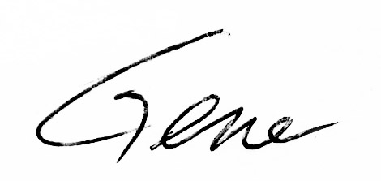
Gene Klco, Club Secretary

