WILLIAMSTON SUNRISE ROTARY CLUB
MINUTES
BOARD OF DIRECTOR’S MEETING
March 20, 2012

MEMBERS PRESENT: Fred Campbell, Gene Klco, Steve Terry, Julie Pfeifle, Tom Clay, Mark Steinberg (Absent: Carrie Thorburn, Merlin Hopkins)

President Fred Campbell called the meeting to order at 8:30 am.
Agenda – Agenda reviewed & approved (M/S/P)
Prior Board minutes – Reviewed & approved (M/S/P)

Hero Award:
- District request
- Must be a member
- Suggestions?

PETS - Julie:
- District budget – didn’t pass
  - Lansing Rotary against
  - To raise dues to $38/member – Up $3.80/member
  - Wanted them to look closer at the dollars
- Mason does a Duck Race too
  - May want to see how they do it
- Interact Club – should we get one started?

Duck Race Planning:
- Sponsors:
  - Have 4 committed – some paid
  - Need to contact or get letters out
  - Like results by end of March
- Duck Race application to be made to the Lottery Commission
  - Still plan regular Duck Race (if water level is low)
    - Backup plan to do a Duck Pen
  - Brochure – fast turn around time
    - Plan at end of April
    - Gene to suggest changes to format of brochure
  - In 12 years of Duck Race, only last 3 years has water level been high
  - Sell ducks with ticket sales on day of race
    - Cleanup some of the ducks to sell
  - Duck Pen
    - Plan on a larger pen
    - Last year was 6’x8’ – too small
    - Need 10’x12’ size
    - Idea: Use old banners from previous years – tied to stakes – for sides
  - Blow up ‘Ducky’ is dirty – needs cleaning if to use

Other Business:
- Poker Night – May 21-23, 2012
  - Tom applied to Lottery Commission
    - For May Poker Nights - $50/night x 3 = $150
  - Gene to bring a Poker sign-up sheet to next Tuesday’s meeting

There being no further business before the Board, the meeting was adjourned at 9:10 am.

The next Board meeting is set for Tuesday, April 17, 2012 after the regular Club meeting.

Respectfully submitted,

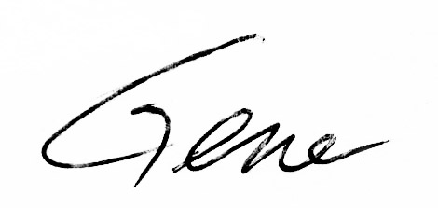
Gene Klco, Club Secretary

