WILLIAMSTON SUNRISE ROTARY CLUB
MINUTES
BOARD OF DIRECTOR’S MEETING
February 28, 2012

MEMBERS PRESENT: Fred Campbell, Gene Klco, Steve Terry, Julie Pfeifle, Tom Clay, Mark Steinberg & Rick Delaney (Absent: Carrie Thorburn, Merlin Hopkins)

President Fred Campbell called the meeting to order at 8:15 am.
Agenda – Agenda reviewed & approved (M/S/P)
Prior Board minutes – Reviewed & approved (M/S/P)

Duck Race Planning:
- Discussed at regular meeting
  - Still plan regular Duck Race (if water level is low)
    - Backup plan to do a Duck Pen
- Sponsors:
  - Tom has sent out list from last year for signup
  - Many businesses signed up for
  - Like results by end of March

Other Business:
- Narda – on April 17 will have the Robotics Team from the HS – 11 kids
  - Unsure can handle?
  - Just let Mary Ann know ahead of time – so prepared for larger number
- Bev wants us to negotiate with Mary Ann at Brookshire
  - Variation of food served at meetings – change menu - simplify
    - Only serve one meat vs. three
    - Ask for options
      - More variety of food
      - Even if it only saves them money or waste
  - Currently pay $7 per person – with 25 person minimum
    - Seldom go over 25 (today with Students of the Quarter had 27)

Grant Request by Williamston Theater:
  - Presented by Rick Delaney
  - Rick saw what happened in Chelsea, MI – before/after Purple Rose Theater started
    - Saw big increase in downtown
    - It was a magnet to bring people downtown and to the restaurants
  - Want to see that continue to happen in Williamston with the Theater here
  - Asking for an extra grant to help bring in matching funds
    - From Capital Regional Community Foundation – for $20,000
    - The grant will double our investment
  - For building improvements
    - Added escape door (steel-fireproof)
      - Provides entry-exits for actors and costume changes
    - Remove drop ceiling in theater
      - To add improved lighting for stage
    - Installation of new light pipes ad stages
  - Williamston Theater has increased in attendance each year
    - 914 – 1st year (2005-6)
    - 5081 : 2006-7
    - 6000+ : 2007-8
    - 7000+ : 2008-9
    - 8000+ : 2009-10
    - 9475 : 2010-11
  - Half of the dollars are from donations
  - Requesting about $10,000 total
    - Including other area organizations
  - We currently have about $18,000 in the foundation account
    - Concern that we not spend moneys that usually give to other organizations
    - Also want to do a “Capital Project”
      - Don’t think this really qualifies
  - Tom motioned that we offer to add $2000 to our regular $3000 donation
    - Bring our total to the Theater this year to $5000
    - Seconded by Gene
    - Motion passed

There being no further business before the Board, the meeting was adjourned at 8:45 am.

The next Board meeting is set for Tuesday, March 20, 2012 after the regular Club meeting.

Respectfully submitted,

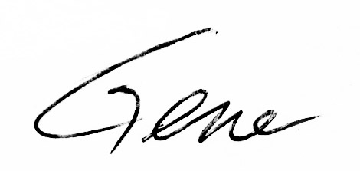
Gene Klco, Club Secretary

