Williamston ***Sunrise*** Rotary

www.williamstonrotary.org

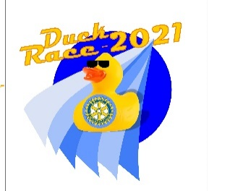

January 24, 2023

To All Who Are Interested:

Williamston Sunrise Rotary is pleased to announce that our annual grants process is open to applicants between now and June 1, 2023. These grants are awarded each year for programs and projects that benefit the community. Rotary has given over $500,000 to individuals and organizations in our community. We are proud to have supported so many worthy projects and programs that have and continue to enrich people’s lives.

Grant applications will be considered for ‘new’ projects that benefit a broad spectrum of individuals/groups within our community.

The process for application can be found on our website:

[www.Williamstonrotary.org](http://www.Williamstonrotary.org) - (Go to “*Documents”* tab; then to “*Community Service Grants*” tab; look for “*Grant Guideline”* tab and *“Grant Application*” tab.)

**OR**, click on the link below:

<http://www.williamstonrotary.org/?s=documents>

Service projects and programs must align with one or more of the Rotarian goals. These are listed and defined on the Grant Guidelines document. You will find the directions for submission on the grant application.

We look forward to reading your application and potentially providing for your requests as well. If you have any questions, please contact me.

Sincerely,

Laska Creagh, President

[laskacreagh@gmail.com](mailto:laskacreagh@gmail.com)