**Instructions for using Square credit attachment to phone**

1. Download the Square point of sale app - App looks like this 
2. Tap on the app icon and it will open to this screen

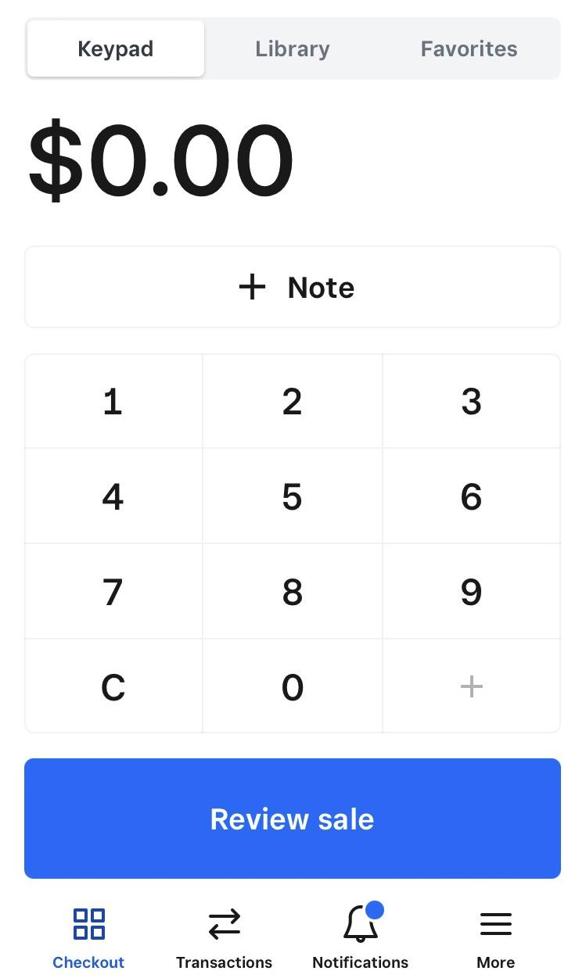

1. Enter the amount to be charged.
2. Plug in square with logo facing up
3. Tap review sale (at bottom of screen)
4. Tap charge (at bottom of screen)
5. Swipe card with magnetic strip down
6. You will see a screen that will send a receipt to the buyer if they want- offer this and let them shoes the method- email, text